A
Major Project
on

STATIC RESPONSE OF FRAMED STRUCTURE USING THE EFFECT OF SOIL STRUCTURE INTERACTION

Submitted in Partial fulfillment of the requirement
for the award of the degree of
MASTER OF ENGINEERING
(Structural Engineering)

Submitted by
AHMAR AFZAL
(University Roll No. 10302)

Under the Guidance of
Dr. ASHOK KUMAR GUPTA
Assistant professor



DEPARTMENT OF CIVIL & ENVIRONMENTAL ENGINEERING,
DELHI COLLEGE OF ENGINEERING,
BAWANA ROAD, DELHI -110042.
UNIVERSITY OF DELHI

July 2008

Department of Civil & Environmental Engineering

Delhi College of Engineering, Delhi-110042

CERTIFICATE


This is to declare that the major project on “Static response of framed structure using the effect of soil structure interaction” is a bonafide record of work done by me for partially fulfillment of requirement of degree of M.E. Civil Engineering (Structural Engineering) at Delhi College of Engineering

This project has been carried out under the supervision of Dr. Ashok Kumar Gupta, Assistant Professor, Delhi College of Engineering, Delhi.

I have not submitted the matter embodied in this report to any other University or Institution for the award of any Degree or Diploma.

Name – Ahmar Afzal
College Roll no - 02/STR/06
University Roll no - 10302

This is to certify that the above statement laid by the candidate is correct to the best of my knowledge.

Dr. Ashok Kumar Gupta
Assistant Professor
Dept. of Civil and Environmental Engineering,
Delhi College of Engineering,
New Delhi - 110042

ACKNOWLEDGEMENT

It is a great pleasure to have the opportunity to extent my heartfelt gratitude to everybody who helped me throughout the course of this project.
It is distinct pleasure to express my deep sense of gratitude and indebtedness to my learned supervisor Dr. Ashok Kumar Gupta for his invaluable guidance, encouragement and patient reviews. His continuous inspiration has made me complete this major project. He kept on boosting me time and again for putting an extra ounce of effort to realize his work.
I would also like to take this opportunity to present my sincere regards to H.O.D. Dr. Awadhesh Kumar for his support and encouragement.
I am thankful to our Librarian, Computer Center Head and other staff members for providing me unconditional and anytime access to the resources.
I am very thankful to Mr. Manish Gupta and Mr. Alok Athaley for helping me in the completion of my thesis work.
I am also thankful to my friends for their unconditional support and motivation during this work.

Ahmar Afzal
College Roll no 02/STR/06
University Roll no. 10302
M.E. (Structural Engineering)
Department of Civil and
Environmental Engineering,
Delhi College of Engineering,
Delhi-110042

LIST OF CONTENT
Page No.
CHAPTER-1: INTRODUCTION
1.1 General 1
1.2 Soil-Structure Interaction Effect on Soil Settlements and
Structural Forces 3
1.3 Static Analysis 3
1.4 Objective of Study 4
1.5 Organisation of Thesis 4
CHAPTER-2: LITERATURE REVIEW
2.1 General 5
2.2. The Literature Review 5
2.3 Justification for selecting the present work 13

CHAPTER-3: NUMERICAL METHODS OF ANALYSIS
3.1 General 14
3.2 Finite Element Method 14
3.3 Boundary Element Method 18
3.4 Discrete Element Method 21
3.5 Explicit Finite Difference Method 22
3.6 Winkler Method 23
CHAPTER-4: NUMERICAL MODELING USING ANSYS

4.1 Elastic Models 25
4.2 Static Analysis 27
4.3 ANSYS and its Features 27
4.3.1 Building the computer model 28

4.3.2 Selecting the coordinates system 28
4.3.3 Generation of the solid model 29
4.4 Loads and Boundary Condition 32
CHAPTER-5: METHODOLOGY
5.1 Modeling 34
5.1.1 Problem description 34
5.1.2 Assumption 35
5.1.3 Material properties 35
5.1.4 Type of element used 37
5.1.4.1 2-D ELASTIC 3 Element (BEAM 3) 37
5.1.4.2 PLANE 182 Element 38
5.1.5 Real constant 38
5.1.6 Creation of Geometrical Model 38
5.2 Meshing 39
5.3 Applying Loads and Boundary Conditions 39
CHAPTER – 6: RESULTS AND DISCUSSIONS
6.1 General 40
6.2 Effect of Variation of Modulus of Elasticity of Soil When the
Poisson Ratio of Soil is Constant 41
6.3 Effect of Variation of Poisson Ratio of Soil When the Modulus
of Elasticity of Soil is Constant 47
6.4 Effect of Variation of Thickness of Raft When the Property of
Soil is Constant 53
CHAPTER -7: CONCLUSIONS 57
REFRENCES 59
APENDIX A 62
APENDIX B 66
APENDIX C 70
APENDIX D 73

LIST OF FIGURE
Page No.
Figure 3.1 Quadrilateral element 16
Figure 3.2 Layered soil subjected to forces on the surface,
base of boundary, top and side. 18
Figure 3.3 Winkler idealisation 23
Figure 4.1 Stress vector diagram 26
Figure 4.2 Coordinate System
Figure 4.3 2-D view of an area defined by keypoints and lines. 30
Figure 4.4 Mapped meshed area. 31
Figure 4.5 Free and mapped meshed areas (Ansys). 31
Figure 4.6 Quadrilateral and triangular elements (Ansys). 32
Figure 5.1 2D view of superstructure soil foundation system 35
Figure 5.2 2D ELASTIC 3 Element (BEM 3) Geometry 37
Figure 5.3 PLANE182 Element Geometry 38
Figure 6.1 Variation of deflection with variable modulus of elasticity
and constant poisson ratio along width of soil strata. 41
Figure 6.2 Variation of deflection with variable modulus of elasticity
and constant poisson ratio along depth of soil strata. 42
Figure 6.3 Variation of stress with variable modulus of elasticity
and constant poisson ratio along width of soil strata. 43
Figure 6.4 Variation of strain with variable modulus of elasticity
and constant poisson ratio along width of soil strata. 44
Figure 6.5 Variation of deflection with variable modulus of elasticity
and constant poisson ratio along length of raft 45
Figure 6.6 Variation of stress with variable modulus of elasticity
and constant poisson ratio along width of raft 46
Figure 6.7 Variation of strain with variable modulus of elasticity
and constant poisson ratio along width of raft 46
Figure 6.8 Variation of deflection with variable poisson ratio and
constant modulus of elasticity along width of soil strata 47
Figure 6.9 Variation of deflection with variable poisson ratio and
constant modulus of elasticity along depth of soil strata 48
Figure 6.10 Variation of stress with variable poisson ratio and constant
modulus of elasticity along width of soil strata 49
Figure 6.11 Variation of strain with variable poisson ratio and constant
modulus of elasticity along length of soil strata 50
Figure 6.12 Variation of deflection with variable poisson ratio and
constant modulus of elasticity along width of raft. 51
Figure 6.13 Variation of stress with variable poisson ratio and constant
modulus of elasticity along length of raft 52
Figure 6.14 Variation of strain with variable poisson ratio and constant
modulus of elasticity along width of raft 52
Figure 6.15 Variation of deflection with variable thickness of raft along
width of soil strata 53
Figure 6.16 Variation of deflection with variable thickness of raft along
depth of soil strata 54
Figure 6.17 Variation of stress with variable thickness of raft along width
of soil strata 54
Figure 6.18 Variation of strain with variable thickness of raft along width
of soil strata 55
Figure 6.19 Variation of deflection with variable thickness of raft along
width of raft 56
FigureD-1 2-D Model showing the Frame-raft-soil interaction 75
Figure D -2 Deformed shape of building with raft and soil 72
Figure D-3 Produced Deformation in Building, Raft & Soil 72
Figure D-4 Produced Stresses in Building, Raft & Soil in Y-direction 73
Figure D-5 Produced Stresses in Building, Raft & Soil in X-direction 73
Figure D-6 Produced Strains in Building, Raft & Soil in X-direction 74
Figure D-7 Produced Strains in Building, Raft & Soil in Y-direction 74

LIST OF TABLES
Page No.

Table 5.1 Variable modulus of elasticity and constant
poisson ratio 36
Table 5.2 Variable poisson ratio and constant modulus
of elasticity 36
Table A-1 Variation of deflection with variable modulus of elasticity
and constant poisson ratio along length of soil strata. 61
Table A-2 Variation of deflection with variable modulus of elasticity
and constant poisson ratio along depth of soil strata. 62
Table A-3 Variation of stress with variable modulus of elasticity and
Constant poisson ratio along length of soil strata. 62
Table A-4 Variation of strain with variable modulus of elasticity and
constant poisson ratio along length of soil strata. 63
Table A-5 Variation of deflection with variable modulus of elasticity
and constant poisson ratio along length of raft 63
Table A-6 Variation of stress with variable modulus of elasticity and
constant poisson ratio along width of raft 64
Table A-7 Variation of strain with variable modulus of elasticity and
constant poisson ratio along length of raft 64
Table B-1 Variation of deflection with variable poisson ratio and
constant modulus of elasticity along length of soil strata 65
Table B-2 Variation of deflection with variable poisson ratio and
constant modulus of elasticity along depth of soil strata 66
Table B-3 Variation of stress with variable poisson ratio and
constant modulus of elasticity along length of soil strata 66
Table B-4 Variation of strain with variable poisson ratio and
constant modulus of elasticity along length of soil strata 67
Table B-5 Variation of deflection with variable poisson ratio and
constant modulus of elasticity along length of raft. 67
Table B-6 Variation of stress with variable poisson ratio and
constant modulus of elasticity along length of raft 68
Table B-7 Variation of strain with variable poisson ratio and
constant modulus of elasticity along length of raft 68
Table C-1 Variation of deflection with variable thickness of
raft along length of soil strata 69
Table C-2 Variation of deflection with variable thickness of
raft along depth of soil strata 70
Table C-3 Variation of stress with variable thickness of raft along
length of soil strata 70
Table C-4 Variation of strain with variable thickness of raft along
length of soil strata 71
Table C-5 Variation of deflection with variable thickness of raft
along length of raft 71

ABSTRACT

The Soil-Structure interaction is a very important phenomenon which is principally affected by the mechanism of energy exchange between the soil and structure and its primary influence is to modify the static response of the interaction system in terms of deformation, stress and strain.
Superstructure-raft-soil interaction represents an integrated system. However, this complex problem is always analysed in separated parts. The static response of the structure-raft-soil interaction is influenced by the properties of soil media. The interrelationship between the response of a structure and characteristics of soil media is termed as interaction effect. The study, include the determination of the effects of soil structure interaction of framed structure for varying soil conditions. ANSYS 9.0 software has been used for 2D static linear analysis of the structure on different types of soil continuum. The soil continuum and raft foundation is modelled as 4-noded 182 element and superstructure is 2-noded beam element. The results of 2-D static numerical analyses in the forms of deformation, stress, strain and acceleration are presented. From the results it is found that the variation of modulus of elasticity of soil significantly effects the behaviour of the deflection and strain while the behaviour of stress has less affect as compared to the other two responses at structure-raft interaction and raft-soil interaction. Variation of Poisson’s ratio of soil does not affect significantly for all the responses as compared to modulus of elasticity, the behaviour of deflection and strain has a little more effect than the stress at both the interaction. When variation of thickness of raft is taken into account, all the responses have significantly affecting the behaviour of the system at both the interaction. On increasing the modulus of elasticity (2.0 x 10⁷ – 5.0 x 10⁷ N/m²) the decrease in deformations is approximately 61% whereas increase in Poisson’s ratio (0.10 – 0.30) resulted in 5 % increase of deformation.

CHAPTER-1
INTRODUCTION
1.1 General
Structures are generally supported on soils unless rock is very near the ground surface. The behavior of structures under static or dynamic loads, founded on soils, is different from that of similar structures founded on rock. This difference in the behavior is because of the phenomenon commonly referred to as Soil-Structure Interaction (SSI).The Soil-Structure interaction is a very important phenomenon which is principally affected by the mechanism of energy exchange between the soil and structure.
Superstructure-raft-soil interaction represents an integrated system. However, this complex problem is always analysed in separated parts. This simplification is generally necessary because of the inherent complexity of treating Super Structure-raft-soil interaction as a whole, as each of the sub systems, by itself, represents a vast field of possible mechanical idealizations and a wide choice of physical and geometrical parameters. Two different approaches to the problem are commonly found. One group of researchers is concerned with applying rigorous models to the superstructure and they usually consider the soil as a rigid base or use simple models for the analysis. On the other hand, some others are more interested in applying rigorous mechanical models to the soil without coupling it to the superstructure and/or they just consider a raft of a simple two-dimensional frame resting on the deformable soil. However, several studies analyse Super Structure-Raft-Soil interaction as an integrated system, but most of them simplify the problem by considering the structure in two-dimensional space and the soil a homogeneous isotropic linear continuum in an infinite half-space ignoring its heterogeneous and discontinuous nature.
In current design practice, structural engineers usually disregard any influence that the displacement of the supporting ground may have on the response of framed structures. Likewise, in foundation design, analysis of actual displacements is based upon flexible loading pattern with no assessment of the effect of the stiffness of the structure on the patterns and magnitudes of foundation displacements. Conventional structural design methods neglect the Soil-Structure Interaction (SSI) effects. Neglecting SSI is reasonable for light structures in relatively stiff soil such as low rise buildings and simple rigid retaining walls. The effect of SSI, however, becomes prominent for heavy structures resting on soft soils for example nuclear power plants, high rise buildings and elevated highways on soft soils.
The principal results that can be obtained from an SSI analysis using finite elements are the stresses and displacements of the structure and the soil. In most real design problems, the stresses and displacements of the soil and structure can only be calculated using a numerical method like a finite element analysis. Conventional limit equilibrium methods, which do not predict displacements, are adequate for design where there is a sufficient base of experience. When there is less experience, or when displacements are critical, SSI analyses may be needed. Stresses and deformations of the structure and/or the soil can be calculated, and the calculated values can be compared to allowable values. If necessary, changes in the system configuration or the constructed component stiffness can be made, and the SSI analysis can be repeated until the calculated stresses and deformations are acceptable.
The exact analysis of response of a structure considering soil-structure interaction requires that the structure be considered a part of a larger system that includes the foundation and the supporting medium, and that the effect of the spatial variability of the ground motion and the properties of the soils involved is taken into consideration.
However, because of the complexity of the problem, performing such a detailed analysis for all types of structures is not always possible in practice. Therefore, approximate methods to incorporate the effects of soil-structure interaction have often been used. One of the approaches involves modifying the free-field ground motion (ground motion in the absence of any structure or foundation) and evaluating the response of the structure to the modified motion of the foundation (Gazetas et al., 1992).

1.2 Soil-Structure Interaction Effect on Soil Settlements and Structural Forces
Soil settlement is a function of the flexural rigidity of the superstructure. The structural stiffness can have a significant influence on the distribution of the column loads and moments transmitted to the foundation of the structure, and load redistribution may modify the pattern of or mitigate settlements. Increase stiffness of the frame generally reduces differential settlement, and when the soil is soft the interaction is beneficial. The common practice of obtaining foundation loads from structure analysis without allowance for foundation settlement may, therefore, result in extra cost that might have been avoided had the effect of soil-structure interaction been taken into account in determining the settlements. Accommodation of movement without damage leads to significant overall economy as well as improved serviceability. This requires that the engineers not only understand the properties of the ground but they also need to know how the building will respond to deformation and what the consequences of such deformation will be to its function.
The load redistribution significantly modifies the pattern of and mitigates differential settlements. Furthermore, the footing loads may increase or decrease due to the consideration of the effect of soil-structure interaction. Structures and their supporting soils should, therefore, be considered as a one system, and taking their interaction into account is essential for reasonably obtaining accurate predictions of both soil settlements and distribution of stresses in the structural members. Even if neglecting the interaction effect do not result into harmful damages, it would however considerably reduce the margin of safety, or result in over-or underestimation of the real bending moments of the structural members.
1.3 Static Analysis
Static analysis is used to determine the displacements, stresses, strains, and forces in structures due to loads that do not induce significant inertia and damping effects. The loads and the structure’s response are assumed to vary slowly, if at all, with respect to time, the primary application of FEA in ship structures is in support of design and this usually involves static analyses. These may range from global models encompassing the whole ship, to very detailed local models, Apart from FEA performed in support of design, static analysis is also used in the investigation of certain types of structural failures.
1.4 Objective of Study
The objective of this study is to determine the effects of soil structure interaction of framed structure for varying soil conditions and thickness of raft. ANSYS 9.0 software has been used for 2D static linear analysis of the structure on different types of soil continuum. In FEM modeling, framed structure (beams and column) have been modelled as beam elements and soil as solid elements. 2D-elastic element is used as beam element and 4-noded 182 element as solid element. A two dimensional mesh is created for the geometric model of the problem. The results of 2-D static numerical analyses in the forms of deformation, stress, and strain are presented.
1.5 Organisation of Thesis
Chapter-2 includes the study of literature survey.
Chapter-3 include the study of Method Used for Analysis of Structure-foundation-Soil interaction
Chapter-4 shows how the Numerical Modeling Using ANSYS is done
Chapter-5 shows the steps of modeling, how the static models are constructed, the material properties are selected are explained
Chapter-6 gives the analysis and results in the forms of curves.
Chapter-7 presents the conclusions and recommendations for future studies.

CHAPTER-2
LITERATURE REVIEW
2.1 General
Various researchers suggested varying approaches to study the Structure-Raft-Soil Interaction problem. Difference of opinion exists in the method of analysis approach proposed to be adopted while studying the forces in raft and superstructure. The various reaches papers have been studied. An extensive literature survey of research was carried out in this work and is arranged in chronological order with reference to date of publication. Some of them are presented here. In the recent past not much work was done in this area, the foundation and superstructure were always dealt separately.
2.2. The Literature Review
Larsson, R. and Wxberg, N. (1987) presented a new exact element for a beam on elastic foundation according to second order theory. When the solution to the differential equation is exactly satisfied one single element can represent a continuous part of the structure. Thus, only a few elements are required for an accurate result and, further, more, this result in a reduced computer cost. A general structural coupling has been described in order to include stiff areas, hinges and rollers in a unified frame analysis. This is important when the structure is to be coupled to the foundation. The described structural stiffness relation contains all variables introduced, which is advantageous when the buckling load of the structure is to be calculated. In the numerical examples showing different soil-structure interaction problems the accuracy and the efficiency obtained by using exact solutions were demonstrated.
Molla, M.K.A. and Rays, D.P. (1992) investigated on the vertical response of flexible rectangular raft foundations subjected to vibratory load. The raft is assumed to be supported on a Winkler medium. The finite element method with eight-nodded isoperimetric plate bending elements of rectangular shape is used for the analysis. The Newmark integration method is applied to solve the dynamic equilibrium equations. Different type of foundation soil, namely sand, soft clay and peat, are considered. The subgrade modulus of these soils is determined in the laboratory. Dynamic response curves for four aluminium plates are obtained both by analytical methods and experimental investigations and the results are compared. The agreement is quite good in respect of the qualitative nature of the curves and reasonable in respect of quantitative values. They developed a computer program for the purpose of the analysis of a rectangular raft under dynamic loading by the finite element method. The program can be suitably modified to cater for a raft of any shape. The theoretical study indicates that the amplitude-frequency curve always fluctuates. In most of the cases resonant amplitude also increases with the increase of aspect ratio of the raft up to a certain limit, and then decreases. Thickness of raft is the most important factor which has a notable influence on both resonant and design amplitudes. Both these amplitudes decrease as the thickness increases. It is observed in most of the cases that the values of resonant and design amplitudes are higher for peat and soft clay than those for sand. Moreover, for soft clay and peat the long-term settlement will be much more which is dangerous for foundation under vibratory load. Therefore, it is not wise to use soft clay and peat as foundation soil under dynamic loading without adopting a suitable technique.
For ground improvement, the resonant amplitude is higher for eccentric load than for concentric load in most of the cases. The resonant amplitudes and resonant frequencies are different for different eccentricities. The resonant amplitude-eccentricity curve fluctuates and resonant amplitude attains the maximum value at some intermediate point, the position of which is different for different types of soils. The maximum moments and shears for eccentric load have much higher valves than those for concentric load. For this reason eccentricity should be avoided for vibratory loads. The dynamic response curves of four aluminium plates obtained by experimental investigation show consistent qualitative conformity to those obtained by analytical method. The experimental values are found to be much lower than the theoretical values. This indicates that the assumption of ideal Winkler model on the action of foundation soil is not in conformity to in situ performance of foundation. In spite of having different limitations, this method can be used to calculate cut-off zone, design frequency and nodal displacements of mat foundation due to lack of available alternatives. Once the displacements are known, the calculation of moments and shares and hence the design becomes a routine procedure.
Choi, C. K. and Kim, H.S. (1992) considered the variable node plate bending element, i.e. an element with one or two additional mid-side nodes is used effectively in the analysis of a mat foundation. The variable node elements can generate a nearly ideal grid for mat foundation analysis in which more nodes are defined near the column location where the steep stress gradient is expected. The plate bending element used in their study is based on Mindlin/Reissner plate theory with substitute shear field. The nodal stresses of that element are obtained by local smoothing. The interaction between the soil and the mat foundation is modeled with Winkler springs connected to nodal points in the mat model. The vertical stiffness of the soil material is terms of a modulus of subgrade reaction and is computed in similar way to the computation of consistent nodal force of uniform surface loading. They investigated the use of the variable node plate bending element in mat foundation from a clamped plate test it could be seen that this type of element could be efficiently used in mat foundation analysis
And this was verified in the numerical example of the mat foundation for a 25 storey reinforced concrete building. Local stress smoothing techniques were successfully applied to obtain the nodal stresses from the stresses at the Gauss points of the variable node elements. Among the proposed mesh schemes which include the variable node elements in modeling, scheme which is having more nodes near column was found to be optimum considering the analysis results obtained and the number of DOFs involved in the analysis. The performance of scheme which is having more nodes near column along the column lines, which is the most important area in mat foundation design, is significantly improved by simply adding a few mid-side nodes to the 4x4 uniform models. The findings in this study have been implemented for practical applications in the mat foundation analysis routines of BUILDS-F, which is a foundation analysis and design computer program for building structures.
For the finite element mesh for mat foundation analysis, it is desirable that the element should have an aspect ratio, length/width. Of near unity (1.0) and sharp interior angles should be avoided. At locations in the mat where high rates of change curvature are expected, a finer local mesh should be provided. Reasonably accurate results may be obtained whenever the element size does not exceed 150% of the mat thickness in the areas of angel curvature and low moment.
Rao, P. S. , Rambabu, K.V. and Allam, M.M. (1994) have made a comparison between the more realistic half-space continuum and the plane-strain approach to examine the approximation involved in the latter type of representation of soil. Whether presence of other plane frames in the vicinity will impart a confining effect to the soil support and thereby justify a plane-strain modeling of the soil is also investigated and concluded that sagging moments in the superstructure beams as obtained using the plane-strain model are always greater than those obtained from the elastic half-space over the entire practical range of relative stiffness between foundation and soil. For structures with low relative stiffness between superstructure and soil the moments are much closer to those obtained for the half-space model. Hogging moments obtained using the plane-strain model is, however, always smaller for all relative stiffness between foundation and soil values. The difference decreases for structures with low relative stiffness between superstructure and soil. Choice of soil models ahs lesser effect on sagging moments in the superstructure than on the hogging moments. The effect of the model on sagging moments in the foundation beam is dependent on relative stiffness between superstructure and soil unlike the effect on hogging moment, for which plane-strain always yields higher values. The presence of adjacent frames does not significantly influences the results from half-space model in the practical ranges of relative stiffness between foundation and soil and relative stiffness between superstructure and soil. It is therefore not realistic to represent the interior frames in a long structure by a plane-strain condition. However if forces in the superstructure elements only are of interest, representation of the soil support by the plane-strain condition is a fair approximation of the actual situation for structures possessing low relative stiffness between superstructure and soil and high relative stiffness between foundation and soil. In such cases a considerable saving in computational effort and memory requirements occurs, particularly when soil properties vary with depth, as in such cases elastic half-space solution do not exist which could be used to model the soil reaction on the basis of the foundation structure.
Melerski, E. S. (1997) used a simple technique of numerical modelling of elastic interaction between a half-space and circular plates under conditions of axial symmetry are outlined. Homogeneous, cross-anisotropic and isotropic material properties of the elastic half-space medium are allowed for, and the plate bottom surface is assumed to be smooth. The soil interface response is based on the solution to the problem of a vertical surface point load, and used to develop the medium stiffness matrix related to the plate settlements. Combining this stiffness matrix with the plate stiffness matrix leads to a set of simultaneous equations governing the problem considered.
To develop the plate stiffness matrix, two techniques of numerical modelling are employed in the work, namely a finite element method and a finite difference procedure. The used finite element technique (called modified mixed finite element method) is based on the element displacement function in the form of a cubic polynomial and involves 2d.f. at each nodal line. The applied finite difference method derives from the calculus of variations and, like conventional finite difference procedures, utilizes only 1 D.F. (vertical displacement) at each nodal line. However, unlike the conventional finite difference techniques, this approach uses the same structural idealization and allows for analysis of the same range of loadings as its finite element counterpart. Thus, different thickness elements can be connected at a nodal line, and in addition to distributed loadings, uniform nodal line forces and moments are admissible.
Computer programs developed on the basis of the procedures described above are very easy to use, require minimal data and run-time, produce quite accurate results and allow for most of the practical loading cases to be considered. Furthermore, the separation between the raft plate and the elastic half-space can be considered, and either elastic or unyielding circular line supports provided. Due to axial symmetry, the structural response fields are entirely represented by the relevant values along the applied nodal lines of the raft plate. These discrete structural response fields consist of vertical displacements, radial slopes, radial and circumferential bending moments, shearing forces and contact pressures. The effectiveness and usefulness of the proposed numerical approaches and the developed computer programs are demonstrated.
Nasri, V and Magnan, J.P.(1997) used nonlinear consolidation analysis using finite element formulation based on Biot’s consolidation theory to study the time dependent behavior of three dimensional (3-D) frame structure resting on an elastic or elastic perfectly plastic soil satis fying the Drucker-Prager yiekd criterion. The effect of soil consolidation on the behavior of a 3-D frame-raft-soil mass system is considered. The initial stress method with a modified Newton-Raphsn iterative scheme has been used for this study. A coupeled fiite-infinite element moments of the mat foundation and the structural elements (beams and columns) are compared with those time-dependent analysis. The results show that the consolidation of soil increases the internal forces in some elements , so that cheking the final forces in the frame by time –independent conventional frame alalysis may be not sufficient.
Al-Shamrani, M. A. and Al-Mashary, F. A. (1999) have evaluated the effect of interaction on the predicted settlements and footing loads of two-dimensional multi-bay framed structures. They presented a modular computer program that provides a simple, yet reliable computational tool for the analysis of the interaction behaviour of two-dimensional steel or reinforced concrete framed structures supported by spread footings. The development of the program capitalized on the power of the new release of Fortran 90 in terms of data handling and programming fashion. They presented two numerical examples to illustrate the effect of interaction on the predicted settlements and footing loads of two-dimensional multi-bay framed structures. Interaction between soil and structure has been found to significantly affect the estimated settlements and footing loads. The results of the analyzed examples showed that load redistribution significantly modifies the pattern of and mitigates differential settlements. Furthermore, the footing loads may increase or decrease due to the consideration of the effect of soil-structure interaction. Structures and their supporting soils should, therefore, be considered as a one system, and taking their interaction into account is essential for reasonably obtaining accurate predictions of both soil settlements and distribution of stresses in the structural members. Even if neglecting the interaction effect do not result into harmful damages, it would however considerably reduce the margin of safety, or result in over-or underestimation of the real bending moments of the structural members.
It should, however, be pointed out that in the presented analysis the behavior of the structure was taken to be linear elastic. Under large differential settlement it is quite possible that the actual behavior of most members in the frame will be neither linear nor elastic. However, the results obtained may be considered an indicative on the inter relationship between structure and its supporting soil.

Wang, C.M., Chow, Y.K. and How, Y.C. (2000) presented the Ritz method for the settlement analysis of rectangular thick rafts resting on a homogeneous elastic half-space. As the considered raft is thick, the midline plate theory has been used to model the raft in order to allow for the effect of transverse shear deformation in the raft as it bends under transverse loading. A penalty function is introduced in the Ritz formulation to satisfy the natural boundary conditions of free edges. The correctness of the Ritz formulation and the software developed was established by the close agreement of bending results of the raft foundation obtained by the present Ritz method and those determine by previous researchers. They concluded that the bending problems of a transversely loaded rectangular thick raft with free edges, resting on an elastic half-space is solved using the Ritz method. By approximating the displacement functions using complete two-dimensional polynomials of sufficient degree, the Ritz method is shown to be an accurate technique in solving this class of raft-soil interaction problem. Except for a noticeable improvement for the shear forces at the edges of the raft, the use of a penalty functional to ensure the satisfaction of the natural boundary conditions only improves the stress-resultants marginally at the expense of more computational effort, the effect on settlement is also marginal. Thus it is practically acceptable to use the Ritz method without any penalty functional for the bending solutions, by setting the stress-resultants (bending moments and shear forces) at the free edges to zero. It is clearly seen that the effect of shear deformation is important for rafts under patch loading especially with small loading area (small c=B ratio) and when Krs < 0.1. Due to the dearth of bending results of rafts under a patch loading on an elastic half-space, a large amount of results presented would give an appreciation of the settlement behaviour of the rafts under this loading condition.
Kumar, D. and Das, S. K. (2004) analysis of stability (mainly bearing strength and settlement) under a footing on regularly bedded, jointed and layered model rock mass is conducted using non-linear FEM analysis. A simple method to estimate bearing strength of both intact and jointed rock mass under circular, square and rectangular footings is proposed. In jointed and layered rock mass conditions, the floor bearing characteristics analysis were carried out by considering the parameters like orientations of joint and weak layer with respect to the direction of loading, variations in the joint sets (joint spacing) and the layer thickness (as a function of footing plate width). The location of footing plates with respect to joint and weak layer were also varied.
3D non-linear FEM analyses of floor bearing characteristics (under the similar conditions as in the case of laboratory investigation) were carried out using a commercially available FEM software package. Three dimensional numerical models were developed for different conditions of surface footing foundations using appropriate rock mass properties. The inputs required for the FEM modeling were imported from the laboratory results of the measurements. Rock mass was modeled as elastic-plastic with Drucker- Prager failure criteria for plane strain condition. The joints and the weak layers in the floor rock mass were modeled in order to enable separation of zones in the models. The footing settlements correspond to the maximum applied bearing pressure on floor strata (for different sizes and shapes of footing plates and also under varying anisotropy conditions of floor strata) as obtained from the experimental results and FEM investigations, were compared and the maximum deviation was observed as 32 % whereas the minimum was even less than 1 %.
From FEM analysis it is interpreted that maximum stress concentration occurs at the tip of the footing plate all along the boundary. The stress concentration extends maximum to a distance 2 to 3 times footing plate width in all direction of floor strata. It is further interpreted that maximum vertical settlement occurs near to the vicinity of the footing plate.
Maheshwari, P. and Madhav, M.R.(2006) described numerical procedure for the analysis of the vertical deformation and the stress distribution of the strip footings on layered soil media. Three layers of soil with different stiffness are considered with the middle soil layer the thinnest and most stiff layer. The soil media is discretized and using the theory of elasticity, the governing differential equations are obtained in terms of vertical and horizontal displacements. These equations along with appropriate boundary and continuity conditions are solved by using the finite difference method. The vertical and horizontal displacements, strains and stresses are found at various nodes in the soil media. Parametric studies are carried out to study the effect of the placement depth of the middle soil layer, the relative ratios of the moduli of deformation of the soil layers on the vertical displacement of the footing and the vertical stress distribution. These studies reveal that the middle thin but very stiff layer acts like a plate and redistributes the stresses on the lower soft soil layer uniformly. The displacement on the top and bottom of the middle soil layer is almost the same showing that the compression of the middle layer is negligible as it is very stiff.

2.3 Justification for selecting the present work
The literature discussed above is related to the study of the soil-structure interaction including frame-raft-soil interaction. Various types of responses has been discussed in the literature using Finite Element Method like static response such as displacement, stress, strain, bending moment and shear forces and some of them include dynamic response as well. On the basis of this literature review, a study of a simple model of framed structure consisting of raft-frame-soil is modeled for analysing the static response of the system. This is one of the areas where more such studies are required.

CHAPTER-3
NUMERICAL METHODS OF ANALYSIS
3.1 General
Finite element, boundary element and finite difference methods are used in the solution of the complex mechanical problems for which analytical methods do not give a solution. Some of these numerical techniques will be explained in this section.
The numerical method can be classified as follows:
- Finite Element Method (FEM)
- Finite Difference Method (FDM)
- Boundary Element Method (BEM), and
- Discrete Element Method (DEM)
3.2 Finite Element Method
The Finite element method treats a continuum as an assemblage of discrete elements whose boundaries are defined by nodal points. In finite element method it is assumed that the response of the continuum can be described by the response of the nodal points. The finite element method is a numerical approach based on elastic continuum theory that can be used to model structure-foundation-soil interaction by considering the soil as three-dimensional, quasi-elastic continuum. Finite element techniques have been used to analyze complicated loading conditions on important projects and for research purposes. Salient features of this powerful method include the ability to apply any combination of axial, torsion, and lateral loads; the capability of considering the nonlinear behavior of structure and soil; and the potential to model structure-foundation-soil interactions. Time-dependent results can be obtained and more intricate conditions such as battered piles, slopes, excavations, tie-backs, and construction sequencing can be modeled. The method can be used with a variety of soil stress-strain relationships, and is suitable for analyzing pile group behavior performing three-dimensional finite element analyses requires considerable engineering time for generating input and interpreting results. For this reason, the finite element method has predominately been used for research on pile group behavior, rarely for design.
The main advantages and disadvantages for geotechnical analysis may be summarized as follows.
Advantages
- Nonlinear material behavior can be considered for the entire domain analyzed.
- Modeling of excavation sequences including the installation of reinforcement and structural support system is possible.
- Structural features in the soil or rock mass, such as closely spaced parallel sets of joints or fissures, can be efficiently modeled, e.g., by applying a suitable homogenization technique.
- Time-dependent material behavior may be introduced.
- The equation system is symmetric (except for non-associated flow rules in elasto-plastic problems tangent stiffness methods)
- The conventional displacement formulation may be used for most load-path analyzes.
- Special formulation are now available for other types of geotechnical problem, e. g., seepage analyzes, and the bound theorem solution in plasticity theory.
- The method has been extensively applied to solve practical problems and thus a lot of experience is already available.
Disadvantages;
The following disadvantages are particularly pronounced for 3-D analysis and are less relevant for 2-D models.
- The entire volume of the domain analyzed has to be discretised, i.e., large pre- and post processing efforts are required.
- Due to large equation system, run times and disk storage requirements may be excessive (depending on the general structure and the implemented algorithms of the finite element code).
- Sophisticated algorithms are needed for strain hardening and softening constitutive models.
- The method is generally not suitable for highly jointed rocks are highly fissured soils when these defects are randomly distributed and dominate mechanical behavior.
In Finite element method the problem of interest is first discretized by dividing it into elements. Then the displacement at any point within an element is expressed in terms of the nodal point displacements as the following ({v}^{T} = {u,v}). For a quadrilateral element nodal point displacements can be given as {q^{T}} = {u1, u2, u3, u4, v1, v2, v3, v4} as shown in Fig. (2.5) and displacements for any point in the element can be expressed in the following form.
Fig. 3.1 Quadrilateral element
{v} = [N]{q} (3.1)
Where, [N] is a matrix of shape functions. The strain displacements matrix, [B], allows the strains to be determined from the nodal point displacements
{ϵ} = [B]{q} (3.2)
And, the stress strain matrix [D], relates stresses to strains:
{ϭ} = [D]{ϵ} (3.3)

Defining a local coordinate system (s, t) and using the strain displacement and stress-strain relationships, an element stiffness matrix can be written as
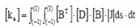 (3.4)
Where, J is the jacobian matrix used in transformation of an arbitrary quadrilateral element to a gauss square.
A consistent element mass matrix can be written, assuming constant density within the element, as
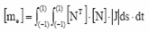 (3.5)
Similarly a consistent damping matrix and the force vector for the element can be written respectively
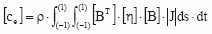 (3.6)
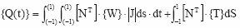 (3.7)
Where, [η] is a matrix of damping terms. {W} is the vector of prescribed body forces and {T} is a vector of external tractions that may be applied to some surface, S.
The equations of motion for the element can then be written as
[m_{e}]{q||}+[c_{e}]{q|}+[k_{e}]{q}={Q(t)} (3.8)
Once the equations of motion for each element are obtained, they are combined in a way that satisfies compatibility of displacements to obtain the global equations of motion,
[M]{u||}+[C]{u|}+[K]{u}={R(t)} (3.9)
where [M] is the global mass matrix, [C] the global damping matrix, [K] the global stiffness matrix, {u} is the global nodal point displacement vector and {R(t)} the global nodal point force vector. For the case of loading induced by base motion, the global equation of motion is
[M]{u||}+[C]{u|}+[K]{u}=[M][1]{u||_{b})} (3.10)

Where, u| |b is the base acceleration.

3.3 Boundary Element Method
Boundary element methods have been effectively used in solving problems involving unbounded domains. The BEM has been applied to the determination of the static as well as dynamic stiffness of a rigid foundation resting on or embedded in an elastic half space. The studies have shown that BEM provides an accurate and effective procedure for problem s in soil structure interaction. Significant advances have been made in the development of the boundary element method and as a consequences this technique provides an alternative to the finite element method under certain circumstances, particularly for some problems in rock engineering (Beer and Watson,1992).
Fig. 3.2 Layered soil subjected to forces on the surface, base of boundary, top and side.
The boundary element method applied to problems
In the absence of volume forces, the Navier–Cauchy equations are given by:
(3.11)
Where, u_{i}(s) is the displacement in the orthogonal direction i from the point s inside the solid and satisfies certain boundary conditions, and n is Poisson’s ratio. These domain equations can further be expressed as surface equations, which are represented by the Somigliana Identity:
(3.12)
Where, p and S are, respectively, the source point where a unit force is applied and a boundary point at the surface, u_{j} and p_{j} are, respectively, the real displacement field and surface forces on the boundary S in the jth direction, while u*_{ij} and p*_{ij} represent weighted field coefficients which indicate the response obtained in the direction j in S; to a force applied in the direction i at the point p: This identity is based on Betti’s reciprocal theorem and weighted or fundamental solutions given by u*_{ij} and p*_{ij} represent particular solutions of the partial differential equations of Eq. (3.11) for a given boundary condition.
The strategy to obtain the boundary integral equations involves transferring p; which is inside the body, to the boundary. Thus, expression (3.12) can be written as follows:
(3.13)
Where, the integral in Eq. (3.13) is defined in the sense of the Cauchy principal value and C_{ij} are coefficients that depend on the problem’s geometry. The fundamental solutions used herein are the known Kelvin solutions for the three-dimensional case.
Since the analytical solutions of expression (3.13) are not given in closed form, they have to be estimated numerically. Hence, the Boundary Element Method (BEM) is based on the assembly of a system of algebraic equations resulting from boundary integral equations, Eq. (3.13), written in terms of nodal variables that are approximated to the boundary values using shape functions. The integral equations of Eq. (3.13) are then written without considering the domain forces as:

(3.14)
Where, NE, ψ, j are, respectively, the number of boundary elements, the shape function and the Jacobian transformation. In present study, all the surfaces of the soil layers were discretized into flat triangular elements with linear shape functions of the form ψ_{i} (ξ_{1,} ξ_{2,} ξ ₃ ) = ξ_{i} where ξ_{i} are homogeneous coordinates.
The integrals proposed is cannot, however, be solved analytically for any generic surface. In the present paper, the integral equations are calculated numerically by using a three-dimensional triangular quadrature integral.
It is possible to assemble the shape matrices of Eq. (3.14), which takes on the following form:
[H]{U} = [G] {P} (3.15)
Where, the Dirichlet and/or Neumann boundary conditions of the given problem are applied at each nodal point.
The main advantages and disadvantages may be summarized as follows.
Advantages;
- Pre- and post-processing efforts are reduced by an order of magnitude (as a result of surface discretisation rather than volume discretisation ).
- The surface discretisation leads to a smaller equation system and less disk storage requirement, thus computation time is generally decreased.
- Distinct structure features such as faults and interfaces located in arbitrary positions can be modeled very efficiently, and the non linear behavior of the fault can be readily included in the analysis (e.g., Beer,1995).

Disadvantages;
- Except for interfaces and discontinuities, only elastic material behavior can be considered with surface discretisation.
- In general, non-symmetric and often fully populated equation system obtained.
- A detailed modeling of excavation sequences and support measures is practically impossible.
- The standard formulation is not suitable for highly jointed rock when the joints are randomly distributed.
- The method has only been used for only solving a limited class of problems, e.g., tunneling problems, and thus less experience is available than with finite element models.
3.4 Discrete Element Method
The methods described so for are based on continuum mechanics and are therefore restricted to the problems where the mechanical behavior is not governed to a large extent by the effects of joint and cracks. If this is the case discrete element methods are much better suited for numerical solution. These methods can be characterized as follows:
- Finite deformation and rotation of discrete block (deformable or rigid) are calculated.
- Blocks that are originally connected may separate during the analysis.
- New contacts which developed between the blocks due to displacement and rotation are detected automatically.
Due to the different nature of a discontinuous analysis as compared to continuum techniques, a direct comparison may not seems to be appropriate. The major strength of discrete element method is certainly the fact that a large number of irregular joints can be taken into account in a physically rational way. The drawback associated with the technique are that establishing model , taken into account all relevant construction stages, is still very time consuming, at least for a 3-D analysis. In addition a lot of experience necessary in determining the most appropriate value of input parameter such as joint stiffness. These values are not always available from experiments and specification of inappropriate values for these parameters may lead to computational problems. In addition runtime for 3-D analysis are usually quite high.
3.5 Explicit Finite Difference Method
Mainly, the finite difference method is used to solve differential equations numerically. In finite difference approach, the methods can be classified according to their convergence criteria. For convergence, explicit finite difference methods look for a conditional value. Implicit finite difference methods on the other hand are convergent in any condition. Explicit finite difference methods are faster when the incremental time, (Δt), is bigger. When Δt is small, the convergence rate drops dramatically. On the other hand explicit finite difference methods match the physics more accurately, thus most of the formulations used in the analysis of mechanical problems are explicit.
The finite difference method does not have a long-standing tradition in geotechnical engineering, perhaps with the exception of the analyzing flow problems including those involving consolidation and contaminant transport. However, with the development of the finite difference code FLAC (Cundall and Board, 1988), which is based on an explicit time marching scheme using full dynamic equation of motion, even for static problems, an attractive alternative to the finite element method was introduced. Any disturbance of equilibrium is propagated at a material dependent rate. This scheme conditionally stable and small time steps must be used to prevent propagation of information beyond neighboring calculation points with one time steps. Artificial nodal damping is introduced for solving static problems in FLAC. The method is comparable to the finite element method (using constant strain triangles) and therefore some of the arguments listed above are basically hold for finite difference method as well. However, due to the explicit algorithm employed some additional advantages and disadvantages may be identified.

Advantages
- The explicit solution method avoids the solution of large sets of equations.
- Large strain plasticity, strain hardening and softening models and soil-structure interaction are generally easier to introduce than in finite elements.
- The model preparation for simple problems very easy.
Disadvantages
- The method is less efficient for linear or moderately non-linear problems.
- Until recently, model preparation for complex 3-D structure has not been particularly efficient because sophisticated pre-processing tools have not been as readily available, compared to finite element preprocessors.
- Because the method is based on Newton’s law of motion no converged solution for static problems exists, as in the case of static finite element analysis.
3.6 Winkler Method
The Winkler method also called the subgrade reaction theory is the oldest method for predicting the foundation deflections and bending moments. The idealised model of soil media proposed by the Winkler assumes that the deflection of the soil medium at any point on the surface is directly proportional to the stress applied at that point and independent of the stresses applied at other location.

Physically Winkler’s idealization of the soil medium consists of system of mutually independent spring elements with spring constant k. One important feature of this soil model is that the displacement occurs immediately under loaded area and outside this region, the Winkler model, the displacement of the loaded region will be constant whether the soil is subjected to an infinitely rigid load or a uniform flexible load.

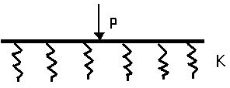
Fig. 3.3 Winkler idealisation

Winkler idealization represents the soil medium as a system of identical but mutually independent, closely spaced, discrete linear elastic springs. According this idealization, deformation of foundation due to applied load is confined to load region only shows the physical representation of the winkler foundation. The pressure deflection relation at any point is given by,
P = k .Δ
Where p is the pressure, k is the coefficient of subgrade reaction or subgrade modulus, and Δ is the deflection.
The Winkler model is widely used in SSI analysis because of its simplicity and ability to incorporate different nonlinear aspects of the behaviour at a reduced computational effort compared to other approaches. The use of the Winkler model has been extended to dynamic SSI applications by introducing the Beam-on-Nonlinear Winkler Foundation (BNWF) models

Limitation of Winkler method:
The fundamental problem with the use of this model is to determine the stiffness of elastic spring used to replace the soil below the foundation becomes two folds since the numerical value of the coefficient of subgrade reaction not only depends on the nature of the subgrade ,but also on the dimension of the loaded area as well.

CHAPTER-4

NUMERICAL MODELING USING ANSYS

The finite element analysis was initially developed on a physical basis for the
analysis of problems in structural mechanics, but it was realized later that this method can be applied to solutions for many other kinds of problems. The method is based on the principle of solving the problem by going from a small part to the whole. The whole medium of the problem is assumed to consist of a combination of small parts joined together to form the whole structure. The small parts (elements) then are assembled to reach the final solution. Solutions resulting from finite element analysis are not exact solutions. In many engineering problems a close form solution is hard to reach sometimes.

4.1 Elastic Models
Elastic model provides the simplest representation of material behavior. A linear relationship stress and strain is the simplest link that can be proposed, implying a constant proportionality between stresses increments and strain increments. For an isotropic, linear elastic material the stress-strain relation is defined as
{ϭ} = [D]{ϵ} (4.1)
Where
{ϭ} = Stress vector = {ϭ_{x} ϭ_{y} ϭ_{z} ϭ_{xy} ϭ_{yz} ϭ_{xz} }
[D] = Elasticity matrix
{ϵ} = Total strain vector = {ϵ_{x} ϵ_{y} ϵ_{z} ϵ_{xy} ϵ_{yz} ϵ_{xz}}

The stresses in three directions are shown in Fig 4.1

Fig.4.1 Stress vector diagram
Where, E_{x} = Young’s Modulus in the X - direction,
E_{y} = Young’s Modulus in the Y direction,
E_{Z =} Young’s Modulus in the Z - direction,
ν = Poisson’s ratio, G_{xy} = shear modulus in the XY plane
For isotropic materials
E_{x}= E_{y} = E_{z} = E and ν_{xy} = ν_{yz} = ν_{xz} = ν
G_{xy} = G_{yz} = G_{xz} = G = E/2(1+ν)

4.2 Static Analysis
The overall equilibrium equations for linear structural static analysis are
[K]{u} = {F} (4.2)
Where, [K] = total stiffness matrix,
{u} = nodal displacement vector and
{F}= the total applied load vector, is defined by
{F} = {F^{nd}} + {F^{ac}} +_{e} ^{pt} (4.3)
Where, {F^{nd}} = applied nodal load vector,
{F^{ac}} = - [M] {a_{c}} = acceleration vector,
[M] = total mass matrix,
{a_{c}} = total acceleration vector
And, _{e} ^{pt} = element pressure load vector

4.3 ANSYS and its Features
Numerous finite element codes are available with high capabilities in handling very complicated structures. ANSYS is one of such powerful tools in finite element method of analysis. ANSYS is a multi-purpose software which has multiple finite element capabilities that range from simple linear static analysis to complex nonlinear, transient dynamic analysis. Any complicated geometry can be analysed easily using ANSYS. ANSYS is more flexible since it has options to perform analysis in the fields like structural, thermal, fluid mechanics and electromagnetic, also it performs different types of analysis such as static, modal, spectrum, transient, harmonic, Eigen buckling and sub structural field. The ANSYS element library contains a wide range of element types that fit different types of structures.
Analysis using ANSYS can be performed in three major steps:
1. Build the model (Preprocessing).
2. Apply loads and obtain solutions (Solution).
3. Review the results (Post Processing).

4.3.1 Building the computer model
The main objective of finite element modeling is to create a mathematical representation of any engineering system that reflects the actual geometry and behaviour of that system. The model should have similar boundary conditions and the same loading schemes so that it can serve as a physical prototype of the real system. Building finite element models in ANSYS requires familiarity with the ANSYS operating manual and the ANSYS element library. Each element in ANSYS has specific properties and behaviours to be defined according to the structure in the problem. Model generation by ANSYS can be approached through two different methods: solid modeling and the direct generation method. In solid modeling the model is defined geometrically by describing the general shape, boundaries, element shape and size. However, in direct generation the user has to predefine all node locations and the shape, size and connectivity of each element. The first method is more powerful with more flexibility in meshing and the element generation. It is more appropriate for large 3-D models because it allows later modifications for the model geometry and facilitates the model management.
The following sections describe the major steps in building a finite element model using ANSYS.

4.3.2 Selecting the coordinates system
ANSYS offers multiple coordinate systems that fit different shapes and
Geometries:
- Global and local coordinate systems
- A nodal coordinate system that defines the nodes, their directions and degrees of freedom.
- An element coordinate system which describes the element results output and its material properties orientation.
- ANSYS has three built-in global coordinate systems that share the same origin:
Cartesian, cylindrical, and spherical as shown in Figure 4.2. The appropriate coordinate system has to be chosen according to the geometry of the problem.
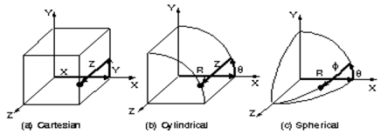
Fig.4.2 Coordinate System
4.3.3 Generation of the solid model
As presented earlier, the element generation can be done in different ways; each of them has its own advantages. The solid modeling method is more convenient in such models because of its flexibility over other methods. Several major steps are recommended to follow in this approach starting with keypoints and ending with the final meshed model.
The following steps summarize the basic steps in the solid modeling approach:

Step 1: Defining key points and lines
Keypoints are the lowest order of the solid model entities which normally define the vertices of the model. The keypoints work as a foundation for the solid model that locates the position of the model in the global coordinate system. A key point in the global system can be defined by three major coordinates; X, Y, and Z.

Step 2: Creating areas and volumes
The next step is to create an area or a volume from the previously defined
keypoints and lines. Lines will serve as the boundaries for the created areas and volumes. Volume and area elements can be created directly through keypoints and line generation can be skipped. Lines should be created when mapped meshing is desired. Figure 4.3 shows an isometric view of an area created through keypoints and lines.

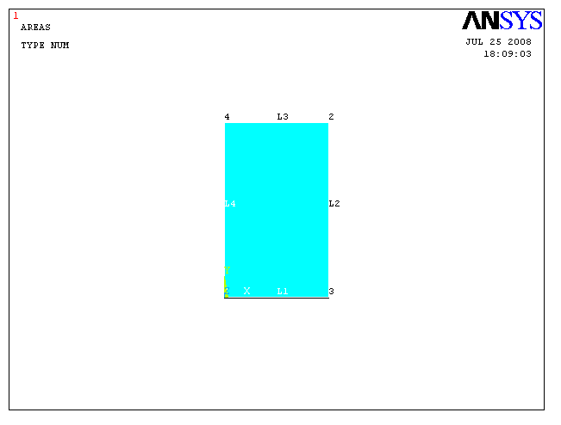
Fig.4.3 2-D view of an area defined by keypoints and lines.

Step 3: Defining element attributes
Setting element attributes is necessary before generating elements and nodes from the solid model. Each element in the ANSYS library has specific properties and requires a set of attributes to be defined. The following attributes should be defined:
- Element type: in which the required elements have to be specified and defined before the meshing process.
- Real constants: The real constants usually describe the element geometrical properties such as thickness, area, inertia or fiber orientation angle and number of layers in the case of layered orthotropic materials.
- Material properties: Provide the necessary material properties, like elastic modulus, shear modulus, and Poisson’s ratio.
- Element coordinate system: To locate the element axis system that’s necessary for the output.

Step 4: Mesh generation
After setting all element types and attributes and before start meshing, it is required to set the mesh control. Two types of meshing are available: free and mapped meshing. Free meshing usually generated randomly without any restriction on the size and shape of the element. Mapped meshing is more restricted and done in a systematic way in terms of shape, size and elements pattern. ANSYS provides two mapped meshing options, quadrilateral and triangular elements. Figure 4.4 and Figure 4.5 show an illustration for a free and mapped meshed area. Figure 4.6 shows a sketch for the quadrilateral and triangular elements.

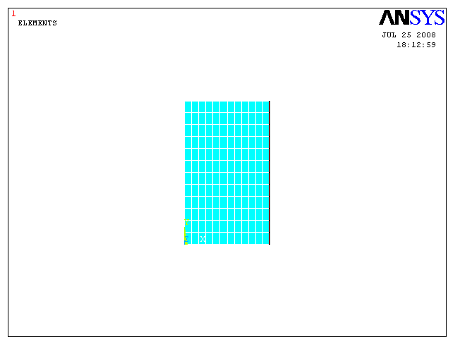
Fig.4.4 Mapped meshed area.

Fig.4.5 Free and mapped meshed areas (ANSYS).

(a) Quadrilateral (b) Triangular
Fig.4.6 Quadrilateral and triangular elements (ANSYS).

Step 5: Applying loads and boundary conditions
Applying loads and boundary conditions is part of the solution phase in ANSYS.
All loading and boundary conditions have to be specified before running the solution process.
4.4 Loads and Boundary Condition
In ANSYS boundary conditions and externally or internally applied forcing functions such as displacements, forces, pressures, temperatures (for thermal strain), and gravity are known as loads. The loads can be applied either on the solid model (on key points, lines, and areas) or on the finite element model (on nodes and elements). For example, forces can be specified at a key point or at a node. No matter how you specify the loads, the solver expects all loads to be in terms of the finite element model. Therefore, if load on the solid model is specified, the program automatically transfers them to the nodes and elements at the beginning of solution. Loads are divided into five categories: DOF constraints, forces (concentrated loads), surface loads, body loads, inertia loads.

1. DOF constraints: A DOF constraint fixes a degree of freedom (DOF) to a known value. Examples of constraints are specified displacements and symmetry boundary conditions.

2. Forces: A force is a concentrated load applied at a node in the model. Examples are forces and moments.

3. Surface loads: A surface load is a distributed load applied over a surface such as pressures.

4. Body loads: A body load is a volumetric or field load. Examples are temperatures and fluencies.

5. Inertia loads: Inertia load is a volumetric or field load. Examples are temperatures and fluencies.

CHAPTER-5
METHODOLOGY
Modeling and Meshing
Finite element method is a numerical procedure for analyzing structure and continua. It is a powerful tool in structure analysis of simple to complicated geometries. In recent years with the coming of super computers the job of performing finite element analysis of a complicated geometry has become more acceptable. The finite element program (ANSYS) is one of such powerful tools in finite element method of analysis, which have been applied in the present study.
5.1 Modeling
5.1.1 Problem description
The frame with raft foundation and soil continua has been considered for two-dimensional finite element analysis. The section chosen for the analysis is shown in Figure 5.1.A two bay four storey frame is taken with a raft of width 10 m and 1 m thickness. The section, above the raft foundation (between structure and raft) and below the raft foundation (between raft and soil) has been chosen for the comparative analysis under different parametric variations. The parameters chosen for analysis are as follows:
(i) Modulus of elasticity of soil
(ii) Poisson’s ratio
(iii) Thickness of raft
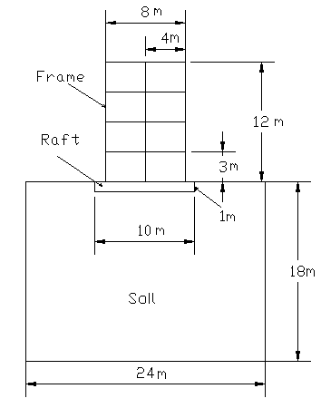
Fig. 5.1 2-D Section showing frame, raft and soil of the system
5.1.2 Assumption
- The self-weight of soil is neglected because it has been assumed that the soil is settled by its own weight.
- Throughout the analysis linear variations of material properties have been taken.

5.1.3 Material properties
The finite element model consists of two different types of material. They are concrete and soil. The material properties of the materials are shown in Table

Table 5.1 Variable Modulus of Elasticity and Constant Poisson Ratio of soil
Material | Young’s Modulus | Unit Weight | Poisson’s Ratio
Material | (N/mm²) | (KN/m³) | Poisson’s Ratio
Superstructure | 2.25×10⁴ | 25 | 0.2
Raft | 2.00×10⁴ | 24 | 0.2
Soil | 20 | - | With constant poisson ratio of .3
Soil | 30 | - | With constant poisson ratio of .3
Soil | 40 | - | With constant poisson ratio of .3
Soil | 50 | - | With constant poisson ratio of .3

Table 5.2 Variable Poisson Ratio and Constant Modulus of Elasticity of soil
Material | Poisson’s Ratio | Unit Weight | Young’s Modulus
Material | Poisson’s Ratio | (KN/m³) | (N/mm²)
Superstructure | 0.2 | 25 | 2.25×10⁴
Raft | 0.2 | 24 | 2.00×10⁴
Soil | 0.1 | - | 20
 | 0.15
 | 0.2
 | 0.25
 | 0.3

5.1.4 Type of element used
In finite element modeling, raft and soil have been modeled using 4-noded solid element (PLANE 182 Element). 2-noded beam elements (2-D ELASTIC 3 Element) have been used for the superstructure modeling. The elements used for the modeling are lower order element its behaviour is linear.
5.1.4.1 2-D ELASTIC 3 Element (BEAM 3)
The element is defined by two nodes, the cross-sectional area, the area moment of inertia, the height, and the material properties. The initial strain in the element (ISTRN) is given by Δ/L, where Δ is the difference between the element length, L (as defined by I and J node locations), and the zero strain length. The initial strain is also used in calculating the stress stiffness matrix, if any, for the first cumulative iteration.
BEAM3 is a uniaxial element with tension, compression, and bending capabilities. The element has three degrees of freedom at each node: translations in the nodal x and y directions and rotation about the nodal z-axis.
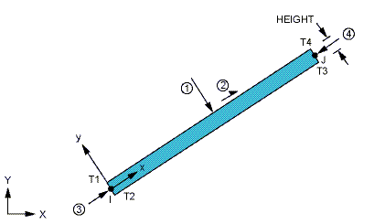

Fig.5.2 2D ELASTIC 3 Element (BEAM 3) Geometry

5.1.4.2 PLANE 182 Element
PLANE182 is used for 2-D modeling of solid structures. The element can be used as either a plane element (plane stress, plane strain or generalized plane strain) or an axisymmetric element. It is defined by four nodes having two degrees of freedom at each node: translations in the nodal x and y directions. The element has plasticity, hyperelasticity, stress stiffening, large deflection, and large strain capabilities. It also has mixed formulation capability for simulating deformations of nearly incompressible elastoplastic materials, and fully incompressible hyperelastic materials.
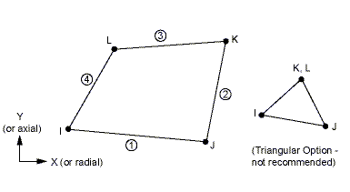

Fig. 5.3 PLANE182 Element Geometry
5.1.5 Real constant
For 2-D ELASTIC 3 Element, the real constants are
- Cross-section area of beam = .35 m x .45 m = 0.1575 m²
- Moment of inertia of beam = 2.6578 x 10⁻³ m⁴
- Depth of beam = 0.45 m
For PLANE 182 Element, the constants are already defined in finite element program (ANSYS).
5.1.6 Creation of Geometrical Model
- Create key points
- Key points are joining by lines.
- Create area by joining the line for soil and raft foundation.

5.2 Meshing
One nice feature of the ANSYS program is that you can automatically mesh the model without specifying any mesh size controls. This is using what is called a default mesh. But in the above problem manual meshing is done and iterative process is adopted for getting the optimum meshing of the problem.
5.3 Applying Loads and Boundary Conditions
The building is analyzed for the gravity load of the structure and raft of the system.
The movement of considered soil continua is prevented in x and y direction by providing the hinge.

CHAPTER - 6
RESULTS AND DISCUSSIONS
6.1 General
As explained in the previous chapter, finite element method has been applied for modeling. The Finite element method treats continua as an assemblage of discrete elements whose boundaries are defined by nodal points. In finite element method it is assumed that the response of the continua can be described by the response of the nodal points. The conventional methods of structure analysis such as moment distribution method, slope deflection method, strain energy method etc. gives the deformation, moment, shear stress etc. at certain fixed location of structure whereas finite element method gives the deformations, stresses, strains etc. at any nodes of the structure.
In this chapter, the results of 2-D static analysis will be presented in the forms of
i) Deformation
ii) Stress
iii) Strain
The multistoried buildings have been analyzed for different soil properties and different thickness of raft. By these analyses, the results are presented for conditions-
- When the modulus of elasticity (Es) is variable and Poisson’s ratio is constant.
- When Poisson’s ratio (µ) is variable and modulus of elasticity (Es) is constant.
- When the thickness of raft is variable.
The analysis of result is compared with the study made by the Dheeraj Kumar and Samir Kumar Das for the layered rock foundation for the analysis of the deformation and stresses in the soil strata.
6.2 Effect of Variation of Modulus of Elasticity of Soil When the Poisson Ratio of Soil is Constant
A typical 2-D four storey building with raft foundation and soil continua has been analyzed by finite element program (ANSYS). The range of the Modulus of Elasticity is chosen for the range of medium soil i.e.20 N/mm² to 50 N/mm². The response of structure system is calculated in the form of deflection, stress and strain. The section, above the raft foundation (between structure and raft) and below the raft foundation (between raft and soil) have been chosen for the analysis under different condition. The results above and below the raft give two types of interactive analysis-
1. Response of Soil-Structure interaction (below Raft)
2. Response of Raft-Structure interaction (above Raft)
The results in the graphical form is presented here and in tabular form have been presented in appendix-A for this case.
6.2.1 Response of Soil-Structure interaction
6.2.1.1 Variation of Deflection with Variable Modulus of Elasticity and Constant Poisson Ratio along width of Soil Strata.
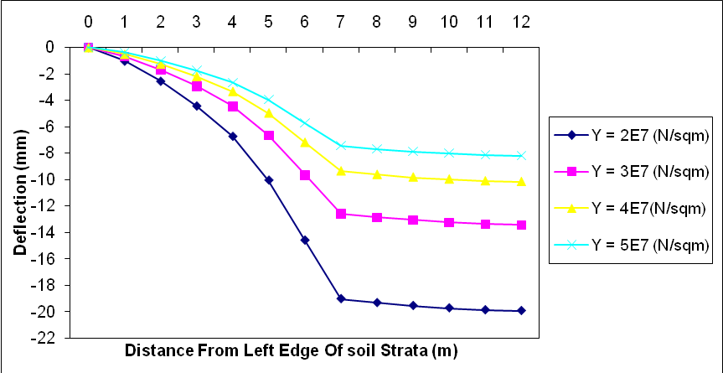 Fig.6.1 Variation of deflection with variable modulus of elasticity and constant poisson ratio along width of soil strata.

Figure 6.1 shows that when the modulus of elasticity of soil increased the deformation decreases along width of Soil Strata as stiffness of soil increases. It resembles that if the modulus of elasticity of soil increased, the load carrying capacity of soil also increases. The variation of deflection lies in the range of 0 % at the edge of soil strata to 18 % to 60 % at the centre of the raft.

6.2.1.2 Variation of Deflection with Variable Modulus of Elasticity and Constant Poisson Ratio along depth of Soil Strata.
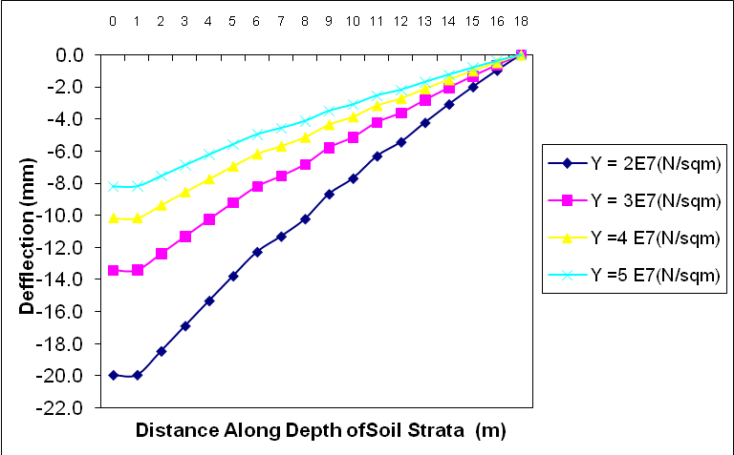
Fig.6.2 Variation of deflection with variable modulus of elasticity and constant Poisson ratio along depth of soil strata.
Figure 6.2 shows that when the modulus of elasticity of soil increased the deformation decreases along depth of Soil Strata as stiffness of soil increases. Here also the variation of deflection lies in the range of 0 % at the bottom of the soil strata to 18 % to 60 % at the centre of the raft.

6.2.2.3 Variation of Stress with Variable Modulus of Elasticity and Constant Poisson Ratio along width of Soil Strata.
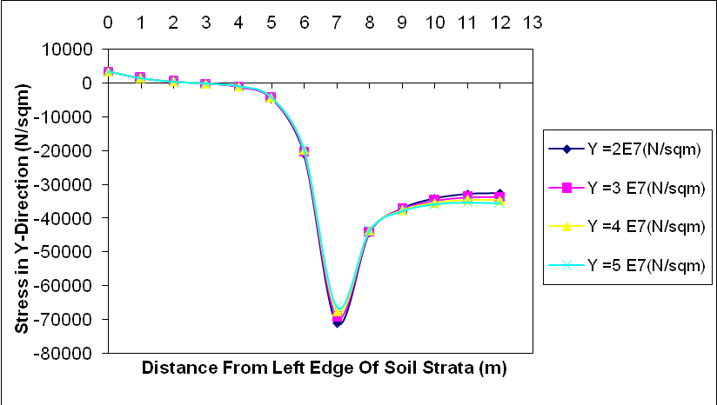
Fig.6.3 Variation of stress with variable modulus of elasticity and constant Poisson ratio along width of soil strata.
Figure 6.3 shows that when the modulus of elasticity of soil increased the stresses decreases along width of soil strata upto the edge of the raft and increases below the centre of the raft as stiffness of soil increases. The variation of the stresses lies in the range of 0 % to 1 % at the edge of the soil strata to 2 % to 8 % below the centre of the raft. It also shows that the maximum stress acts below the edge of the raft and stresses are positive at the edge of the soil shows tension in the soil.

6.2.2.4 Variation of Strain with Variable Modulus of Elasticity and Constant Poisson Ratio along width of Soil Strata.
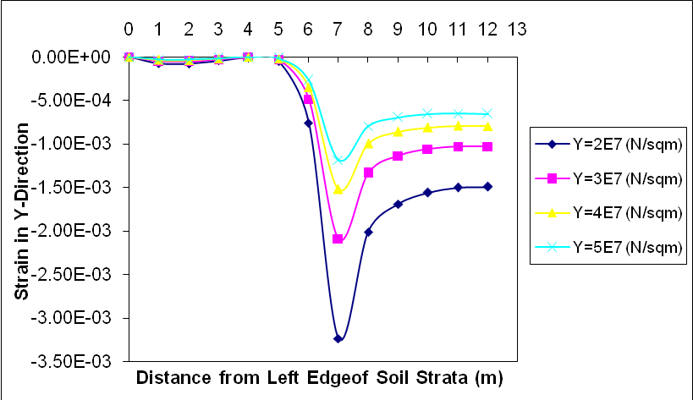
Fig.6.4 Variation of strain with variable modulus of elasticity and constant Poisson ratio along width of soil strata.
Figure 6.4 show that when the modulus of elasticity of soil increased the strains decreases along width of Soil Strata as stiffness of soil increases. The variation of the strains lies in the range of 0 % at the edge of the soil strata to 8 % to 60 % below the centre of the raft. It also shows that the maximum strain acts below the edge of the raft.

6.2.2 Response of Raft-Structure interaction
6.2.2.1 Variation of Deflection with Variable Modulus of Elasticity and Constant Poisson Ratio along width of Raft.
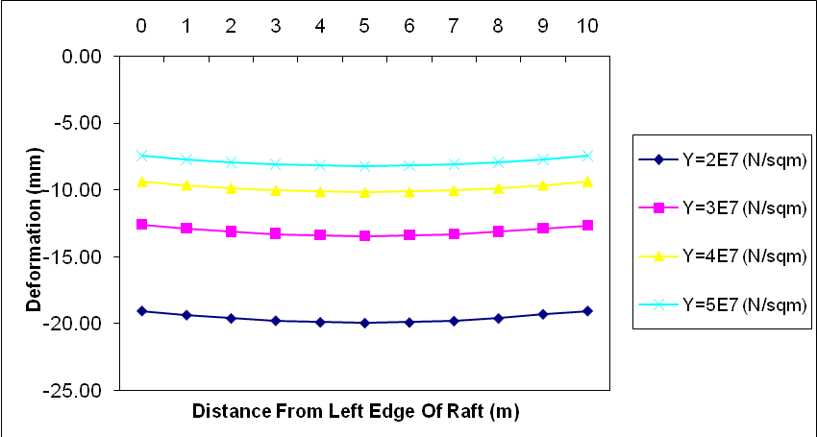
Fig.6.5 Variation of deflection with variable modulus of elasticity and constant Poisson ratio along width of raft
Figure 6.5 shows that when the modulus of elasticity of soil increased the deformation decreases along width of raft as stiffness of soil increases. It resembles that if the modulus of elasticity of soil increased, the load carrying capacity of soil also increases. The variation of deflection lies in the range of 10 % at the edge to 60 % at the centre of the raft.

6.2.2.2 Variation of Stress with Variable Modulus of Elasticity and Constant Poisson Ratio along width of Raft.
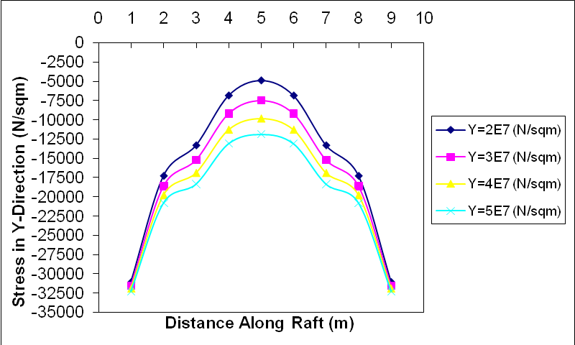
Fig.6.6 Variation of stress with variable modulus of elasticity and constant Poisson ratio along width of raft.
Figure 6.6 show that when the modulus of elasticity of soil increased the stresses in the raft is increases as stiffness of soil increases. The variation of the stresses lies in the range of 15 % to 55 % at the centre of the raft.
6.2.2.3 Variation of Strain with Variable Modulus of Elasticity and Constant Poisson Ratio along width of Raft.
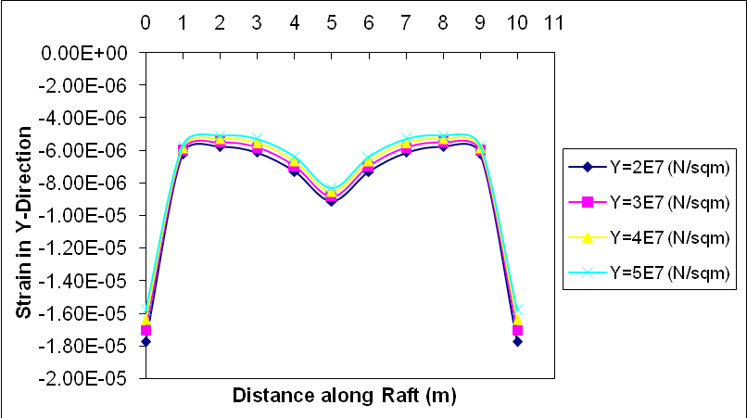
Fig.6.7 Variation of strain with variable modulus of elasticity and constant poisson ratio along width of raft
Figure 6.7 show that when the modulus of elasticity of soil increased the strains in the base of the raft decreases as stiffness of soil increases. The variation of the strains lies in the range of 3 % to 9 % at centre of the raft.

6.3 Effect of Variation of Poisson Ratio of Soil When the Modulus of Elasticity of Soil is Constant
The range of Poisson ratio of soil is taken between .1 to .3
The results in the graphical form have been presented here and in tabular form have been presented in appendix-B for this case.
6.3.1 Response of Soil-Structure interaction
6.3.1.1 Variation of Deflection with Variable Poisson Ratio and Constant Modulus of Elasticity along width of Soil Strata
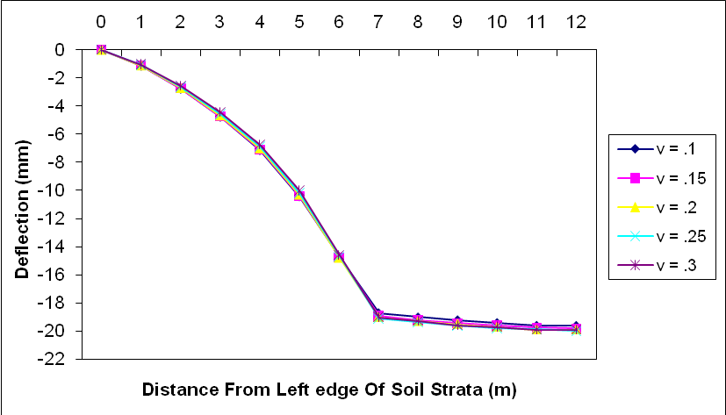
Fig.6.8 Variation of deflection with variable Poisson ratio and constant modulus of elasticity along width of soil strata
Figure 6.8 shows that when the Poisson ratio of soil increased the deformation decreases along width of Soil Strata. The variation of deflection lies in the range of 0 % at the edge of soil strata to 1 % to 3 % at the centre of the raft.

6.3.1.2 Variation of Deflection with Variable Poisson Ratio and Constant Modulus of Elasticity along depth of Soil Strata
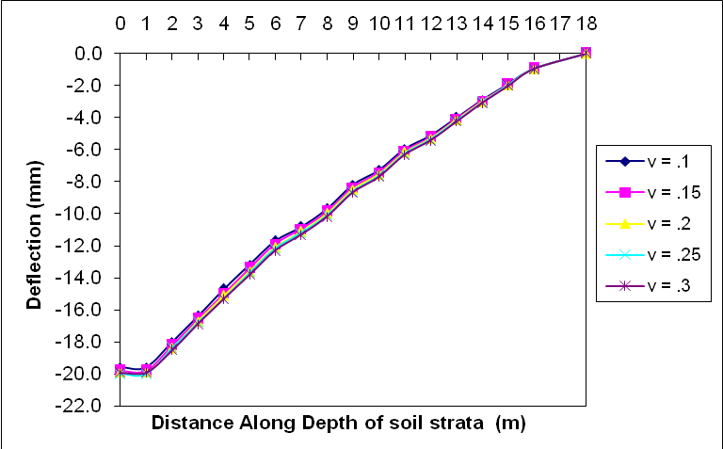
Fig. 6.9 Variation of deflection with variable Poisson ratio and constant modulus of elasticity along depth of soil strata
Figure 6.9 shows that when the Poisson ratio of soil increased the deformation increases along depth of Soil Strata . Here the variation of deflection lies in the range of 0 % at the bottom of the soil strata to 2 % to 4 % at the centre of the raft.

6.3.1.3 Variation of Stress with Variable Poisson Ratio and Constant Modulus of Elasticity along width of Soil Strata
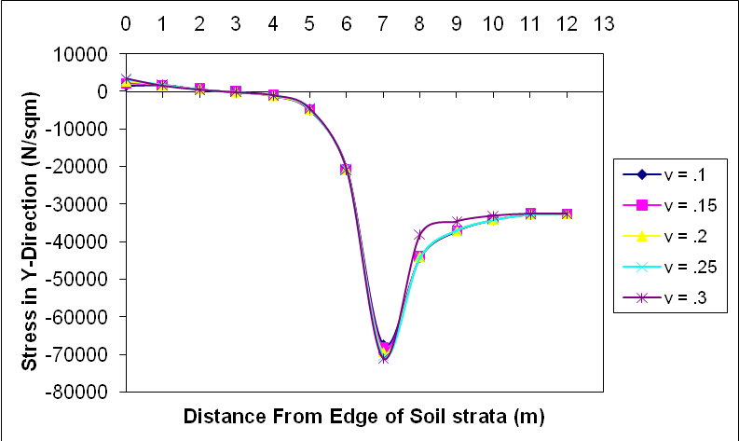
Fig.6.10 Variation of stress with variable Poisson ratio and constant modulus of elasticity along width of soil strata
Figure 6.10 shows that when the Poisson ratio of soil increased the stresses increases along width of soil strata upto the edge of the raft and decreases below the centre of the raft. The variation of the stresses lies in the range of 0 % to 2 % at the edge of the soil strata to 1 % to 4 % edge of the raft and almost negligible change at the centre of raft. It also shows that the maximum stress acts below the edge of the raft and stresses are positive at the edge of the soil shows tension in the soil.

6.3.1.4 Variation of Strain with Variable Poisson Ratio and Constant Modulus of Elasticity along width of Soil Strata
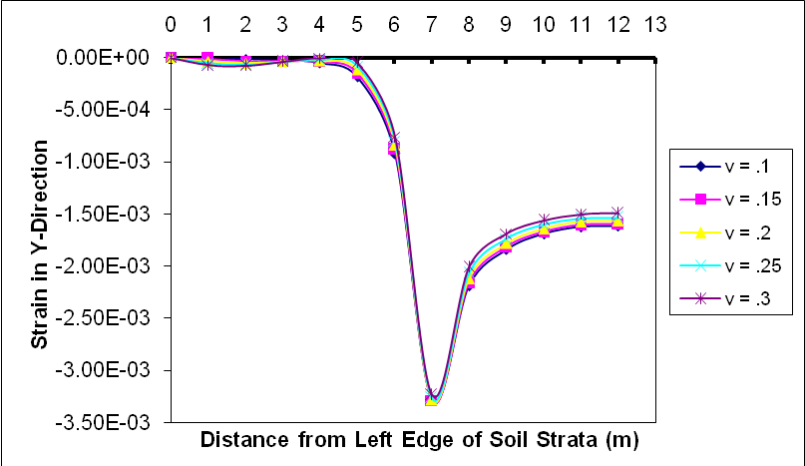
Fig.6.11 Variation of strain with variable Poisson ratio and constant modulus of elasticity along width of soil strata
Figure 6.11 show that when the modulus of elasticity of soil increased the strains decreases along width of Soil Strata . The variation of the strains lies in the range of 0 % at the edge of the soil strata to 2% to 8 % below the centre of the raft. It also shows that the maximum strain acts below the edge of the raft

6.3.2 Response of Raft-Structure interaction
6.3.2.1 Variation of Deflection with Variable Poisson Ratio and Constant Mod. Elasticity along width of Raft.
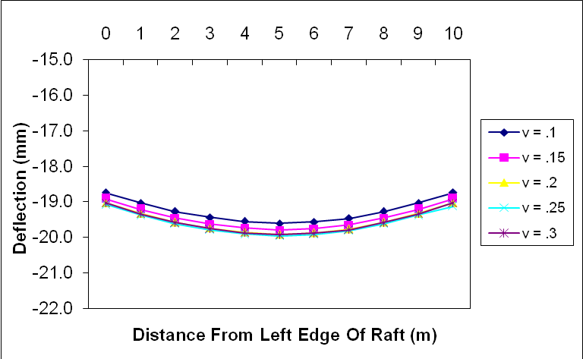
Fig.6.12 Variation of deflection with variable Poisson ratio and constant modulus of elasticity along width of raft.
Figure 6.12 shows that when the modulus of elasticity of soil increased the deformation increases along width of raft as stiffness of soil increases. The variation of deflection lies in the range of 1 % to 2 % at the centre of the raft.

6.3.2.2 Variation of Stress with Variable Poisson Ratio and Constant Modulus of Elasticity along width of Raft
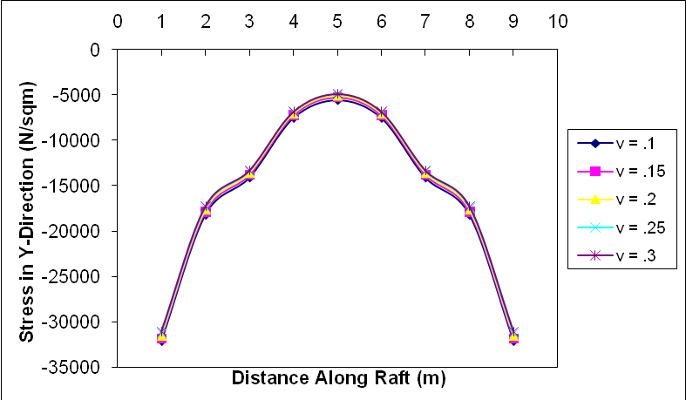
Fig.6.13 Variation of stress with variable Poisson ratio and constant modulus of elasticity along width of raft
Figure 6.13 show that when the modulus of elasticity of soil increased the stresses in the raft is decreases . The variation of the stresses lies in the range of 3 % to 13 % at the centre of the raft.
6.3.2.3 Variation of Strain with Variable Poisson Ratio and Constant Modulus of Elasticity along width of Raft
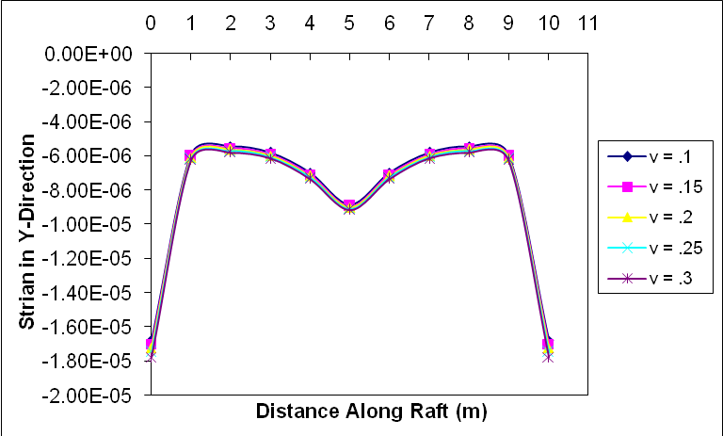
Fig.6.14 Variation of strain with variable Poisson ratio and constant modulus of elasticity along width of raft
Figure 6.14 show that when the Poisson ratio of soil increased the strains increases. The variation of the strains lies in the range of 1 % to 4 %.
6.4 Effect of Variation of Thickness of Raft When the Property of Soil is Constant
The range of thickness of raft is taken between .5 to 1.5 meter. The response of structure system is calculated in the form of deflection, stress and strain as shown below.
6.4.1 Response of Soil-Structure interaction
6.4.1.1 Variation of Deflection with Variable Thickness of Raft along width of Soil Strata
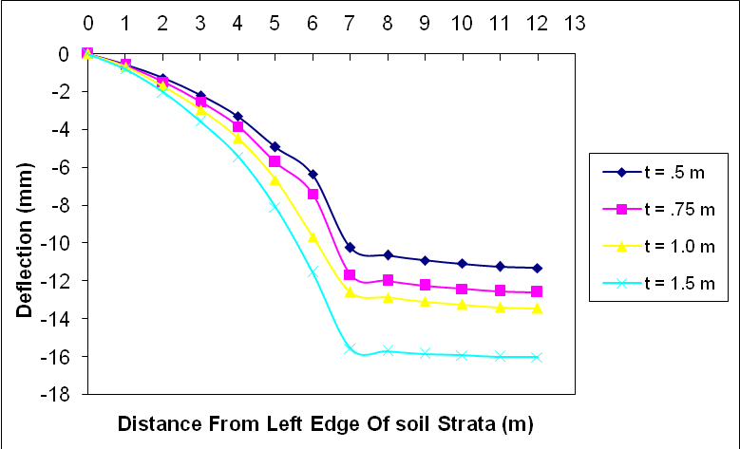
Fig. 6.15 Variation of deflection with variable thickness of raft along width of soil strata
Figure 6.15 shows that when the thickness of the raft increased the deformation increases along width of Soil Strata as dead load on the raft is increases. It resembles that if the thickness of the raft increased the load carrying capacity of soil decreases. The variation of deflection lies in the range of 0 % at the edge of soil strata to 14 % to 37 % at the centre of the raft.

6.4.1.2 Variation of Deflection with Variable Thickness of Raft along depth of Soil Strata
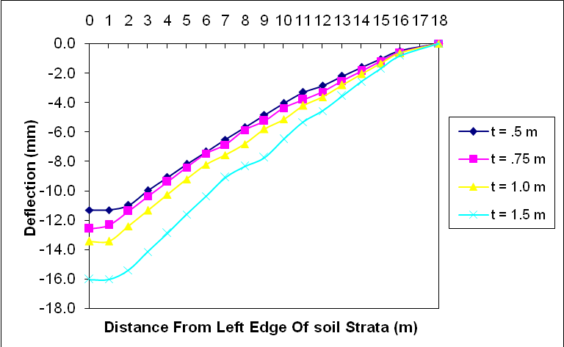
Fig. 6.16 Variation of deflection with variable thickness of raft along depth of soil strata
Figure 6.16 shows that when the thickness of the raft is increased the deformation increases along depth of Soil Strata as dead load on the raft increases. Here the variation of deflection lies in the range of 0 % at the bottom of the soil strata to 12 % to 34 % at the centre of the raft.

6.4.1.3 Variation of Stress with Variable Thickness of Raft along width of Soil Strata
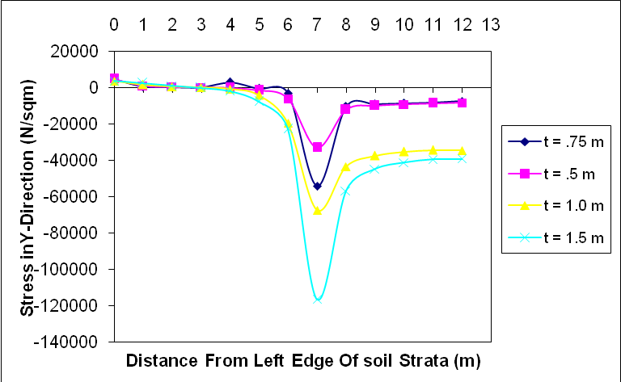
Fig.6.17 Variation of stress with variable thickness of raft along width of soil strata
Figure 6.17 show that when the thickness of the raft increased the stresses increases along width of soil strata upto the centre of the raft dead load on the raft increases. The variation of the stresses lies in the range of 8 % to 35 % at the edge of the soil strata to 10 % to 80 % below the centre of the raft. It also shows that the maximum stress acts below the edge of the raft and stresses are positive at the edge of the soil shows tension in the soil.

6.4.1.4 Variation of Strain with Variable Thickness of Raft along width of Soil Strata
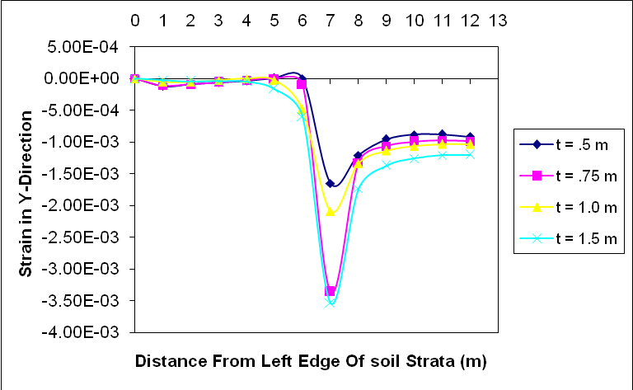
Fig.6.18 Variation of strain with variable thickness of raft along width of soil strata
Figure 6.18 show that when the thickness of the raft increased the strains increases along width of Soil Strata as dead of raft increases. The variation of the strains lies in the range of 19 % to 58 % at the edge of the raft to 8% to 25 % below the centre of the raft. It also shows that the maximum strain acts below the edge of the raft.

6.4.2 Response of Raft-Structure interaction
6.4.2.1 Variation of Deflection with Variable Thickness of Raft along width of Raft
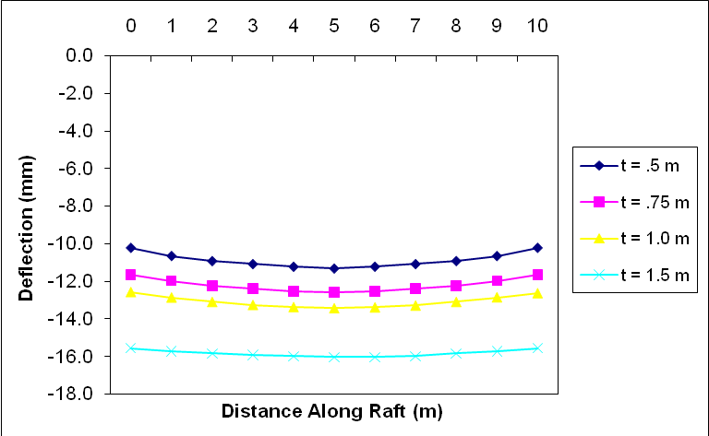
Fig.6.19 Variation of deflection with variable thickness of raft along width of raft
Figure 6.19 shows that when the thickness of the raft increased the deformation increases along width raft as dead load on the raft is increases. It resembles that if the thickness of the raft increased the load carrying capacity of soil decreases. The variation of deflection lies in the range of to 18 % to 60 % at the centre of the raft.

CHAPTER -7
CONCLUSIONS
On the basis of detailed finite element analysis of framed structure using effect of soil-structure interaction with different soil properties, the following conclusions can be drawn
(1) The static response of the system is calculated in terms of deflection, stress and strain, from the result it is found that the variation of modulus of elasticity of soil significantly affects the behaviour of the deflection and strain while the behaviour of stress has less affect as compared to the other two responses at structure-raft interaction and raft-soil interaction.
(2) From the result it is found that variation of Poisson’s ratio of soil does not affect significantly for all the responses as compared to modulus of elasticity, the behaviour of deflection and strain has a little more affect than the stress at both the interaction.
(3) When variation of thickness of raft is taken into account, all the responses has significantly affecting the behaviour of the system at both the interaction
(4) On increasing the modulus of elasticity (2.0 x 10⁷ – 5.0 x 10⁷ N/m²) the decrease in deformations is approximately 61% whereas increase in Poisson’s ratio (0.10 – 0.30) resulted in 5 % increase of deformation.

Scope of Further Studies
In continuation of present study thesis, the following work may further be carried out-
- From these studies mathematical model can be developed for calculating the deformations and stresses directly without any analysis.
- Two dimensional dynamic and non-linear analysis of soil-structure interaction for framed structures.
- Complete three dimensional analysis of soil-structure interaction for framed structures.

REFRENCES
- Almeida, V. S. and Paiva, J. B. (2004). “A mixed BEM–FEM formulation for layered soil–superstructure interaction”. J Elsevier Engineering Analysis with Boundary Elements, 28, 1111–1121
- Almeida, V. S. and Paiva, J. B. (2007). “Static analysis of soil/pile interaction in layered soil by BEM/BEM coupling”,Journal of Advances in Engineering Software, 38, 835–845
- Bhattacharya, K., Dutta, S. C. and Dasgupta, S. (2004). “Effect of soil-flexibilityon dynamic behaviour of building frames on raft foundation.” Journal of Sound and Vibration, 274,111–135
- Bouzid, D. A., Vermeer, P.A. and Tiliouine, B. (2005). “Finite element vertical slices model: Validation and application to an embedded square footing under combined loading.” Computers and Geotechnics, 32, 72–91
- Dutta S.C., Bhattacharya G. and Moitra D. (1999). “Effect of soil–structure interaction on building frames.” Proc Indian Geotech Conf., 1, 123–6.
- Kumar, D and Das, S. K. (2004). “Floor Bearing Characteristics of Jointed and Layered Rock Foundation.” Journal of the Institution of Engineers (India), 84 (2), 78-91.
- Larsson, R. and Wxberg, N. (1988). “A new exact element for a beam on elastic foundation.” Computers & Structures, 29 (5), 845-855.
- Lianga, F. Y., Chena, L. Z. and Shib. X. G. (2003). “Numerical analysis of composite piled raft with cushion subjected to vertical load.” Computers and Geotechnics, 30, 443–453
- Maheshwari, P. and Madhav, M. R. (2006). “Analysis of a rigid footing lying on three-layered soil using the finite difference method.” Geotechnical and Geological Engineering, 24, 851–869
- Melerski, E. S. (1997). “Numerical modelling of elastic interaction between circular rafts and cross-anisotropic media.” Computers & Structures, 64 (4), 567-578,

- Nasri, V. and Magnan, J.P. (1997). “Effect of soil consolidation on space frame-raft-soil interaction.” Journal of structural Engineering, 11, 1528-1534
- Rao, P. S., Rambabu, K.V. and Allam, M. M.(1995). “Representation of soil support in anlysis of open plane frames.” Computers and Structures,56(6), 917-925.
- Rashed, Y. F.(2005). “A boundary/domain element method for analysis
of building raft foundations.” Engineering Analysis with Boundary Elements 29 (7) ,859–877
- Stavridis, L. T.(2002). “Simplified Analysis of Layered Soil-Structure” Interaction Journal of structural Engineering,128(2), 224-230
- Todorovska, M.I. (1992), “Effects of the depth of the embedment on the system response during building-soil interaction”. Journal of Soil Dynamics and Earthquake Engineering, 11,111-123
- Viladkar, M. N., Godbole, P. N. and Noorzaei, J. (1991). “Soil-structure
interaction in plane frames using coupled finite-infinite elements”. Computers and Structures, 39, 535-546
- Wang, Y.H., Tham, L.G., Tsui, Y. And Yue, Z.Q. (2003). “Plate on layered foundation analyzed by a semi-analytical and semi-numerical method”. Computers and Geotechnics, 30, 409–418
- Wang, Y.H., Cheung,Y.K. (2001). “Plate on cross-anisotropic foundation analyzed by the finite element method”. Computers and Geotechnics, 28, 37-54

APENDIX -A
EFFECT OF VARIATION OF MODULUS OF ELASTICITY OF SOIL WHEN THE POISSON RATIO OF SOIL IS CONSTANT
a) Response of Soil-Structure interaction
Table A-1 Variation of deflection with variable modulus of elasticity and constant poisson ratio along length of soil strata.
Distance (m) | Deflection (mm)
 | Y = 2E7 (N/m²) | Y = 3E7 (N/sqm) | Y = 4E7(N/sqm) | Y = 5E7 (N/sqm)
0 | 0 | 0 | 0 | 0
1 | -1.0 | -0.7 | -0.5 | -0.4
2 | -2.6 | -1.7 | -1.3 | -1.0
3 | -4.4 | -2.9 | -2.2 | -1.8
4 | -6.7 | -4.5 | -3.3 | -2.7
5 | -10.0 | -6.7 | -5.0 | -4.0
6 | -14.6 | -9.7 | -7.2 | -5.7
7 | -19.0 | -12.6 | -9.4 | -7.5
8 | -19.3 | -12.9 | -9.6 | -7.7
9 | -19.6 | -13.1 | -9.8 | -7.9
10 | -19.7 | -13.2 | -10.0 | -8.0
11 | -19.9 | -13.4 | -10.1 | -8.2
12 | -19.9 | -13.4 | -10.2 | -8.2

Table A-2 Variation of deflection with variable modulus of elasticity and constant poisson ratio along depth of soil strata.
Distance (m) | Deflection (mm)
 | Y = 1E7(N/sqm) | Y =2 E7(N/sqm) | Y =3 E7(N/sqm) | Y =4 E7(N/sqm)
0 | -19.9 | -13.4 | -10.2 | -8.2
1 | -19.9 | -13.4 | -10.2 | -8.2
2 | -18.5 | -12.4 | -9.4 | -7.6
3 | -16.9 | -11.3 | -8.6 | -6.9
4 | -15.3 | -10.3 | -7.7 | -6.2
5 | -13.8 | -9.2 | -7.0 | -5.6
6 | -12.3 | -8.2 | -6.2 | -5.0
7 | -11.3 | -7.6 | -5.7 | -4.6
8 | -10.2 | -6.8 | -5.1 | -4.1
9 | -8.7 | -5.8 | -4.4 | -3.5
10 | -7.7 | -5.1 | -3.9 | -3.1
11 | -6.3 | -4.2 | -3.2 | -2.5
12 | -5.4 | -3.6 | -2.7 | -2.2
13 | -4.2 | -2.8 | -2.1 | -1.7
14 | -3.1 | -2.1 | -1.5 | -1.2
15 | -2.0 | -1.3 | -1.0 | -0.8
16 | -1.0 | -0.6 | -0.5 | -0.4
18 | 0 | 0.00E+00 | 0.00E+00 | 0.00E+00

Table A-3 Variation of stress with variable modulus of elasticity and constant poisson ratio along length of soil strata.
Distance (m) | Stress in Y-Direction (N/m²)
Distance (m) | Y = 1E7(N/sqm) | Y =2 E7(N/sqm) | Y =3 E7(N/sqm) | Y =4 E7(N/sqm)
0 | 3456.7 | 3429.7 | 3406.1 | 3385.3
1 | 1567.4 | 1557.3 | 1548.3 | 1540.4
2 | 452.17 | 450.13 | 448.36 | 446.81
3 | -136.85 | -131.51 | -126.67 | -122.25
4 | -1030 | -1004.5 | -981.61 | -960.95
5 | -4539.7 | -4412.9 | -4299.5 | -4197.3
6 | -20846 | -20255 | -19728 | -19253
7 | -71031 | -69218 | -67599 | -66144
8 | -44091 | -43867 | -43674 | -43508
9 | -37048 | -37355 | -37627 | -37871
10 | -34166 | -34796 | -35352 | -35845
11 | -32802 | -33726 | -34549 | -35286
12 | -32567 | -33658 | -34641 | -35533

Table A-4 Variation of strain with variable modulus of elasticity and constant poisson ratio along length of soil strata.
Distance (m) | Strain in Y-Direction (N/m²)
Distance (m) | Y=2E7 (N/sqm) | Y=3E7 (N/sqm) | Y=4E7 (N/sqm) | Y=5E7 (N/sqm)
0 | -4.99E-19 | -3.04E-19 | -2.32E-19 | -2.14E-19
1 | -7.55E-05 | -4.99E-05 | -3.71E-05 | -2.94E-05
2 | -8.02E-05 | -5.29E-05 | -3.92E-05 | -3.11E-05
3 | -4.23E-05 | -2.76E-05 | -2.03E-05 | -1.60E-05
4 | -6.25E-06 | -3.32E-06 | -1.94E-06 | -1.17E-06
5 | -4.88E-05 | -2.90E-05 | -1.94E-05 | -1.38E-05
6 | -7.61E-04 | -4.86E-04 | -3.50E-04 | -2.70E-04
7 | -3.24E-03 | -2.09E-03 | -1.52E-03 | -1.19E-03
8 | -2.01E-03 | -1.34E-03 | -1.00E-03 | -7.98E-04
9 | -1.69E-03 | -1.14E-03 | -8.62E-04 | -6.95E-04
10 | -1.56E-03 | -1.06E-03 | -8.11E-04 | -6.59E-04
11 | -1.50E-03 | -1.03E-03 | -7.95E-04 | -6.51E-04
12 | -1.50E-03 | -1.03E-03 | -8.00E-04 | -6.58E-04

b) Response of Raft-Structure interaction
Table A-5 Variation of deflection with variable modulus of elasticity and constant poisson ratio along length of raft.
Distance (m) | Deflection (mm)
Distance (m) | v = .1 | v = .15 | v = .2 | v = .25 | v = .3
0 | -18.7 | -18.9 | -19.0 | -19.1 | -19.0
1 | -19.0 | -19.2 | -19.3 | -19.4 | -19.3
2 | -19.3 | -19.5 | -19.6 | -19.6 | -19.6
3 | -19.4 | -19.6 | -19.7 | -19.8 | -19.8
4 | -19.6 | -19.7 | -19.9 | -19.9 | -19.9
5 | -19.6 | -19.8 | -19.9 | -20.0 | -19.9
6 | -19.6 | -19.8 | -19.9 | -19.9 | -19.9
7 | -19.5 | -19.7 | -19.8 | -19.8 | -19.8
8 | -19.3 | -19.5 | -19.6 | -19.6 | -19.6
9 | -19.0 | -19.2 | -19.3 | -19.4 | -19.3
10 | -18.7 | -18.9 | -19.0 | -19.1 | -19.0

Table A-6 Variation of stress with variable modulus of elasticity and constant poisson ratio along width of raft
Distance (m) | Stress in Y-Direction (N/m²)
Distance (m) | Y=2E7 (N/sqm) | Y=3E7 (N/sqm) | Y=4E7 (N/sqm) | Y=5E7 (N/sqm)
1 | -31030 | -31483 | -31898 | -32279
2 | -17261 | -18583 | -19761 | -20816
3 | -13303 | -15190 | -16864 | -18358
4 | -6841.3 | -9170.7 | -11245 | -13105
5 | -4883.9 | -7470.5 | -9791.8 | -11889
6 | -6841.3 | -9170.7 | -11245 | -13105
7 | -13303 | -15190 | -16864 | -18358
8 | -17261 | -18583 | -19761 | -20816
9 | -31030 | -31483 | -31898 | -32279

Table A-7 Variation of strain with variable modulus of elasticity and constant poisson ratio along length of raft
Distance (m) | Strain in Y-Direction (N/m²)
Distance (m) | Y=2E7 (N/sqm) | Y=3E7 (N/sqm) | Y=4E7 (N/sqm) | Y=5E7 (N/sqm)
0 | -1.77E-05 | -1.70E-05 | -1.64E-05 | -1.58E-05
1 | -6.23E-06 | -6.04E-06 | -5.87E-06 | -5.72E-06
2 | -5.79E-06 | -5.53E-06 | -5.30E-06 | -5.10E-06
3 | -6.13E-06 | -5.82E-06 | -5.54E-06 | -5.29E-06
4 | -7.32E-06 | -6.97E-06 | -6.67E-06 | -6.39E-06
5 | -9.14E-06 | -8.83E-06 | -8.55E-06 | -8.30E-06
6 | -7.32E-06 | -6.97E-06 | -6.67E-06 | -6.39E-06
7 | -6.13E-06 | -5.82E-06 | -5.54E-06 | -5.29E-06
8 | -5.79E-06 | -5.53E-06 | -5.30E-06 | -5.10E-06
9 | -6.23E-06 | -6.04E-06 | -5.87E-06 | -5.72E-06
10 | -1.77E-05 | -1.70E-05 | -1.64E-05 | -1.58E-05

APENDIX -B
EFFECT OF VARIATION OF POISSON RATIO OF SOIL WHEN THE MODULUS OF ELASTICITY OF SOIL IS CONSTANT
a) Response of Soil-Structure interaction
Table B-1 Variation of deflection with variable poisson ratio and constant modulus of elasticity along length of soil strata
Distance (m) | deflection (mm)
Distance (m) | v = .1 | v = .15 | v = .2 | v = .25 | v = .3
0 | 0 | 0 | 0 | 0 | 0
1 | -1.1 | -1.1 | -1.1 | -1.1 | -1.0
2 | -2.8 | -2.7 | -2.7 | -2.6 | -2.6
3 | -4.8 | -4.7 | -4.7 | -4.6 | -4.4
4 | -7.1 | -7.1 | -7.0 | -6.9 | -6.7
5 | -10.4 | -10.4 | -10.3 | -10.2 | -10.0
6 | -14.7 | -14.8 | -14.8 | -14.7 | -14.6
7 | -18.7 | -18.9 | -19.0 | -19.1 | -19.0
8 | -19.0 | -19.2 | -19.3 | -19.4 | -19.3
9 | -19.2 | -19.4 | -19.5 | -19.6 | -19.6
10 | -19.4 | -19.6 | -19.7 | -19.8 | -19.7
11 | -19.6 | -19.7 | -19.9 | -19.9 | -19.9
12 | -19.6 | -19.8 | -19.9 | -20.0 | -19.9

Table B-2 Variation of deflection with variable poisson ratio and constant modulus of elasticity along depth of soil strata
Distance (m) | Deflection (mm)
Distance (m) | v = .1 | v = .15 | v = .2 | v = .25 | v = .3
18 | -19.6 | -19.8 | -19.9 | -20.0 | -19.9
17 | -19.6 | -19.8 | -19.9 | -20.0 | -19.9
16 | -18.0 | -18.2 | -18.4 | -18.4 | -18.5
15 | -16.4 | -16.6 | -16.7 | -16.8 | -16.9
14 | -14.7 | -15.0 | -15.1 | -15.3 | -15.3
13 | -13.2 | -13.4 | -13.6 | -13.7 | -13.8
12 | -11.7 | -11.9 | -12.1 | -12.2 | -12.3
11 | -10.8 | -10.9 | -11.1 | -11.2 | -11.3
10 | -9.7 | -9.9 | -10.0 | -10.1 | -10.2
9 | -8.2 | -8.4 | -8.5 | -8.6 | -8.7
8 | -7.3 | -7.4 | -7.5 | -7.6 | -7.7
7 | -6.0 | -6.1 | -6.2 | -6.3 | -6.3
6 | -5.1 | -5.2 | -5.3 | -5.4 | -5.4
5 | -4.0 | -4.1 | -4.1 | -4.2 | -4.2
4 | -2.9 | -3.0 | -3.0 | -3.1 | -3.1
3 | -1.9 | -1.9 | -2.0 | -2.0 | -2.0
2 | -0.9 | -0.9 | -1.0 | -1.0 | -1.0
0 | 0.00E+00 | 0.00E+00 | 0.00E+00 | 0.00E+00 | 0.00E+00

Table B-3 Variation of stress with variable poisson ratio and constant modulus of elasticity along length of soil strata
Distance (m) | Stress in Y-Direction (N/m²)
Distance (m) | v = .1 | v = .15 | v = .2 | v = .25 | v = .3
0 | 1566.3 | 2196.3 | 2722.9 | 3144 | 3456.7
1 | 1695.4 | 1724.9 | 1713.6 | 1661.2 | 1567.4
2 | 595.69 | 575.23 | 544.62 | 503.7 | 452.17
3 | -140.36 | -133.58 | -130.64 | -131.67 | -136.85
4 | -1216.4 | -1166.4 | -1118.6 | -1073.1 | -1030
5 | -4887 | -4802.3 | -4716 | -4628.4 | -4539.7
6 | -20443 | -20628 | -20757 | -20830 | -20846
7 | -67341 | -68407 | -69375 | -70249 | -71031
8 | -44210 | -44147 | -44106 | -44087 | -37974
9 | -37113 | -37065 | -37038 | -37032 | -34572
10 | -34163 | -34130 | -34119 | -34131 | -33091
11 | -32775 | -32745 | -32739 | -32758 | -32577
12 | -32559 | -32523 | -32511 | -32526 | -32567

Table B-4 Variation of strain with variable poisson ratio and constant modulus of elasticity along length of soil strata
12. Distance (m) | Strain in Y-Direction (N/m²)
12. Distance (m) | v = .1 | v = .15 | v = .2 | v = .25 | v = .3
0 | 8.91E-19 | 4.56E-19 | 1.16E-19 | -1.83E-19 | -4.99E-19
1 | 1.61E-05 | -1.07E-05 | -3.51E-05 | -5.69E-05 | -7.55E-05
2 | -1.75E-05 | -3.76E-05 | -5.48E-05 | -6.91E-05 | -8.02E-05
3 | -2.76E-05 | -3.44E-05 | -3.91E-05 | -4.18E-05 | -4.23E-05
4 | -5.04E-05 | -4.08E-05 | -3.03E-05 | -1.87E-05 | -6.25E-06
5 | -1.85E-04 | -1.51E-04 | -1.17E-04 | -8.26E-05 | -4.88E-05
6 | -9.21E-04 | -8.82E-04 | -8.42E-04 | -8.02E-04 | -7.61E-04
7 | -3.29E-03 | -3.29E-03 | -3.28E-03 | -3.27E-03 | -3.24E-03
8 | -2.19E-03 | -2.16E-03 | -2.12E-03 | -2.07E-03 | -2.01E-03
9 | -1.84E-03 | -1.82E-03 | -1.78E-03 | -1.74E-03 | -1.69E-03
10 | -1.69E-03 | -1.67E-03 | -1.64E-03 | -1.61E-03 | -1.56E-03
11 | -1.63E-03 | -1.61E-03 | -1.58E-03 | -1.54E-03 | -1.50E-03
12 | -1.62E-03 | -1.60E-03 | -1.57E-03 | -1.54E-03 | -1.50E-03

b) Response of Raft-Structure interaction
Table B-5 Variation of deflection with variable poisson ratio and constant modulus of elasticity along length of raft.
Distance (m) | Deflection (mm)
Distance (m) | v = .1 | v = .15 | v = .2 | v = .25 | v = .3
0 | -18.7 | -18.9 | -19.0 | -19.1 | -19.0
1 | -19.0 | -19.2 | -19.3 | -19.4 | -19.3
2 | -19.3 | -19.5 | -19.6 | -19.6 | -19.6
3 | -19.4 | -19.6 | -19.7 | -19.8 | -19.8
4 | -19.6 | -19.7 | -19.9 | -19.9 | -19.9
5 | -19.6 | -19.8 | -19.9 | -20.0 | -19.9
6 | -19.6 | -19.8 | -19.9 | -19.9 | -19.9
7 | -19.5 | -19.7 | -19.8 | -19.8 | -19.8
8 | -19.3 | -19.5 | -19.6 | -19.6 | -19.6
9 | -19.0 | -19.2 | -19.3 | -19.4 | -19.3
10 | -18.7 | -18.9 | -19.0 | -19.1 | -19.0

Table B-6 Variation of stress with variable Poisson ratio and constant modulus of elasticity along length of raft
Distance (m) | Stress in Y-Direction (N/m²)
Distance (m) | v = .1 | v = .15 | v = .2 | v = .25 | v = .3
1 | -32129 | -31798 | -31506 | -31251 | -31030
2 | -18226 | -17903 | -17636 | -17422 | -17261
3 | -14126 | -13827 | -13592 | -13417 | -13303
4 | -7551 | -7275.6 | -7065.9 | -6921.2 | -6841.3
5 | -5592.3 | -5314 | -5103.5 | -4960.2 | -4883.9
6 | -7551 | -7275.6 | -7065.9 | -6921.2 | -6841.3
7 | -14126 | -13827 | -13592 | -13417 | -13303
8 | -18226 | -17903 | -17636 | -17422 | -17261
9 | -32129 | -31798 | -31506 | -31251 | -31030

Table B-7 Variation of strain with variable poisson ratio and constant modulus of elasticity along length of raft
. Distance (m) | Strain in Y-Direction (N/m²)
. Distance (m) | v = .1 | v = .15 | v = .2 | v = .25 | v = .3
0 | -1.68E-05 | -1.70E-05 | -1.72E-05 | -1.75E-05 | -1.77E-05
1 | -5.91E-06 | -6.00E-06 | -6.08E-06 | -6.16E-06 | -6.23E-06
2 | -5.43E-06 | -5.53E-06 | -5.63E-06 | -5.71E-06 | -5.79E-06
3 | -5.78E-06 | -5.88E-06 | -5.97E-06 | -6.06E-06 | -6.13E-06
4 | -6.97E-06 | -7.07E-06 | -7.17E-06 | -7.25E-06 | -7.32E-06
5 | -8.82E-06 | -8.92E-06 | -9.00E-06 | -9.08E-06 | -9.14E-06
6 | -6.97E-06 | -7.07E-06 | -7.17E-06 | -7.25E-06 | -7.32E-06
7 | -5.78E-06 | -5.88E-06 | -5.97E-06 | -6.06E-06 | -6.13E-06
8 | -5.43E-06 | -5.53E-06 | -5.63E-06 | -5.71E-06 | -5.79E-06
9 | -5.91E-06 | -6.00E-06 | -6.08E-06 | -6.16E-06 | -6.23E-06
10 | -1.68E-05 | -1.70E-05 | -1.72E-05 | -1.75E-05 | -1.77E-05

APENDIX -C
EFFECT OF VARIATION OF THIKNESS OF RAFT WHEN THE PROPERTY OF SOIL IS CONSTANT
The range of thickness of raft is taken between .5 to .1.5 meter.
a) Response of Soil-Structure interaction
Table C-1 Variation of deflection with variable thickness of raft along length of soil strata
Distance (m) | deflection (mm)
Distance (m) | t = .5 m | t = .75 m | t = 1.0 m | t = 1.5 m
0 | 0 | 0 | 0 | 0
1 | -0.5 | -0.6 | -0.7 | -0.8
2 | -1.3 | -1.5 | -1.7 | -2.0
3 | -2.2 | -2.5 | -2.9 | -3.6
4 | -3.3 | -3.8 | -4.5 | -5.4
5 | -4.9 | -5.7 | -6.7 | -8.1
6 | -6.4 | -7.4 | -9.7 | -11.5
7 | -10.2 | -11.7 | -12.6 | -15.6
8 | -10.6 | -12.0 | -12.9 | -15.7
9 | -10.9 | -12.2 | -13.1 | -15.8
10 | -11.1 | -12.4 | -13.2 | -15.9
11 | -11.2 | -12.5 | -13.4 | -16.0
12 | -11.3 | -12.6 | -13.4 | -16.0

Table C-2 Variation of deflection with variable thickness of raft along depth of soil strata
Distance (m) | deflection (mm)
Distance (m) | t = .5 m | t = .75 m | t = 1.0 m | t = 1.5 m
0 | -11.3 | -12.6 | -13.4 | -16.0
1 | -11.3 | -12.3 | -13.4 | -16.0
2 | -11.0 | -11.4 | -12.4 | -15.4
3 | -10.0 | -10.4 | -11.3 | -14.1
4 | -9.1 | -9.4 | -10.3 | -12.9
5 | -8.2 | -8.4 | -9.2 | -11.6
6 | -7.3 | -7.5 | -8.2 | -10.4
7 | -6.5 | -6.9 | -7.6 | -9.1
8 | -5.7 | -5.9 | -6.8 | -8.4
9 | -4.8 | -5.3 | -5.8 | -7.8
10 | -4.1 | -4.4 | -5.1 | -6.5
11 | -3.3 | -3.8 | -4.2 | -5.3
12 | -2.9 | -3.3 | -3.6 | -4.6
13 | -2.2 | -2.5 | -2.8 | -3.6
14 | -1.6 | -1.9 | -2.1 | -2.6
15 | -1.0 | -1.2 | -1.3 | -1.7
16 | -0.5 | -0.6 | -0.6 | -0.8
18 | 0 | 0 | 0 | 0

Table C-3 Variation of stress with variable thickness of raft along length of soil strata
Distance (m) | Stress in Y-Direction (N/m²)
Distance (m) | t = .5 m | t = .75 m | t = 1.0 m | t = 1.5 m
0 | 4665.8 | 4637.3 | 3406.1 | 3413.1
1 | 3.58E+02 | 7.99E+02 | 1548.3 | 2414.6
2 | 1.37E+02 | 2.42E+02 | 448.36 | 816.23
3 | 1.80E+01 | 2.15E+01 | -126.67 | -338.08
4 | 2.74E+03 | -2.53E+02 | -981.61 | -2137.8
5 | -8.29E+02 | -1.66E+03 | -4299.5 | -7952.8
6 | -3.26E+03 | -6.19E+03 | -19728 | -22902
7 | -5.43E+04 | -3.31E+04 | -67599 | -1.17E+05
8 | -10433 | -1.23E+04 | -43674 | -56953
9 | -9.08E+03 | -1.00E+04 | -37627 | -45017
10 | -8.62E+03 | -9.30E+03 | -35352 | -41382
11 | -8.20E+03 | -8.80E+03 | -34549 | -39618
12 | -7.69E+03 | -8.49E+03 | -34641 | -39292

Table C-4 Variation of strain with variable thickness of raft along length of soil strata
Distance (m) | Strain in Y-Direction (N/m²)
Distance (m) | t = .5 m | t = .75 m | t = 1.0 m | t = 1.5 m
0 | -1.79E-18 | -1.49E-18 | -3.04E-19 | 2.84E-20
1 | -1.20E-04 | -1.09E-04 | -4.99E-05 | -2.40E-05
2 | -9.01E-05 | -9.11E-05 | -5.29E-05 | -4.79E-05
3 | -6.12E-05 | -6.06E-05 | -2.76E-05 | -4.13E-05
4 | -3.13E-05 | -2.83E-05 | -3.32E-06 | -4.61E-05
5 | 8.63E-06 | -7.84E-07 | -2.90E-05 | -1.63E-04
6 | 1.43E-06 | -9.37E-05 | -4.86E-04 | -5.96E-04
7 | -1.65E-03 | -3.36E-03 | -2.09E-03 | -3.54E-03
8 | -1.21E-03 | -1.32E-03 | -1.34E-03 | -1.73E-03
9 | -9.58E-04 | -1.07E-03 | -1.14E-03 | -1.37E-03
10 | -8.80E-04 | -9.96E-04 | -1.06E-03 | -1.26E-03
11 | -8.79E-04 | -9.77E-04 | -1.03E-03 | -1.21E-03
12 | -9.13E-04 | -9.88E-04 | -1.03E-03 | -1.20E-03

Table C-5 Variation of deflection with variable thickness of raft along length of raft
Distance (m) | deflection (mm)
Distance (m) | t = .5 m | t = .75 m | t = 1.0 m | t = 1.5 m
0 | -10.2 | -11.7 | -12.6 | -15.6
1 | -10.6 | -12.0 | -12.9 | -15.7
2 | -10.9 | -12.2 | -13.1 | -15.8
3 | -11.1 | -12.4 | -13.3 | -15.9
4 | -11.2 | -12.5 | -13.4 | -16.0
5 | -11.3 | -12.6 | -13.4 | -16.0
6 | -11.2 | -12.5 | -13.4 | -16.0
7 | -11.1 | -12.4 | -13.3 | -16.0
8 | -10.9 | -12.2 | -13.1 | -15.8
9 | -10.6 | -12.0 | -12.9 | -15.7
10 | -10.2 | -11.7 | -12.6 | -15.6

APENDIX-D
Plot Result of Deformed Shape and Contours of Deformation, Stress and Strain
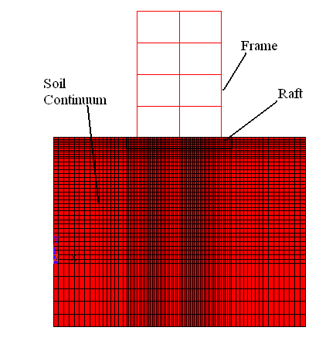
Fig. D-1 2-D Model showing the Frame-raft-soil interaction

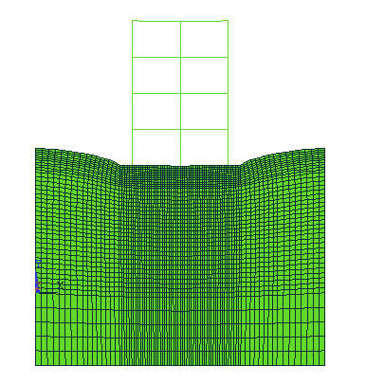
Fig. D -2 Deformed shape of building with raft and soil
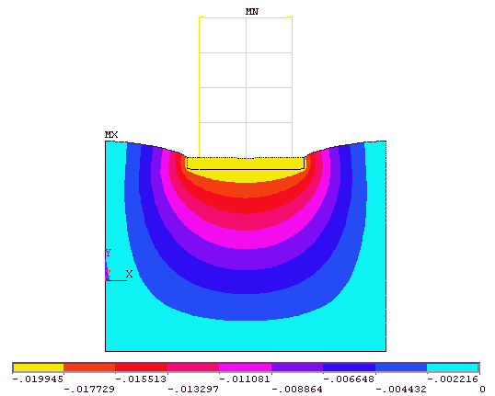
Fig. D-3 Produced Deformation in Building, Raft & Soil

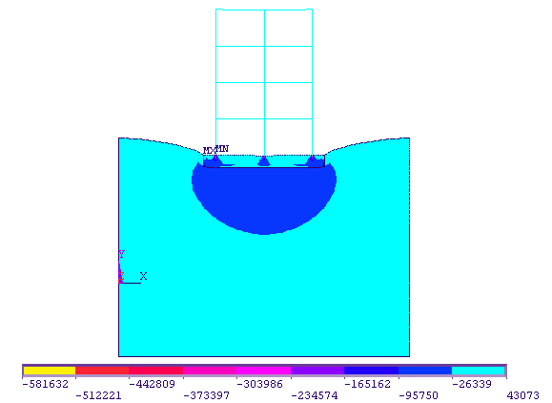
Fig. D-4 Produced Stresses in Building, Raft & Soil in Y-direction
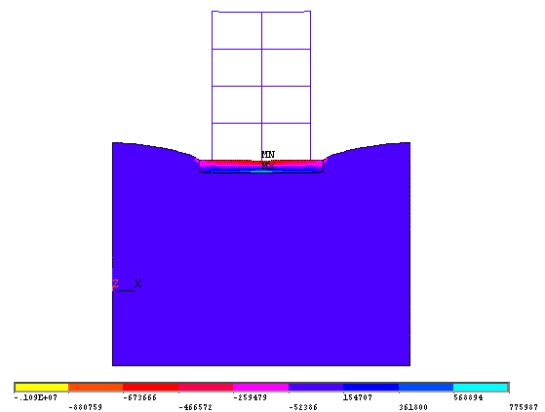
Fig. D-5 Produced Stresses in Building, Raft & Soil in X-direction
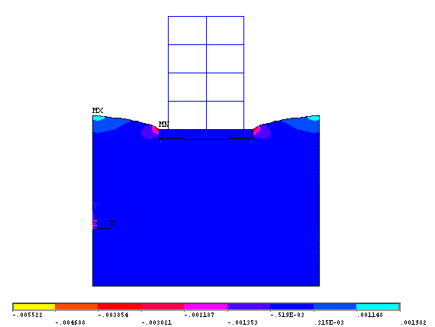
Fig.D-6 Produced Strains in Building, Raft & Soil in X-direction
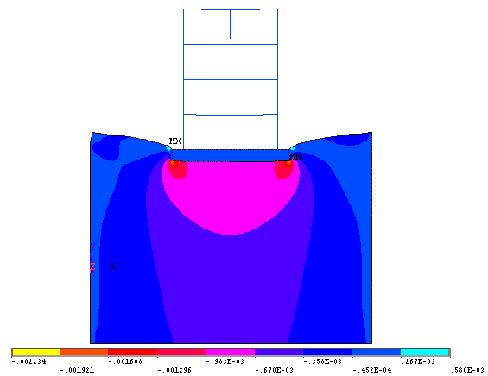
Fig. D-7 Produced Strains in Building, Raft & Soil in Y-direction

