EFFECTS OF CONTINUOUS HOT WATER CURING ON THE COMPRESSIVE STRENGTH OF A PUMPABLE CONCRETE USING A SUITABLE CEMENT AND SUPERPLASTICIZER

A MAJOR THESIS

SUBMITTED IN PARTIAL FULFILLMENT OF THE REQUIREMENT FOR THE AWARD OF DEGREE OF

MASTER OF ENGINEERING

IN
CIVIL ENGINEERING
[ STRUCTURAL ENGINEERING ]

SUBMITTED BY

ISHWAR CHAND
20/STR/2004
( UNIVERSITY ROLL NO.4802 )



UNDER THE GUIDANCE OF

DR. ASHOK KUMAR GUPTA
Assistant Professor
Department of Civil Engineering
Delhi College of Engineering

DEPARTMENT OF CIVIL AND ENVIRONMENTAL ENGINEERING
DELHI COLLEGE OF ENGINEERING
DELHI UNIVERSITY, DELHI – 110042

2004 – 2007

ACKNOWLEDGEMENT

With the sense of great pleasure and satisfaction I present this report entitled “Effect of continuous hot water curing on the compressive strength of a pumpable concrete using a suitable cement and super plasticizer”.

I am extremely thankful to Dr. A.K.Gupta for his invaluable support in the completion of this project. His ever encouraging attitude, guidance and whole hearted help were biggest motivation for me in making the project.

I express my sincere thanks to all my friends and staff of Civil Engineering Department of Delhi College of Engineering who left no stone unturned whenever I needed their assistance.

ISHWAR CHAND

CANDIDATE’S DECLARATION & CERTIFICATE

This is to declare that the minor project entitled “Effect of continuous hot water curing on the compressive strength of a pumpable concrete using a suitable cement and super plasticizer ” is a bonafide record of work done by me,Ishwar Chand for the partial fulfillment of the requirements for the degree in the Master of Civil Engineering (Structural Engineering), Delhi College of Engineering Delhi.

This project has been carried out under the supervision of Dr. A.K. Gupta. I have not submitted the matter embodied in this dissertation for the award of any other degree.

Ishwar Chand
Enrollment No.20/Structure/04
University Roll No.4802

This is to certify that the above statement made by the candidate is correct to the best of my knowledge.

Dr. A.K.Gupta
Assistant Professor
Deptt. Of Civil Engineering
Delhi College of Engineering, Delhi.

CONTENTS
Chapter 1 Page no.
Concrete
1.1 Introduction

1.2 Mix design

1.2.1 Object of mix design

1.3 Workability

1.3.1 Need for chemical mixture

1.3.2 Water reducers

1.3.3 High range water reducer

1.4 Super plasticizer

1.5 Compressive strength

1.5.1 Water cement ratio
Chapter 2
Pumpable concrete
2.1 Design consideration for pumpable concrete

2.1.1 Common problem in pumpable concrete

2.1.2 Clearing blockage
Chapter 3
Influence of early temperature on strength of concrete
Chapter 4
Laboratory equipments used
4.1 Electronic weighing machine
4.2 Cube mould
4.3 Slump cone
4.4 Temping rod
4.5 Water curing tank
4.6 Compression testing machine
Chapter 5
Photographs

Chapter 6
Properties of materials used
6.1 Cement
6.2 Admixture

6.2.1 Cemwet SP 3000

6.2.2Glenium tm 51

6.2.3 Dr. Fixit pidicrete CF 21

6.3 Water

6.4 Fine aggregate

6.5 Coarse aggregate

6.6 Size of cube
Chapter 7
Mix design as per Indian standard code
Chapter 8
Laboratory work
8.1 Workability Results

8.1.1 Binani 43 Grade Cement

8.1.2 Birla Faulad 53 Grade Cement

8.1.3 PPC ambuja cement

8.2 Compressive strength results

8.3 Conclusions and scope of further study
Chapter 9
Laboratory work for
Suitable combination of cement and superplasticizer
Chapter 10
Laboratory work for effect of w/c ratio
and no. of days of hot water curing
10.1.1 Result at 27⁰ c temp for 28 days curing
10.1.2 Result at 3days 40⁰ c temp. and 24 days 27⁰ c temp.curing.
10.1.3 Result at 2days 40⁰ c temp. and 25 days 27⁰ c temp.curing.
10.1.4 Result at 1days 40⁰ c temp. and 26 days 27⁰ c temp.curing.
10.1.5 Result at 3days 55⁰ c temp. and 24 days 27⁰ c temp.curing.
10.1.6 Result at 2days 55⁰ c temp. and 25 days 27⁰ c temp.curing.
10.1.7 Result at 1days 55⁰ c temp. and 26 days 27⁰ c temp.curing.

Chapter 11
Conclusion

Chapter 12
References

CHAPTER ONE
CONCRETE

1.1 INTRODUCTION

From the stage of mixing, till it is transported, placed in the form work and compacted, fresh concrete satisfy a number of requirements.
(i) The mix should be stable, in that it should not segregate during transportation and placing. The tendency of bleeding should be minimized
(ii) The mix should be cohesive and mobile enough to be placed in the form
around the reinforcement and should be able to castable in to the required shape.
(iii) The mix should be amenable to proper and thorough compaction as
possible in the situation of placing and with the facilities of compaction available,
(iv) It should be possible to obtain a satisfactory surface finish

1.2 MIX DESIGN

Mix design is the process of selecting suitable ingredients of concrete and determining their relative proportion with the object of producing concrete of certain minimum strength and durability as economically as possible.
1.2.1 Objects of mix design
(i) To achieve the stipulated minimum strength and durability.
(ii) The second object is to make the concrete in the most economical manner.

1.3 WORKABILITY

1.3.1 Need for Chemical Admixture

Chemical admixtures are used to improve workability. They are capable to give high workability without segregation or bleeding. Concrete can be placed and compacted in congested reinforcement.

Admixtures, although not always cheap, do not necessarily represent additional expenditure because their use can result in concomitant savings, for example, in the cost of labour required to effect compaction, in the cement content which would otherwise be necessary, or in improving durability without the use of additional measures.

It should be stressed that, while properly used admixtures are beneficial to concrete, they are no remedy for poor quality mix ingredients, for use of incorrect mix proportions, or for poor workmanship in transporting, placing and compaction.

1.3.2 Water Reducers

It is classified as low range, medium range and high range water reducers and depends on range of water content reducible. It is also called Plasticizers. When added to a concrete mix, plasticizers (water reducing agents) are absorbed on the surface of the binder particles, causing them to repel each other and defloculated. This results in improved workability and provides a more even distribution of the binder particles.It is covered in Type A chemical Admixture of ASTM C 494. It lowers the water content and increases the strength. It can obtain higher slump using the same water content. It allows reducing cement content at same water-cement ratio. It aggravates slump loss problems and may improve pumpability. It tends to retard setting of concrete and sometimes has accelerators blended in to offset the retardation. The main types of plasticizers lignosulphonic acids and their salt. Hydroxilated carboxylic acid and their salt, and modification of both. The typical dosage of plasticizers varies from 200ml to 450 ml per 100 kg of cementious material. Plasticizers can reduce the water requirement of a concrete mix for a given workability, as a rule-of thumb by about 10%.

1.3.3 High Range Water Reducers (HRWR)

These are called as special class of water reducers, and Super plasticizers. Super plasticizers are usually chemical compounds such as sulphonated melamine formaldehyde, sulphonated naphthalene formaldehydes, and modified lignosulphonates. It is covered in Types F (water reducing High range) and G (water reducing high range and retarding) chemical Admixtures of ASTM C 494, and C 1017 Types 1 and 2. It reduces the water content of a given concrete from 12 to 25% which in turn increases strength and greatly increases the slump to produce “flowing” concrete. Adding a normal dosage to concrete having slump 75-100 mm will produce a concrete with a slump of about 200 mm, however within 30 to 60 minutes the concrete will return to its original slump.

Dosage:

The normal dosage of a super plasticizer is maximum 2% by weight of cement according to I.S. 456 – 2000.

1.4 Super Plasticizer-Cement Compatibility

It is important to establish a compatible super plasticizer-cement combination. When the two materials are well-matched, a large single dosage can lead to the retention of high workability for a sufficiently long period 60 to 90 minute can be achieved.

While assessing compatibility the required dosage of the super plasticizer should be established. The usual approach is to determine the percentage water reduction which will result in the same workability as an admixture free mix. If the cement is finer, higher the dosage of a super plasticizer required to obtain a given workability.

1.5 Compressive Strength

The compressive strength of concrete is defined as the load which causes the failure of specimen, per unit area of cross-section in uniaxial compression under given rate of loading. The compressive strength at 28 days after casting is taken as a criterion for specifying the quality of concrete. This is termed as Grade of concrete. IS 456-2000 stipulates the use of 150 mm cube specimens.

1.5.1Water Cement Ratio

The compressive strength of concrete at a given age and cured under prescribed conditions is assumed to depend primarily on two factors namely, W/C ratio and degree of compaction. The strength is affected by the air voids in the concrete. For a fully compacted concrete, its strength is taken to be inversely proportional to the W/C ratio which is defined as the ratio of mass of water added to the mass of cement in the mix.
If the aggregate/cement ratio is reduced, but the water/cement ratio is kept constant, the water content increases, and consequently the workability also increases.

CHAPTER TWO
PUMPABLE CONCRETE

A concrete which can be pushed through a pipeline is called a pumbable concrete. It is made in such a manner that its friction at the inner wall of the pipeline does not become very high and that it does not wedge while flowing through the pipeline. Pumpable concrete emerging from a pipeline flows in the form of a plug which is separated from the pipe wall by a thin lubricating layer consisting of cement paste. The water in the paste is hydraulically linked with the interparticle water layer in the plug.

  - Design Considerations for Pumpable Concrete

The mix is proportioned in such a way that it is able to bind all the constituent materials together under pressure from the pump and thereby avoiding segregation and bleeding. The mix must also facilitate the radial movement of sufficient grout to maintain the lubricating film initially placed on the pipeline wall, the mix should also be able to deform while flowing through bends. To achieve this, the proportion of fines i.e., cement and fine particles below 0.25 mm size (particles below 300 microns Approximate) is of prime importance,. The quantities of fine particles between 350 to 400 kg/m³ are considered necessary for pumpable concrete. The above quantities are not only found necessary for maintaining the lubricating film, but it is important for quality and workability and to cover individual grains.

There are two main reasons why blockages occur and that the plug of concrete will not move:
    - Water is being forced out of the mix creating bleeding and blockage by jamming, or
    - There is too much frictional resistance due to the nature of the ingredients of the mix.
It is important to maintain good grading and low void content, it is not always possible
To design pumpable mix around ideal aggregate. Naturally occurring aggregate aswell as crushed aggregates are suitabke for pumpable mix, but it is essential to be
Aware of grading, void content and uniformity. The slump of pumpable concrete is
kept at 75 mm to collapse range and the diameter of the pipe line is at least 3- 4 times the maximum size of aggregate.

2.1.2 Common Problems in Pumping Concrete

The most common problem in pumping concrete is blockage. If concrete fails to emerge at the end of pipeline, if pump is mechanically sound, it would mean that there is blockage somewhere in the system. This will be indicated by an increase in the pressure shown on the pressure gauge. Most blockages occur at tapered sections at the pump end.

Blockages take place generally due to the unsuitability of concrete mix, pipeline and joint deficiencies and operator’s error or careless use of hose end.

A pipeline which is not well cleaned after the previous operation, uncleaned, worn-out hoses, too many and too sharp bends, use of worn out joints are also other reasons for blockages.

2.1.3 Clearing Blockages

1. A minor blockage may be cleared by forward and reverse pumping.
2. Sometime shortening the pipeline will reduce pressure and on restarting pumping the blockage gets cleared off.
3. Tapping the pipeline with hammer and observing the sound one an often locate a blockage.
4. Blockage could be cleared by rodding or by using sponge ball pushed by compressed air or water at high pressure

CHAPTER THREE
INFLUENCE OF EARLY TEMP.
ON STRENGTH OF CONCRETE

INFLUENCE OF EARLY TEMPERATURE ON STRENGTH OF CONCRETE

The development of early strength of concrete is a function of not only time but also that of temperature. When concrete is subject to higher temperature it accelerates the hydration process resulting in faster development of strength. Concrete can not be subjected to dry heat to accelerate the hydration process as the presence of moisture is also an essential requisite.therfore subjecting the concrete to higher temperature and maintaining the required wetness can be achieved by subjecting the concrete to hot water curing.

A faster attainment of strength will contribute to many other advantages mentioned below.

A. Concrete is vulnerable to domage only for short time
B. Concrete member can be handled very quickly.
C. Less space will be sufficient in the casting yard.
D. A smaller curing tank will be sufficient.
E. A higher outturn is possible for a given capital out lay.
F The work can be put on to service at a much early time.

It is intresting to note that concrete subjected to higher tempreture at the early period of hydration is found to lose some of the strength gained at a later stage. Such concrete is said to under go “ retrogression of strength” on the contrary, concrete cured at a comparatively lower temperature takes longer time to develop strength but the strength attained will not be lost at the later ages.

The phenomenon of retrogression of strength explains that faster hydration will result in the formation of quality gels with porous open structure, whereas the gel formed slowely but steadly at lower temperature are of good quality wich are compact and dense in nature.

It has been emphasized that a very young concrete should not be subjected suddenly to higher temperature. Certain amount of delay period on casting the concrete is desirable. It has been found that if 49 degree c is reached in a period shorter than 2 to 3 hrs or 99 degree is reached in less than 6 to 7 hrs from the time of mixing, the gain of strength beyond the frist few hrs is affected adversely.

CHAPTER FOUR
LABORATORY EQUIPMENT USED

4.1 Electronic Weighing Machine
The weighing machine can be weigh up to one gram precisely.The maximum
limit of this weighing machine is 20kg.

4.2 Cube moulds
The moulds which are used for making the cubes are of the size 15cm x 15cm x 15cm.

4.3 Slump cone
The apparatus for conducting the slump test essentially consists of a metallic mould in the form of a frustum of a cone having the internal dimensions as under:
Bottom diameter : 20 cm
Top diameter : 10 cm
Height : 30 cm
4.4 Tampering rod
A steel tamping rod 16 mm diameter, 0.6 meter along with bullet end is used.
4.5 Water curing tank
The curing tank used for curing of the cubes consists capacity of 500 liters
4.6 Compression testing machine
The Compression testing machine can be measured up to a maximum limit of 100 tonne (load).

CHAPTER FIVE
PHOTOGRAPHS

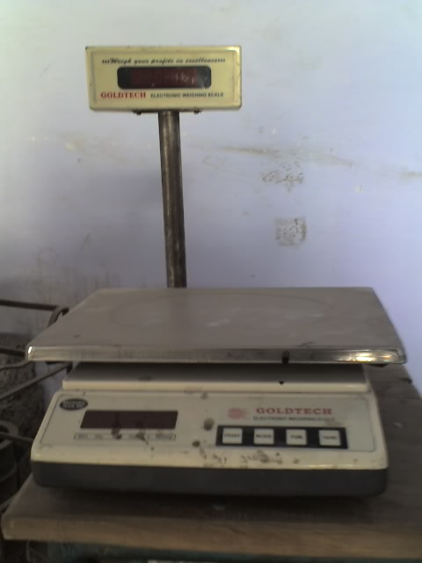
WEIGHING MACHINE

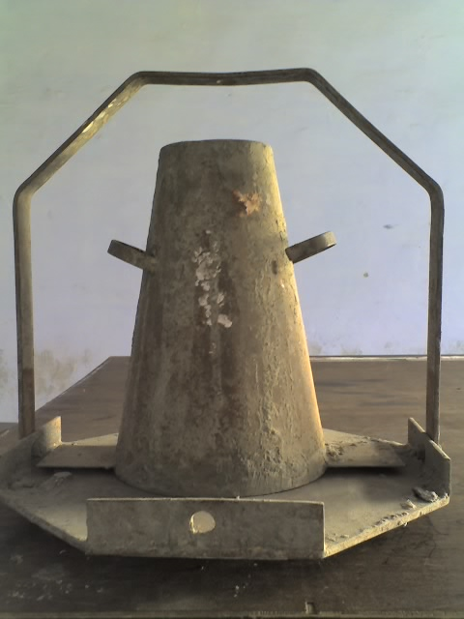
SLUMP CONE
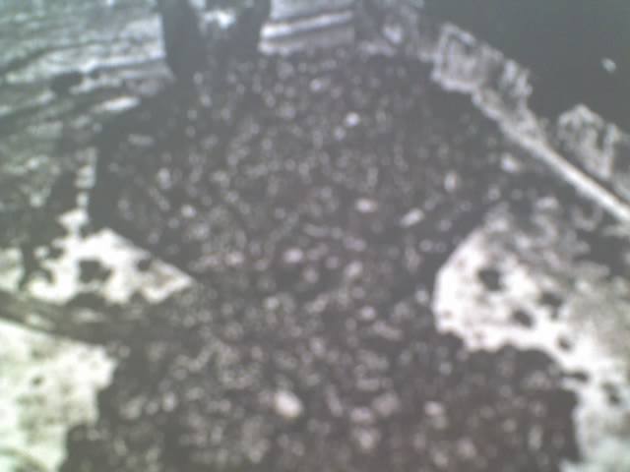
VIEW OF SLUMP

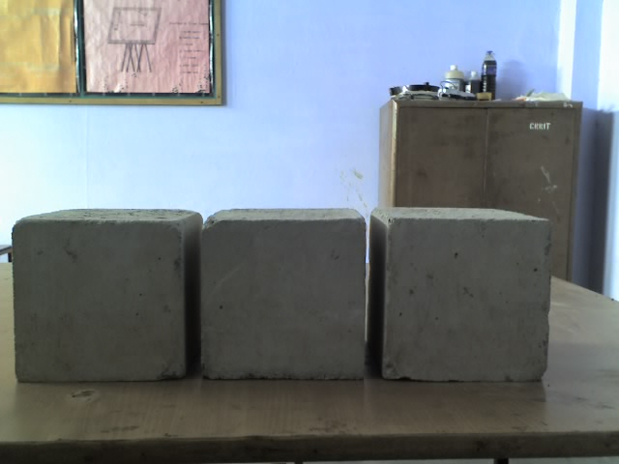
CUBES BEFORE TESTING


CURING OF CUBES

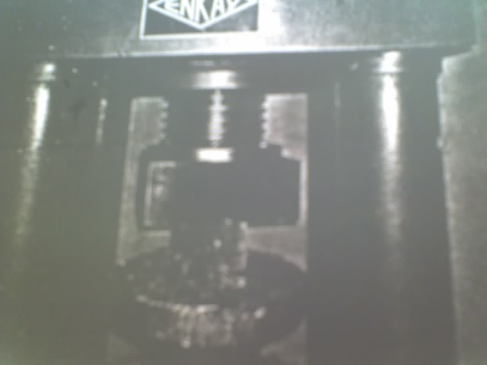
COMPRESSION TESTING MACHINE

CHAPTER SIX
PROPERTIES OF MATERIALS USED

6.1 Cement

Name of Cement used in research work with their specific gravities are as follows:

NAME OF CEMENT | SPECIFIC GRAVITY
43 Grade Binani Cement | 2.81
53 Grade Birla Faulad | 2.91
P.P.C Ambuja Cement | 3.1

6. 2 Admixtures

Name of water reducing agents used in research work are as follows:

NAME OF WRA | RECOMMENDED DOSAGE
Cemwet SP 3000 | 0.5% to 2 %
Glenium TM 51 | -do-
Dr. Fixit CF 21 | -do-

6.2.1 Cemwet SP 3000

A product of Asian Laboratories (India)

Description:
The basic component of Cemwet SP 3000 (M) are synthetic polymers with high molecular weight Naphethelene formaldehyde condensates which allows mixing water to be reduced considerably.
Cemwet SP-3000 (M) is a chloride free product having a prestigious mark of I.S:9103-99.

Primary uses
- Production of plastic self compaction concrete.
- Ready Mixed concrete.
- Low water cement ratio concrete.

Advantages:
Cemwet SP-3000 (M) makes the concrete highly flowable with low water/cement ratio. The concrete treated with Cemwet SP-3000(M) shows strength higher than concrete without admixture having the same workability.

Specialty
Cemwet SP 3000(M) can maintain slump of concrete for more than two hours especially for high C3A 53 Grade cement where normal super Plasticizer do not work.
Cemwet SP-3000(NR) satisfies ASTM C-494 Type-G at normal Dosage. However at higher Dosages it can extend setting time without effecting later date compressive strength. Due to the reduction in water/cement ratio, all the properties of hardened concrete improve significant, creep, workability & modulus of elasticity.

Compatibility:
Cemwet Sp 3000 (M) is compatible with all cements especially high C3A (>8) and high fineness. Cement (>2700 cnt/g) viz: L&T, DLF, Shree, ACC 53 Grade Cement.
Low C3A cements, Sulphate Resistant Cement, Slag cement requires smaller dosages.

Dosage:
Recommended dosage is 0.3% to 2.0% by wt. of cement.

Typical properties:
Colour : Brown free flowing liquid
Specific gravity : 1.22 + 0.020
Chloride content : Nil to BS 5075 to is 456-78
Nitrate content : Nil
Freezing point : Can be reconstituted if stirred after thawing
Air entertainment : Maximum 1.5%

6.2.2 GLENIUM TM 51
A product of Degussa Construction Chemical (INDIA)

Description;
Glenium 51 has been primarily developed for application in high performance concrete where the highest durability and performance required. Glenium 51 is compatible with all Portland cement that meet recognized international standards

Advantage
    - Increased early and ultimate compressive strength
    - Increased flexural strength
    - Higher E modulus
    - improved adhesion to reinforcing and stressing steel
    - lower permeability
    - reduced shrinkage and creep

Typical Properties
Colour : Yellowish liquid
Relative density : 1.09 + 0.01
Ph : 7 + 1
Chloride content : Nil to en934 -2

Transport : Not classified as dangerous
Labeling : No hazard label required
Standards : Astmc494 types a and f is 9103:2003

Compatibility
It must not be used in conjunction with any other admixture unless prior approval is received from DCC India technical service.
6.2.3 Dr. Fixit Pidicrete CF 21

A product of PIDILITE (INDIA)
Dr. Fixit Pidicrete CF 21 is a super platicising admixture to produce pumpable or flowable concrete with a low W/C ratio. When added to the concrete mix it gives a high slump without any bleeding or segregation in the fresh state and high early and ultimate strengths in the hardened state.

Specification
Meets the requirement of IS: 9103-1999 and ASTM-C-494-86.Type F
Area of Application

- High performance concrete for columns, beams, decks & dams
- General purpose ready mix concrete prestressed & precast concrete
- Complex & heavily, reinforced concrete Railway sleepers
- High strength & low permeable concrete
- Mass concrete

Features & Benefits
- Reduces water up to 25% without effecting the workability
- Increases workability at a given W/C ratio, easy compaction eliminates honeycombing
- Provides highly cohesive concrete mix & reduces the chance of bleeding & segregation
- Makes concrete less permeable and hence more durable
- No chloride –suitable of RCC

- Compatible with all types of Portland cement/including slag/SRC
- Helps in reducing cement content for a required strength
- High early and ultimate compressive strength concrete

Method of Application
- The correct quantity of Dr. Fixit Pidicrete CF 21 should be measured with recommended dispenser and should be thoroughly dispersed with approx 5-10% of the recommended water content (based on mix design by weight)
- Mix concrete constituents along with balance approx 90-95% of the recommended water content (based on mix design by weight)of 3 minutes
- As soon as step 2 is over, the admixture dispersed in water (as in step-1) is to be added to the wet concrete and mix it further for 2-3 minutes to get a homogeneous mix.

Precautions & Limitations
- Dr. Fixit Pidicrete CF 21 should not be added in dry mixes under any circumstances
- Keep the liquid above freezing temperature
- Overdosing may lead to delay in setting time
- Dr. Fixit Pidicrete CF 21 is non-toxic and inflammable. When in contact with the skin it can be washed with water

Technical Information
- Colour Dark Brown
- Base Sulfonated Napthalene Formaldehyde
- Sp. Gravity 1.15 + C 0.02 at 30c
- Chloride Content Nil
- Dose Up to 750 ml per 50 kg bag of cement
(Depending upon site requirements)
Packing
30 Liters & 225 Liters.

6.3 Water
Potable tap water was used for the mixing and curing of concrete.

6.4. Fine Aggregate
Yamuna Nagar sand was used as fine aggregate in mix . fine aggregate confirms to grading zone III of IS: 383-1963. Specific gravity of sand is 2.72
6.5 Coarse Aggregate
Locally available crushed stone aggregate of 20 mm nominal size was used. Specific gravity of coarse aggregate is 2.68
6.6 Size of Cubes
15 cm cubes were used for the research work. For each mix 3 cubes had been cast and their mean strength was taken for the comparisons.

CHAPTER SEVEN
MIX DESIGN AS PER INDIAN STANDARD CODE

Mix design (M35) should be according to I.S. SP -23 by Indian mix design method. The calculation work is given below.

7.1 (a) Design Stipulations
Characteristic compressive strength required in the field at 28-days | 35 N/mm²
Maximum size of aggregate | 20 mm  (Angular)
Degree of workability | 0.9  Compacting Factor
Degree of quality control | Good
Type of exposure | Moderate
Standard Deviation | 5

(b) Test Data for Materials

NAME OF CEMENT | Sp.Gravity
CEMENT O.P.C. BINANI 43 | 2.81
CEMENT O.P.C. BIRLA FOULAD 53 | 2.45
CEMENT P.P.C. AMBUJA | 3.1
Specific Gravity Of Coarse Aggregates | 2.68

(c) WATER ABSORPTION

Coarse Aggregate | 19%
Fine Aggregate | 12%

(d) FREE SURFACE MOISTURE

Coarse Aggregate | .19%
Fine Aggregate | .83%

(e) ADJUSTMENT REQUIRED

Change in condition TABLE 44 | Adjustment Required.
Change in condition TABLE 44 | Water content | % sand in Total Aggregate
For decrease in water content ratio by 0.60 - 0.33 = 0.27 | 0 | -5.4
Increase in compacting factor 0.9 - 0.8 = 0.1 | +3 | 0
For sand conforming Zone III table 4 (383 – 1970) | 0 | -1.5
Total Adjustment | +3 | -6.9

Therefore: - Required sand content as %age of total
Aggregate by absolute volume (35-6.9) = 28.1%

Required water content (186 x 106) =191.58 kg /m³
100

(f) Determination of Cement Content
Water cement ratio = 0.33
Water = 191.58 kg /m³
Cement 191.58 / 0.33 = 580.5 kg /m³
Note: Cement content limited to 450 kg /m³ according to
IS 456 -2000
So water content ( 450 x 0.33 ) = 148.5 kg/m³

(g) Determination of Coarse and Fine Aggregate

V = (W + C/Sc + 1/P. Fa/Sfa) x 1/1000 and
V = (W + C/Sc + 1/1-P .Ca/Sca) x 1/1000
Where
V = Absolute volume of fresh concrete
= Gross volume (1m³) minus the volume of entrapped air,
Sc = Specific gravity of cement,
W = mass of cement (kg) per m³ of concrete,
C = mass of cement (kg) per m³ of concrete.
P = ratio of fine aggregate to total aggregate by
Absolute volume,
Fa, Ca = total masses of fine aggregate and coarse
Aggregate, (kg) per m³ of concrete respectively,
and
Sfa , Sca = specific gravities of saturated surface dry fine aggregate
and coarse aggregate respectively.

Determination of coarse aggregate and fine aggregate (BINANI 43)
Coarse aggregate:
0.98 = (148.5 + 450/2.81 + 1/.715 x Ca /2.68) x 1/1000
Ca = 1282.3 kg /m³

Fine aggregate:
0.98 = (148.5 + 450/2.81 + 1/.285 x Fa /2.72 ) x 1/1000
Fa = 520.4 kg/m³

Mix Proportion

Water | Cement | Fine Aggregate | Coarse Aggregate
148.5 | 450 | 520.4 | 1282.3
0.33 | 1 | 1.16 | 2.85

(h) Actual quantity for one bag of cement required

Cement Sand Coarse Aggregate Water
50 kg 58 kg 142.5 kg 16.5 kg

Correction applied

Extra water needed for S.S.D coarse aggregate =142.5 x 0.19% = 270gm
Extra water needed for S.S.D fine aggregate = (0.83-0.12) x 58 = 412gm

So corrected quantity of materials are

Cement Sand Coarse Aggregate Water
50 kg 57.6 kg 142.2 kg 17.2 kg

Material required for 15kg mix
Cement Sand Coarse Aggregate Water
2.80 3.23 7.98 0.965

7.2 CALCULATION OF HRWR

The limitation of super plasticizers (2%) is divided in to four steps I.e. .5%, 1%, 1.5%, 2%.after that the quantity of super plasticizers is calculated by weight of cement

Name | DOSAGE OF  HRWR | Weight of HRWR by WT of Cement | Water required
Cemwet  Sp-3000 | 0.5%  1.0%  1.5%  2.0% | 14gm  28gm  42gm  56gm | 951gm  937gm  923gm  909gm
Glenium  0.51 | 0.5%  1.0%  1.5%  2.0% | 14gm  28gm  42gm  56gm | 951gm  937gm  923gm  909gm
Dr.fixit  Cf-21 | 0.5%  1.0%  1.5%  2.0% | 14gm  28gm  42gm  56gm | 951gm  937gm  923gm  909gm

7.3.1 Determination Of Coarse Aggregate & Fine Aggregate

BIRLA FAULAD-53

Coarse aggregate
0.98 = (148.5 + 450/2.45 + 1/.715 x Ca /2.68) x 1/1000
Ca = 1237.4 kg/m³

Fine aggregate
0.98 = (148.5 + 450/2.45 + 1/.285 x Fa /2.72) x 1/1000
Fa = 502.1 kg/m³

Mix Proportion

Water | Cement | Fine aggregate | Coarse aggregate
148.5 | 450 | 502.1 | 1237.4
0.33 | 1 | 1.12 | 2.75

Actual quantity for one bag of cement required

Cement Sand Coarse Aggregate Water
50 kg 56kg 137.5 kg 16.5 kg

Correction applied
Extra water needed for S.S.D coarse aggregate = 137.5 x 0.19% = 261gm
Extra water needed for S.S.D fine aggregate = (0.83-0.12) x 56 =3 97gm

So corrected quantity of materials are
Cement Sand Coarse Aggregate Water
50 kg 55.6 kg 137.24 kg 17.16 kg

Material required for 15kg mix
Cement Sand Coarse Aggregate Water
2.885 3.208 7.920 0.990

7.3.2CALCULATION OF HRWR
NAME | DOSAGE Of HRWR | WEIGHT OF HRWR BY WT OF CEMENT | WATER REQUIRED
CEMWET  SP-3000 | 0.5%  1.0%  1.5%  2.0% | 14gm  28gm  43gm  57gm | 976  962  947  933
GLENIUM  0.51 | 0.5%  1.0%  1.5%  2.0% | 14gm  28gm  43gm  57gm | 976  962  947  933
DR.FIXIT  CF-21 | 0.5%  1.0%  1.5%  2.0% | 14gm  28gm  43gm  57gm | 976  962  947  933

7.4.1 Determination of Coarse aggregate & Fine aggregate
(PPC AMBUJA CEMENT)

Coarse aggregate :
0.98 = (148.5 + 450/3.1 + 1/.715 x Ca /2.68) x 1/1000
Ca = 1317.78 kg/m³
Fine aggregate :
0.98 = (148.5 + 450/3.1 + 1/.285 X Fa /2.72) X 1/1000
Fa = 531.92 kg/m³
Mix Proportion :

WATER | CEMENT | FINE AGGREGATE | COARSE AGGREGATE
148.5 | 450 | 531.92 | 1317.78
0.33 | 1 | 1.182 | 2.93

Actual quantity for one bag of cement required
Cement Sand Coarse Aggregate. Water
50 kg 59.1 146.5kg 16.5 kg
Correction Applied

Extra water needed for S.S.D coarse aggregate =146.5 X0.19% = 284gm
Extra water needed for S.S.D fine aggregate = (0.83-0.12) X 59.1 = 419gm

So corrected quantity of materials are

Cement Sand Coarse Aggregate. Water
50 kg 58.68 kg 146.216 kg 17.2 kg

Material required for 15 kg mix

Cement Sand Coarse Aggregate Water
2.75kg 3.23kg 8.041 kg 0.946kg

6.4.2 CALCULATION OF HRWR

NAME | DOSAGE OF HRWR | WEIGHT OF HRWR BY WT OF CEMENT | WATER REQUIRED
Cemwet  Sp-3000 | 0.5%  1.0%  1.5%  2.0% | 13gm  27gm  41gm  55gm | 933gm  919gm  905gm  891gm
Glenium  0.51 | 0.5%  1.0%  1.5%  2.0% | 13gm  27gm  41gm  55gm | 933gm  919gm  905gm  891gm
Dr.fixit  Cf-21 | 0.5%  1.0%  1.5%  2.0% | 13gm  27gm  41gm  55gm | 933gm  919gm  905gm  891gm

CHAPTER EIGHT
LABORATORY WORK

8.1 WORKABILITY RESULTS

8.1.1 BINANI – 43

HRWR | %AGE | SLUMP VALUE
CEMWET  SP-3000 | 0.5%  1.0%  1.5%  2.0% | Nil  Nil  Nil  Nil
GLENIUM  0.51 | 0.5%  1.0%  1.5% *  2.0% | 20  50  80  water separated from the mix and rest material hardened immediately
DR.FIXIT  CF-21 | 0.5%  1.0%  1.5%  2.0% | Nil  10  20  50

Note: * Indicates casting of cubes

8.1.2 BIRLA FAULAD - 53

HRWR | %AGE | SLUMP VALUE
CEMWET  SP-3000 | 0.5%  1.0%  1.5%  2.0% | Nil  Nil  Nil  25
GLENIUM  0.51 | 0.5%  1.0%  1.5% *  2.0% * | 15  40  85  110
DR.FIXIT  CF-21 | 0.5%  1.0%  1.5%  2.0% | Nil  Nil  30  55

Note: * Indicates casting of cubes

8.1.3 AMBUJA (PPC)

HRWR | %AGE | SLUMP VALUE
CEMWET  SP-3000 | 0.5%  1.0%  1.5%  2.0% | Nil  Nil  Nil  nil
GLENIUM  0.51 | 0.5%  1.0%  1.5%  2.0% | nil  nil  25  45
DR.FIXIT  CF-21 | 0.5%  1.0%  1.5%  2.0% | Nil  Nil  10  30

8.2 COMPRESSIVE STRENGTH RESULTS

The slump required for a pumpable concrete is minimum 75 mm, so we select only those results of mix design in which a value of slump (75) as per the requirement achieved.

Sr no. | Cement | HRWR | Slump | Dosage of hrwr | Compressive  Strength  N/mm² | Average Compressive Strength
1 | Binani-43 | Glenium-0.51 | 80 | 1.5% | 31.55, 30.44, 32 | 31.33 N/mm²
2 | Birla faulad-53 | Glenium-0.51 | 85 | 1.5% | 33.4, 31.02, 35.86 | 33.42 N/mm²
3 | Birla faulad-53 | Glenium-0.51 | 110 | 2.0% | 29.7, 27.5, 26.4 | 27.86 N/mm²

From the acceptability criteria, it is found that none of these three combination not give the compressive strength as required in the study.

8.3 CONCLUSIONS

1 The mix has been designed for (M35) grade concrete. It is found that one cube of combination 2 does achieve a compressive strength higher than 35 N/mm².However the average compressive strength of all the three combination tested is less than 35N/mm².

2 The use of cemwet sp 3000 and dr. fixit with the three different type of cement used in the study, has not produced pumpable concrete, even at the highest dosage of HRWR permitted. Hence these super plasticizer have not been used further.

3 The use of Glenium 0.51 superplisticizer with Binani 43 cement and Birla Faulad 53 cement has produced pumpable concrete.

4 It has not been possible to produced pumpable concrete using PPC Ambuja cement with any of the three super plasticizers used in the study.

5 The use of 2% Glenium HRWR with Birla Faulad 53 cement reduces the compressive strength achieved when 1.5% Glenium HRWR used. The reduction is 16.6.%.

6 The use of 1.5% Glenium HRWR with Birla Faulad 53 grade cement gives a cube strength 33.42N/mm² for a slump of 85 mm.As a next step, the water cement ratio will be reduced slightly to maintain the slump at 75mm,to increase the compressive strength.

CHAPTER NINE
LABORATORY WORK FOR SUITABLE COMBINATION OF CEMENT AND SUPER PLASTICIZER

9.1 SUPER PLASTICIZER USED

Glenium 0.51 is used because this gives good slump value in previous mix design,and decides the dosage as a.5% on the basis of test result

9.2 CEMENT USED

Birla faulad 53 cement ia used because this particular cement gives good result with glenium 0.51

9.3 WATER CEMENT RATIO

Range of w/c ratio from 0.28 to0.36 is selected and the water cement ratios are 0.28,0.30,0.32,0.34,and0.36.

9.4CURING WATER TEMPERTURE

Three stages of water temperature for the research work were decides as 27ºc,40ºc and55º c.

9.5 MATERIALS REQUIRED FOR DIFFERENT W/C RATIO

Table Below Shows the Requirement Of Material For Three Cubes
(15cm X 15cm X 15cm )

W/C  RATIO | CEMENT  (KG) | FINE  AGG.(KG) | COARSE AGG.  (KG) | WATER  (KG) | GLENIUM 0.51 (GM)
0.28 | 5.5 | 6.56 | 16.32 | 1.533 | 82.5
0.30 | 5.52 | 6.52 | 16.21 | 1.658 | 82.8
0.32 | 5.56 | 6.47 | 16.12 | 1.773 | 83.4
0.34 | 5.59 | 6.42 | 16 | 1.9 | 83.8
0.36 | 5.626 | 6.38 | 15.89 | 2.02 | 84.3

CHAPTER TEN
LABORATORY WORK FOR EFFECTS OF W/C RATIO & NUMBER OF DAYS OF HOT WATER CURING

    - Fifteen cubes were cast for curing at 27⁰c temp. Three cubes were cast for each w/c ratio decided. These fifteen cubes were cured at 27⁰c for 27 days after demoulding .

Table given below shows slump and compressive strength of cubes at different w/c ratio at 27⁰c temp. for 27 days curing

W/C RATIO | SLUMP (MM) | INDIVIDUAL  COMP.STRENGTH  N/MM² | AVERAGE  COMP.STRENGTH  N/MM²
0.28 | 29 | 32.5,31.8,30.9 | 31.73
0.30 | 60 | 31.6,34.7,33.3 | 33.2
0.32 | 86 | 34,35.8,35.9, | 35.23
0.34 | 98 | 35.7,34.9,34.8 | 35.13
0.36 | 112 | 33.2,32.7,33.9 | 33.27

    - Fifteen cubes were cast for curing at 40⁰c temp. Three cubes were cast for each w/c ratio decided. These fifteen cubes were cured at 40⁰c for three days after demoulding. And then cured at 27⁰c for 24 days .

Table given below shows slump and compressive strength of cubes at different w/c ratio at 3 days 40⁰c temp. and 24 days 27⁰c temp. curing

W/C RATIO | SLUMP (MM) | INDIVIDUAL  COMP.STRENGTH  N/MM² | AVERAGE  COMP.STRENGTH  N/MM²
0.28 | 30 | 31.3,30.4,31.1 | 30.93
0.30 | 60 | 30.7,29.8,31.2 | 30.57
0.32 | 88 | 32.4,31.9,33.4 | 32.57
0.34 | 98 | 34.4,33.3,34.5 | 34.06
0.36 | 110 | 32.8,31.6,32.9 | 32.43

    - Fifteen cubes were cast for curing at 40⁰c temp. Three cubes were cast for each w/c ratio decided. These fifteen cubes were cured at 40⁰c for two days after demoulding. And then cured at 27⁰c for 25 days .

Table given below shows slump and compressive strength of cubes at different w/c ratio at 2 days 40⁰c temp. and 25 days 27⁰c temp. curing

W/C RATIO | SLUMP (MM) | INDIVIDUAL  COMP.STRENGTH  N/MM² | AVERAGE  COMP.STRENGTH  N/MM²
0.28 | 31 | 31.0,32.0,31.9 | 31.63
0.30 | 59 | 30.9,31.2,32.8 | 31.64
0.32 | 86 | 32.7,32.1,33.9 | 32.9
0.34 | 96 | 34.3,34.4,33.3 | 34
0.36 | 113 | 31.8,33,32.6 | 32.46

    - Fifteen cubes were cast for curing at 40⁰c temp. Three cubes were cast for each w/c ratio decided. These fifteen cubes were cured at 40⁰c for one days after demoulding. And then cured at 27⁰c for 26 days .

Table given below shows slump and compressive strength of cubes at different w/c ratio at 1 day 40⁰c temp. and 26 days 27⁰c temp. curing

W/C RATIO | SLUMP (MM) | INDIVIDUAL  COMP.STRENGTH  N/MM² | AVERAGE  COMP.STRENGTH  N/MM²
0.28 | 30 | 31.9,31.3,32.2 | 31.7
0.30 | 61 | 31.4,31.7,32.8 | 31.96
0.32 | 88 | 33.8,33.2,34.8 | 33.93
0.34 | 97 | 35.6,34.9,33.8 | 34.76
0.36 | 112 | 32.4,33.7,32.9 | 33

    - Fifteen cubes were cast for curing at 55⁰c temp. Three cubes were cast for each w/c ratio decided. These fifteen cubes were cured at 55⁰c for three days after demoulding. And then cured at 27⁰c for 24 days .

Table given below shows slump and compressive strength of cubes at different w/c ratio at 3 days 55⁰c temp. and 24 days 27⁰c temp. curing

W/C RATIO | SLUMP (MM) | INDIVIDUAL  COMP.STRENGTH  N/MM² | AVERAGE  COMP.STRENGTH  N/MM²
0.28 | 27 | 30.8,29.8,29.7 | 30.1
0.30 | 59 | 30.4,30,31.3 | 30.56
0.32 | 86 | 31.7,32.0,31.8 | 31.83
0.34 | 98 | 34.6,31.7,30.8 | 32.36
0.36 | 110 | 31.7,32.0,31.4 | 31.7

    - Fifteen cubes were cast for curing at 55⁰c temp. Three cubes were cast for each w/c ratio decided. These fifteen cubes were cured at 55⁰c for two days after demoulding. And then cured at 27⁰c for 25 days .

Table given below shows slump and compressive strength of cubes at different w/c ratio at 2 days 55⁰c temp. and 25 days 27⁰c temp. curing

W/C RATIO | SLUMP (MM) | INDIVIDUAL  COMP.STRENGTH  N/MM² | AVERAGE  COMP.STRENGTH  N/MM²
0.28 | 28 | 30.7,30.0,29.9 | 30.2
0.30 | 58 | 30.1,31.0,30.7 | 31.5
0.32 | 87 | 32.1,32.1,33.3 | 32.5
0.34 | 96 | 32.6,33.8,33.5 | 33.3
0.36 | 110 | 31.8,31.5,32.4 | 31.9

    - Fifteen cubes were cast for curing at 55⁰c temp. Three cubes were cast for each w/c ratio decided. These fifteen cubes were cured at 55⁰c for one days after demoulding. And then cured at 27⁰c for 26 days .

Table given below shows slump and compressive strength of cubes at different w/c ratio at 1 day 55⁰c temp. and 26 days 27⁰c temp. curing

W/C RATIO | SLUMP (MM) | INDIVIDUAL  COMP.STRENGTH  N/MM² | AVERAGE  COMP.STRENGTH  N/MM²
0.28 | 27 | 30.0,30.9,30.4 | 30.43
0.30 | 59 | 31.0,31.7,31.4 | 31.6
0.32 | 86 | 32.6,34.2,33.3 | 33.37
0.34 | 95 | 35.8,3434,34.0 | 34.73
0.36 | 110 | 31.6,33.3,32.7 | 32.53

CHAPTER ELEVEN
CONCLUSIONS

- it is known fact that hot water curing increases the early comp. strength of concrete, as reported by dudeja,gautam and kaushik. The seven days compressive sterbgth of concrete cubes cast with w/c ratio 0.35 and o.p.c cement increased 26 % at 45 0 c one day curing and 17 % at 60 o c one day curing.

- it is found that the 28 days compressive strength of concrete is maximum at 27 o c curing for a w/c ratio 0.32.

- the 28 days strength of the mix cured at 40 0 c for three days is maximum at w/c ratio 0.34, and is 3 % less than the corresponding 27o c value, as the no. of days of hot water curing are decresed, the 28 days compressive strength increases
for one day curing at 40o c the 28 days strength is only 1 % less than the corresponding 27 oc value.

- similar results have been found observed at 55 o c curing. When hot cured for 3 days there is 7.8 % reduction in strength at 2 days hot curing, the strength reduces by 5.2 %, while at one day hot water curing the strength reduction is 1.1 % only.

- it is observed that as the temp. increase the reduction in 28 days strength also increases.

- as the no. of days of hot curing increases, the reduction in strength also increases.

- it is concluded that hot water curing is advisable for one day only as the reduction in strength of 28 days strength only 1 %

CHAPTER TWELVE
REFFRENCES

- NEVILLE A.M., “Properties Of Concrete” , 4th edition, (Pearson Education ) FLTRP Building , Beijing ,Year 2004.

- SHETTY M.S , (Concrete Technology” , 5th edition ,(Dhanpat Rai And Sons ),1st floor,67/4,Madras House,Daryang ,New Delhi,Year 2000

- GAMBHIR M.L “Concrete Technology” 3rd edition (T.M.H), B-4,Sector 63,Noida, Year 1996

- SP:23-1982 “Hand Book Of Concrete Mixes”, Bureau Of Indian Standards, Manak Bhawan, Bahadur Shah Jaffar Marg,Delhi.

- IS:456-2000 “Plain And Reinforced Concrete, Code Of Practice”
Bureau Of Indian Standards, Manak Bhawan, Bahadur Shah Jaffar Marg,Delhi

- RAM CHANDERAN V.S, Malhotra V.M, JOLICOEUR S., “Super Plasticizers: Properties and Application in Concrete”, Canmet, Ottawa, Canada 1998.

- PUNEET,RAMAVTAR,VIKAS, “A study on the effect of hot water curing on compressive strength of concrete with OPC”,B.Tech D.C.E. 2006-2007

