EFFECT OF STABILIZING LENGTH IN STRAIGHT CORE ANNULAR DIFFUSER

A major project report submitted
In partial fulfillment for the requirements of the award of degree
of
Master of Engineering
In
Thermal Engineering
Submitted by
SHAILENDRA SINGH
Under the Guidance of
Dr. B. B. ARORA


Department of Mechanical Engineering
Delhi College of Engineering
University of Delhi
Session 2006-08

CANDIDATE’S DECLARATION
I hereby declare that the work which being present in the major project entitled “Effect Of Stabilizing Length In Straight Core Annular Diffuser” in the partial fulfillment for the award of degree of MASTER of ENGINEERING with specialization in “THERMAL ENGINEERING” submitted to Delhi College of Engineering, University of Delhi, is an authentic record of my own work carried out under the supervisions of Dr. B.B.ARORA, Department of Mechanical Engineering, Delhi College of Engineering, University of Delhi. I have not submitted the matter in this dissertation for the award of any other Degree or Diploma or any other purpose what so ever.

SHAILENDRA SINGH
University Roll No: 10238
College Roll No. 11-THR-2006

*******************************************************
CERTIFICATE
This is to certify that the above statement made by SHAILENDRA SINGH is true to the best of my knowledge and belief.

Dr. B. B. ARORA
Assistant Professor
Department of Mechanical Engineering
Delhi College of Engineering, Delhi

ACKNOWLEDGEMENT
Sometime words are poor substitute in expressing one’s feeling, but eventually they are the only means for expressing oneself.
It is distinct pleasure to express my deep sense of gratitude and indebtedness to my learned supervisor Dr. B. B. ARORA, Assistant Professor, Department of Mechanical Engineering, Delhi College of Engineering (DCE), for their invaluable guidance, encouragement and patient review. His continuous inspiration only has made me complete this major project.
I would also like to take this opportunity to present my sincere regards to my teachers and HOD Prof. S. Maji for their kind support and encouragement. I am thankful to my friends and classmates for their unconditional support and motivation for this major project.

.

SHAILENDRA SINGH
University Roll No. 10238
College Roll No. 11-THR-06

ABSTRACT

A diffuser is a device for converting the kinetic energy of an incoming fluid into pressure. As the flow proceeds through the diffuser there is continuous retardation of the flow resulting in conversion of kinetic energy into pressure energy. Such a process is termed as diffusion. Diffuser forms an important part in flow machinery and structures. The present study involves the CFD analysis for the prediction of flow characteristics using various mathematical models. The straight core annular diffuser considered in the present case has increasing stabilizing length at different divergence angle and area ratio. The flow patterns have been presented for studying at stabilizing length d and 3d for different divergence angles.

TABLE OF CONTENTS
Candidate’s Declaration
Acknowledgement
Abstract
Table of Contents
List of Figures
Nomenclature
1. INTRODUCTION
1.1 Type of Diffusers
1.1.1 Axial Diffuser
1.2 Diffuser Study
1.3 Performance Parameters
1.3.1 Static Pressure Recovery Coefficient
1.3.2 Diffuser Effectiveness
1.3.3 Total Pressure Loss Coefficient
2. LITERATURE REVIEW
2.1 Geometric Parameter
2.1.1 Effect of Geometric Parameters 2.1.2 Passage Divergence and Length
2.1.3 Wall Contouring
2.2 Effects of Flow Parameters
2.2.1 Aerodynamic Blockage
2.2.2 Inlet Swirl
2.2.3 Inlet Turbulence
2.2.4 Mach Number Influence
2.2.5 Reynolds Number Influence
2.3 Boundary Layer Parameter
2.3.1 Boundary Layer Suction
2.3.2 Blowing and Injection
3. MATHEMATICAL FORMULATION
3.1 Conservation principals
3.1.1 Mass Conservation Equation (Continuity Equation)
3.1.2 Momentum Conservation Equations
3.2 TURBULENCE MODELLING
3.2.1 Choosing a Turbulence Model
3.3 The Standard, RNG, and Realizable k- ε Models
3.3.1 The Standard k-ε Model
3.3.2 Transport Equations for the Standard k-ε Model
3.3.3 Modeling the Turbulent Viscosity
3.3.4 The model constants
3.3.5 The RNG k-ε Model
3.3.6 Transport Equations for the RNG k-ε Model
3.3.7 Modeling the Effective Viscosity
3.3.8 The Realizable k-ε Model
3.3.9 Transport Equations for the Realizable k-ε Model
3.3.10 Modeling the Turbulent Viscosity
3.3.11 Model Constants
3.4 Turbulence Modeling in Swirling Flows

4. CFD ANALYSIS
4.1 Program Capabilities
4.2 Planning CFD Analysis
4.2.1 Definition of the Modeling Goals:
4.2.2 Grid Generation and its Independence:
4.2.3 Choice of the Computational Model:
4.2.4 Choice of Physical Models:
4.2.5 Determination of the Solution Procedure:
4.3 Discretization
4.4 Convergence Criteria 4.5 Implementation of boundary conditions
4.5.1 Inlet boundary condition 4.5.2 Outlet boundary condition
4.5.3 Wall boundary condition
4.6 Simulation Procedure

5. RESULT AND DISCUSSION
6. CONCLUSION AND FUTURE WORK
REFERENCES
APPENDIX
LIST OF FIGURES

Figure 1-12 Longitudinal velocity graph Figure 13-24 Pressure Coefficient Graph
Figure 25-30 Colour Contours of Velocity and Pressure

NOMENCLATURE

A Area
AR Area ratio
B blockage factor
C Constants
C_{P} Pressure recovery co-efficient
C_{PI} Ideal pressure recovery co-efficient
D Diameter
G generation of turbulence kinetic energy
g acceleration due to gravity
K Total pressure loss co-efficient
k Turbulent kinetic energy
P Static pressure
P_{t} Total pressure
Re Reynolds number
S Swirl Number of flow
S_{m} Mass added
U Velocity
w Swirl velocity
x,y,z Cartesian coordinate system
Y_{M} fluctuating dilatation in compressible turbulence.
SYMBOLS

$\bar{\bar{τ}}$ Stress tensor
µ Laminar viscosity
µ_{t} Turbulent viscosity
2θ Equivalent cone angle
Γ Circulation
ε Turbulent kinetic energy dissipation rate
η Diffuser effectiveness
θ Wall angle
ν Kinematics viscosity
ξ Total pressure loss co-efficient
ρ Density
Σ Turbulent Prandtl no.

SUBSCRIPT

B Blocked
ci casing inlet
co casing outlet
E Effiective
eq Equivalent flow
hi hub inlet
ho hub outlet
in inlet
m maximum
out outlet
r radial direction
t tangential direction
x longitudinal direction
INTRODUCTION Chapter 1

Diffusers are one of the standard challenges in fluid mechanics. The task of a diffuser is to decelerate the flow and to regain total pressure. It is more difficult to arrange for an efficient deceleration of flow than it is to obtain an efficient acceleration.
Diffusers play a vital role in many fluid machines to convert kinetic energy into pressure energy. The efficiency of this conversion process is important as it affects the overall performance of the machine. The pressure recovery, which is the measure of performance of diffusers, depends on many geometrical and dynamical parameters. Some geometrical parameters that govern the performance of a diffuser are inlet length and size of the duct, area ratio of the diffuser, angle of expansion, length of the diffuser, shape of the exit duct with free or submerged discharge conditions, etc. The dynamical parameters are inlet velocity profile, boundary layer parameters, Reynolds number, Mach number and so on. In the present work, two parameters namely inlet velocity profile and the geometry of the diffuser were selected in order to study their effects on the flow structure and performance of annular diffusers. Swirling flow in the diffuser plays an important role in controlling the flow separation and therefore the performance of the diffuser. Consequently, increased attention is being paid to the prediction of the swirling flow characteristics in the diffuser in order to optimize design. It has been realized that flows in the annular diffusers are strongly dependent on the geometries of the inlet and outlet conditions.
Diffusers are extensively used in centrifugal compressors, axial flow compressors, ram jets, combustion chambers, inlet portions of jet engines etc. The energy transfer in these turbo machineries involves the exchange of significant levels of kinetic energy in order to accomplish the intended purpose. As a consequence, very large levels of residual kinetic energy frequently accompany the work input and work extraction processes, sometime as much as 50% of the total energy transferred. A small change in pressure recovery can increases the efficiency significantly. Therefore diffusers are absolutely essential for good turbo machinery performance.

1.1 TYPE OF DIFFUSERS
1.1.1 Axial Diffuser – In axial diffusers, fluid flows along the axis of diffusers and there is continuous retardation of the flow. Axial diffuser is divided in to the following categories-
• Conical diffuser
• Channel diffuser
• Annular diffuser
The basic geometric parameters for these type of diffusers are as follows:
For conical diffuser-
Non dimensional length, L/W₁
Aspect ratio, AS = b/W₁
Area ratio, AR = A₂/A₁
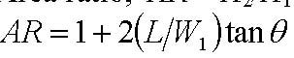

For channel diffuser- Non dimensional length, L/D₁
Area ratio, AR = A₂/A₁
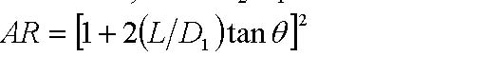
For annular diffuser- Non-dimensional length, L/∆r or L/h
Area ratio, AR = A₂/A₁
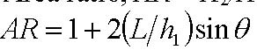 (For equiangular case)
1.2 DIFFUSER STUDY
A survey of diffuser research has revealed that considerably more investigations have been carried out on two dimensional and conical diffusers. Much of the extent data covering annular diffusers was done in the experimental laboratory Stafford and James [1957]. But, the annular diffusers have a very strong industrial significance and have received attention in recent years. These types of diffuser are very much used in aircraft applications. With the help of annular diffuser the maximum presser recovery is achieved within the shortest possible length. With annular diffuser, good performance is possible with large wall angles since an inner surface is present to guide the flow radially outward. The annular diffuser affords the possibility of introducing many different geometric combinations since there is now an inner surface that can be varied independently of the outer surface. It is more difficult to define the essential geometric parameters for annular diffusers since the numbers of independent variables are large Goebel and Japikse [1981]. The essential variables to define the geometry of annular diffuser are two wall angles, area ratio, non-dimensional length and inlet radius ratio. As the number of variables increases, geometry becomes more complex. This has not been economically possible by experiments and hence led to the development of computational fluid dynamic methods to analyze the performance characteristics of annular diffuser Arora, Pathak and Singh [2005]. The present study investigates the unequal angle type of annular diffuser. In these types of annular diffusers both hub and casing are diverging outward with different angle of divergence. Hub angle is kept constant at 5°.

1.3 PERFORMANCE PARAMETERS
Performance parameters are very helpful in designing and predicting the performance of diffusers. These parameters reveal that diffuser geometry will give the desire output or not. The following parameters are important to find out diffuser performance.
1.3.1 Static Pressure Recovery Coefficient –
The pressure recovery coefficient of a diffuser is most frequently defined as the static pressure rise through the diffuser divided by the inlet dynamic head.
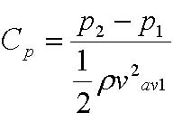
Where subscripts 1 and 2 refers to diffuser inlet and outlet conditions respectively. v_{av1} represents the average velocity at the inlet. An ideal pressure recovery can be defined if the flow is assumed to be isentropic. Then, by employing the conservation of mass, this relation can be converted to an area ratio for incompressible flow.
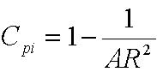

1.3.2 Diffuser Effectiveness –
The diffuser effectiveness is simply the relation between the actual recovery and the ideal pressure recovery.
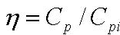
This is an excellent parameter for judging the probable level of performance when it is necessary to estimate the expected performance under unknown conditions, relative to available data.

1.3.3 Total Pressure Loss Coefficient –
The total pressure loss coefficient reflects the efficiency of diffusion and drag of the system. The most common definition of loss coefficient is as the ratio of total pressure rise to the diffuser inlet dynamic head.
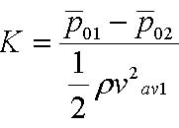
Where is the total pressure in the core region at the exit, the over bar indicate the mass averaged quantity, and 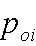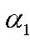 and 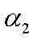 are the kinetic energy parameters at the inlet and exit of the diffuser.
For the case where the velocity profile at the inlet of diffuser is flat with a thin wall boundary layer,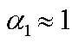 . However, due to the thickening of boundary layer through the diffuser, 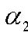 is generally greater than unity. Nonetheless, it is often assumed that kinetic energy coefficient are equal to unity, than
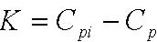
Since flow in diffusers are subjected to an adverse pressure gradient there is a potential danger for flow separation to occur which could lead to loss in performance as well as damage of downstream equipment. The aim of design is to keep the adverse pressure gradient as high as possible, but below a critical limit, by controlling the length versus area-ratio of the diffuser.
The design requirements for a good diffuser are as following-
1. Convey the flow efficiently transferring a portion of the kinetic energy into a static pressure rise.
2. It must accept a variety of inlet conditions including extreme swirl, blockage and Mach number.
3. Deliver the fluid with reasonable velocity and angle profiles without separated regions.
4. Wall curvature must not have a deleterious effect upon passage performance.
5. Pressure recovery achieved over a short axial length.
While obtaining the best possible design, some limitations are imposed on a diffuser.
1. Limited length
2. Specified area ratio
3. Specified cross- sectional shape
4. Maximum static pressure recovery
5. Minimum stagnation pressure loss
It is not hard to appreciate that the performance of the diffuser directly and often strongly influences the overall efficiency of the turbo machine. Thus the detailed processes which occur in diffusing elements must be carefully understood and thoroughly optimized if good turbo machinery performance is to be obtained

CHAPTER-2 Literature Review
Flow through a diffuser is accompanied by reduction of mean kinetic energy and a consequent increase in pressure. It is more difficult to arrange for an efficient deceleration of flow than it is to obtain an efficient acceleration. There is a natural tendency in a diffusing process for the flow to break away from the walls of the diverging passage, reverse its direction, and flow back in direction of the pressure gradient. If the divergence is too rapid, this may result in the formation of eddies with consequent transfer of some kinetic energy into internal energy and a reduction in useful pressure rise. A small angle of divergence, however, implies a long diffuser and a high value of skin friction loss. Usually, flow separation in a diffuser is sought to be avoided due to the invoked additional pressure loss. Other than in many strongly separated flows, such as the flow over a backward facing step, the point of flow separation, in diffuser, is not defined by the geometry but entirely by the pressure gradient. Hence, diffuser flows are very sensitive and are difficult to predict with numerical means. Diffusers have been studied extensively in the past, since this is a very common flow configuration. Apart from the characterization of diffusers, these flows are used to study fundamental physics of pressure-driven flow separations.
Much of the extant data covering annular diffusers comes from the period from the 1950s through the 1980s. In this period of time, a considerable amount of research was done in the experimental laboratory to uncover some of the unusual performance characteristics of annular diffusers. By the late 1980s, however, the experimental research had reduced substantially due to a lack of government funding in a number of countries where the work had previously been extensive. It is, therefore, useful to review the data which has been made available and to look for patterns within this data. It is also necessary to determine how this data may best be used in future design studies and where it needs to be further improved. Much of the original data was taken in order to support studies of axial compressor discharge diffusion as flow leaves a compressor and enters a combustion chamber. Other work was done for exhaust diffusers of hydroelectric turbines, small gas turbines, and turbochargers. While these topics are still important today and there are important unresolved questions, the level of activity has reduced. Now important research topics must be carefully selected for the more limited studies possible in future years.
Many persons have done a lot of tests on geometric parameter of diffuser Sovran and Klomp [1967] who tested over one hundred different geometries, nearly all of which had conically diverging centre bodies with an inlet radius ratio [Ri/Ro] of 0.55 to 0.70. The tests were carried out with a thin inlet boundary layer and the diffusers have free discharge. The tests were present as Contours of pressure recovery plotted against area ratio and non-dimensional length Howard et al [1967] also tested symmetrical annular diffusers with centre bodies of uniform diameter, using fully developed flow at inlet. The limits of the various flow regimes and the optimum performance lines were established. Besides it, some other researchers also contributed in the field of annular diffuser and concluded various important results. Much of the extent data covering the annular diffusers was done in the experimental laboratory to uncover some of the unusual performance characteristics of annular diffusers. But there are still some important unresolved questions. The reason for it is that the numbers of independent variables are large for annular diffusers. In the annular diffuser the flow take place between two boundary surfaces which can varies independently This chapter involves a systematic study of different geometric and flow parameters which influence the overall and internal performance of annular diffusers. In this regard the available literature has been examined with a view to make comments on the state of the art and to recognize the scope of further research on the subject.
2.1Geometric parameters
Any diffuser geometry with increasing area in the stream wise direction constitutes subsonic diffuser geometry .therefore, the number of different diffusers geometries that can be conceived in infinite .however in practice adequate design data are available for limited numbers of geometries.
- Rectangular cross section plan diffusers
- Conical diffuser
- Annular diffuser
These geometric parameters can be consolidated to few non dimensional parameters that are found to be important in terms of diffuser performance. The first is area ratio, AR the area ratio of diffuser exit to inlet areas .the area ratio is measure of theoretical diffusion of pressure recovery expected.
The second important parameter is the dimensionless diffuser length is define as N/Wi or L/Wi for planar diffusers, and L/ (Rit-Rih), for annular diffusers.
The third geometric parameter commonly used in displaying diffuser performance is the wall divergence angle 2ɵ for planar and conical diffusers.
Area ratio and non dimensional length tells the overall diffusion and pressure gradient respectively, which is the main factor in boundary layer development. Paterson Cockrell and Markland [1986] found that a variation in the AR from 2.5 to 8.0 has a small effect on the loss coefficients of the 2-D diffuser. Sharan[1972] reported that for a constant AR the performance of diffuser deteriorates with the increase in diffusion angle. Reneau et al [1967] concluded that for two dimensional straight diffusers the maximum pressure recovery at a constant area ratio occurs in the range of diffuser angle equal to 6-8deg.

2.1.1Effect of Geometric Parameters
In an annular diffuser, a number of different geometric variables can influence the variation of pressure recovery and inlet condition of flow. The basic equations of motion reveal the importance of both geometric and aerodynamic parameters on the ultimate performance of annular diffuser. The specification of a wide variety of geometric parameters is essential before the performance of diffuser is given. In this section, the various geometric parameters and there influence on diffuser performance is reviewed. Effect of geometry on the performance of annular diffuser governs by Arora B.B., Pathak B.D. [2005]. Numerical analysis of the impact of conical diffuser geometry change on velocity distribution in its outlet cross-section by Krystyna prync-skotniczny [2006]. Correlation of annular diffuser performance with geometry, swirl and blockage is given by Japikse Dr. David [2003].
2.1.2Passage Divergence and Length
Area ratio and non-dimension length prescribes the overall diffusion and pressure–gradient respectively, which is the principle factor in boundary layer development. The study by Henry and Wood [1958] is useful to understand the subsonic annular diffuser. Two diffusers with area ratio 2.1 and divergence of 5º and 10º were tested at various Mach number. It found by this study that most of data clusters around a line of constant Effectiveness. It is also observed that the inner wall is being starved of fluid. If a higher divergence had been used, then one might anticipate stall on the inner surface. An extensive study is carried out by Kmonicek and Hibs [1974] in which, the pressure loss coefficient is found out on the basis of the work of compression required to meet the static pressure rise, the results are very interesting but difficult to understand due to use of unconventional terminology
Sovran and Klomp [1967] and Howard et al. [1967] produced the first widely used annular diffuser maps for channel diffusers. Sovran and Klomp conducted a large number of performance measurements which spanned a broad selection of geometric types of diffusers. The map is only a broad representation of the bulk of configurations tested in the vicinity of their best performance areas. The poorer diffusers are not well defined by the map. These maps also show optimal diffuser geometrics under different conditions and two optimum lines are established. The same results were found out by Howard et al [1967]. The important difference between this and the Sovran and Klomp [1967] map was that the latter was made for very low inlet aerodynamic blockage whereas the former study was carried out for fully developed inlet profiles, implying high aerodynamic blockage Along the line of peak recovery there is fairly good agreement between the two maps but in the region of heavy transitory stall the maps disagree substantially.
Johnston [1959] and Johnston [1953] reported a study of four different annular diffusers. Three of the four agree tolerably well with the basics Sovran and Klomp [1967] map, one of them disagree substantially; the case a strong disagreement is probably in stall. Srinath [1968] studied four equiangular annular diffuser with 2θ = 7º, 10º, 15º and 20º respectively. Tests were reported with a variety of L/Δr values. An extensive study of diffusers which, although annular, begin with a circular cross section was reported by Ishikawa and Nakamura [1989]. The author found that the performance of the diffuser differed significantly depending on whether it is parallel or diverging for L/r1 greater than about 2. When both types have the same non dimensional length and area ratio, the parallel diffuser has the higher CP. The lines of optimum performance are also drawn. Ishikawa and Nakamura [1989], also attempted to compare their results with those of Sovran and Klomp[1967], for a conventional annular diffuser for the same wall length and area ratio, their diffuser was superior, but since the inlet conditions were different in the two studies, this conclusion is only tentative. It was also found that the addition of a conical centre body improves the performance of simple conical diffusers with appreciable or large stall. The study carried out by Moller [1965], who designed an axial to radial band with the intention of eliminating diffusion in the inlet region; found that the peak pressure recovery for the entire band and radial diffuser sections was 0.88 and 0.82 for the low blockage and high blockage cases, respectively. Cockrell and Markland [1963], reported that a variation in the area ratio from 2.5 to 8.0 has a small effect on the loss coefficients of conical diffusers.
2.1.3Wall Contouring
Several annular diffuser studies have been published in which contoured walls were an essential part of the design problem. Thayer [1971], reported that curved wall diffusers had pressure recovery as high as 0.61 to 0.65 for an area ratio of 2.15. An extensive study by Stevens and Williams [1980], reported that for curved wall diffuser, good pressure recovery was found for a loss significantly below the level which would be expected from pressure recovery loss correlation , but pressure recovery values were lower then those which would be expected from the Sovran and Klomp [1967], map. Upon careful examination, it was determined that the boundary layers in this diffuser are different from those which would be expected in most diffuser studies. Takehira et al [1977], presented extensive data for a large set of both straight annular diffusers and curved wall diffusers, and determined that the use of strong curvature at the exit of diffuser was not debilitating but did produce a penalty compared to no curved diffusers or diffusers with curvature at the inlet.
An additional study by Japikse [2000] shows that wall contouring is an important parameter regarding pressure recovery. Adkins et al [1983], tested an annular diffuser of constant outer radius and a conical centre body with cones of different angles. In general the pressure recovery increases with decreasing cone angle for various area ratios, but the 132º and sometimes the 45º-cone angle produced lower pressure recoveries than an equivalent sudden expansion. This was attributed to a large and rapid separation at the base of the cone where the diffuser starts. Adding a radius to the base of the cone so that it smoothly blended into the upstream hub, was found to improve the performance.
2.2Effects of Flow Parameters
2.2.1Aerodynamic Blockage
The basic boundary layer equations reveal the importance of the displacement thickness as a characteristic length scale of the inlet boundary layer flow .Startford and Tubbs [1965] and (evidently ) Bragg recognized the importance of the boundary layer displacement thickness to pressure recovery process .it is clear that thin inlet boundary layer should be beneficial to high diffuser recovery and that longer diffusers are necessary to achieve high level of recovery as the inlet boundary thickness increases. Thayer [1971], reported that curved wall diffusers had pressure recovery as high as 0.61 to 0.65 for an area ratio of 2.15. An extensive study by Stevens and Williams [1980], reported that for curved wall diffuser, good pressure recovery was found for a loss significantly below the level which would be expected from pressure recovery loss correlation , but pressure recovery values were lower then those which would be expected from the Sovran and Klomp [1967],map. Klein [1995] compared Stevens and Williams [1980] data with the result of Sovern and Klomp[1967] for an inlet blockage of .02 and with predictions using the latter’s method for diffuser performance fat larger blockages. A comprehensive study on the influence of aerodynamic blockage on annular diffuser performance cariedout by Globel and Japikse [1981].similar measurements were made at 20º and 40º of inlet swirl. In all cases the data trend was in the direction of reduced pressure recovery for increased aerodynamic blockage. Upon careful examination, it was determined that the boundary layers in this diffuser are different.Mazumdar P.M. et,al [2003] done aerodynamic design optimization at cased. . First, the influence of inlet conditions
On annular diffuser performance is more complicated than for channel and conical diffuser. In this case, both the hub and casing surfaces can develop boundary layers with significantly different histories. The two differing boundary layers will experience different growth processes as they pass through the diffuser. Furthermore, blockage on one wall has the effect of modifying the effective flow area and hence the core flow velocity, thereby influencing the growth of the boundary layer on the opposite wall. Hence complex interactions can develop within the diffuser.
2.2.2Inlet Swirl
The method of swirl generation can itself influence the performance of an annular diffuser and, therefore, consideration must be given first to this question. Most investigators have chosen to generate swirled in a radial inflow plane in order to take advantage of the simple cascade design geometry. Others have preferred to use axial cascade which have the advantage that they more closely simulate specific turbo machinery flow condition and permit control of the spacing between the diffuser and the vanes in form that may be more typical of an actual turbo machine. On the other hand axial cascade invariably introduces tip and hub leakage since the cascades are of a variable geometry type, an effective sealing is impossible. In addition to inlet swirl, there may be changes in inlet turbulence intensity, velocity or total pressure gradients, vorticity or wake shading, and inlet aerodynamic blockage may change indirectly as a function of the swirl angle as it is varied. In order for firm conclusion to be drawn, the effect of swirl variation must be deciphered from the performance data Divehi and Kartavenko [1975] also reported by the same type of study that the best performance can be achieved between the ranges of 10º to 20º of inlet swirl angle. A study is presented by Japikse and Pamprreen [1979] of an exhaust diffuser and hood found that substantial recovery has been achieved even up to swirl angle in excess of 40º.
Steenbergen W. J. Voskamp [1998] The rate of decay of swirl in turbulent pipe flow
He found that on increase of swirl number the rate of increase.Guo It seems that higher swirl level require fine grid. Numerical Investigation of Swirling Flow in Annular Diffusers With a Rotating Hub Installed at the Exit of Hydraulic Machines is done by Kochevsky A.N. [2000] Numerical investigation of swirl flow on conical diffuser was done by the Walter Gyllenram et, al [2004] . Najafi A.F. [2005] have done Numerical analysis of turbulent swirling decay pipe flow The flow characteristics through a rotating honeycomb and resulting downstream swirling decay flow through a fixed pipe have been investigated in this research. The modeling of the rotating honeycomb is observed to be of major importance for the prediction of the downstream flow. Several methods are used and tested. The flow field properties obtained by the honeycomb tubes which are the annular cylinders in our axi-symmetric computations have a considerable effect on the downstream flow. Ogor Buntiæ et al, [2006] give the An Adaptive Turbulence Model for Swirling Flow.

2.2.3Inlet Turbulence
With long approach pipes diffuser performance rises as approach length increases. This was first noted in the Cockrell and Markland [1963] and attributed this to changes in turbulence which enhances mixing transverse to flow directions, thus reducing the distortions. Indeed, the core turbulence intensity of developing pipe flow rises significantly from La /D is equal to 20 to 45 and than remains nearly constant. Two studies have been published which considered variation in inlet turbulence intensity or structure for there impact on annular diffuser performance. The data of Coladieiepro et al [1974] have included both low and high inlet turbulence intensity levels, and this may be explanation for the unusual measurements observed at different blockage. The second study is the work of Williams and Stevens [1969] and Stevens and Fry (1973), which showed that substantial improvements in radial momentum transport were achieved by turbulence producing grids and wall spoilers. Additional results by Hestermann et al [1995], and Klein [1995] also show that increasing the level of turbulence to 6 – 8.5 % is beneficial in increasing the pressure recovery and, in one case of removing the separation of stalled diffuser. Ubertini and Desideri [2000] determined the flow development in terms of the mean and fluctuating components of the velocity and turbulence dissipating eddy length scales in annular exhaust diffuser.The K-ε and other turbulent models are evaluated with respect to their applicability in swirling flows by Arora.B.B. et.al[2005] In most of the past numerical simulations, swirling air is introduced around this, in most cases perpendicular to the axis. In this configuration, it is straightforward to specify the inlet velocity profiles Ogor Buntiæ et al, [2006]give the An Adaptive Turbulence Model for Swirling Flow . Leschziner M.A.[2004] had hdone modelling turbulent separated flow in the context of aerodynamic applications. Bajcar Tom et, al [2006] Heat transfer influenced by turbulent airflow inside an axially rotating diffuser. Tornblom Olle[2006] give an Experimental and computational studies of turbulent separating internal flows The experimental investigation of the mean flow and turbulence properties revealed a flow with several interesting characteristics: strong and suddenly imposed shearing, non-equilibrium turbulence, separation, reattachment and turbulence relaxation. The conclusion of above study is that the effect of increasing inlet turbulence intensity is to increase pressure recovery.
2.2.4Mach number Influence
Most annular diffuser research has been carried out at low inlet mach numbers. However, several studies have shown measurement at different Mach number. The study by Thayer [1971], Wood and Henry [1958] and Japikse and Pampreen [1979] illustrate virtual independence of recovery with Mach number up to some critical level of approximately 0.80 to 1.1. The actual level depends on method of measurement and the type of inlet. Wood and Henry [1971] show that a shock structure must be presented before the performance begins to deteriorate, but the reference Mach number may have little to do with the actual shock location and shock structure. In most cases, the reduction of performance with Mach number is very slight but in a few cases there can be a degradation of five or ten point of performance recovery.
2.2.5Reynolds Number Influence
Viscosity is an important parameter in any fluid dynamic process and normally appears in the form of a Reynolds number. Typically, diffusers are characterized by a Reynolds number based on an inlet hydraulic diameter. All studies reported that the Reynolds number is a comparatively weak parameter as long as the flow is in the fully turbulent regime. Crockrell and Markland [1963] state that a variation of the inlet Reynolds number has no significant effect on the diffuser performance if this variation is uncoupled from its effects on the inlet boundary layer parameters. For Reynolds number variation within the range of 2×10⁴–7×10⁵, they also pointed out that the diffuser performance would be practically independent of Reynolds number provided the inlet boundary parameters remain constant. Sharan [1972] reported that for thick boundary layers, there is no change in pressure recovery as the Reynolds number increases.
2.3Boundary Layer Parameter
The flow in diffuser is governed by the behavior of the boundary layers at the diffuser walls. The deceleration of the flow through the diffuser produces a pressure rise in the stream wise direction. The wall shear layers are therefore subjected to a positive or adverse pressure gradient. As is well known, an adverse pressure gradients cause the wall boundary layers to thicken and possibly separate from the diffuser walls, forming areas of backflow in the diffuser. The net result of thinking of the wall boundary layers or the formation of regions of backflow is the blockage of flow area which reduces the effective area available to the flow. Reduction in effective flow area in turn results in a reduced pressure rise through the diffuser.
2.3.1Boundary Layer Suction
The effect of suction consists in the removal of decelerated fluid particles from the boundary layer before they are given a chance to cause separation. Wilbur and Higginbotham [1957] investigated the suction phenomenon and found that a suction flow rate of 2.3% increased the static pressure rise by 25 – 60% and decreased the measured total pressure loss by 63%. In another study by Wilbur and Higginbotham [1955], it is shown that suction control is not efficient when applied in an extensive backflow region such as exists immediately downstream of an abruptly turned body. Experiments by Juhasz [1974], on short annular diffuser showed that the diffuser exit profiles could be shifted either towards the hub or towards the casing of annulus by bleeding off a small fraction of the flow through the inner and outer wall respectively. Boundary Layer Suction is also adopted by Ackert [1967], for both channel and conical diffuser with large divergence angle.
2.3.2Blowing and Injection
Wilbur and Higginbotham [1955], found that at an injection rate of 3.4%, a 33% increases in the measured static pressure rise and a 50% decrease in the measured total pressure loss can be obtained. Juhasz [1974], have reported results of their investigations on the effect of injecting secondary fluid into wild angle conical diffusers through annular slot at inlet. Injection was found to result in considerable improvement in the uniformity of exit flow as well as in the magnitude of pressure recovery.

Mathematical Modelling CHAPTER 3

The present study involves various models and basic laws of fluid mechanics to attain the results. FLUENT provides comprehensive modeling capabilities for a wide range of incompressible laminar and turbulent fluid problems. In FLUENT, a broad range of mathematical models for transport phenomena (like heat transfer swirl and chemical reactions) is combined with the ability to model complex geometries. The range of problems that can be addressed is very wide. The turbulence models provided have broad range of applicability without the need for fine tuning to a specific application.

FLUENT uses four equations to simulate a 2-D flow problem in addition to the turbulence modelling equations. These four equations are:

- Conservation Principle
  - Momentum equation
  - Continuity equation
- Velocity Equations
  - X- velocity equation
  - Y- velocity equation

3.1 Conservation principals
Conservation laws can be derived considering a given quantity of matter or control mass and its extensive properties, such as mass, momentum and energy. This approach is used to study the dynamics of solid bodies. In fluid flows, however it is difficult to follow a parcel of matter. It is more convenient to deal with the flow within a certain spatial region we call a control volume, rather than a parcel of matter, which quickly passes through the region of interest. For all fluid flows the two extensive properties mass and momentum are solved. Flows involving heat and mass transfer or compressibility, an additional equation of energy conservation are solved. Additional flow transport equations are solved when the flow is turbulent.

3.1.1 Mass Conservation Equation (Continuity Equation)
The equation for conservation of mass, or continuity equation, can be written as follows:
Equation is the general form of the mass conservation equation and is valid for incompressible as well as compressible flows. The source S_{m} is the mass added to the continuous phase from the dispersed second phase (e.g., due to vaporization of liquid droplets) and any user-defined sources.
For 2D ax symmetric geometries, the continuity equation is given by
Where x is the axial coordinate, r is the radial coordinate, v_{x} is the axial velocity, and v_{r} is the radial velocity.

3.1.2 Momentum Conservation Equations
Conservation of momentum in an inertial (non-accelerating) reference frame
where p is the static pressure, τ is the stress tensor (described below), and ρg and F are the gravitational body force and external body forces (e.g., that arise from interaction with the dispersed phase), respectively. F also contains other model-dependent source terms such as porous-media and user-defined sources.
The stress tensor τ is given by
$$\overline{\overline{τ}}=μ\left[\left(∇\vec{v}+∇\vec{v^{T}}\right)−\frac{2}{3}∇⋅\vec{v}I\right]$$
Where µ is the molecular viscosity, I is the unit tensor, and the second term on the right hand side is the effect of volume dilation.

For 2D axisymmetric geometries, the axial and radial momentum conservation equations are given by
and

where
$$∇⋅\vec{v}=\frac{∂v_{x}}{∂x}+\frac{∂v_{r}}{∂r}+\frac{v_{z}}{r}$$
and $v_{z}$is the swirl velocity

The tangential momentum equation for 2D swirling flows may be written as
3.2 TURBULENCE MODELLING
Turbulent flows are characterized by fluctuating velocity fields. These fluctuations mix with transported quantities such as momentum, energy, and species concentration, and cause the transported quantities to fluctuate as well. Since these fluctuations can be of small scale and high frequency, they are too computationally expensive to simulate directly in practical engineering calculations. Instead, the instantaneous (exact) governing equations can be time-averaged, ensemble-averaged, or otherwise manipulated to remove the small scales, resulting in a modified set of equations that are computationally less expensive to solve. However, the modified equations contain additional unknown variables, and turbulence models are needed to determine these variables in terms of known quantities.

3.2.1 Choosing a Turbulence Model
It is an unfortunate fact that no single turbulence model is universally accepted as being superior for all classes of problems. The choice of turbulence model will depend on considerations such as the physics encompassed in the flow, the established practice for a specific class of problem, the level of accuracy required, the available computational resources, and the amount of time available for the simulation. To make the most appropriate choice of model for your application, one needs to understand the capabilities and limitations of the various options. The purpose of this section is to give an overview of issues related to the turbulence models provided in FLUENT. The computational effort and cost in terms of CPU time and memory of the individual models is discussed. While it is impossible to state categorically which model is best for a specific application, general guidelines are presented to help you choose the appropriate turbulence model for the flow you want to model.

FLUENT provides the following choices of turbulence models:
- Spalart-Allmaras model
- k- ε models
- Standard k- ε model
- Renormalization-group (RNG) k- ε model
- Realizable k- ε model
- k- ω models
- Standard k- ω model
- Shear-stress transport (SST) k- ω model
- Reynolds stress model (RSM)
- Large eddy simulation (LES) model

3.3 The Standard, RNG, and Realizable k- ε Models
All three models have similar forms, with transport equations for k and ε. The major differences in the models are as follows:

- the method of calculating turbulent viscosity
- the turbulent Prandtl numbers governing the turbulent diffusion of k and ε
- the generation and destruction terms in the ε equation

The transport equations, methods of calculating turbulent viscosity, and model constants are presented separately for each model.
3.3.1 The Standard k-ε Model
The simplest “complete models" of turbulence are two-equation models in which the solution of two separate transport equations allows the turbulent velocity and length scales to be independently determined. The standard k- ε model in FLUENT falls within this class of turbulence model and has become the workhorse of practical engineering flow calculations in the time since it was proposed by Launder and Spalding. Robustness, economy, and reasonable accuracy for a wide range of turbulent flows explain its popularity in industrial flow and heat transfer simulations. It is a semi-empirical model, and the derivation of the model equations relies on phenomenological considerations and empiricism.
The standard k- ε model is a semi-empirical model based on model transport equations for the turbulence kinetic energy (k) and its dissipation rate (ε). The model transport equation for k is derived from the exact equation, while the model transport equation for ε was obtained using physical reasoning and bears little resemblance to its mathematically exact counterpart.
For k- ε model, it was assumed that the flow is fully turbulent, and the effects of molecular viscosity are negligible, therefore valid only for fully turbulent flows.

3.3.2 Transport Equations for the Standard k-ε Model
The turbulence kinetic energy, k, and its rate of dissipation, ε, are obtained from the following transport equations:
and
In these equations, G_{k} represents the generation of turbulence kinetic energy due to the mean velocity gradients. G_{b} is the generation of turbulence kinetic energy due to buoyancy. Y_{M} represents the contribution of the fluctuating dilatation in compressible turbulence to the overall dissipation rate. C_{1ε}, C_{2ε}, and C_{3 ε} are constants. σ_{k} and σ_{ε} are the turbulent Prandtl numbers for k and ε , respectively.
3.3.3 Modeling the Turbulent Viscosity
The turbulent (or eddy) viscosity, µ_{t}, is computed by combining k and ε as follows:
where C_{µ} is a constant.
3.3.4 The model constants
C_{1ε}, C_{2ε}, C_{µ}, σ_{k}, and σ_{v} have the following default values:
C_{1ε} = 1.44, C_{2ε} = 1.92, C_{µ} = 0.09, σ_{k} = 1.0, σ_{ε} = 1.3
These default values have been determined from experiments with air and water for fundamental turbulent shear flows including homogeneous shear flows and decaying isotropic grid turbulence. They have been found to work fairly well for a wide range of wall-bounded and free shear flows.

3.3.5 The RNG k-ε Model
The RNG-based k-ε turbulence model is derived from the instantaneous Navier-Stokes equations, using a mathematical technique called “renormalization group” (RNG) methods. It is similar in form to the standard k-ε model, but includes the following refinements:
- The RNG model has an additional term in its ε equation that significantly improves the accuracy for rapidly strained flows.
- The effect of swirl on turbulence is included in the RNG model, enhancing accuracy for swirling flows.
- The RNG theory provides an analytical formula for turbulent Prandtl numbers, while the standard k-ε model uses user-specified, constant values.
- While the standard k-ε model is a high-Reynolds-number model, the RNG theory provides an analytically-derived differential formula for effective viscosity that accounts for low-Reynolds-number effects. Effective use of this feature does, however, depend on an appropriate treatment of the near-wall region.

These features make the RNG k-ε model more accurate and reliable for a wider class of flows than the standard k-ε model.

3.3.6 Transport Equations for the RNG k-ε Model
The RNG k- ε model has a similar form to the standard k-ε model:
and
In these equations, G_{k} represents the generation of turbulence kinetic energy due to the mean velocity gradients. G_{b} is the generation of turbulence kinetic energy due to buoyancy. Y_{M} represents the contribution of the fluctuating dilatation in compressible turbulence to the overall dissipation rate,. The quantities α_{k} and α_{ε} are the inverse effective Prandtl numbers for k and ε, respectively. S_{k} and S_{ε} are user-defined source terms.

3.3.7 Modeling the Effective Viscosity
The scale elimination procedure in RNG theory results in a differential equation for turbulent viscosity:

where
Equation is integrated to obtain an accurate description of how the effective turbulent transport varies with the effective Reynolds number (or eddy scale), allowing the model to better handle low-Reynolds-number and near-wall flows.
In the high-Reynolds-number limit, Equation gives
with C_{µ} =0.0845, derived using RNG theory. It is interesting to note that this value of Cµ is very close to the empirically-determined value of 0.09 used in the standard k- ε model.

3.3.8 The Realizable k-ε Model
The realizable k-ε model is a relatively recent development and differs from the standard k-ε model in two important ways:
- The realizable k-ε model contains a new formulation for the turbulent viscosity.
- A new transport equation for the dissipation rate, ε, has been derived from an exact equation for the transport of the mean-square vorticity fluctuation.
The term “realizable" means that the model satisfies certain mathematical constraints on the Reynolds stresses, consistent with the physics of turbulent flows. Neither the standard k-ε model nor the RNG k- ε model is realizable. An immediate benefit of the realizable k-ε model is that it more accurately predicts the spreading rate of both planar and round jets. It is also likely to provide superior performance for flows involving rotation, boundary layers under strong adverse pressure gradients, separation, and recirculation. Since the model is still relatively new, it is not clear in exactly which instances the realizable k-ε model consistently outperforms the RNG model. One limitation of the realizable k-ε model is that it produces non-physical turbulent viscosities in situations when the computational domain contains both rotating and stationary fluid zones (e.g., multiple reference frames, rotating sliding meshes). This is due to the fact that the realizable k- ε model includes the effects of mean rotation in the definition of the turbulent viscosity. This extra rotation effect has been tested on single rotating reference frame systems and showed superior behavior over the standard k-ε model.

3.3.9 Transport Equations for the Realizable k-ε Model
The modeled transport equations for k and ε in the realizable k-ε model are
and
where

3.3.10 Modeling the Turbulent Viscosity
As in other k-ε models, the eddy viscosity is computed from
The difference between the realizable k-ε model and the standard and RNG k-ε models is that C_{µ} is no longer constant. It is computed from
where
and

3.3.11 Model Constants
The model constants C₂, σ_{k}, and σ_{ε} have been established to ensure that the model performs well for certain canonical flows. The model constants are
C_{1ε} = 1:44; C2 = 1:9; σ_{k} = 1:0; σ_{ε} = 1:2

3.4 Turbulence Modeling in Swirling Flows
If you are modeling turbulent flow with a signiflcant amount of swirl (e.g., cyclone flows, swirling jets), you should consider using one of FLUENT’s advanced turbulence models: the RNG k-ε model, realizable k- ε model, or Reynolds stress model. The appropriate choice depends on the strength of the swirl, which can be gauged by the swirl number. The swirl number is deflned as the ratio of the axial flux of angular momentum to the axial flux of axial momentum:
where R is the hydraulic radius.
For swirling flows encountered in devices such as cyclone separators and swirl combustors, near-wall turbulence modeling is quite often a secondary issue at most. The fldelity of the predictions in these cases is mainly determined by the accuracy of the turbulence model in the core region. However, in cases where walls actively participate in the generation of swirl (i.e., where the secondary flows and vortical flows are generated by pressure gradients), non-equilibrium wall functions can often improve the predictions since they use a law of the wall for mean velocity sensitized to pressure gradients.

CFD ANALYSIS CHAPTER 4

FLUENT is a state-of-the-art computer program for modeling fluid flow and heat transfer in complex geometries. FLUENT provides complete mesh flexibility, solving your flow problems with unstructured meshes that can be generated about complex geometries with relative ease. Supported mesh types include 2D triangular/quadrilateral, 3D tetrahedral/hexahedral/pyramid/wedge, and mixed (hybrid) meshes. FLUENT also refine or coarsen grid based on the flow solution.

4.1 Program Capabilities
The FLUENT solver has the following modeling capabilities:
- 2D planar, 2D axisymmetric, 2D axisymmetric with swirl (rotationally symmetric), and 3D flows
- Quadrilateral, triangular, hexahedral (brick), tetrahedral, prism (wedge), pyramid, polyhedral, and mixed element meshes
- Steady-state or transient flows
- Incompressible or compressible flows, including all speed regimes (low subsonic, transonic, supersonic, and hypersonic flows)
- Inviscid, laminar, and turbulent flows
- Newtonian or non-Newtonian flows
- Heat transfer, including forced, natural, and mixed convection, conjugate (solid/fluid) heat transfer, and radiation
- Chemical species mixing and reaction, including homogeneous and heterogeneous combustion models and surface deposition/reaction models
- Free surface and multiphase models for gas-liquid, gas-solid, and liquid-solid flows
- Lagrangian trajectory calculation for dispersed phase (particles/droplets/bubbles), including coupling with continuous phase and spray modeling
- Cavitation model
- Phase change model for melting/solidification applications
- Porous media with non-isotropic permeability, inertial resistance, solid heat conduction, and porous-face pressure jump conditions
- Lumped parameter models for fans, pumps, radiators, and heat exchangers
- Acoustic models for predicting flow-induced noise
- Inertial (stationary) or non-inertial (rotating or accelerating) reference frames
- Multiple reference frame (MRF) and sliding mesh options for modeling multiple moving frames
- Mixing-plane model for modeling rotor-stator interactions, torque converters, and similar turbo-machinery applications with options for mass conservation and swirl conservation
- Volumetric sources of mass, momentum, heat, and chemical species
FLUENT is ideally suited for incompressible and compressible fluid-flow simulations in complex geometries.

4.2 Planning CFD Analysis
The following consideration should be taken while planning CFD analysis:
4.2.1 Definition of the Modeling Goals:
What specific results are required from the CFD model and how will they be used? What degree of accuracy is required from the model?
4.2.2 Grid Generation and its Independence:
What type of element will be used? What size of the mesh should be kept so as to optimize between accuracy and time and resources being cosumed?
4.2.3 Choice of the Computational Model:
How will you isolate a piece of the complete physical system to be modeled? Where will the computational domain begin and end? What boundary conditions will be used at the boundaries of the model? Can the problem be modeled in two dimensions or is a three-dimensional model required? What type of grid topology is best suited for this problem?
4.2.4 Choice of Physical Models:
Is the flow inviscid, laminar, or turbulent? Is the flow unsteady or steady? Is heat transfer important? Will you treat the fluid as incompressible or compressible? Are there other physical models that should be applied?
4.2.5 Determination of the Solution Procedure:
Can the problem be solved simply, using the default solver formulation and solution parameters? Can convergence be accelerated with a more judicious solution procedure? Will the problem fit within the memory constraints of your computer, including the use of multigrain? How long will the problem take to converge on your computer?
Careful consideration of these issues before beginning CFD analysis will contribute significantly to the success of modeling effort.

4.3 Discretization
The governing equations are converted into algebraic equations with the help of the finite volume technique that can be solved numerically. This control volume technique consists of integrating the governing equations about each control volume, yielding discrete equations that conserve each quantity on a control-volume basis.
Discretization of the governing equations can be illustrated most easily by considering the steady-state conservation equation for transport of a scalar quantity φ. This is demonstrated by the following equation written in integral form for an arbitrary control volume V as follows:
where
ρ = density
v = velocity vector A = surface area vector
Γ_{φ} = diffusion co-efficient for φ
_{φ} = gradient of φ
S_{φ} = source of φ per unit volume
Above equation is applied to each control volume, or cell, in the computational domain. Discretization of Equation on a given cell yields
Where
N_{faces} = number of faces enclosing cell
φf = value of φ convected through face f
ρ_{f} v_{f} A_{f} = mass flux through the face
A_{f} = area of face f, |A
(∇φ)_{n} = magnitude of ∇φ normal to face f
V = cell volume
The equations take the same general form as the one given above and apply readily to multi-dimensional, unstructured meshes composed of arbitrary polyhedral, the discrete values of the scalar φ at the cell centers. However, face values φ_{f} is required for the convection terms in Equation and must be interpolated from the cell center values. This is accomplished using an upwind scheme.
Up winding means that the face value φf is derived from quantities in the cell upstream, or “upwind,” relative to the direction of the normal velocity v_{n}
4.4 Convergence Criteria
Finally, one needs to set the convergence criteria for the iterative method. Usually, there are two levels of iterations, within which the linear equations are solved and outer iteration that deal with the non-linearity and coupling of the equations. Deciding when to stop the iterative process on each level is important, from both the efficiency and accuracy point of view. A numerical is said to be convergent if the solution of the discretized equations tend to exact the solution of the differential as the grid spacing tends to be zero. For convergence criteria around 10⁻⁶ for X velocity variable, the results are stable in the present problem.
4.5 Implementation of boundary conditions
Each CV provides one algebric equation. Volume integrals are calculated for every control volume, but flux through Cv faces coinciding with the domain boundary requires special treatment. These boundary fluxes must be known, or be expressed as a combination of interior values and boundary data. Two types of boundary conditions need to be specified.

4.5.1 Inlet boundary condition
The present analysis involves the velocity with and without swirl. The incorporation of velocity without swirl can be specified by any one of the velocity specification methods described in FLUENT. Turbulence intensity is specified as
I = 0.16(Re_{DH})^{-1/8} х100
The inlet based on the Reynolds number with respect to equivalent flow diameter.
Where, Re_{DH} is the Reynolds number based on the hydraulic diameter.
For specifying the velocity in case of flow with swirl, tangential component of velocity will also have to be defined along with axial component. Inlet velocity of 60 m/s with flat profile is considered for both the cases.

4.5.2 Outlet boundary condition
Atmospheric pressure condition is applied at the outlet boundary condition and set a “back flow” conditions is also specified if the flow reverses direction at the pressure outlet boundary during the solution process. In the “back flow” condition turbulence intensity is specified based on the equivalent flow diameter.

4.5.3 Wall boundary condition
Wall boundary conditions are used to bind fluid and solid regions. In viscous flows the no slip boundary condition is enforced at the walls. Wall roughness affects the drag (resistance) and heat and mass transfer on the walls. Hence roughness effects were considered for the present analysis and a specified roughness based on law of wall modified for roughness is considered. Two inputs to be specified are the physical roughness height and the roughness constant. And the default roughness constant (0.5) is assigned which indicates the uniform sand grain roughness.
4.6 Simulation Procedure
(STEP 1) Modeling (In Gambit):
- Diffuser geometry is created
- Stabilizing length equal to D was attached at inlet.
- Boundary layer was attached to both the hub and casing wall with growth factor 1.1 and 10 rows.
- The model has been meshed with quadratic-mesh. Fine meshing with spacing 0.07 was done and mesh elements range from 12000 – 75000 elements.
- Boundary conditions taken were for velocity at inlet, pressure at outlet and wall type for both the hub and casing.
- Fluid was specified as air for the continuum type and the mesh was exported to Fluent for post processing.
(STEP 2) Post Processing (In Fluent):
- Grid was checked and scaled.
- 2D axisymmetric solver and segregated solution method was chosen.
- Air was chosen as the fluid for flow, and its properties were selected.
- K-ε RNG models is selected.
- At air inlet section, the inlet velocity of 60 m/s with different swirl intensity was specified.
- Turbulence intensity of 3% based on inlet flow diameter was specified. At the exit section, the pressure was specified being equal to atmospheric pressure.
- Second order upwind scheme was selected to solve continuity and momentum equations.
- Convergence criteria of 10⁻⁶ were taken.
- Solution was initialized at inlet and made to iterate until it converges.
Once solution is converged, various data for pressure and velocity were obtained and graphs were plotted.

Result and Discussion Chapter 5

In the present thesis subsonic turbulent flows inside the straight core annular diffusers with the increasing stabilizing length, pressure coefficient have been predicted using the FLUENT code. The following conclusions can be drawn from the results.
- In the straight core annular diffuser for area ratio 2, divergence angle 5 and increasing stabilizing length d times of inlet, in the section x=0.2 the maximum longitudinal velocity is found at y/Ym=.56.
Further from the section x =0.4, 0.6, 0.8 & 1, it transfer towards the hub side. In this case there is no separation found at hub or casing.
Referred fig (1)
- At fix area ratio and stabilizing length, increasing the divergence angle 10 degree. Therefore we find that the maximum longitudinal velocity found at y/Ym=.53 in the section x=0, then it is continuously decreasing and sifted towards the hub side .In this case no separation is found at casing.
Referred fig (3).
- In the straight core annular diffuser for same area ratio 2and 5 degree divergence angle ,increasing stabilizing three times (3d) of inlet we find that in the section x=1 the maximum longitudinal velocity is found at y/Ym=.56.
Further from the section x =.4,.6,.etc it transfer towards the hub side.
Referred fig (2).
- In this case we find that at divergence angle 10and 15 the longitudinal velocity sifted from casing to hub.
Referred fig (4 & 6).
- In the straight core annular diffuser for area ratio 3and 5 degree divergence angle and increasing stabilizing length d times of inlet, in the section x=0.8 the maximum longitudinal velocity is found at y/Ym=.51.and the maximum longitudinal velocity shifted from casing to hub side.
Further from the section x =.2,.6,1 etc it transfer towards the casing side .
Referred fig (7)
- At fix area ratio and stabilizing length, increasing the divergence angle 10 degree. Therefore we find that the maximum longitudinal velocity found at y/Ym=.48 in the section x=.4, then it is continuously decreasing and sifted towards the hub side. Further from the section x =.2, 6 etc it transfer towards the hub side.
Referred fig. (9)
- In the straight core annular diffuser for same area ratio 3and 5 degree divergence angle ,increasing stabilizing length three times (3d) of inlet we find that in the section x=.6 the maximum longitudinal velocity is found at y/Ym=.54.
Referred fig. (8)
- At fix area ratio and stabilizing length, increasing the divergence angle 10 &15 degree. Therefore we find that the maximum longitudinal velocity found at y/Ym=.49 in the section x=.2, then it is continuously decreasing and sifted towards the hub side. Further from the section x =.4, 6 etc it transfer towards the hub side.
Referred fig. (10 & 12).
- In the straight core annular diffuser for area ratio 2, divergence angle 5,10 & 15 and increasing stabilizing length d times of inlet, Pressure coefficient at casing increases (-ve to +ve) at 5 (-.15 to .58) at 10 (-.21 to .58) & at 15 (-.3to .58).And at hub it increases at 5 (0 to .58) at 10 (-.05 to .58) & at 15(.03 to .61). Referred fig (13, 15, and 17).
- In the straight core annular diffuser for area ratio 2, divergence angle 5, 10 & 15 and increasing stabilizing length 3d times of inlet, Pressure cofficent at casing increases (-ve to +ve) at 5 (-.01 to .6) at 10 (-.18 to .62) & at 15 (-.28 to .61).And at hub it increases at 5 (.0 to .6) at 10 (0 to .62) & at 15(-.02 to .61).
Referred fig (14, 16, and 18).
- In the straight core annular diffuser for area ratio 3, divergence angle 5,10 & 15 and increasing stabilizing length d times of inlet, Pressure coefficient at casing increases (-ve to +ve) at 5 (-.1 to .71) at 10 (-.2 to .77) & at 15 (-.25 to .64).And at hub it increases at 5 (-.01 to .71) at 10 (0 to .77) & at 15(.02 to .49).
Referred fig (19, 21, and 23).
- In the straight core annular diffuser for area ratio 3, divergence angle 5, 10 & 15 and increasing stabilizing length 3d times of inlet, Pressure coefficient at casing increases (-ve to +ve) at 5 (-.16 to .78) at 10 (-.19 to .79) & at 15 (-.3 to .69).And at hub it increases at 5 (-.06 to .78) at 10 (0 to .78) & at 15 (.01 to .69).
Referred fig (20, 22, and 24).
- Fig 24-38 shows the result generated by FLUENT. In these figures the fluid characteristics like velocity magnitude, pressure coefficient and velocity vector are shown by different colours. A particular colour does not give single value of these characteristics, but shows the range of these values. If the value of a characteristic at a particular point falls in this range, there will be colour of that range.

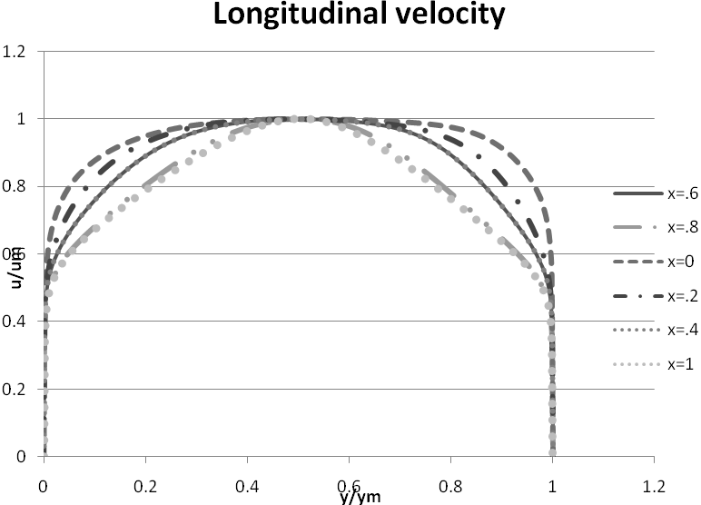
Fig.-1 Area ratio=2;divergence angle 5°; Stabilizing length=d, Maximum velocity(U_{m})=120m/s
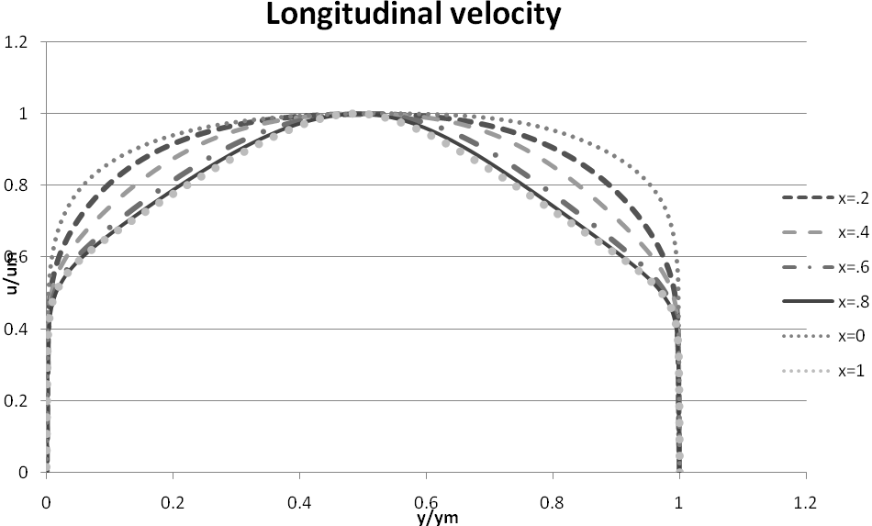
Fig.-2 Area ratio=2;divergence angle 15°; Stabilizing length=3d, Maximum velocity(U_{m})=120m/ 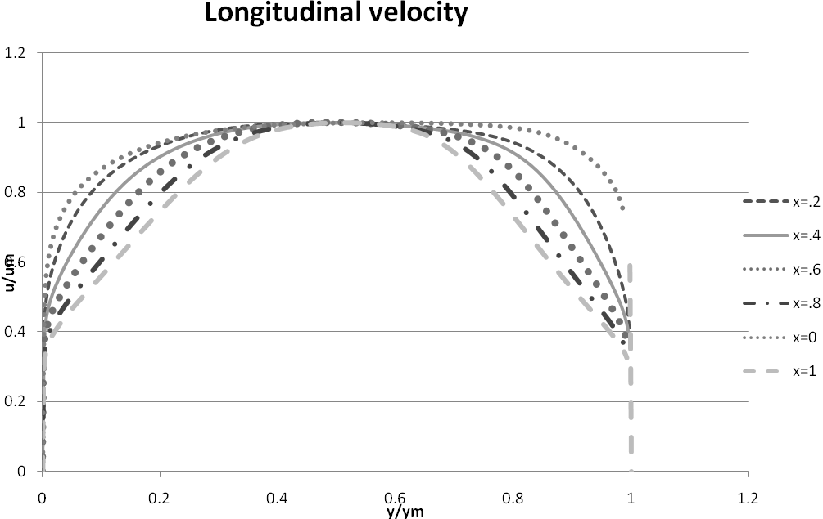
Fig.-3 Area ratio=2;divergence angle 10°; Stabilizing length=d, Maximum velocity(U_{m})=120m/s
Longitudinal velocity
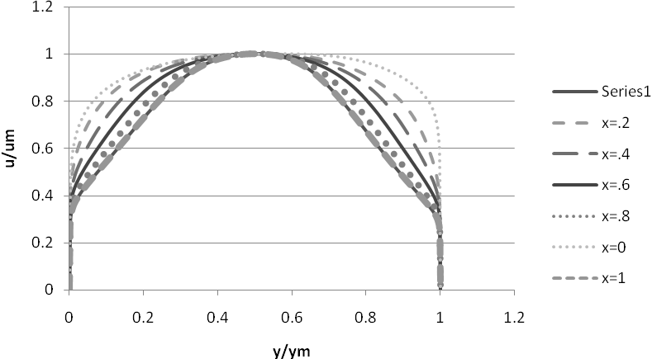
Fig.-4 Area ratio=2;divergence angle 10°; Stabilizing length=3d, Maximum velocity(U_{m})=120m/s

Longitudinal velocity
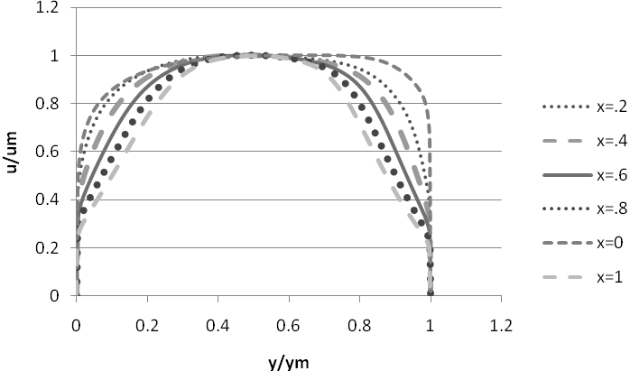
Fig.-5 Area ratio=2;divergence angle 15°; Stabilizing length=d, Maximum velocity(U_{m})=120m/s

Longitudinal velocity
Longitudinal velocity
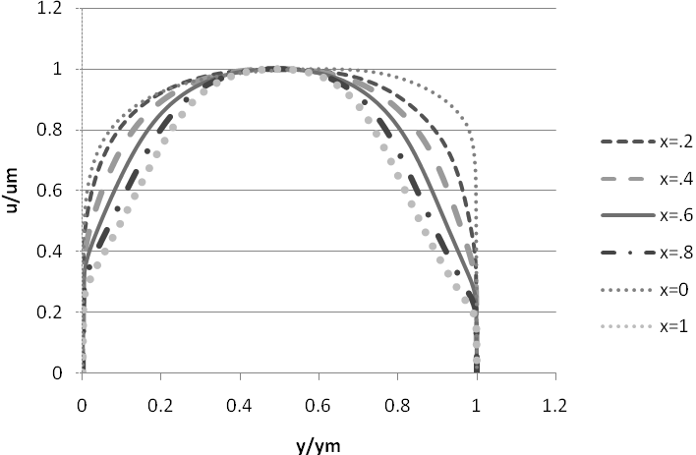
Fig.-6 Area ratio=2;divergence angle 15°; Stabilizing length=3d, Maximum velocity(U_{m})=120m/s

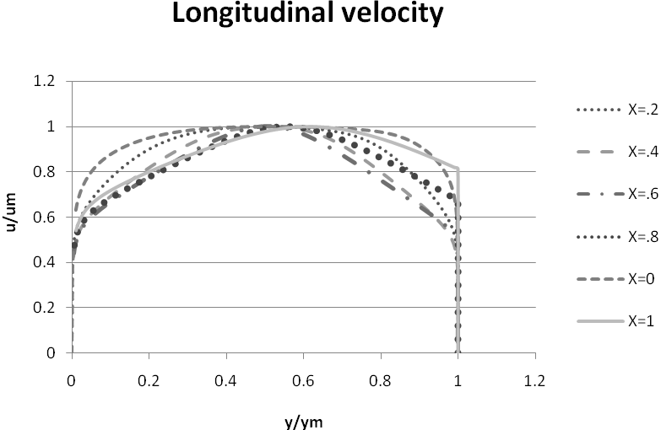
Fig.-7 Area ratio=3;divergence angle 5°; Stabilizing length=d, Maximum velocity(U_{m})=120m/s

Longitudinal velocity
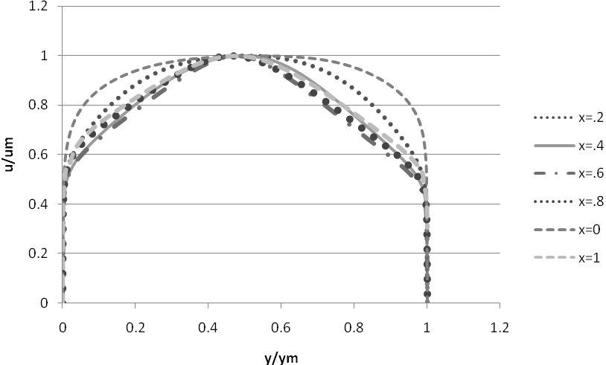
Fig.-8 Area ratio=3;divergence angle 5°; Stabilizing length=3d, Maximum velocity(U_{m})=120m/s
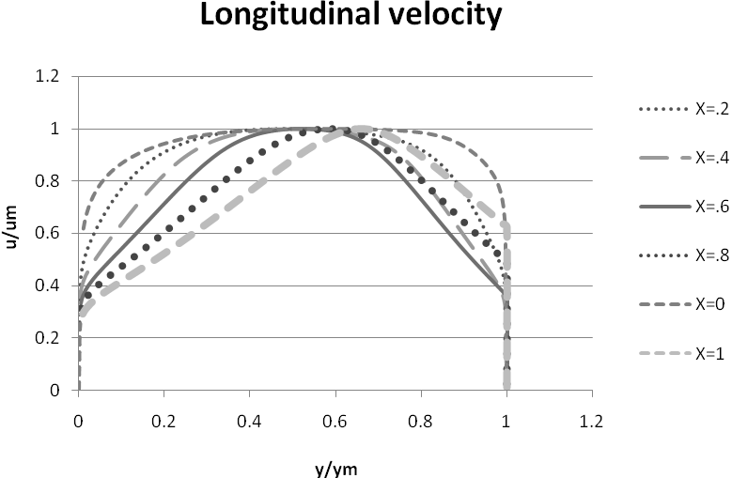
Fig.-9 Area ratio=3;divergence angle 10°; Stabilizing length=d, Maximum velocity(U_{m})=120m/s
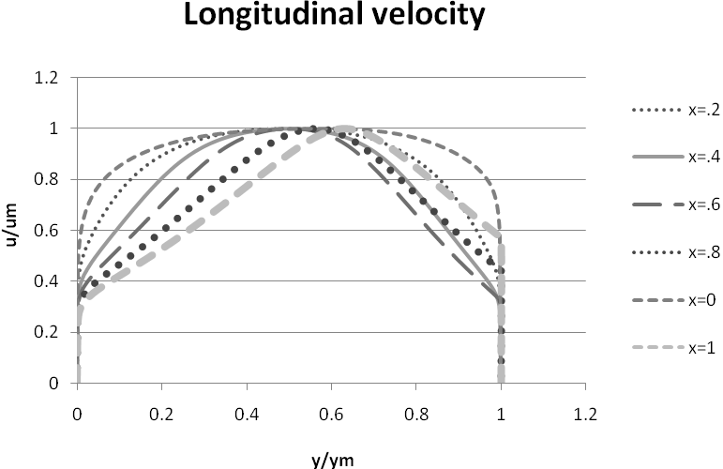
Fig.-10 Area ratio=3;divergence angle 10°; Stabilizing length=3d, Maximum velocity(U_{m})=120m/s
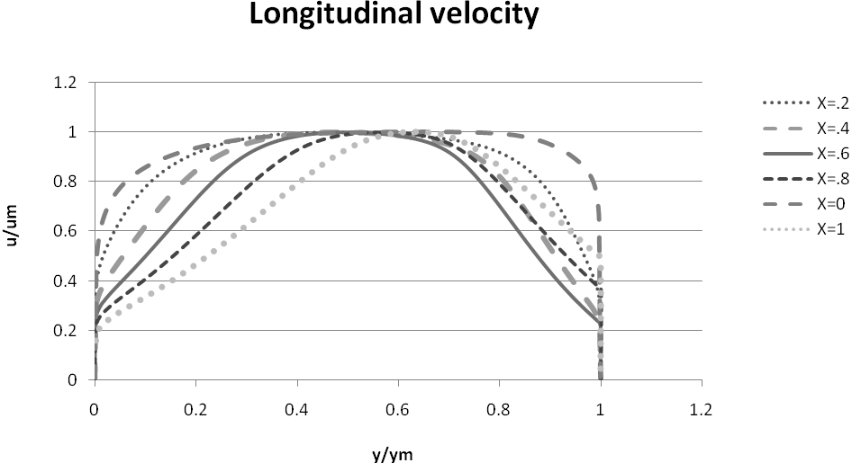
fig.-11 Area ratio=3;divergence angle 15°; Stabilizing length=d, Maximum velocity(U_{m})=120m/s
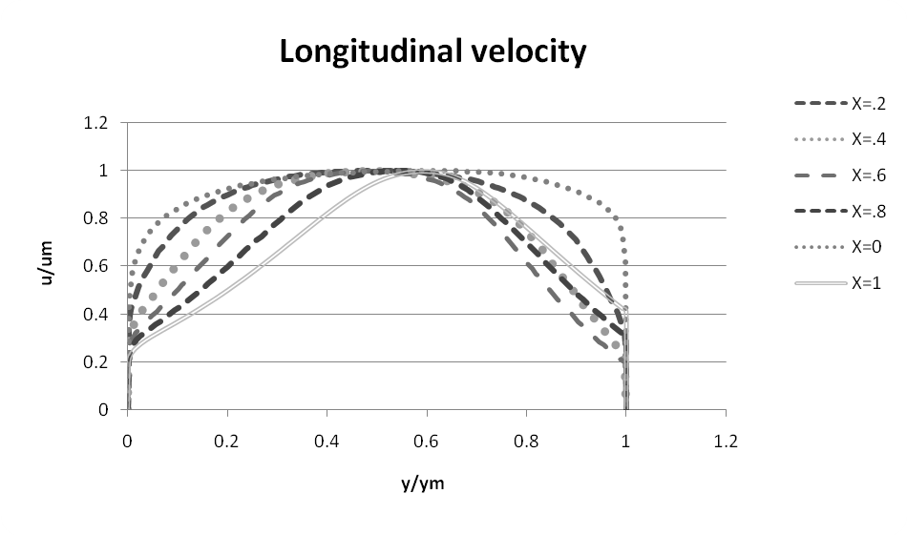
Fig.-12 Area ratio=3;divergence angle 15°; Stabilizing length=3d, Maximum velocity(U_{m})=120m/s
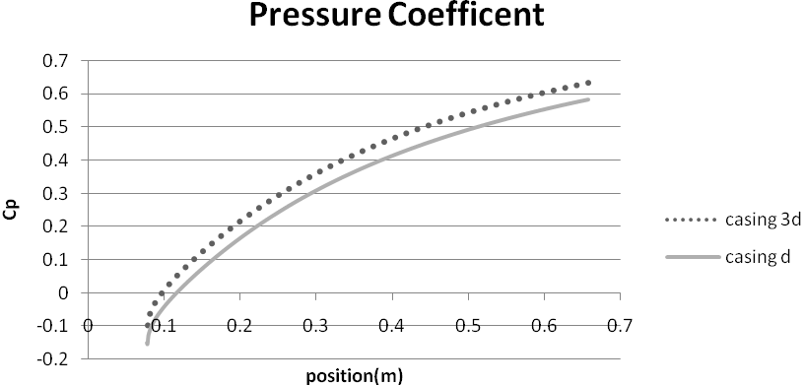
Fig.-13 Area ratio=2;divergence angle 5°; Stabilizing length=d & 3d, Maximum velocity(U_{m})=120m/s

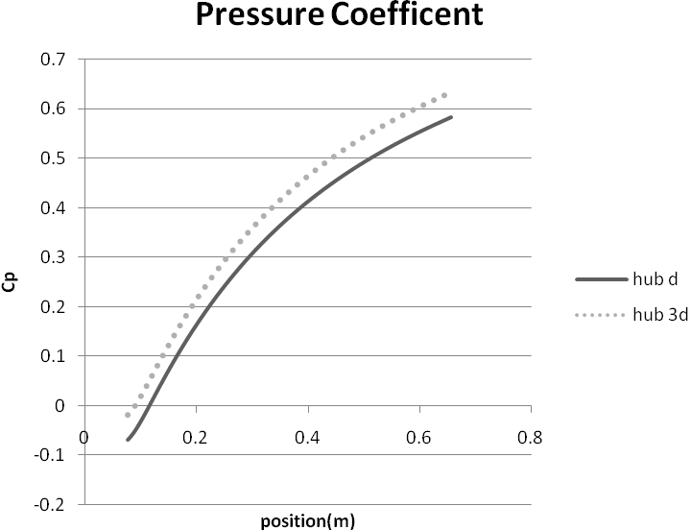
Fig.-14 Area ratio=2;divergence angle 5°; Stabilizing length=d &3d, Maximum velocity(U_{m})=120m/s
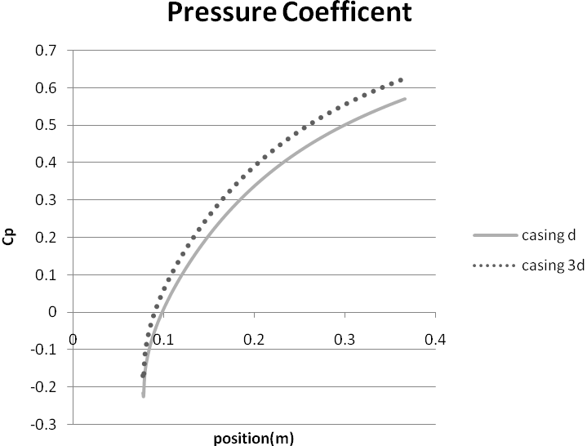
Fig.-15 Area ratio=2;divergence angle 10°; Stabilizing length=d &3d,Maximum velocity(U_{m})=120m/s

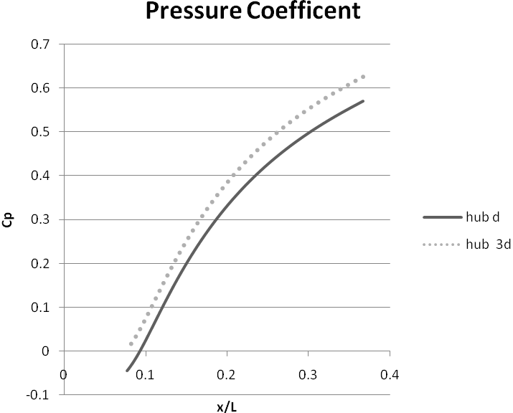
Fig.-16 Area ratio=2;divergence angle 10°; Stabilizing length=d&3d, Maximum velocity(U_{m})=120m/s
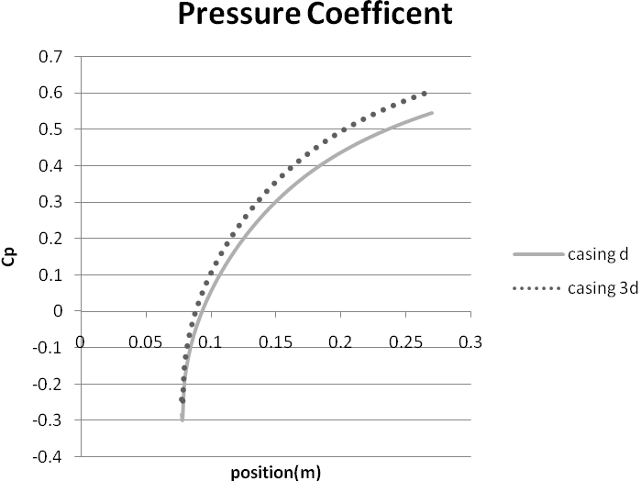
Fig.-17 Area ratio=2;divergence angle1 5°; Stabilizing length=d& 3d, Maximum velocity(U_{m})=120m/s

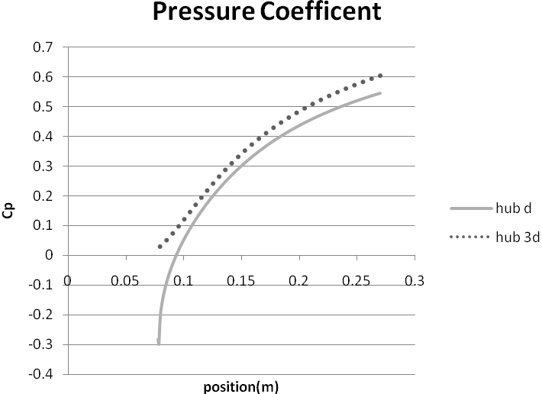
Fig.-18 Area ratio=2;divergence angle1 5°; Stabilizing length=d&3d, Maximum velocity(U_{m})=120m/s
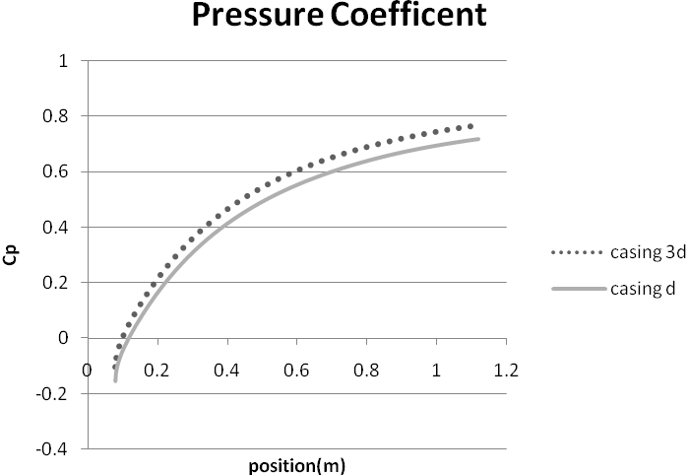
Fig.-19 Area ratio=3;divergence angle5°; Stabilizing length=d&3d, Maximum velocity(U_{m})=120m/s

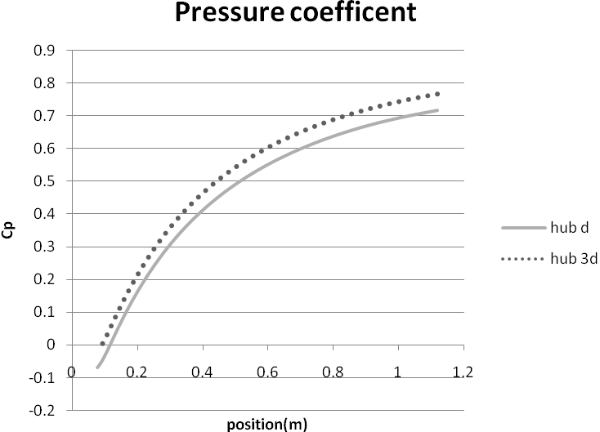
Fig.-20 Area ratio=3;divergence angle 5°; Stabilizing length=d&3d, Maximum velocity(U_{m})=120m/s

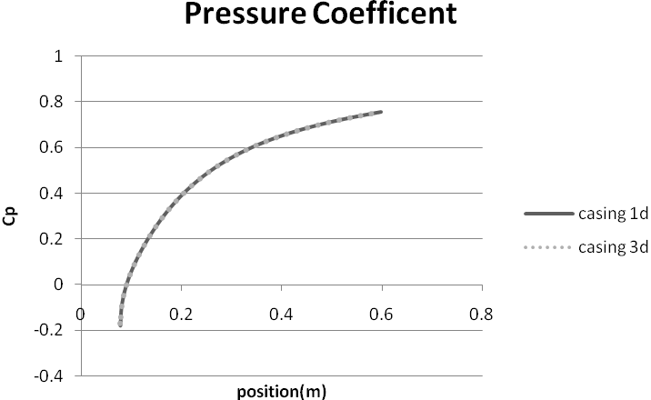
Fig.-21 Area ratio=3;divergence angle1 0°; Stabilizing length=d&3d, Maximum velocity(U_{m})=120m/s

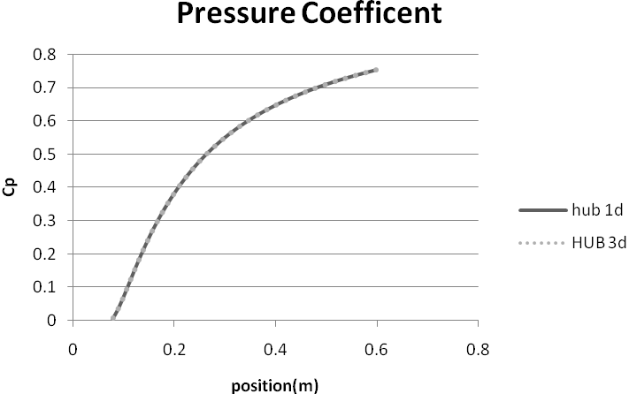

Fig.-22 Area ratio=3;divergence angle1 0°; Stabilizing length=d&3d, Maximum velocity(U_{m})=120m/s
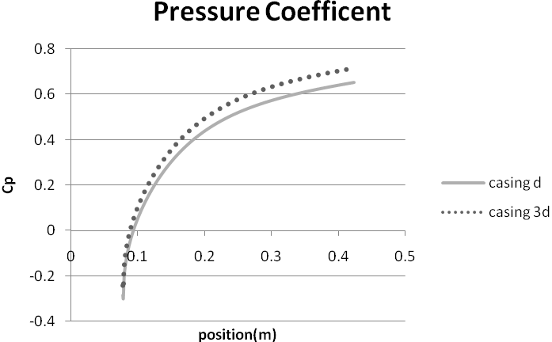

Fig.-23 Area ratio=3;divergence angle1 5°; Stabilizing length=d&3d, Maximum velocity(U_{m})=120m/s

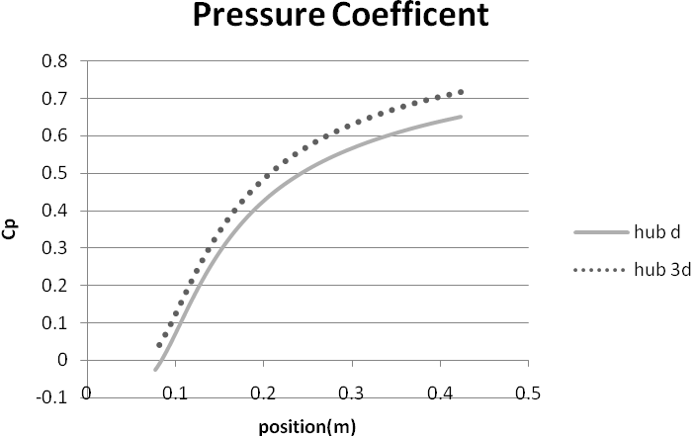

Fig.-24 Area ratio=3;divergence angle1 5°; Stabilizing length=d&3d, Maximum velocity(U_{m})=120m/s

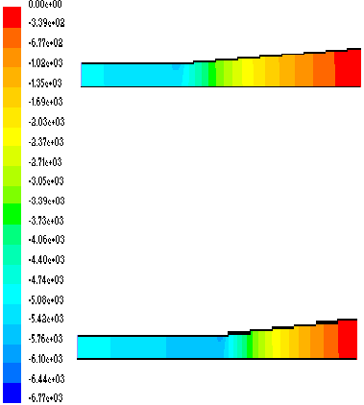

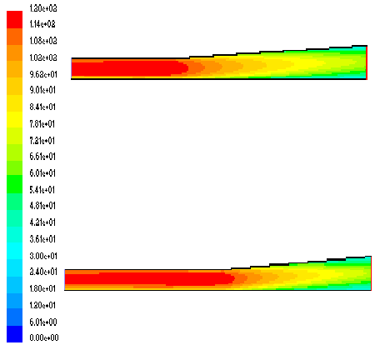

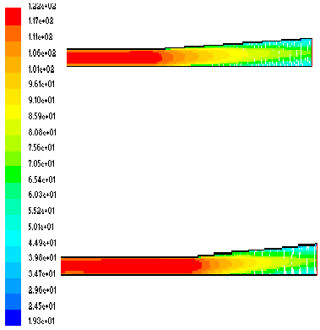

Fig.-25 Area ratio=2; divergence angle 5°; Stabilizing length=d (above in fig), 3d (below in fig); Maximum velocity (U_{m}) =120m/s
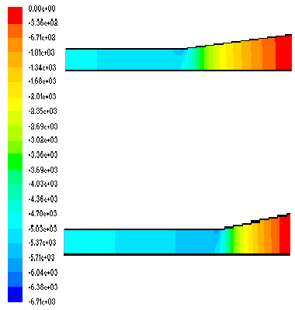
51

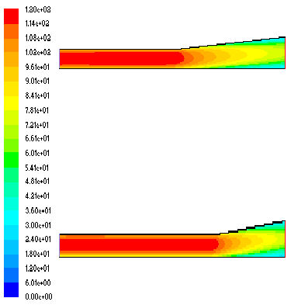

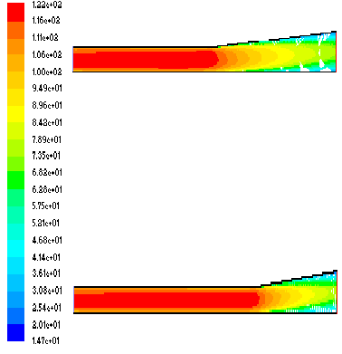

Fig.-26 Area ratio=2; divergence angle 10°; Stabilizing length=d (above in fig), 3d (below in fig); Maximum velocity (U_{m}) =120m/s

52

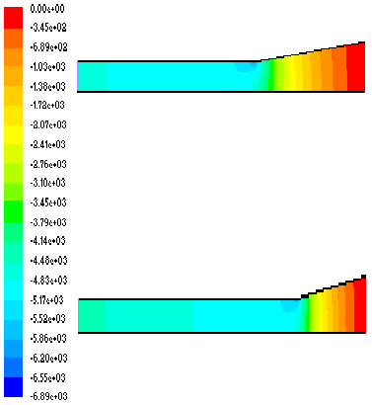

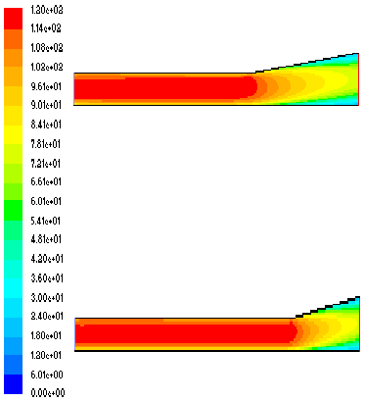

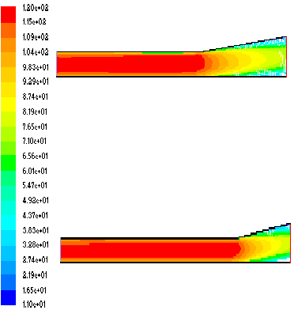

Fig.-27 Area ratio=2; divergence angle 15°; Stabilizing length=d (above in fig), 3d (below in fig); Maximum velocity (U_{m}) =120m/s

53

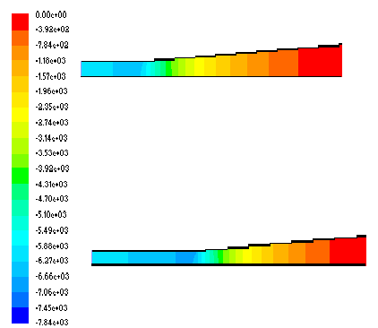

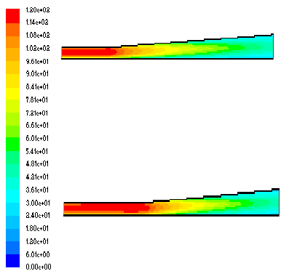

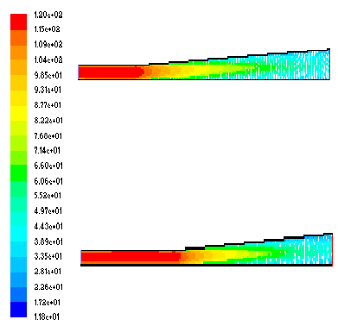

Fig.-28 Area ratio=3; divergence angle 5°; Stabilizing length=d (above in fig), 3d (below in fig); Maximum velocity (U_{m}) =120m/s
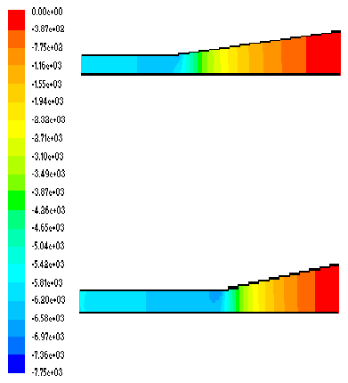 54
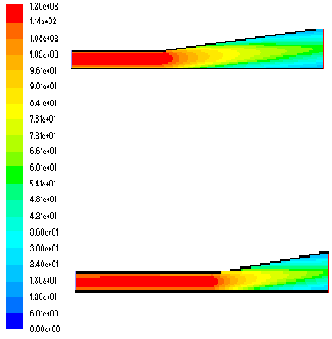

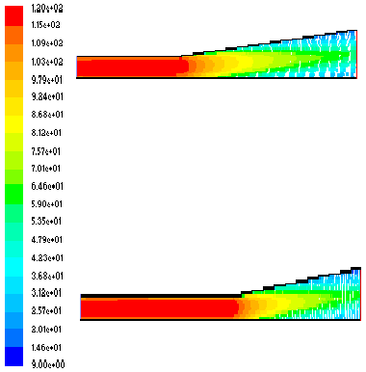

Fig.-29 Area ratio=3; divergence angle 10°; Stabilizing length=d (above in fig), 3d (below in fig); Maximum velocity (U_{m}) =120m/s

55

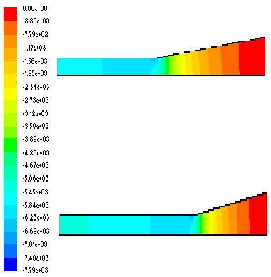

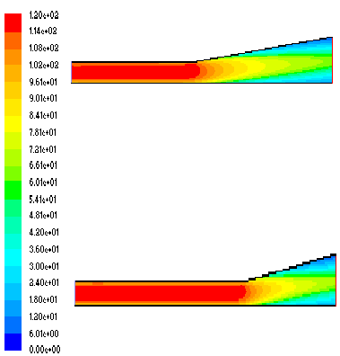

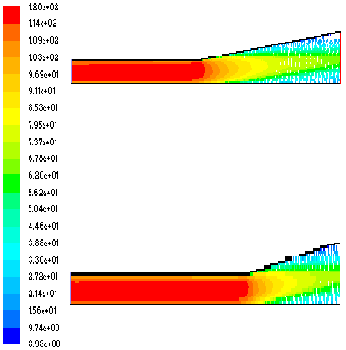

Fig.-30 Area ratio=3; divergence angle 15°; Stabilizing length=d (above in fig), 3d (below in fig); Maximum velocity (U_{m}) =120m/s

56

CONCLUSION AND FUTURE WORK CHAPTER6

It is concluded that increasing the stabilizing length at different area ratio and different divergence angle, pressure recovery coefficient (c_{p} ) increases. That means more kinetic energy is converted into pressure energy.

- The present work was done for sub-sonic flow uncompressible flow only. The scope can be extended to compressible and sonic flows.

- Annular diffuser in considered in the present study. Future work can be done on conical, rectangular, radial type diffusers.

- The present analysis is done for a diverging type diffuser. As the geometry is an important parameter, which indicates the overall diffusion and hence varying the geometry type can extend further studies.

- The effect of hub-generated swirl can be considered for future study.

- The effect of Mach number can be studied.

- The present analysis is done for stationary hub and casing. Further studies can be done on rotating hub and casing diffuser.

- Modeling of the geometry can be modified by attaching a tailpipe at the exit to recover some of the excess kinetic energy of a non-uniform diffuser exit profile in to pressure energy.

- The analysis is basically performed with an advanced k-ε RNG model for swirling flows. Using higher order discretization schemes and better turbulence models can be used for better results in case of swirling flows.

REFRENCES _

- Ackert, J. 1967. “Aspect of Internal Flow. Fluid Mechanics of Internal Flow” Ed. Sovaran G., Elsvier Amsterdum, ppl.
- Adkins R.C ,Jacobsen OH , Chevealier P, 1983, “A Premilary Study of Annular Diffuser With Constant Diameter Outer Wall” ASIVIE paper no. 83-GT-218
- Adkins R.C., 1983. “A simple Method for Design Optimum Annular Diffusers” ASTVE Paper No. 83-GT-42.
- Awai T., Nakagawa T., Sakai T., 1986. “Study of Axially Curved Mixed Flow Vane-less Diffuser”. Bull JSME 29, 1759-1764.
- Arora, B.B., 2007, “Aerodynamic Analysis of Diffuser”, PhD Thesis, 2007, DU, Delhi.
- Arora, B.B.,Pathak, B.D.,2005 “Flow characteristics of parallel hub diverging casing axial annular diffusers”. ISME publication pp 794-798.
- Cockrell, D.J., Markland, E., 1963. “A Review of Incompressible Diffuser Flow” Aircraft Engg. Volume 35, pp 286.
- Coladipietro, R., Schneider, J.M., Sridhar, K.1974. “Effects of Inlet Flow Conditions on the Performance of Equiangular Annular Diffusers,” Trans. CSME 3 (2): pp. 75-82.
- Dovzhik, S.A., Kartavenko, V.M., 1975. “Measurement of the Effect of Flow Swirl on the Efficiency of Annular Ducts and exhaust Nozzles of Axial Turbo-machines,” Fluid Mechanics/Soviet Research 4(4): 156-172.
- Goebel J. H., Japikse D., 1981. “The Performance of an Annular Diffuser Subject to Various Inlet Blockage and Rotor Discharge Effects “. Consortium Final Report, Creare TN-325.
- Hesterman R., Kim S., Ban Khalid A., Witting S., 1995. “Flow Field and Performances Characteristics of Combustor Diffusers”. ASME Journal Engineering for Gas Turbine and Power 117, pp 686-694.
- Hoadley D., 1970. “Three Dimensional Turbulent Boundary Layers in an Annular Diffuser “. Ph.D. Thesis University of Cambridge.
- Hoadley D., Hughes D .W, 1969. “Swirling Flow in an Annular Diffuser”. University of Cambridge, Department of Engineering, Report CUED/ATurbo/TR5.
- Howard J. H. G., Thornton, Trump A. B., Henseler H. J., 1967. “Performance and Flow Regime for Annular Diffusers “. ASME Paper No. 67-WA/FE-2 1.
- Ishkawa K,Nakamura I, 1989. “An Experimental Study on The Performance of Mixed Flow Type Conical Wall Annular Diffuser”, ASIVIE FED-69.
- Japikse, D., 1986. “A New Diffuser Mapping Technique — Studies in Component Performance: Part 1,” ASIVIE Paper No. 84-GT-237, Amsterdam, June 1984; also, Journal of Fluids Engineering, Vol. 108, No. 2. pp. 148-156.
- Japikse, D., and Pampreen, R., “Annular Diffuser Performance for an Automotive Gas Turbine,” ASIVIE Publication 78-GT-147. 1978.
- Japikse, D., 1980. “The Influence of Inlet Turbulence on Diffuser Performance,” Concepts ETI, Inc., Design Data Sheet No. 1,
- Japikse, D., 2000. “Performance of Annular Diffusers Subject to Inlet Flow Field Variations and Exit Distortion,” Presented at the ISROMAC conference in Honolulu, Hawaii, March 26-30,.
- Johanston I.H., 1959. “Effect of Inlet Conditions on the Flow in Annular Diffusers.” National Gas Turbine Establishment Memo No. 167,Cp No.178
- Johnston J. P., 1959. “Summary of Results of Test on Short Conical Diffuser with Flow Control Inserts”: as of June 1, 1959.Ingersoll —Rand TN No. 71.
- Juhasz,A.J. 1974. “Performance Of An Asymmetric Annular Diffuser With Non Diverging Inner Wall Using Suction”, NASA TN -7575.
- Kamonicek V., Hibs M., 1974. “Results of Experimental and Theoretical Investigation ofAnnular Dffuiser.” CSIRO, Division of Mechanical Egg.
- Klein, A., 1995. “Characteristics of Combustor Diffusers.” Program Aerospace Science 31: 171-271
- Mahalakshmi N.V., Krithiga G., Sandhya S., Vikraman J., Ganesan V., 2007, “Experimental investigations of flow through conical diffusers with and without wake type velocity distortions at inlet” Experimental Thermal and Fluid Science (2007), doi: 10.1016/j.expthermflusci. 2007.
- Moller E.S, 1965. “Radial Diffuser Using Incompressible Flow between Disks.” ASIVIE paper no. 65-FE-12.
- Moller ES., 1965. “Radial Flow without Swirl between Parallel Disks Having both Supersonic and Subsonic Regions.” ASME Paper No. 65-FE-li.
- Shaalan, M.R.A., Shabaka, I.M.M., 1975. “An Experimental Investigation of the Swirling Flow Performance of an Annular Diffuser at Low Speed,” ASIVIE Paper No. 75-WA/FE-17.
- Sharan V K, 1972.Diffuser Performance Co-Relations. JASI, Volume 24, pp 4l5.
- Sovran, G., Klomp, E.D., 1967. “Experimentally Determined Optimum Geometries for Rectilinear Diffusers with Rectangular, Conical or Annular Cross- Section,” Fluid Dynamics of Internal Flow, Elsevier Publishing Company.
- Srinath T, 1968, “An Investigation of the Effects of Swirl on The Flow Regimes and Performance of Annular Diffuser With Equal Inner and Outer Cone Angles. “ M.A. Science Thesis , University of Waterloo Canada
- Stafford W. Wilbur, James T.H. 1957. “Investigation of Short Annular Diffuser Configuration Utilizing Suction as a Means of Boundary Layer Control”, NACA TN-3996
- Stafford W.Willbur, James T.H. 1957. “Investigation Of Short Annular Diffuser Configuration Utilizing Suction As A Means Of Boundary Layer Control.” NACA TN-3996
- Stafford, W. Wilbur, James T. Higginbotham, 1955. “Investigation of Two Short Annular Diffuser Configurations Utilizing Suction and Injection as Means of Boundary Layer Control”. NACA RI\4 L54K18.
- Stevan S. J., Williams G.J., 1980. “The Influence of Inlet Conditions on The Performance of Annular Diffuser.” Trans. ASIVIE Journal Fluids Engg. 2002, 357-363.
- Stevens S. J., Fry P., 1973. “Measurements of the Boundary Layer Growth in Annular Diffusers”. Journal Aircraft Feb., pp 73-89.
- Stevens S. J., Williams G. J., 1969. “Performance of Annular Diffusers” Gas Turbine Collaboration Committee Report No. 299.
- Stevens S. J., Williams G. J., 1980. “The Influence of Inlet Conditions on the Performance of Annular Diffuser”. Trans. ASME Journal Fluids Egg. 102, 357-363.
- Stevens S.J., Fry P., 1973. “Measurements of the Boundary Layer Growth in Annular Diffusers.” Journal Aircraft Feb., pp 73-89.
- Takehira A., et. al., 1977. “An Experimental Study of the Annular Diffusers in Axial-Flow Compressors and Turbines” Japan Society of Mechanical Engineers, Paper No.39, 1977.
- Takehira, A., et al., 1977, “An Experimental Study of the Annular Diffusers in Axial- Flow Compressors and Turbines,” Japan Society of Mechanical Engineers, Paper No.39, 1977.
- Thayer E B, 1971 “Evaluation of Curved Wall Annular Diffuser” ASIVIE paper no .71 -WA/FE-3 5
- Thayer E. B., 1971. “Evaluation of Curved Wall Annular Diffuser” ASME Paper No.71 -WA/FE-3 5
- Wood C.C., Henry J. R., 1958. “Effects of Shock Boundary Layer Interaction on the Long and Short Subsonic Annular Diffuser” .NACA RI\4 L5 8A3 1.
- Wood, C .C. Henary, JR., 1958. “Effects of Shock Boundary Layer Interaction on the Long and Short Subsonic Annular Diffuser”, NACA RIVI L58A3 1.

APPENDIX

Flow-Chart for CFD Modeling and Simulation
Geometry
Boundary Layer Meshing
Meshing

Stop
Selection of Solver and types of boundaries
Export Mesh and Case to solver (FLUENT)
Grid check, Smoothing and swapping
Boundary conditions
Model Selection
Initialization
Converge Criteria, Solution Controls
Iterations

Convergence
Post Processing

