EFFECT OF EUPHORBIA COAGULUM ON THERMO-MECHANICAL PROPERTIES OF POLYESTER –NATURAL FIBER COMPOSITES

A major project submitted in the partial fulfillment of the requirement for the award of the degree of

MASTER OF ENGINEERING
IN
POLYMER TECHNOLOGY

Submitted by

ANIL KUMAR
(ROLL NO: 10292)

UNDER THE GUIDANCE OF
DR. A.P.GUPTA
Department of Applied Chemistry & Polymer Technology
Delhi College of Engineering, Delhi-110042


DEPARTMENT OF APPLIED CHEMISTRY AND POLYMER TECHNOLOGY
DELHI COLLEGE OF ENGINEERING
BAWANA ROAD, DELHI -110042
(UNIVERSITY OF DELHI)
2006-2008

CERTIFICATE

This is to certify that Mr. Anil Kumar has satisfactorily completed the project work entitled “Effect of Euphorbia Coagulum on Thermo -Mechanical Properties of Polyester-Natural Fiber Composites” in partial fulfillment of the award of the degree of Master of Technology in Polymer Technology of Delhi College of Engineering, University of Delhi, Delhi, during the session of 2006-2008. This work has not been submitted in part or full in any other university or institution for the award of any degree or diploma.

Dr. Amita Malik Dr. A. P. Gupta
(External Supervisor) (Internal Supervisor)
Assistant Director Department of Applied Chemistry
Shriram Institute for Industrial Research & Polymer Technology
19, University Road, Delhi-110007 Delhi College of Engineering
Delhi-110042

Prof. G. L. Verma
(HOD)
Department of applied chemistry
& Polymer Technology
Delhi College of Engineering,
Delhi-110042

ACKNOWLEDGEMENT

I am greatly indebted to my internal supervisor Dr. A. P. Gupta, Department of Applied Chemistry & Polymer Technology, Delhi University, for guiding me and helping me in solving all problems before and during the project period from such a long apart.

I would like to thank Dr. Amita Malik, Assistant Director, Shriram Institute for Industrial Research, Delhi for giving me an opportunity to work and complete my entire project under his valuable guidance.

I am heartily thankful to Dr. G. L. Verma, HOD, Applied Chemistry & Polymer Technology, Delhi University, for his valuable support in recommending me in such a reputed organization and unconditional support throughout the project work.

I would like to thank Dr. R.K. Diwan (Sr. Assistant Director, SRI), to allow for practical work in SRI Materials Science Division and guide me in my practical work.

I am highly indebted to Mr. Amit Kumar (Research Associate) MSD for all their guidance and technical support throughout the project work. They gave significant inputs in terms of methodological guidance as the work progressed. It was almost impossible to come up with this kind of work without the valuable insights provided by them during discussions.

I would not like to miss the opportunity of giving my heartiest gratitude to Dr. R.K Khandal (Director , Shri Ram Institute For Industrial Research Delhi), for giving me the opportunity to complete my M. E. Project and placing me to the right department of such a research organization of international repute.

I convey my special thanks to our teachers Dr. R. C. Sharma and Dr. D. Kumar.
I am thankful to Mr. R.K Singh (Sr. Scientist, SRI), Mr. Dheeraj Kumar Singh, Mr. Praveen Gogia , Mr. Vinay Tyagi, Dr. Madhuri Gupta , Miss. Pusplata , Mr. Preet tyagi, for their moral support and suggestions during progress of the entire project.

I would like to convey my special thanks to Mr. Nand Lal Razak, for helping me in characterizing the developed product. They improved the quality of the work with their best experience in practical work.

Last but not the least I would like to convey my heartiest and warmth gratitude to all the scientists and supporting staff of Material Science Division, SRI through out the entire Project and giving me valuable suggestion, support and inspiration during the project sharing their valuable time.

I would like to thank, Mr. Venktesh N. L., Mr. Vimal Kumar, Miss. Anshu Dev, Mr. Parveen and Mr. Veerendra kumar for valuable support in my project work.

Lastly, I convey my special thanks to my friends and classmates.

Finally, to my Parents, go my eternal gratitude for their constant love and support for study.

ANIL KUMAR
University Roll No. 10292
M.E / Polymer Technology

CONTENTS
Page No.
Contents i-iii
The list of Figures iv
The list of Tables vi
Abstract vii
Chapter 1: Objectives 1
Chapter 2: Introduction 2-7
Chapter 3: Literature review 8-32
3.1 Composite materials 8
3.1.1 General 8
3.1.2 Composite classification 8
3.2 Polymer Matrix Composites 9
3.2.1 Introduction 9
3.2.2 Properties of Polymer Matrix Composites are determined by 10
3.2.3 Rule of Mixtures 10
3.3 Natural fiber composites 10
3.3.1 General 10
3.3.2 Matrix materials 11
3.3.2.1 Unsaturated polyester resin (UPR) 11
3.3.2.1.1 Introduction 11
3.3.2.1.2 Synthesis 12
3.3.2.1.3 Curing 13
3.3.2.1.4 Grades of UPR 16
3.3.2.1.5 Properties 16
3.3.2.1.6 UPR Processing 17
3.3.2.1.7 Applications 17
3.3.2.2 Euphorbia latex 18
3.3.2.2.1 Introduction 18
3.3.2.2.2 Euphorbia royleana plant 18
3.3.2.2.3 Euphorbia latex and coagulum 19
3.3.2.2.4 Uses 20
3.3.3 Reinforcement 20
3.3.3.1 Natural fibers 20
3.3.3.1.1 Introduction 20
3.3.3.1.2Advantages of Natural fiber applications in polymer composites 21
3.3.3.1.3 Natural fibers in composites can compete with synthetic fibers by 21
3.3.3.1.4 Chemical composition of fibers 22
3.3.3.1.5 Structure of cellulose, hemicellulose and lignin. 22
3.3.3.1.6 Fiber properties 24
3.3.3.1.7 Banana fiber 24
3.3.3.1.7.1 General 24
3.3.3.1.7.2 Chemical compositions and properties of banana fibers 25
3.3.3.1.7.3 Commercial applications 25
3.3.3.1.8 Property improvement of natural fiber composites 26
3.3.3.1.8.1 Fiber treatment 26
3.3.3.1.8.2 Chemical modification of natural fiber 26
3.3.4 Method of Fabrications of composites 30

Chapter 4: Experimental work 33-44
4.1 Materials 33
4.2 Methods 34
4.2.1 Methods of collection of latex and coagulation 34
4.2.2 Latex Coagulation 34

4.2.3 Fiber treatment 34
4.2.4 Composite development 34
4.2.4.1 Preparation of matrix 34
4.2.4.2 Wetting of fiber by hand lay up method 35
4.2.4.3 Sheet preparation 35
4.2.4.3.1 Compression moulding 35
4.3 Characterization of composites 36
4.3.1 Sample preparation 37
4.3.2 Testing techniques 37

Chapter 5: Results and Discussion 45-65
5.1 Composition of euphorbia coagulum 45
5.2 Effect on properties with variation in fiber weight fraction. 45
5.3 The effect of coagulum on properties of polyester -banana fiber composites 45

Conclusion 66
References 67-70

List of Figures

Fig 1: Classification of natural fibers according origin
Fig 2: Structure of isophthalic acid polyester resins is given above
Fig 3: Reaction of polyester resin formation
Fig 4: Structure of methyl ethyl ketone peroxide (MEKP) and hydrogen peroxide
Fig 5: Curing of polyester resin
Fig 6: Cross linking mechanism of UP resins
Fig 7: Euphorbia royleana
Fig 8: Structure of Euphol chemical compound
Fig 9: Structure of cellulose molecule
Fig 10: Some monomers of hemicellulose are shown in the sketch:
Fig. 11: An example of a possible lignin structure
Fig 12: Banana fiber applications
Fig 13: Lattice structures of cellulose
Fig 14: Scheme of interaction of silanes with cellulosic fibers
Fig 15: scheme of compression molding
Fig 16: Compression molding machine.
Fig 17: Sample for tensile testing
Fig 18: Instron universal testing machine
Fig 19: Izod impact testing machine
Fig 20: Mechanism of flexural testing
Fig 21: Durometer hardness tester
Fig 22: HDT and VST Apparatus
Fig 23: Variation in density of treated and untreated polyester banana fiber composites with variation in coagulum wt fraction.
Fig 24: Variation in water absorption of treated and untreated polyester banana fiber composites with variation in coagulum wt fraction.
Fig 25: Variation in impact strength of treated and untreated polyester banana fiber composites (unnotched) with variation in coagulum wt. fraction.
Fig 26: Variation in impact strength of treated and untreated polyester banana fiber composites (notched) with variation in coagulum wt. fraction.
Fig 27: Variation in Tensile Strength of treated and untreated polyester banana fiber composites with variation in coagulum wt fraction.
Fig 28: Variation in flexural strength of treated and untreated polyester banana fiber composites with variation in coagulum wt fraction.
Fig 29: Variation in flexural modulus of treated and untreated polyester banana fiber composites with variation in coagulum wt fraction.
Fig 30: Variation in Shore D Hardness of treated and untreated polyester banana fiber composites with variation in coagulum wt fraction.
Fig 31: Variation in HDT of treated and untreated polyester banana fiber composites with variation in coagulum wt fraction.
Fig 32: Variation in VST of treated and untreated polyester banana fiber composites with variation in coagulum wt fraction.
Fig 33: TGA thermogram of euphorbia coagulum.
Fig 34: TGA thermogram of polyester-euphorbia coagulum composite.

List of Tables

Table No. 1. Biopolymers from renewable resources
Table No. 2. Values of polyester hand lay up laminates
Table No. 3. Availability and composition of biofibers
Table No. 4. Structure and properties of biofibers
Table No. 5. List of chemicals
Table No. 6: Effect on properties of composites with variation in fiber weight fraction.
Table No. 7: The effect of euphorbia coagulum on properties of polyester -banana fiber composites.
Table No. 8: Variation in density of treated and untreated polyester banana fiber composites with variation in coagulum wt fraction.
Table No. 9: Variation in water absorption of treated and untreated polyester banana fiber composites with variation in coagulum wt fraction.
Table No. 10: Variation in impact strength of treated and untreated polyester banana fiber composites with variation in coagulum wt. fraction.
Table No. 11: Variation in Tensile Strength of treated and untreated polyester banana fiber composites with variation in coagulum wt fraction.
Table No. 12: Variation in flexural strength of treated and untreated polyester banana fiber composites with variation in coagulum wt fraction.
Table No. 13: Variation in flexural modulus of treated and untreated polyester banana fiber composites with variation in coagulum wt fraction.
Table No. 14: Variation in Shore D Hardness of treated and untreated polyester banana fiber composites with variation in coagulum wt fraction.
Table No. 15: Variation in HDT of treated and untreated polyester banana fiber composites with variation in coagulum wt fraction.
Table No. 16: Variation in VST of treated and untreated polyester banana fiber composites with variation in coagulum wt fraction.
Abstract
------------------------------------------------------------------------------

An attempt has been made to replace synthetic resin i.e. polyester resin by naturally occurring latex of Euphorbia plants. Composites has been developed using varying ratio of Euphorbia coagulum and Polyester resin and with varying fiber content. Physico- mechanical properties and thermal properties have been studied.
In this study composites have been made using varying percentage of coagulum and polyester resin keeping the fiber content constant. Effect of coagulum on various physico-mechanical properties, thermal stability, HDT and VST has been carried out. Such kind of material can be used as binder in composite development and to eliminate poverty by providing employment to the rural India.

CHAPTER -1

Objectives

1. The collection and characterization of Euphorbia Coagulum obtained from Euphorbia royleana.
2. Optimization of fiber and resin fractions in the composites.
3. Optimization of process parameters such as pressure, temperature, curing agent and resin/fiber ratio.
4. Preparation of banana fiber composites by replacing polyester resin by Euphorbia coagulum in varied proportions
5. Study its compatibility by determining its thermo-mechanical properties.
6. Chemical treatment of Banana fiber by different chemicals and preparation of the composite sheets using treated fibers and coagulum modified resins.
7. Determination of thermo-mechanical properties such as tensile strength, flexural strength, flexural modulus, impact strength, water absorption, hardness, HDT, VST and TGA of polyester-coagulum-banana fiber composites.
8. To carry out comparative study of the prepared banana fiber composites with treated and untreated, coagulated and polyester-banana fiber composites.

CHAPTER -2

Introduction

Use of natural fiber and resin materials were known to mankind in the Paleolithic age. The 300 ft high ziggurat or temple tower built in the city center of Babylon was made with clay mixed with finely chopped straw [1, 2]. Composite material is a material composed of two or more distinct phases (matrix phase and dispersed phase) and having bulk properties significantly different form those of any of the constituents. The primary phase, having a continuous character, is called matrix. Matrix is ductile and less hard phase which binds the fibers together and acts as the medium for transfer of externally applied stress force uniformly to the fibers. The second phase, which is imbedded in the matrix in a discontinuous form, dispersed phase. Dispersed phase is usually stronger than the matrix, therefore it is sometimes called reinforcing phase. Reinforcing phase give the strength, modulus to the composite. Reinforcing phase also bear the applied load to the composite.

In recent years, polymeric composite materials are being used in variety of application, such as automotive, sporting goods, marine, electrical, industrial, construction, household applications, etc. Polymeric composites have high strength and stiffness, light weight and high corrosion resistance.

But increasing environmental consciousness and demands of legislative authorities are leading to the scrutiny of manufacture, use, and removal of traditional composite structures, usually made of glass, carbon, or aramid fibers reinforced with epoxy, unsaturated polyester resin, polyurethanes, or phenolics, by governmental and other agencies. The most important disadvantage of such composite materials is the problem of disposal after end use, as the components are closely interconnected, relatively stable, and therefore difficult to separate and even recycle. The limited petroleum stock and

fluctuating price of petroleum based product is increasing economic crisis day by day particularly in developing countries. The depletion of petroleum resources coupled with increasing environmental regulations are acting synergistically to provide the impetus for new materials and products that are compatible with the environment and independent of fossil fuels. The extra burden of disposal of petroleum based composites and environmental problem also raise the attention of people for the use of natural, sustainable, biodegradable and renewable resources. In modern production environment, there is a great demand for every material to be recyclable or degradable.

Composite materials, especially “green composites”, fit well into this new paradigm shift. Simply stated, biobased materials include industrial products for durable goods applications, made from renewable agricultural and forestry feed stocks, including wood, agricultural waste, grasses and natural plant fibers composed of carbohydrates such as sugars and starch, lignin and cellulose, as well as vegetable oils and proteins.

Producing chemical products and new materials from renewable resources is not a new idea. Most of the chemical products and materials came from renewable resources until the early part of the 20th century. Environment as well as economic factors is now driving the trend toward greater utilization of biobased polymers and materials for sustainable and renewable composite development.

The production of chemicals and materials from biobased feedstocks is expected to increase from today’s 5% level to ~ 12% in 2010, ~ 18% in 2020, and ~ 25% in 2030. Research conducted from the 1990s to till date has led to many new products based on biomaterials [3-8]. Recent advances in genetic engineering, natural fiber development, and composite science offer significant opportunities for new, improved materials from renewable resources, which can be biodegradable, recyclable and sustainable resource.
Biopolymers are now moving into the mainstream and biobased polymers may soon be competing with commodity plastics in various applications. The challenge in replacing conventional plastics with biodegradable materials is to design materials that exhibit structural and functional stability during storage and use. The biopolymers which are obtained from renewable resources are given below in table 1.

Table No. 1. Biopolymers from renewable resources
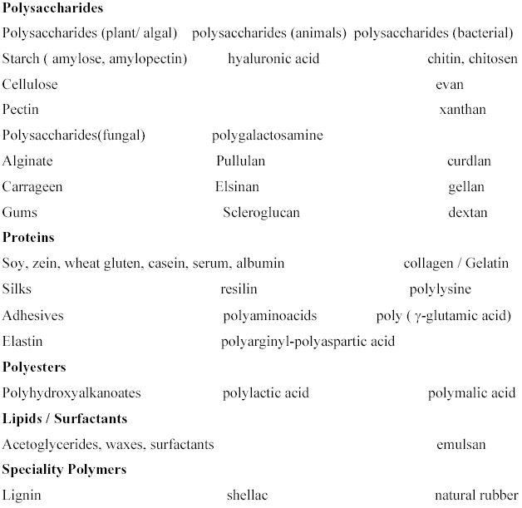

Natural fiber-reinforced plastic composites began with cellulose fiber-reinforced phenolics in 1908, later extending to urea and melamine, and reaching commodity status in the 1940s with glass fiber-reinforced unsaturated polyesters. The use of biocomposites in making interior automotive parts with natural fiber-polypropylene and exterior parts from natural fiber polyester resin based composites has been reported.

In the past decade, extensive research work has been carried out on the natural fiber reinforced biocomposite materials in many applications. In auto-motive parts, compared to glass composites, the composites made from natural fibers reduce the mass of the component and lower the energy needed for production by 80%. Naturally derived biopolymers can be used as matrix materials in the development of composites. Many natural fiber reinforced composites with biopolymers are developed.

Naturally derived biopolymers used in composite development are Polysaccharides (Cellulose, Starch, Chitosan), Proteins (Polyglutamic acid, Soy Derivatives), Polyesters (PLA), Lignin (Polyphenols), and Natural Latex (heave latex, Euphorbia Latex).

Natural latex can be used as matrix materials in the composite materials developments. The natural rubber latex and euphorbia latex are obtainable in nature. These latex are obtained from renewable resources. Natural rubber latex obtained from Hevea brasiliensis plant and euphorbia latex from different species of euphorbia plant. Natural rubber latex has the isoprene and euphorbia latex contain triterpenes, mainly 3-epicyclolaudenol, cyclolaudenol, euphol, tirucallol, cyclotrichosantol and cycloeucalenol.
The euphorbia latex can be coagulate by various chemicals such as tannic acid. euphorbia resin is the main constituent of Euphorbia coagulum. The euphorbia coagulum can be used as the matrix in the composite formation because coagulum can be used as a binder.
There are about 2000 species of euphorbia in the worldwide. Euphorbia plant have a lot of latex which can be converted as a matrix in the composite formation. The use of Euphorbia coagulum can reduce the burden and dependency on the petroleum- based produced. This also helps in reducing the environmental disposal problem because Euphorbia coagulum is a nature/environment compatible material. In the initial stage it is not possible as composite development from use of euphorbia coagulum as a matrix because euphorbia Coagulum is inferior in quality than natural rubber latex. But researchers are trying to substitute the synthetic polymer matrix by use of some weight percentage of euphorbia coagulum.

In natural fiber reinforced polyester composites the some amount of polyester has been replaced by using the euphorbia coagulum. Study the effect of euphorbia coagulum on the polyester natural fiber composite. Study the thermo- mechanical properties of euphorbia modified polyester composite materials. And optimize how many amount of polyester can be substituting without affect the properties of polyester composite. And also evaluate the improvement in the properties of euphorbia modified polyester composite materials. The main propose of this work is to replace polyester resin by substitute by the euphorbia coagulum which is biodegradable, sustainable and obtained from natural resources.

Natural fibers are available in abundance, much higher strength per unit weight than most inorganic fillers, lower density and their biodegradable nature make attractive as reinforcements of engineering polymer systems. Natural fibers from plants are beginning to find their way into commercial applications such as automotive industries, household applications, etc.

A number of investigations have been conducted on several types of natural fibers such as kenaf, hemp, bamboo and jute to study the effect of these fibers on the mechanical properties of composite materials [9-12]. Mansur and Aziz studied bamboo- mesh reinforced cement composite composites, and found that this reinforcing material can enhance the ductility and toughness of the cement matrix, and increase significantly its tensile, flexural, and impact strengths. A pulp fiber reinforced thermoplastic composite are investigated and reported to have a combination of stiffness increase by factor of 5.2 and strength increase by a factor of 2.3 relative to the virgin polymer [13].

Information on the usage of banana fibers in reinforcing polymers is limited in the literature. In dynamic mechanical analysis (DMA), Laly et al. [14] investigated banana fiber reinforced polyester composites and found that the optimum content of banana fiber is 40%. Mechanical properties of banana-fiber-cement composites were investigated physically and mechanically by Corbiere-Nicollier et al. it was reported that kraft pulped banana fiber composite has good flexural strength. In addition, short banana fiber reinforced polyester composite was studied by Pothan et al [15]. The advantages of biofibers over traditional reinforcing materials such as glass fibers, talc, and mica are low cost, low density, high toughness, acceptable specific strength and modulus, and biodegradability.
The main drawback of biofibers is their hydrophilic nature, which lowers their compatibility with hydrophobic polymeric matrixes during composite fabrication [16,17].
To get a good reinforcing effect using these plastics, it is necessary to increase the adhesion between fibers and matrix. Thermoset composites are more desirable than thermoplastics, because their superior mechanical properties. The matrix resins in the thermoset biocomposites are non biodegradable. Howe ever, they maintain a balance between economics and the environment [18-21].

Due to the hydrophilic nature of the natural fibers, their compatibility with relatively hydrophobic polymeric matrixes is reduced. Therefore, biocomposites have water absorption characteristics that reduce their utility in many applications. For useful composites, fiber-matrix adhesion has to be optimized for ensuring good mechanical and thermal properties. The surface chemical modification of natural fibers likes alkali treatment, acrylic acid treatment, cyanoethylation, vinyl grafting, and treatment with natural latex are some means to improve fiber-matrix adhesion of the resulting biocomposites [22, 23]. Evaluate the effect of substitution of polyester resin with euphorbia coagulum. And find out the improvement in thermal and mechanical properties of euphorbia coagulum modified polyester banana fiber composites. And find out that a certain amount of polyester can be replaced with euphorbia coagulum without deterioration of composite properties. In this way euphorbia coagulum can be used as a biopolymer matrix in natural fiber composites.

CHAPTER-3
Literature review

3.1 Composite materials:
3.1.1 General:

Composite material is a material composed of two or more distinct phases (matrix phase and dispersed phase) and having bulk properties significantly different form those of any of the constituents. Composites may be selected to give unusual combination of stiffness, strength, weight, high temperature performance, corrosion resistance, hardness, conductivity or cost effectiveness. Composites consist of mainly two phases which are:
Matrix phase (continuous phase) and Dispersed phase (reinforcing phase)

3.1.2 Composite classification:

There are two classification systems of composite materials.
1) Classification of composite materials based on matrix material
There are three types of composite materials: a) Metal Matrix Composites. b) Ceramic Matrix Composites. c) Polymer Matrix Composites
2) Classification of composite materials based on reinforcing material structure
There are three types of composite materials: a) Particulate Composites. b) Fibrous Composites. C) Laminate Composites
A) Classification of polymer composite reinforced with fiber
i) Polymer composite reinforced with synthetic fiber.
ii) Polymer composite reinforced with natural fiber.

a) Classification of natural fibers
Different types and examples of natural fibers classified according to their origin are presented in Figure1.

3.2 Polymer Matrix Composites:
3.2.1 Introduction:

Polymer Matrix Composite is material consisting of polymer (resin) matrix combined with a fibrous reinforcing agent. Polymer matrix composites are very popular due to their low cost, high strength to weight ratio, non-corrosive and simple fabrication methods. Polymer matrix composites reinforcement by strong fibrous network is characterized by the high tensile strength, high stiffness, high fracture toughness, good abrasion resistance, good puncture resistance, good corrosion resistance and low cost.

The main disadvantages of Polymer Matrix Composites are low thermal resistance, high coefficient of thermal expansion. However, these flaws can be overcome by judicious selection of matrix and fiber and effective compounding of matrix phase.

3.2.2 Properties of Polymer Matrix Composites are determined by:

• Properties of the fibers;
• Orientation of the fibers;
• Concentration of the fibers;
• Properties of the matrix.

3.2.3 Rule of Mixtures:

Rule of Mixtures is a method of approximate estimation of composite properties. It is based on an assumption that the composite property is the volume weighed average of the phases (matrix and dispersed phase) properties. According to rule of mixtures properties of composite materials are estimated as follows:

Density, dc = dm*Vm + df*Vf

Where, dc, dm, df = densities of the composite, matrix and dispersed phase respectively;
Vm, Vf = volume fraction of the matrix and dispersed phase respectively.
Rule of mixture can be applied for the estimation of thermal conductivity, electrical conductivity and modulus of elasticity.

3.3 Natural fiber composites:
3.3.1 General:

Natural fiber composites (NFCs), are composite materials i.e., formed by a matrix (resin) and a reinforcement (fibers), in which the fibers are natural i.e., mainly formed by cellulose and therefore originating from plants. Some of these fibers can be hemp, jute, flax, sisal, banana, kapok etc. NFCs markets are significantly on the rise, mainly because of the increase in oil price, recycling and environment necessities.
Natural fibers, biopolymers, and biocomposites are the genesis of sustainability, industrial ecology, eco-efficiency, green chemistry and engineering for the development of the next generation materials, products, and processes.
Natural/Biofiber composites are emerging as a viable alternative to glass fiber composites, particularly in automotive, packaging, building, and construction industries, and becoming one of the fastest moving additives for thermoplastics.

3.3.2 Matrix materials:
A) Unsaturated polyester resin (UPR)
B) Euphorbia coagulum

3.3.2.1 Unsaturated polyester resin (UPR)
3.3.2.1.1 Introduction:

Unsaturated polyester resins are very versatile materials. The liquid resins are stable at room temperature, for months or even years. Unsaturated polyester resin is the condensation product of dibasic organic acids and polyhydric alcohols.

The actual preparation of the first polyester resin is accredited to both Berzelius in 1847 and Gay-Lussac and Pelouze in 1883. The unsaturated polyester resins used in today’s reinforced plastics (RP) are combinations of reactive monomers. Carleton Ellis introduced the idea for the combination in the 1930’s. Ellis discovered that unsaturated polyester resins made by reacting glycols with maleic anhydride which can be cured to insoluble solids simply by adding a peroxide catalyst. Ellis later discovered that a more useful product could be made by combining the unsaturated polyester alkyd with such reactive monomers as vinyl acetate or styrene, which makes it easier to add the catalyst and apply the resin.
The first use of glass fibre reinforced polyester composites was in aircraft ducting, with the first non-military application in boat hulls. Polyester resin can also attach things together by it, creating a strong bond.
The principal advantage of polyester resins is the ease in which it can be fabricated, a consequence of polymerization via a free radical reaction and low cost.

3.3.2.1.2 Synthesis:

Unsaturated polyesters are usually manufactured by batch process. They are the condensation products of unsaturated dibasic acids (usually maleic anhydride), saturated dibasic acids and glycols. The glycols used may be ethylene glycol, propylene glycol or diethylene glycol. Important saturated acids used are phthalic anhydride and m-phthalic acid. The most common cross linking monomer used is styrene but vinyl toluene, methyl methacrylate and diallyl phthalate can also be used.

The process often begins with molecules like a dialcohol, and diacid. These then cure into a solid polymer.
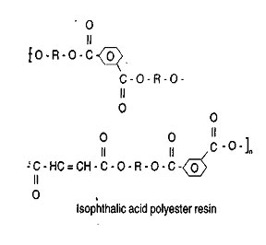
Fig 2: Structure of Isophthalic acid polyester resins is given above
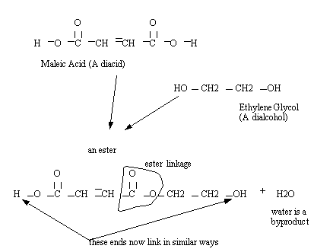
Fig 3: Reaction of polyester resin formation

These reactions create very long chains of polymers in a sort of gel, but the next step involves cross-linking them to make things stiff

3.3.2.1.3 Curing:

Cross-linking reaction is carried out after the resin has been applied to the reinforcing fiber. Curing is carried out either at elevated temperature of about 100 c where press moulding is being produced, or at room temperature in the case of large hand lay-up structures. The polyester is diluted to styrene and additives (for controlling the curing process, color etc.) are added.

Small amount of initiator when mixed with the resin, a reaction between the double bonds of styrene and maleic acid is initiated. This reaction is called curing and resulted in a product that has high strength properties in all directions. There are two main processes for curing.
I) Cold process - the organic peroxide reacts in presence of cobalt salts or organic amines at room temperature. II) Hot process - the organic peroxide is thermally activated at higher temperature.

- The cross linking monomer:

In most cases the cross linking monomer is styrene introduced at concentrations between 25 and 45 wt%, but other monomers can also be used.
b) Curing catalyst:

To initiate the curing reaction, a source of radicals is needed which is known as catalyst. In most of the cases organic peroxides are used.
i) The first step is the decomposition of the peroxide.
ii) The second step is chain propagation reaction via styryl radical formation capable to react with a double bond.
The main organic peroxide used for curing UPR is ketone peroxides, which are generally used at room or mid temperature in combination with Cobalt salts. Diacylperoxides, which like benzoyl peroxide, can be used at room temperature, activated by tertiary aromatic amines, or without promoter at higher temperature (100°C/212°F). Peresters and perketals, which are used at higher temperatures and are preferred in injection and compression molding processes. Hydroperoxides, which are used at higher temperatures in injection and compression molding processes.

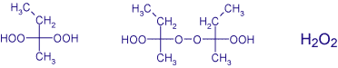

Fig 4: Structure of methyl ethyl ketone peroxide (MEKP) and hydrogen peroxide

c) Accelerator:
Accelerator means which are accelerate the rate of reaction. A purple liquid (Cobalt Naphthenate) accelerator is used with methyl ethyl ketone peroxide (MEKP) catalyst. Accelerator and catalyst must never be mixed directly together as they can cause an explosion.
The accelerator governs the speed of the reaction and without the catalyst the accelerator has no effect on resin. This is why it can be pre-mixed months before use.

d) Curing mechanism:
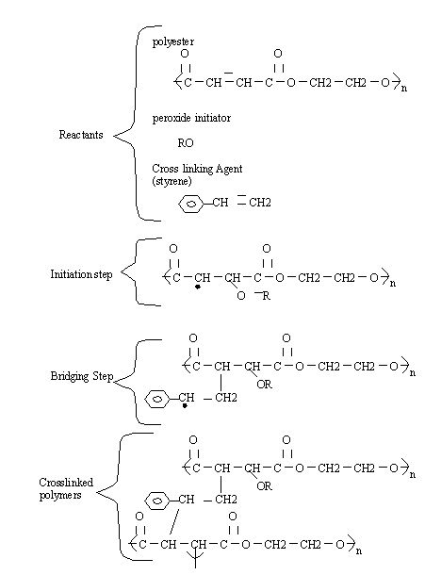
Fig 5: Curing of polyester resin

Various chemical reactions and physical properties can be altered by changing the chemicals above. Rates of reaction can be accelerated with higher temperatures.
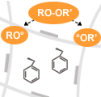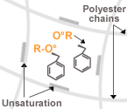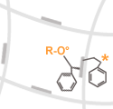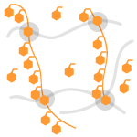

Fig 6: Cross linking mechanism of UP resins

3.3.2.1.4 Grades of UPR:

a) General purpose grade .b) Flexible grade . c) Low shrinkage grade. d) Weather resistant grade. e) Chemical resistant grade. f) Fire resistant grade. g) Filled grade

3.3.2.1.5 Properties:

UP Resins are most commonly used as binder for composite development along with synthetic or natural fibers. Other additive can be incorporated to improve properties or characteristics of composites. Carbon, aramide or most commonly glass fibers may be used yielding FRP (Fiber Reinforced Plastic). Unsaturated polyester resins are used in combination with a reinforcement material like glass fiber to form a fiber reinforced plastic (FPR), which has excellent characteristics that include:
• Light weight
• High strength-to-weight ratio
• Rigid
• Resistant to chemicals
• Good electrical insulating properties
• Retention of dimensional stability across a wide range of temperatures

Table No. 2. Values of polyester hand lay up laminates
Properties | Values
Tensile strength, MPa | 8 - 17
Water absorption, % | 0.2 -0.8
Flexural strength, MPa | 10 - 20
Flexural modulus, MPa | 3440
Power factor 106Hz | 0.02 - 0.08
Dielectric constant 106Hz | 3.2 - 4.5

3.3.2.1.6 UPR Processing:

Hand lay up and spray up techniques, preform moulding , centrifugal casting , pultrusion and filament winding , matched metal die moulding , injection moulding and compression moulding for SMCs and DMCs can be used to process unsaturated polyester resin based intended applications.

3.3.2.1.7 Applications:

Building & Construction: Building panels, cultured marbles, beams, water tanks, skylights, outdoor structural panels, fume hoods, play ground equipments, room dividers, roofing, siding, tanks, pipes and corrugated paneling.

Automotive: Automobile structural parts, auto body putty, aircrafts, safety helmets, guards, gel coats, automobile springs, truck cabs, truck feners, recreational vehicles, automobile exterior parts and auto patching compounds.

Electrical/Electronic: Switch gear parts, fuse holders, street light housings and electrical components.

Household: Bathtubs, laundry tubs, septic tanks, trays, shower stalls, picture frames, appliances, buttons, furniture and tool boxes.

Industrial: Reaction vessels, tanks, large diameter pipes, mine bolts and castings.
Sports: Golf club shafts, archery bows, bowling balls and swimming pools.

Miscellaneous: fiberglass boats, building panels, fans, fences, helmets, compressor housing, auto body components, bathroom accessories

3.3.2.2 Euphorbia latex:
3.3.2.2.1 Introduction:

Euphorbia latex is obtained from the Euphorbia plant. Euphorbia is a genus of plants belonging to the family Euphorbiaceae family. This family consists of about 2160 species, Euphorbia is one of the most diverse genera in the plant kingdom. Euphorbia plants are found in the tropical and subtropical regions of Africa and the Americas, but also in temperate zones worldwide.
All the species of this genus have latex and a unique flower structure. The Euphorbias are named after a Greek surgeon called Euphorbus. He was physician of Juba II who was the Romanised king of a North African kingdom, and is supposed to have used their milky latex as an ingredient for his potions. The main species of euphorbia are Euphorbia neriifolia, Euphorbia nivulia, Euphorbia royleana and Euphorbia caducifolia which are found in India.

3.3.2.2.2 Euphorbia royleana plant:

Latex of Euphorbia royleana plant which are found in Himalyas (Utranchal) to Rajasthan hill areas has been utilized as resin material for composite development by substituting polyester in varied proportions. The plants are annual or perennial herbs, woody shrubs or trees with a caustic, poisonous milky sap (latex).

Scientific Name: Euphorbia royleana Boiss.
Family: Euphorbiaceae
Origin: Himalayas, India, Bhutan at medium elevations
Growth Habits: Deciduous succulent tree
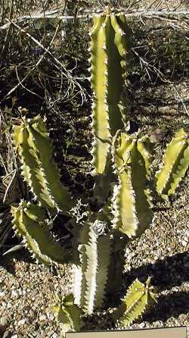
Fig 7: Euphorbia royleana

3.3.2.2.3 Euphorbia latex and coagulum:

Latex is a milky sap with a complex composition, which includes alkaloids, terpenoids, and amine oxidase. The latex can be tapped directly from plant for collecting latex. The euphorbia latex can be coagulated using alcohol and acids in the euphorbia coagulum. The main constituents of the coagulum of these plants are resin (77-80%), protein (14-17%) and isoprene rubber (4-6%), ash content (0.5-1%). Euphorbia resin is the main constituent of Euphorbia coagulum.
Latex is off white, but in rare cases (e.g. E. abdelkuri) yellow Euphorbia latex contains triterpenes, 3-epicyclolaudenol, cyclolaudenol, euphol, tirucallol, cyclotrichosantol and cycloeucalenol. Among the component parts are many di- or tri-terpen esters, which can vary in composition according to species. There are two main constituents of Euphorbia Neifolia are Euphol and monohydroxy triterpene – nerifoliol

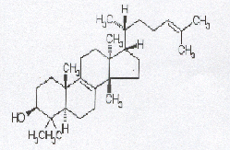
Fig 8: Structure of Euphol chemical compound

3.3.2.2.4 Uses:

These resins and rubber hydrocarbons are oligomeric in nature and can be exploited for producing various useful products. These products are adhesives, protective coatings, paints, composites etc.

3.3.3 Reinforcement:
3.3.3.1 Natural fibers:
3.3.3.1.1 Introduction:

Natural fibers usually derived from plants or cellulose. Natural fibers are obtained from agricultural byproducts and renewable resources. Natural fibers such as banana, cotton, coir, sisal and jute have attracted the attention of scientists and technologists for application in consumer goods, low cost housing and other civil structures with wide-ranging uses from environment-friendly biodegradable composites to biomedical.

It may seem surprising, but first natural fiber composites were used more than 100 years ago. In 1896, for example, airplane seats and fuel-tanks were made of natural fibers with a small content of polymeric binders. As early as 1908, the first composite materials were applied for the fabrication of large quantities of sheets, tubes and pipes for electronic purposes (paper or cotton to reinforce sheets, made of phenol- or melamine-formaldehyde resins) [25]. However, these attempts were without recognition of the composite principles. The use of natural fibers was suspended due to low cost and growing performance of technical plastics and, moreover, synthetic fibers. A renaissance in the use of natural fibers as reinforcements in technical applications began in 90s of 20th century.

3.3.3.1.2Advantages of Natural fiber applications in polymer composites:

From the materials science point of view, there is growing interest in green, environmentally friendly materials. If we consider composites, one of solutions can be use of natural fibers instead of more traditional glass and carbon fibers [24-27]. The possible advantages of such natural fiber composites are:

1) Natural fibers are renewable resources.
2) Using biodegradable polymers as matrix, we can have totally recyclable materials.
3) They are biodegradable; however this can be a draw back during the lifetime of a product.
4) Lower cost. However, all these previous statements should be supported by quantitative analysis.
5) Lower pollution level during production.
6) Energy necessary for fiber production is lower than that of glass.
7) CO2 neutral: amount of CO2 neutralized during fiber plant growth is comparable with that emitted during processing.

3.3.3.1.3 Natural fibers in composites can compete with synthetic fibers by—

a) Lower density;
b) Healthier in use due to their natural origins;
c) Less abrasive to the processing equipment.
d) Low density is the main point why NFC is interesting in automotive sector.

3.3.3.1.4 Chemical composition of fibers:

Cellulose, hemicellulose and lignin are the three main constituents of any lignocellulosic fibers, and the proportion of these components in fiber depends on the age, source of the fiber and the extraction conditions used to obtain the fibers in table 3, various components has been reported.

Table No. 3. Availability and composition of biofibers

Fiber source Availability Cellulose Hemicellulose Lignin Ash Reference () (103 tonnes) % % % %
Corn stover 727 38–40 28 7–21 3.6–7.0 [31,32]
Coir 100 36–43 0.15–0.25 41–45 2.7–10.2 [27,29,34,37]
Bagasse 100 32–48 19–24 23–32 1.5–5
Banana – 60–65 6–8 5–10 4.7 [27,29,30]
Wheat straw 568 33–38 26–32 17–19 6–8 [38]
Rice straw 579 28–36 23–28 12–14 14–20
Sorghum stalks 252 27 25 11 – [38]
Barley straw 195 31–45 27–38 14–19 2–7

3.3.3.1.5 Structure of cellulose, hemicellulose and lignin.
a) Cellulose
Cellulose is a long chain of linked sugar molecules that gives fiber its remarkable strength. The links in the cellulose chain are a type of sugar: ß-D-glucose. Linking just two of these sugars produces a disaccharide called cellobiose.
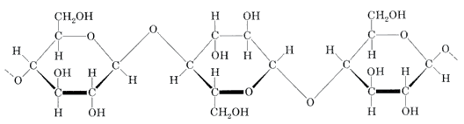
Fig 9: Structure of cellulose molecule

The cellulose chain bristles with polar -OH groups. These groups form many hydrogen bonds with OH groups on adjacent chains, bundling the chains together.

b) Hemicellulose

A hemicellulose can be any of several heteropolymers (matrix polysaccharides) present in almost all plant cell walls along with cellulose. While cellulose is crystalline, strong, and resistant to hydrolysis, hemicellulose has a random, amorphous structure with little strength.
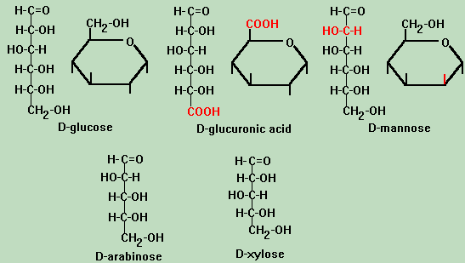
Fig 10: Some monomers of hemicellulose are shown in the sketch:
c) Lignin
Lignin is a complex chemical compound. It is the most abundant organic polymer on Earth after cellulose.
Lignin fills the spaces in the cell wall between cellulose, hemicellulose and pectin components.
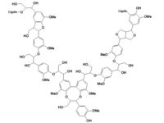
Fig. 11: An example of a possible lignin structure

3.3.3.1.6 Fiber properties

The amount of cellulose and noncellulosic constituents in a fiber determine the structure and properties and influence its crystallinity and moisture regain [36]. Properties such as density, electrical resistivity, tensile strength, modulus, moisture regain and crystallinity are related to the composition and internal structure of the fibers table 4, describes the structure and properties of various naturals fibers.

Table No. 4. Structure and properties of biofibers
Fiber Fiber structure Fiber properties References

Cell dimensions Crystallinity % Tenacity g/dena Elongation % Moisture
content %
Length (mm) Width (mm)

Cornhusk 0.5–1.5 10–20 48–50 2.0–3.0 12–18 9 [32]

Coir 0.3–1.0 100–450 27–33 2.0 17–47 10–12 [29,34,36,37]

Bagasse 0.8–2.8 10–34 – 0.9–1.25 5.5–11.8 8.8

Banana 0.9–4.0 80–250 45 2.4–3.7 1.0–3.5 10–15 [27,29,30,35,39]

Wheat straw 0.4–3.2 8–34 55–65 – – 10 [33,40]

Rice straw 0.4–3.4 4–16 40 – – 6.5 [28]

3.3.3.1.7 Banana fiber:
3.3.3.1.7.1 General:

Banana plants are of the family Musaceae. They are cultivated primarily for their fruit, and to a lesser extent for the production of fibre and as ornamental plants. Bananas are grown in at least 107 countries. Leaves are spirally arranged and may grow 2.7 meters (9 feet) long and 60 cm (2 feet) wide. The leaves of the banana are large, flexible, and waterproof; they are used in many ways, including as umbrellas and to wrap food for cooking, carrying and packing cooked foods, and they are used to build houses in third world countries. India is the largest producer of banana. The cost of banana fiber is low and easily available. Banana fiber have low density, high specific strength. The strength of banana fiber is very compatible with other fibers. So banana fiber can used in commercial scale for composite developments.

3.3.3.1.7.2 Chemical compositions and properties of banana fibers:

Cellulose, hemicellulose and lignin are the three main constituents of any lignocellulosic source. Chemical composition of banana fibers are Cellulose (60–65%), Hemicellulose(6–8 %), Lignin(5–10%), Ash(4.7%) as given in above table 2. Properties of banana fiber is given in above table 3.

3.3.3.1.7.3 Commercial applications:

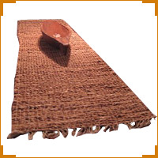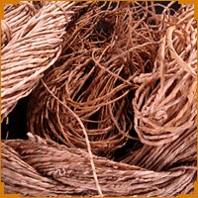
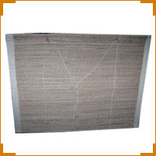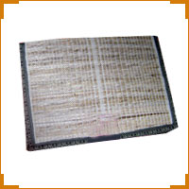
Fig 12: Banana fiber applications

Applications of Natural fibre composites are targeted towards the automotive, construction,(41) furniture(42) and packaging industries.(43)
Automotive applications such as door/ceiling panels and panels separating the engine
and passenger compartments.(44) Panels made from long plant fibers such as flax, banana, hemp, jute and kenaf, and from polypropylene or other thermoplastics, are already in use in many vehicles. All major vehicle manufacturers are exploring their use in other interior applications as well. Various applications are including automobile door panels and dashboards, acoustic ceiling tiles and wall panels.

3.3.3.1.8 Property improvement of natural fiber composites:
Natural abundance, much higher strength per unit weight than most inorganic fillers, lower density and their biodegradable nature make natural fillers attractive as reinforcements of engineering polymer systems. However, certain drawbacks such as incompatibility with the hydrophobic polymer matrix, the tendency to form aggregates during processing and poor resistance to moisture greatly reduce the potential of natural fibers to be used as reinforcements in polymers and final properties of natural fibres with polymeric matrices (thermoplastics, thermosets and biodegradables) and paying attention to the use of physical and chemical treatments for the improvement of fibre-matrix interaction and composite mechanical properties.

3.3.3.1.8.1 Fiber treatment:

Natural fibers are amenable to chemical modification due to the presence of hydroxyl groups. The hydroxyl groups may be involved in the hydrogen bonding within cellulose molecules, thereby activating these groups or can introduce new moieties that form effective interlocks within the system. Surface characteristics, such as wetting, adhesion, surface tension, or porosity of fibers, can be improved upon chemical modification. The irregularities of the fiber surface play an important role in mechanical interlocking at the interface. The interfacial properties can be improved by various ways of modifications which can improve the physical and chemical interactions at the interface.

3.3.3.1.8.2 Chemical modification of natural fiber:
Surface modification of cellulosic fibers has been reported by Belgacem and Gandini [45]. Chemical modification seemed to be the one that gave rise to continuous covalent bonds between cellulose surface and matrix. Surface modifications include (i) physical treatments, such as solvent extraction; (ii) physico-chemical treatments, like the use of corona and plasma discharges [46] or laser, γ-ray, and UV bombardment; and (iii) chemical modifications, both by direct condensation of the coupling agents onto the cellulose surface and by its grafting by free-radical or ionic polymerizations. The common coupling agents used are silanes, isocyanates [47,48], and titanate- based compounds. A few common modifications are described here:

- Alkali treatment

Alkali treatment leads to increase in the amount of amorphous cellulose at the expense of crystalline cellulose. The important modification occurring here is the removal of hydrogen bonding in the network structure. The following reaction takes place as a result of alkali treatment
Fiber – OH + NaOH → Fiber – O⁻ Na⁺ + H₂O ------------------------ (1)
The effect of alkali on cellulose fiber is a swelling reaction, during which the natural crystalline structure of the cellulose relaxes. Native cellulose (i.e. cellulose as it occurs in nature) shows a monoclinic crystalline lattice of cellulose-I, which can be changed into different polymorphous forms through chemical or thermal treatments. The important forms are alkali-cellulose and cellulose-II as shown in Fig. 13.

Fig 13: Lattice structures of cellulose I and cellulose II [49].

- Acetylation:

Acetylation is a wrather attractive method of modification/hydrophobization of the surface of natural fibers. Such treatment can reduce swelling of wood in water and has been studied extensively for lignocellulosic materials. The main principle of the method is to react the hydroxyl groups (OH) of the fiber with acetyl groups (CH₃CO), therefore rendering the fiber surface more hydrophobic. The hydroxyl groups that react are those of the minor constituents of the fiber, i.e. lignin and hemicelluloses, and those of amorphous cellulose.
The hydroxyl groups in the crystalline regions of the fiber are closely packed with strong interchain bonding, and are inaccessible to chemical reagents. The acetylation of the –OH group in cellulose is represented below

Fiber –OH + CH₃CO–O–OC–CH₃ → Fiber –O–CO–CH₃ + CH3COOH ……… (2)
Acetylation has been shown to be beneficial in reducing moisture absorption of natural fibers. Reduction of about 50% of moisture uptake for acetylated jute fibers and of up
to 65% for acetylated pine fibers has been reported in the literature [50]. Acetylation has also been found to enhance the interface in flax/polypropylene composites [51].

C) By acrylic acid:
Chemical treatment of fiber is done with the acrylic acid. Ester bonding occurs between COOH and –OH group of acrylic acid and fiber as following reaction.

Fiber−OH + CH₂ = CH₂−COOH → Fiber O−CO−CH₂ =CH₂ + H₂O ---------- (3)

This modification generates the unsaturation bond on the fiber surface. During the curing this unsaturation increase the cross linking between fiber surface and unsaturated polyester resin euphorbia coagulum, particularly at the interface. This increases the properties of natural fiber composites.

- Silane Treatment:

These chemicals are hydrophilic compounds with different groups appended to silicon such that one end will interact with matrix and the other end can react with hydrophilic
fiber, which act as a bridge between them. The uptake of silane is very much dependent on a number of factors including hydrolysis time, organofunctionality of silane, temperature, and pH. Alkoxy silanes are able to form bonds with hydroxyl groups. Silanes undergo hydrolysis, condensation, and the bond formation stage. Silanols can form polysiloxane structures by reaction with hydroxyl group of the fibers [52]. The chemical reaction is given in Fig. 14.

Fig 14: Scheme of interaction of silanes with cellulosic fibers [53].

In addition to the self condensation of silanes and the condensation on the surface of cellulose fiber, amino silane molecules can interact with the OH groups of cellulose via
their Bronsted basic amino groups.

- By fiber surface coating with natural latex

Natural fiber is impregnated with dilute solution of natural latex. The fiber surfsce is coated with rubber molecules. This makes the fiber surface hydrophobic in nature and creates unsaturation double bond on the fiber surface. And reported useful reduction in water absorption of FRCs. Increase the other properties due to creation of unsaturation double bond on the fiber surface which cross link with resin during curing of resin. This increase the compatibility of fiber surface with resin.

    - Method of Fabrications of composites:

The important methods of development of fiber reinforced composites are as follows

- Hand Lay-up method

The most popular type of Open Molding is Hand Lay-up process. The Hand Lay-up is a manual, slow, labor consuming method, which involves the following operations:
The mold is coated by a release anti-adhesive agent, preventing sticking the molded part to the mold surface. The prime surface layer of the part is formed by applying gel coating. A layer of fine fiber reinforcing tissue is applied. Layers of the liquid matrix resin and reinforcing fibers in form of woven fabric, rovings or chopped strands are applied. The resin mixture may be applied by either brush or roll. The part is cured (usually at room temperature). The part is removed from the mold surface.
The disadvantages of the Hand Lay-up method are: low concentration of reinforcing phase (up to 30%) and low densification of the composites (entrapped air bubbles).

- Spray-up method

In Spray-up process liquid resin matrix and chopped reinforcing fibers are sprayed by two separate sprays onto the mold surface. The fibers are chopped into fibers of 1-2” (25-50 mm) length and then sprayed by an air jet simultaneously with a resin spray at a predetermined ratio between the reinforcing and matrix phase. The Spray-up method permits rapid formation of uniform composite coating, however the mechanical properties of the material are moderate since the method is unable to use continuous reinforcing fibers.

- Compression Molding:

Compression Molding is a Closed Mold process in which a molding charge is squeezed into a preheated mold taking a shape of the mold cavity and performing curing (cross-linking) due to heat and pressure applied to the material. Compression molding process involves the following steps:

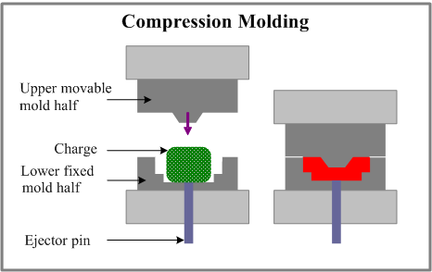
Fig 15: scheme of compression molding

A pre-weighed amount of a polymer (commonly thermosetting resin) mixed with chopped reinforcing fibers, hardening agent, anti-adhesive agent and pigment (charge) is placed into the lower half of the mold. The charge may be in form of powders, pellets, putty-like masses or pre-formed sheets. The charge is usually preheated prior to placement into the mold. Preheated polymer becomes softer resulting in shortening the molding cycle time. The upper half of the mold moves downwards, pressing on the charge and forcing it to fill the mold cavity. The mold, equipped with a heating system, provides curing (cross-linking) of the polymer matrix (if thermosetting resin is processed). The method is suitable for mass production of flat or moderately curved parts.

CHAPTER -4
Experimental work

4.1 Materials:

Euphorbia latex of Euphorbia royleana was obtained from Sahashtradhara, Dehradun, India. Latex was coagulated by 0.5% aqueous solution of tannic acid. The coagulum was used as binder for composite development. The banana fiber obtained from Dhara Mitra, Pune. Some other chemicals used are listed in the table as below

Table No. 5. List of chemicals
Chemical Name | Grade | Company Name | State / Country
Unsaturated Polyester Resin | C-451 | Crystic Resins(India) Pvt. Ltd. | Faridabad, India.
Methyl Ethyl Ketone Peroxide | LR | Otto Kemi | Germany
Chloroform | LR | S. d. fine -chem Limited | Mumbai
Styrene | LR | Otto  Chemika-Biochemika-Reagents | Germany
Cobalt Naphthenate | LR | Otto  Chemika-Biochemika-Reagents | Germany

All the chemicals in the study have been used as received and without further processing.

4.2 Methods:
4.2.1 Methods of collection of latex and coagulation:

Latex of Euphorbia royleana was collected from Dehradun region, India. Tapping method is the most common method for latex collection. During tapping, latex flows out with water, rubber hydrocarbons, certain inorganic salts and organic substances from the tree and collected in the container.

4.2.2 Latex Coagulation:

Latex was coagulated using 0.5% tannic acid solution and washed thoroughly till pH became neutral. Coagulum was dried to constant weight in oven at 60ºC.

4.2.3 Fiber treatment:

Banana short fibers (5-6 cm) have been used in composite sheet preparation.
Treatment of banana fiber with 2M aqueous solution of acrylic acid has been carried out for four hours and washed thoroughly and dried in hot air circulated oven at 100±5°C for 6 hours. Banana short fiber of the size 5-6 cm was also treated with 5% aqueous solution of alkali (NaOH) for four hrs. After this fiber was neutralized and wash with water thoroughly and dried in hot air circulated oven at 100±5°C for 6 hours. Banana fiber was also treated with 10% Natural latex solution for four hrs. After this fiber was dried without washing in hot air circulated oven at 100±5°C for 6 hours.

4.2.4 Composite development:
4.2.4.1 Preparation of matrix:

Honey viscous solution of Polyester resin was made by adding styrene (up to 40 % weight of polyester resin). 1 % accelerator (cobalt naphthenate solution) is added and mixed homogeneously in the honey viscous solution of polyester resin and styrene. After that 0.5 % MEKP initiator is incorporated in the solution.
In this manner Euphorbia coagulum in different proportions is also added in the polyester resin solution. Euphorbia coagulum dissolved in chloroform solvent and then mix in the polyester styrene solution. In this manner polyester resin is substituted by the Euphorbia coagulum in different proportions. Prepare the solution of different compositions of polyester and coagulum.

4.2.4.2 Wetting of fiber by hand lay up method:

Weighed amount of banana fiber is thoroughly wetted by the hand lay up method. Banana fiber then thoroughly wetted with the solution of polyester resin, accelerator and initiator composition. The polyester resin was substituted by various amount of euphorbia coagulum. Banana fiber also mixed with the solution of polyester euphorbia coagulum in different proportions. Banana fiber wetted with only euphorbia coagulum solution also.

4.2.4.3 Sheet preparation:
4.2.4.3.1 Compression moulding:

SANTEC Compression Moulding Machine, Delhi was used for composite sheet preparation. Thoroughly wetted banana fiber with polyester-coagulum solution was uniformly put in the mould of 300 mm X 300 mm X 3mm dimension which are of a highly polished steel .The mould was then pressed between two halves of the compression molding machine. The mould was then heated by electric heaters, fitted with two halves (upper & lower) of the molding machine. The resin was cured at 100⁰C temperature, 40 kg / cm² pressure and cured for 20 minutes. The mould was then allowed to cool by switching off the heaters and circulating water into the machine. The machine was then opened and the mould was removed. Sheet was released from the mould.
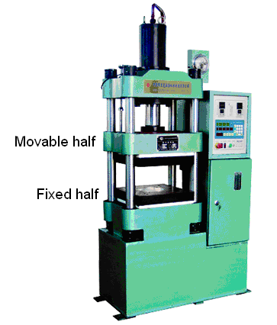
Fig 16: Compression molding machine.

4.3 Characterization of composites

Characterization of sheet composite was done by:
A) Physico mechanical characterization of developed composites
B) Thermal characterization of developed composites

A) Physico-mechanical characterization of developed composites

A) Water absorption
B) Density
C) Tensile strength
D) Flexural strength
E) Flexural modulus
F) Impact strength
G) Hardness

B) Thermal characterization of developed composites
A) HDT
B) VST
C) TGA

4.3.1 Sample preparation

Cured sheet was taken out from mould to get the sample for characterization. The banana fiber polyester and euphorbia coagulum composite sheets were then cut in to different sample size for different testing. Sample for water absorption required the rectangular bar of dimension 1” x 1” x 3.0mm ,Sample for flexural strength required the rectangular bar of dimension 120 mm x 12 mm x 3.0 mm Sample for tensile strength required the doumble shape of dimension (160 mm x 13 mm x 3.0 mm)Sample for impact strength required the rectangular bar of dimension (65 mm x 12 mm x 3.0 mm) ,Sample for density required the rectangular bar of dimension 20 mm x 20 mm x 3.0 mm Sample for HDT required the rectangular bar of dimension 120 mm x 12 mm x 3.0 mm , Sample for VST required the rectangular bar of dimension 20 mm x 20 mm x 3.0 mm
Sample for Hardness required the rectangular bar of dimension 30 mm x 30 mm x 6 mm.
All the above type of the samples was cut from the cured composite sheet using a sharp cutter. Now the sample were smoothed and finished for characterization.

4.3.2 Testing techniques:
A) Tensile Testing (ASTM D 638)

Tensile tests measure the force required to break a specimen and the extent to which the specimen stretches or elongates to that breaking point. Tensile tests produce a stress-strain diagram, which is used to determine tensile modulus.
Equipment: Instron universal testing machine and Star Testing Systems, UTM, Mumbai.
Test specimen: Dumbale shape cut from compression moulded sheet.

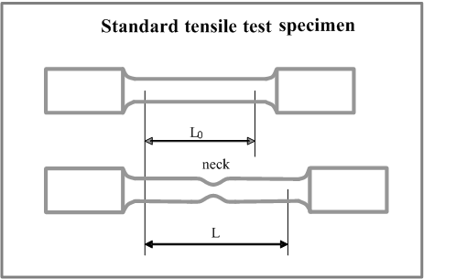
Fig 17: Sample for tensile testing

Procedure:

Make two marks 1 inch apart on all the test specimen at the center of the narrow portion of the sample. Measure the width and thickness of the specimen to the nearest 0.001 mm. Tare the load cell reading. Place the specimen in the grips of the testing machine and tighten the grips. Set the required speed (5mm/min) of testing machine and start the test. Record the load and extension at the yield point and at the moment of rupture. Calculate the tensile strength at yield, ultimate tensile strength.
Tensile strength (Kg /cm2) = F / A
Where, F is load at the yield or breaking of sample, A is cross sectional area of sample
Significance: this test indicates the strength and elasticity of materials. Data is used for plastic engineering design.
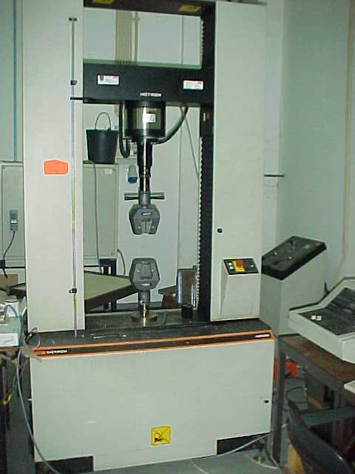
Fig 18: Instron universal testing machine

- Density (ASTM D 1505)

Density of composite sheet material is determined by water displacement method.
The specimen was weighed in air. The specimen was then tied with a fine wire and suspended from the balance head into the immersion vessel (filled with distilled water) placed so on a support. Sufficient care was taken such that the specimen and the wire did not touch the vessel and there were no bubbles adhering to the specimen, wire or vessel. The suspended specimen was then weighed.
Density of the specimen was calculated as follows:

Density = Wt. of specimen in air X Sp. gravity of water at 23⁰C
Wt. loss in water

- Izod impact strength (ASTM D 256)

The impact properties of the polymeric materials are directly related to the overall toughness of the material. Impact energy is a measure of toughness. Impact strength is the energy required to break the notched and unnotched specimen under test condition.
Equipment : CEAST Izod Impact Testing Machine and V – Notch Cutting Machine
Test Specimen : Rectangular bar cut from sheet, having the dimensions (100 mm x 12 mm x 3.0 mm 3.0 & 12.7mm).

Izod Impact Energy =

Procedure:

Select the 2.75 J Energy 'hammer'. Set the instrument for required range, according to the hammer installed. Release the hammer without the specimen. Value on the display indicates the amount of energy lost due to friction, windage etc. This value must be subtracted from each sample reading.
Release the hammer.
Note the breaking energy value on the digital display.

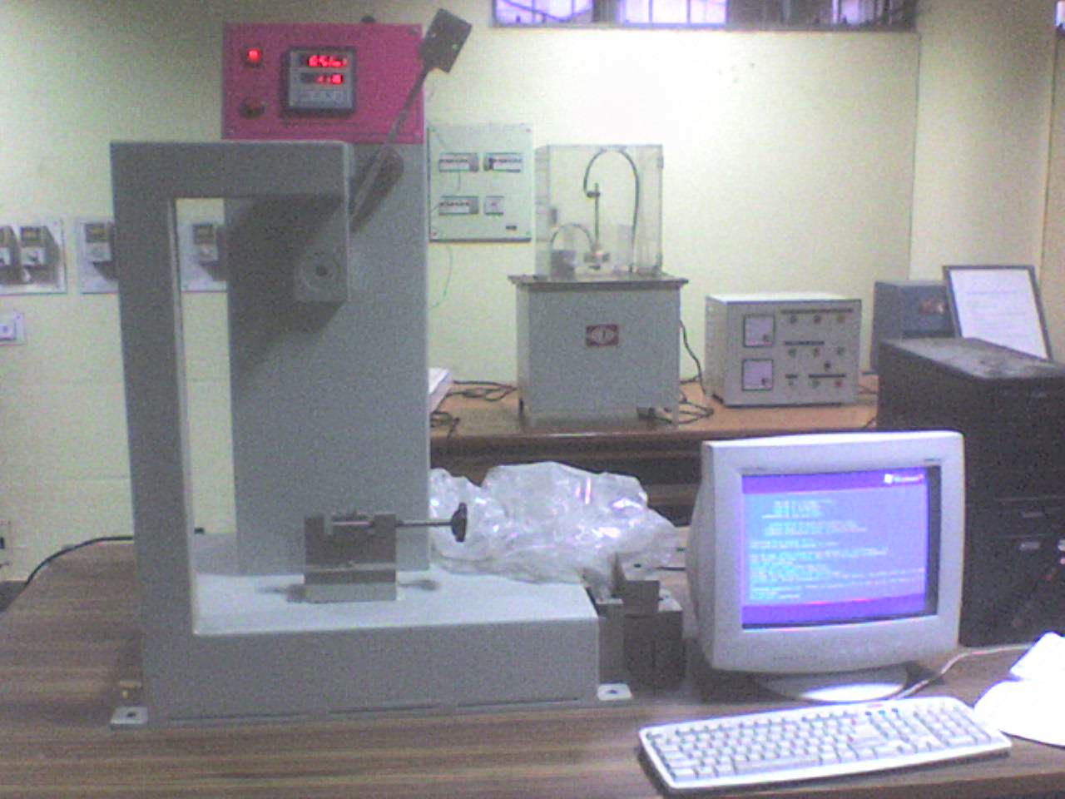
Fig 19: Izod impact testing machine
D) Flexural modulus /strength (ASTM D 790)
The flexural strength of a material is its ability to resist deformation under load for materials that do not break the load at yield, typically measured at 5% deformation / strain of the outer surface. Flexural modulus is the measure of stiffness. Stiffness means resistance to bending. Higher the modulus the greater the stiffness.
Equipment: Instron universal testing machine and Star Testing Systems, UTM, Mumbai.
Sample: Rectangular bar of dimensions of length 120 mm, width 12mm, thickness 3 mm. Support span length 16 times the thickness of the specimen.
σ = 3 PL / 2 bd2
σ = flexural strength (Max. fibre stress in the specimen)
P = weight. To be applied in kN.
b = width of specimen in m
h = depth of specimen in m
L = support span in m

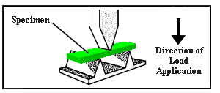
Fig 20: mechanism of flexural testing

Procedure:

Mount the appropriate load cell on the machine. Attach the loading nose to the load cell and the supports to stationary cross head. Switch on the machine and set the instrument parameters, set speed of testing. Enter the width and thickness of the sample. Set the support span. Center the specimen on the supports. Start the experiment and Flexural yield strength and modulus of elasticity are recorded in Kg / cm2 (mPa)

E) Shore D hardness (ASTM D 2240)

It is the resistance of a material to permanent deformation such as indentation or scratching.
Equipment: CEAST (Italy) Durometer Hardness tester
Test Specimen Molded specimen of minimum thickness 6 mm or cut from sheet. Two or more samples of lesser thickness can be pilled up to achieve the desired thickness.
Procedure
Place the specimen on hard, even and horizontal surface. Hold the tester vertically on the specimen (while holding the pressure foot should be parallel to the surface of the specimen. Apply the pressure with hand without shock so that casting is fully pressed against the specimen. Take reading after about 3 seconds after the contact between the surface of the specimen and the pressure foot is made.
Three readings are taken on each specimen and the mean value of three reading is taken as hardness value (number) as shore D.
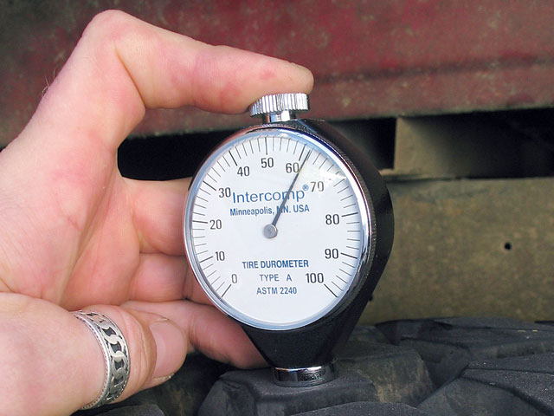
Fig 21: Durometer hardness tester

- Water absorption (ASTM D 570)

This test method covers the determination of the rate of water absorption by plastics when immersed.
Apparatus: Balance an analytical balance of reading 0.0001 g. Oven, capable of maintaining uniform temperatures
Procedure:
Each specimen is weighed to an accuracy of not less than .01 g. The specimen was than submerged horizontally under 25 mm fresh clean water maintained at a temperature. The period of immersion shall be 24 hour or period for which absorption value is needed. The test specimen taken out from the water bath at the end of the appropriate period and excess water shall be wiped off with damped cloth. Each specimen then is reweighed to an accuracy of .01 g.
Water absorption (%) = (M₂ ― M₁ / M₁) * 100
Where M₁ is mass of test specimen before immersion in gm, M₂ is mass of test specimen after immersion in gm

- Thermo gravimetric analysis (TGA)

Thermo Gravimetric Analysis (TGA) is a thermal analysis technique used to measure changes in the weight (mass) of a sample as a function of temperature and/or time.
TGA is commonly used to determine polymer degradation temperatures, residual solvent levels, absorbed moisture content, and the amount of inorganic (noncombustible) filler in polymer or composite material compositions.

PROCEDURE:
A sample (2-4 mg) is placed into a tarred TGA sample pan, which is attached to a sensitive microbalance assembly. The sample holder portion of the TGA balance assembly is subsequently placed into a high temperature furnace. The balance assembly measures the initial sample weight at room temperature and then continuously monitors changes in sample weight (losses or gains) as heat is applied to the sample. TGA tests may be run in a heating mode at some controlled heating rate (5⁰C), or isothermally. Typical weight loss profiles are analyzed for the amount or percent of weight loss at any given temperature, the amount or percent of non-combusted residue at some final temperature, and the temperatures of various sample degradation processes.

i) Applications of TGA:

TGA measures the weight change in materials as a function of time and temperature.
The Measurements provide basic information about the thermal stability of a chemical
and its composition. TGA is one of the most commonly requested thermal techniques
and it is used to characterize both inorganic and organic materials, including polymers.
The measurement is typically carried out on milligram size samples with a heat rate of
10°C/min from 20° to 800°C in a nitrogen atmosphere.

- Heat distortion temperature (ASTM D 648)

HDT is temperature at which a test bar deflects 1/100th. of an inch under stress of 4.6 or 18.4 Kg/cm2. It is the temperature resistance of the material under load. It is the continuous service temperature of the material.
Equipment: Toyo Seiki Seisaku-Sho Ltd, HDT Apparatus
Test Specimen in the form of rectangular bar cut from sheet.
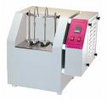
Fig 22: HDT and VST Apparatus
Procedure: The specimen is supported in oil bath and subjected to fibre stress of 4.6 or 18.4 Kg/cm2. Temperature of the oil raised at a 2⁰C/min constant rate. Temperature indicator mounted on the load bar indicates the degree of bending. According to specimen dimension the wt. to be applied is calculated by using the following formula.
P =
Where, P = weight. To be applied in kN., σ = Max. fibre stress in the specimen, b = width of specimen in m, h = depth of specimen in m, L = support span in m

I) Vicat softening temperature (ASTM D 1525)
It indicates heat resistance property of the plastic material. Higher value, higher the heat resistance. Temperature at which a flat ended needle of 1 mm² circular cross-section indents 1 mm depth on the specimen subjected to control rate of heating under a specified subjected to control rate of heating under a specified load.
Equipment: Toyo Seiki Seisaku-Sho Ltd VSP testing apparatus.
Test specimen is a rectangular bar of 20 mm x 20 mm x 3.0 mm dimension of compression moulded sheet.
Procedure: The specimen is kept in an oil bath under the needle with 5 kg load. The temperature of oil bath is increased at 1⁰C/min uniform rate. Dial gauge mounted on the needle indicates the depth of indentation on the sample.

CHAPTER-5
Result and Discussion

5.1 Composition of euphorbia coagulum:

The main constituents of the euphorbia coagulum are euphorbia resin (75.1%), protein (14.3%) and isoprene rubber (5.6%). Euphorbia resin is the main constituent of euphorbia coagulum.

5.2 Effect on properties with variation in fiber weight fraction.

The variation in different properties of polyester banana fiber composites with variation in fiber weight fraction in the composites was described in table .6. The values show that 35 wt. % banana fibers is optimized condition for the polyester banana fiber composites development. Above this wt. % of fiber the properties of composites start to decrease or constant. Fiber can not thoroughly wetted by resin beyond this wt % of fiber. .

Table No. 6: Effect on properties of composites with variation in fiber weight fraction.
Fiber Variation (wt. %) | Density (g/cm³) | Water Absor-ption %@24 hrs | Impact Strength (J/m) |  | Tensile Strength  (MPa) | Flexural Strength (MPa) | Flexural Modulus  (MPa) | Hardness  Shore D | HDT (^{O}C) | VST(^{O}C)
Fiber Variation (wt. %) | Density (g/cm³) | Water Absor-ption %@24 hrs | Unnotched | Notched
20% | 1.0158 | 6.0 | 102 | 59 | 10.0 | 16.2 | 1080 | 54 | 62.2 | 58.0
25% | 0.9821 | 7.6 | 106 | 65 | 11.1 | 18.1 | 1130 | 55 | 62.3 | 58.8
30% | 0.9584 | 8.2 | 114 | 70 | 12.2 | 18.5 | 1160 | 57 | 62.8 | 59.7
35% | .9472 | 10.1 | 120 | 76 | 14.1 | 20.1 | 1202 | 60.2 | 63.1 | 60.9
40% | .9406 | 11.8 | 122 | 79 | 14.0 | 20.2 | 1205 | 61 | 63.2 | 60.9
45% | .9396 | 14.0 | 120 | 75 | 14.5 | 20.2 | 1196 | 61 | 63.0 | 60.4

5.3 The effect of euphorbia coagulum on properties of polyester -banana fiber composites
The effect of euphorbia coagulum on properties of polyester -banana fiber composites are described in table 7. Density of polyester-banana fiber was decreased with adding of euphorbia coagulum in these composites. The water absorption decrease 23 % with replacing the 40 %

polyester with coagulum. The impact strength, flexural strength, flexural modulus, tensile strength and hardness increased with adding the coagulum in the polyester banana fiber composites up to 30-40 wt %. HDT decrease with increasing the addition of coagulum in the polyester banana fiber composites. VST was increasing with substitution of polyester by coagulum in composites. The impact strength, flexural strength, flexural modulus, tensile strength and hardness maximum increased up to 20-25 %, 20 %, 8 %, 28 % and 5 %, correspondingly with addition of coagulum in polyester composites.

Table No. 7: The effect of euphorbia coagulum on properties of polyester -banana fiber composites.

Polyester + coagulum fiber | Density  (g/cm³) | Water Absorption  %@24 hrs | Impact Strength (J/m) |  | Tensile Strength  (MPa) | Flexural Strength (MPa) | Flexural ModulusMPa | Hardness  Shore D | HDT  (^{O}C) | VST  (^{O}C)
Polyester + coagulum fiber | Density  (g/cm³) | Water Absorption  %@24 hrs | Un-notched | Notched
100:0 | .9472 | 10.1 | 120 | 76 | 14.1 | 20.1 | 1202 | 60.2 | 63.1 | 60.9
90:10 | .9201 | 9.2 | 129 | 78 | 15.2 | 22.0 | 1221 | 60.5 | 60.0 | 61.2
80:20 | .8998 | 8.7 | 136 | 82 | 16.1 | 22.8 | 1264 | 60.9 | 59.5 | 61.2
70:30 | .8642 | 8.1 | 144 | 87 | 18.0 | 24.0 | 1300 | 62.0 | 58.0 | 61.4
60:40 | .8332 | 7.8 | 150 | 90 | 18.2 | 23.8 | 1256 | 62.1 | 57.4 | 61.6
50:50 | .8076 | 7.3 | 151 | 89 | 17.9 | 23.3 | 1250 | 62.0 | 56.0 | 61.9
40:60 | .7732 | 6.9 | 136 | 82 | 16.3 | 22.3 | 1204 | 62.8 | 54.7 | 62.5
30:70 | .7618 | 6.7 | 121 | 75 | 15.6 | 20.6 | 1196 | 63.0 | 53.4 | 62.9
20:80 | .7406 | 6.3 | 115 | 72 | 14.1 | 18.4 | 1181 | 63.4 | 52.5 | 63.0
10:90 | .7215 | 5.9 | 108 | 70 | 12.2 | 16.6 | 1140 | 64.0 | 51.4 | 63.2
0:100 | .7134 | 5.4 | 100 | 65 | 10.1 | 15.2 | 1106 | 64.0 | 50.1 | 64.0

a) Density
The density of banana fiber polyester composite and coagulum modified polyester composites are showed in table 8. The values show that density of composites decrease with increasing coagulum wt. % in the polyester banana fiber composites. The density of composites was further decreased when banana fiber treated with NaOH and Natural latex. When fiber treated with acrylic acid density of composites was increased

Table No. 8: Variation in density of treated and untreated polyester banana fiber composites with variation in coagulum wt fraction.

Polyester + Coagulum | Untreated Banana Fiber(g/cm³) | Acid Treated Banana Fiber(g/cm³) | Alkali Treated Banana Fiber(g/cm³) | Natural Latex Treated Banana fiber(g/cm³)
100/.0 | 0.9472 | 0.9968 | 0.9012 | 0.9436
90/10 | 0.9201 | 0.9796 | 0.8862 | 0.9298
80/20 | 0.8998 | 0.9487 | 0.8758 | 0.9114
70/30 | 0.8642 | 0.9356 | 0.8604 | 0.9052
60/40 | 0.8332 | 0.9198 | 0.8566 | 0.8906
50/50 | 0.8076 | 0.9075 | 0.8498 | 0.8816
40/60 | 0.7732 | 0.8892 | 0.8354 | 0.8706
30/70 | 0.7618 | 0.8786 | 0.8266 | 0.8562
20/80 | 0.7406 | 0.8668 | 0.8198 | 0.8408
10//90 | 0.7215 | 0.8561 | 0.8108 | 0.8312
0/100 | 0.7134 | 0.8432 | 0.8058 | 0.8249

The density of banana fiber polyester composite and coagulum modified polyester composites are shown in fig 23. The graph show that there are maximum decreases in density of alkali treated fiber composite. The maximum effect of coagulum was found in the non treated fiber composites. The density of untreated fiber composites decreased maximum than treated fiber with increase in coagulum wt % in polyester resin.

Fig 23: Variation in density of treated and untreated polyester banana fiber composites with variation in coagulum wt fraction.

b) Water absorption
The Water absorption of banana fiber polyester composite and coagulum modified polyester composites are showed in table 9. The values show that water absorption decreased with increase in coagulum wt fraction in polyester banana fiber composites. Water absorption was also decrease with treatment of banana fiber with acrylic acid, alkali, and natural latex.

Table No. 9: Variation in water absorption of treated and untreated polyester banana fiber composites with variation in coagulum wt fraction.

Polyester + Coagulum | Un- Treated Banana Fiber | Acid Treated Banana Fiber | Alkali Treated Banana Fiber | Natural Latex Treated Banana fiber
100/.0 | 10.1 | 6.3 | 7.2 | 5.1
90/10 | 9.2 | 5.7 | 6.8 | 4.9
80/20 | 8.7 | 5.5 | 6.3 | 4.8
70/30 | 8.1 | 5.1 | 6.1 | 4.8
60/40 | 7.8 | 4.9 | 5.9 | 4.5
50/50 | 7.3 | 4.8 | 5.5 | 4.4
40/60 | 6.9 | 4.4 | 5.3 | 4.4
30/70 | 6.7 | 4.2 | 5.1 | 4.2
20/80 | 6.3 | 3.9 | 4.9 | 4.1
10//90 | 5.9 | 3.7 | 4.6 | 4.1
0/100 | 5.4 | 3.3 | 4.1 | 3.8

The water absorption of banana fiber polyester composite and coagulum modified polyester composites are showed in fig 24. The values show that water absorption decrease with increase in coagulum wt. fraction in polyester banana fiber composite. Polyester-euphorbia coagulum (70:30) composites absorbed 22% less water than 100% polyester banana fiber composites. Water absorption was also decrease with treatment of banana fiber with acrylic acid, alkali, and natural latex. Water absorption maximum decrease in acrylic acid treated fiber composites. Natural latex treated Polyester banana fiber composites absorb 49% less water than untreated fiber composites. Acrylic acid and alkali treated fiber composites absorbs correspondingly 37% and 28 % less water than untreated fiber composites.

Fig 24: Variation in water absorption of treated and untreated polyester banana fiber composites with variation in coagulum wt fraction.

- Izod impact strength:

The izod impact strength of banana fiber polyester composite and coagulum modified polyester composites are described in table 10. The values show that impact strength of notched and unnotched sample increase with increase in coagulum wt. fraction in polyester banana fiber composites. Impact strength was also increase with treatment of banana fiber with acrylic acid, alkali, and natural latex.

Table No. 10: Variation in impact strength of treated and untreated polyester banana fiber composites with variation in coagulum wt. fraction.

Polyester + coagulum | Un-Treated Banana Fiber (J/m) |  | Acid Treated Banana Fiber (J/m) |  | Alkali Treated Banana Fiber (J/m) |  | Natural Latex Treated Banana fiber (J/m)
Polyester + coagulum | Un-notched | Notched | Un-notched | Notched | Un-notched | Notched | Un-notched | Notched
100/.0 | 120 | 76 | 135 | 90 | 140 | 92 | 148 | 96
90/10 | 129 | 78 | 142 | 94 | 149 | 95 | 156 | 99
80/20 | 136 | 82 | 156 | 100 | 158 | 103 | 164 | 107
70/30 | 144 | 87 | 167 | 107 | 170 | 110 | 179 | 115
60/40 | 150 | 90 | 170 | 110 | 175 | 115 | 184 | 120
50/50 | 151 | 89 | 169 | 109 | 172 | 113 | 183 | 118
40/60 | 136 | 82 | 150 | 98 | 164 | 102 | 171 | 111
30/70 | 121 | 75 | 138 | 91 | 148 | 96 | 159 | 103
20/80 | 115 | 72 | 129 | 86 | 135 | 91 | 148 | 96
10//90 | 108 | 70 | 121 | 79 | 128 | 86 | 136 | 92
0/100 | 100 | 65 | 115 | 74 | 120 | 80 | 129 | 84

The figure 25.shows the izod impact strength of unnotched sample of banana fiber polyester composite and coagulum modified polyester composites . The values show that impact strength of unnotched sample increase with increase in coagulum wt. % in polyester banana fiber composite. Impact strength was increase up to 24% in the polyester coagulum composites (60:40) than polyester fiber composites.
Impact strength was also increased with treatment of banana fiber with acrylic acid, alkali, and natural latex. The impact strength maximum increased up to 25% in natural latex treated composites than untreated fiber composites.

Fig 25: Variation in impact strength of treated and untreated polyester banana fiber composites (unnotched) with variation in coagulum wt. fraction.

The figure 26 shows the izod impact strength of notched sample of banana fiber polyester composite and coagulum modified polyester composites. The values show that impact strength of notched sample increase with increase in coagulum wt.% in polyester banana fiber composite. Impact strength was increased up to 18 % in the polyester coagulum (60:40) composites than polyester fiber composites.
Impct strength was also increase with treatment of banana fiber with acrylic acid, alkali, and natural latex. The impact strength maximum increase up to 23 % in natural latex treated composites than untreated fiber composites..

Fig 26: Variation in impact strength of treated and untreated polyester banana fiber composites (notched) with variation in coagulum wt. fraction.

- Tensile strength:

The tensile strength of banana fiber polyester composite and coagulum modified polyester composites are showed in table 11. The values shows that tensile strength of composites sample increase with increase in coagulum wt.% in polyester banana fiber composite. Tensile strength was also increase with treatment of banana fiber with acrylic acid, alkali, and natural latex. The maximum increasing in tensile strength was found in acrylic acid treated fiber composites.

Table No. 11: Variation in Tensile Strength of treated and untreated polyester banana fiber composites with variation in coagulum wt fraction.

Polyester + coagulum | Un-Treated Banana Fiber (MPa) | Acid Treated Banana Fiber(MPa) | Alkali Treated Banana Fiber (MPa) | Natural Latex Treated Banana fiber(MPa)
100/.0 | 14.1 | 20.1 | 18.2 | 17.5
90/10 | 15.2 | 21.9 | 19.2 | 18.4
80/20 | 16.1 | 22.8 | 20.7 | 19.8
70/30 | 18 | 24.6 | 21.9 | 21.3
60/40 | 18.2 | 25.1 | 23.8 | 23
50/50 | 17.9 | 23.9 | 23.7 | 23.1
40/60 | 16.3 | 21.8 | 21.3 | 22.2
30/70 | 15.6 | 18.5 | 18.9 | 18.6
20/80 | 14.1 | 17.3 | 16.6 | 16.5
10//90 | 12.2 | 15.6 | 15.2 | 15.1
0/100 | 10.1 | 14.6 | 13.1 | 13

The figure 27 shows the tensile strength of banana fiber polyester composite and coagulum modified polyester composites. The values show that tensile strength of sample increase with increase in coagulum up to 40 wt% in the polyester composite. Tensile strength increased up to 29% in the polyester coagulum (60:40) composites than polyester fiber composites.

Fig 27: Variation in Tensile Strength of treated and untreated polyester banana fiber composites with variation in coagulum wt fraction.

Tensile strength was also increase with treatment of banana fiber with acrylic acid, alkali, and natural latex. The tensile strength maximum increased up to 41 % in acrylic acid treated composites than untreated fiber composites.

e) Flexural strength
The flexural strength of banana fiber polyester composite and coagulum modified polyester composites are showed in table 12. The values show that flexural strength of composites sample increase with increase in coagulum wt % in polyester banana fiber composite. Flexural strength was also increase with treatment of banana fiber with acrylic acid, alkali, but slightly decreases with natural latex treatment. The acrylic acid treated fiber composites increased the flexural strength maximum than other treated fiber composites.

Table No. 12: Variation in flexural strength of treated and untreated polyester banana fiber composites with variation in coagulum wt fraction.

Polyester + coagulum | Un-Treated Banana Fiber (MPa) | Acid Treated Banana Fiber(MPa) | Alkali Treated Banana Fiber (MPa) | Natural Latex Treated Banana fiber(MPa)
100/.0 | 20.1 | 29.2 | 26.1 | 18
90/10 | 22 | 30.6 | 27.8 | 19.4
80/20 | 22.8 | 32.8 | 29.9 | 20.8
70/30 | 24 | 35.1 | 32 | 21.6
60/40 | 23.8 | 35 | 32.4 | 21.8
50/50 | 23.3 | 33.2 | 31.8 | 21.2
40/60 | 22.3 | 31.6 | 28.1 | 20.1
30/70 | 20.6 | 28.3 | 26.8 | 18.6
20/80 | 18.4 | 26.8 | 23.9 | 16.8
10//90 | 16.6 | 24.9 | 20.2 | 15.4
0/100 | 15.2 | 22.3 | 18.6 | 14.1

The figure 28 shows the flexural strength of banana fiber polyester composite and coagulum modified polyester composites. The values show that flexural strength of sample increased with increase in coagulum up to 30 wt % in the polyester banana fiber composite. Flexural strength increase up to 20% in the polyester coagulum (70:30) composites than polyester fiber composites. Flexural strength was also increase with treatment of banana fiber with acrylic acid, alkali, but slightly decreases with natural latex. The flexural strength maximum increase up to 51 % in acrylic acid treated composites.

Fig 28: Variation in flexural strength of treated and untreated polyester banana fiber composites with variation in coagulum wt fraction.

f) Flexural modulus
The flexural modulus of banana fiber polyester composite and coagulum modified polyester composites are shows in table 13. The values show that flexural modulus of composites sample increase with increase in coagulum wt % in polyester banana fiber composite. Flexural modulus was also increase with treatment of banana fiber with acrylic acid, alkali, and natural latex. The flexural modulus was maximum increased in alkali (NaOH) treated fiber composites than untreated fiber composites.

Table No. 13: Variation in flexural modulus of treated and untreated polyester banana fiber composites with variation in coagulum wt fraction.

Polyester + coagulum | Un-Treated Banana Fiber (MPa) | Acid Treated Banana Fiber (MPa) | Alkali Treated Banana Fiber(MPa) | Natural Latex Treated Banana fiber (MPa)
100/.0 | 1202 | 1352 | 1375 | 1340
90/10 | 1221 | 1389 | 1405 | 1386
80/20 | 1264 | 1422 | 1446 | 1415
70/30 | 1300 | 1466 | 1486 | 1446
60/40 | 1256 | 1450 | 1480 | 1430
50/50 | 1250 | 1415 | 1456 | 1395
40/60 | 1204 | 1366 | 1408 | 1366
30/70 | 1196 | 1340 | 1361 | 1321
20/80 | 1181 | 1302 | 1330 | 1302
10//90 | 1140 | 1290 | 1296 | 1266
0/100 | 1106 | 1240 | 1261 | 1223

The figure 29 show the flexural modulus of banana fiber polyester composite and coagulum modified polyester composites. The values show that flexural modulus of sample increase with increase in coagulum wt fraction up to 30% in the polyester composite. Flexural modulus increase up to 8% in the polyester coagulum (70:30) composites than polyester composites.
Flexural modulus was also increase with treatment of banana fiber with acrylic acid, alkali, and natural latex. The flexural modulus maximum increase up to 18 % in alkali treated fiber composites.

Fig 29: Variation in flexural modulus of treated and untreated polyester banana fiber composites with variation in coagulum wt fraction.

g) Shore D hardness

The shore D hardness of banana fiber polyester composite and coagulum modified polyester banana fiber composites are showed in table 14. The values show that hardness of composites sample increase with increase in coagulum wt % in polyester banana fiber composites. Shore D hardness was also increase with treatment of banana fiber with acrylic acid, alkali, but slightly decrease with natural latex. The hardness maximum increased up to 8.6% in acrylic acid treated fiber composites than untreated fiber composites.

Table No. 14: Variation in Shore D Hardness of treated and untreated polyester banana fiber composites with variation in coagulum wt fraction.

Polyester + coagulum | Un-Treated Banana Fiber (Shore D) | Acid Treated Banana Fiber (Shore D) | Alkali Treated Banana Fiber (Shore D) | Natural Latex Treated Banana fiber (Shore D)
100/.0 | 60.2 | 65.1 | 64.6 | 59.1
90/10 | 60.5 | 65.6 | 64.9 | 60.3
80/20 | 60.9 | 66.2 | 65.3 | 60.9
70/30 | 62 | 67.1 | 65.8 | 61.3
60/40 | 62.1 | 67.4 | 66.4 | 61.6
50/50 | 62 | 67.9 | 66.9 | 62
40/60 | 62.8 | 68.2 | 67.2 | 62.5
30/70 | 63 | 68.5 | 67.8 | 62.8
20/80 | 63.4 | 69.1 | 68.4 | 63.3
10//90 | 64 | 69.5 | 69.1 | 63.8
0/100 | 64 | 70.1 | 70 | 64.1

The figure 30 shows the shore D hardness of banana fiber polyester composite and coagulum modified polyester composites. The values show that hardness of sample increase with increase in coagulum wt fraction up to 100% in the polyester banana fiber composites. . Hardness increase up to 3.5% in the polyester coagulum (70:40) composites than polyester fiber composites. Hardness was also increase with treatment of banana fiber with acrylic acid, alkali, but slightly decreases with natural latex. The hardness maximum increased up to 8.6% in acrylic acid treated composites than untreated fiber composites
Fig 30: Variation in Shore D Hardness of treated and untreated polyester banana fiber composites with variation in coagulum wt fraction.

h) Heat distortion temperature
The HDT of banana fiber polyester composite and coagulum modified polyester fiber composites are shows in table 15. The values described that HDT of composites sample decrease with increase in coagulum wt % in polyester banana fiber composite. HDT was increased with treatment of banana fiber with acrylic acid, alkali, but slightly decrease with natural latex treatment composites. The HDT of NaOH treated fiber composites was maximum increased.

Table No. 15: Variation in HDT of treated and untreated polyester banana fiber composites with variation in coagulum wt fraction.

Polyester + coagulum | Un-Treated Banana Fiber (^{O}C) | Acid Treated Banana Fiber (^{O}C) | Alkali Treated Banana Fiber (^{O}C) | Natural Latex Treated Banana fiber (^{O}C)
100/.0 | 63.1 | 65 | 65.1 | 61.9
90/10 | 60 | 63.2 | 64.2 | 61
80/20 | 59.5 | 61.1 | 62.9 | 59.3
70/30 | 58 | 60.1 | 61.8 | 57.6
60/40 | 57.4 | 58.9 | 60.4 | 55.2
50/50 | 56 | 58.2 | 59.7 | 54.6
40/60 | 54.7 | 57.8 | 58.8 | 53.4
30/70 | 53.8 | 57.3 | 57.9 | 52.8
20/80 | 52.5 | 56.6 | 57 | 51.2
10//90 | 51.4 | 55.9 | 55.9 | 50.6
0/100 | 50.1 | 55 | 54.2 | 49.1

The figure 31 shows the HDT of banana fiber polyester composite and coagulum modified polyester composites. The values show that HDT of sample decrease with increase in coagulum wt % in the polyester banana fiber composite. HDT decreased up to 9.3% in the polyester coagulum (60:40) fiber composites than polyester fiber composites.
HDT was increased with treatment of banana fiber with acrylic acid, alkali, but slightly decrease with natural latex treated fiber composites The HDT maximum increased up to 6.5 % in NaOH treated fiber composites than untreated fiber composites.
Fig 31: Variation in HDT of treated and untreated polyester banana fiber composites with variation in coagulum wt fraction.

i) Vicat softening temperature

The VST of banana fiber polyester composite and coagulum modified polyester composites are shows in table 16. The values described that VST of composites sample increase with increase in coagulum wt.fraction in polyester banana fiber composites. VST was also increased with treatment of banana fiber with acrylic acid, alkali, but slightly decrease with natural latex treatment. The VST of NaOH treated fiber composites was
maximum increased than untreated fiber composites.

Table No. 16: Variation in VST of treated and untreated polyester banana fiber composites with variation in coagulum wt fraction.

Polyester + coagulum | Un-Treated Banana Fiber (^{O}C) | Acid Treated Banana Fiber(^{O}C) | Alkali Treated Banana Fiber (^{O}C) | Natural Latex Treated Banana fiber(^{O}C)
100/.0 | 60.9 | 62.1 | 63.2 | 58.9
90/10 | 61.2 | 62.8 | 63.9 | 59.2
80/20 | 61.2 | 63.5 | 64.4 | 59.6
70/30 | 61.4 | 63.9 | 64.8 | 60.1
60/40 | 61.6 | 64.6 | 65.6 | 60.3
50/50 | 61.9 | 65.1 | 66.1 | 60.6
40/60 | 62.5 | 65.4 | 66.4 | 60.8
30/70 | 62.9 | 65.9 | 66.9 | 61.2
20/80 | 63 | 66.3 | 67.4 | 61.3
10//90 | 63.2 | 66.8 | 67.9 | 61.7
0/100 | 64 | 67.2 | 68.5 | 61.9

The figure 32 shows the VST of banana fiber polyester composite and coagulum modified polyester fiber composites. The values shows that VST of sample increase with increase in coagulum wt. fraction in the polyester fiber composite. VST was increased up to 3.8% in the polyester coagulum (60:40) fiber composites than polyester fiber composites.
VST was also increased with treatment of banana fiber with acrylic acid, alkali, but slightly decrease with natural latex. The VST was maximum increased up to 6.3 % in NaOH treated fiber composites than untreated fiber composites.

Fig 32: Variation in VST of treated and untreated polyester banana fiber composites with variation in coagulum wt fraction.

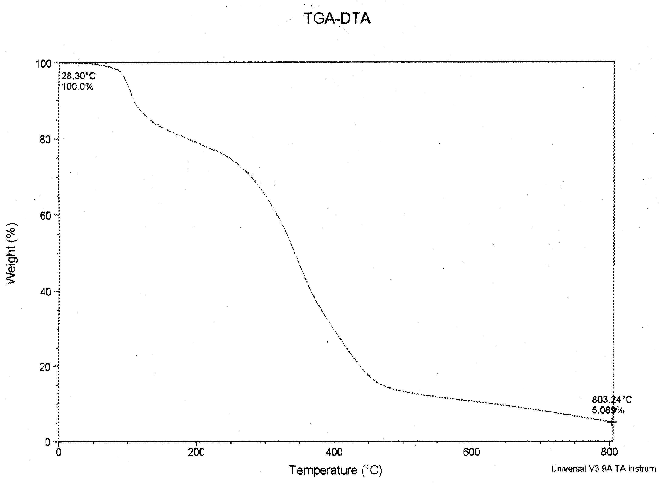
Fig 33: TGA thermogram of euphorbia coagulum.

j) TGA studies

Thermogravimetric Analysis (TGA) is a thermal analysis technique used to measure changes in the weight (mass) of a sample as a function of temperature and/or time.
TGA is commonly used to determine polymer degradation temperatures. The thermal stability of euphorbia coagulum is shown in fig 33. We found that the initial decomposition of euphorbia coagulum starts at 150⁰C and 50 % decomposition of coagulum occur at about 367⁰C. The fig 34 shows the TGA of polyester-euphorbia coagulum blends. We found that the stability of polyester-coagulum composites was good and very stable up to 200 ⁰C
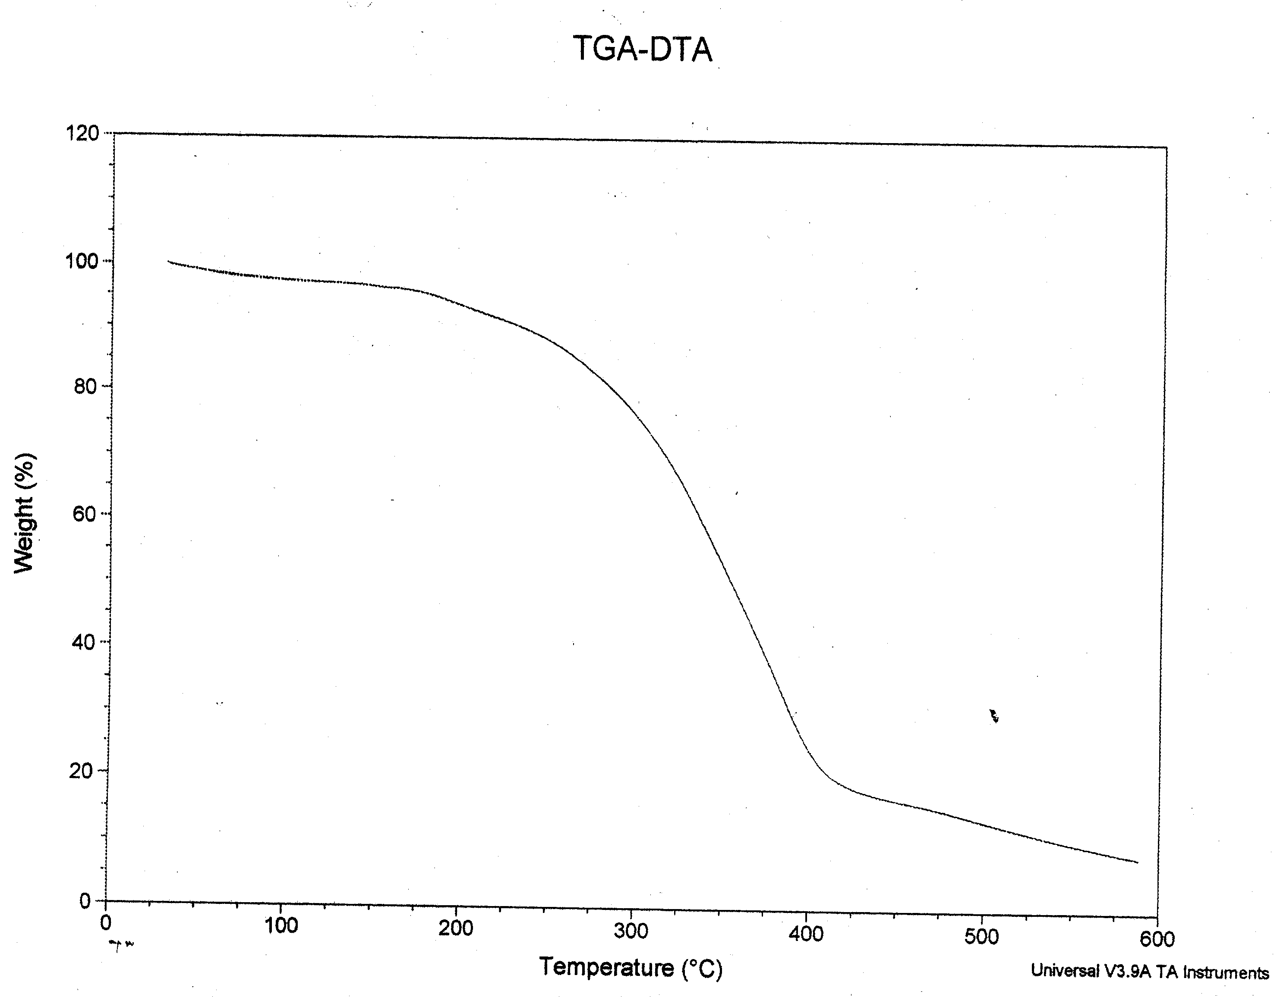

Fig 34: TGA thermogram of polyester-euphorbia coagulum composite.
Conclusion

The incorporation of bio-resources into the materials, products, and processes of today can satisfy these environmental concerns and reduce further dependency on petroleum reserves. The Euphorbia coagulum can replace the polyester resin in the banana fiber composites up to 35-40 weight percent without deteriorating the properties of composites. The Euphorbia coagulum enhances the thermo-mechanical properties of banana fiber reinforced polyester composites. Beyond 40 weight percent substitution of polyester by euphorbia coagulum, the property of composites decreases. Banana fiber can be used up to 30-35 weight percent of composite weight. In this way 50 weight fraction of composites can be substituted by renewable, recyclable and biodegradable materials. This may help in saving the about 50 % of petroleum based materials and decrease the burden of disposal and other environmental problem. We can make less depend on petroleum based materials. Through this work we can conclude that in near future, we could remain less dependent on fossil fuel based products with the added advantage of safer environment.

References

1. http://i-cias.com/e.o/sumer.htm
2. http://www.theplumber.com/history.html
3. Drumright, R.E., Gruber, P.R., and Henton, D.E., Polylactic acid technology, Adv. Mater., 12, 1841-1846, 2000.
4. Petrovic, Z., Guo, A., and Javani, I., Process for the Preparation of Vegetable Oil Based Polyols and Electroninsulating Casting Compounds Created from Vegetable Oil Based Polyols, V.S. Patent 6,107,433, 2000.
5. Thomas, S.M., Biomass Grass makes for composite Cars, Mater. World, 9, 24, 2001.
6. Mapleston, P., Automakers see strong promise in natural fiber reinforcements (thermoplastic reinforced with natural fiber), Modern Plast., 76, 73-74, 1999.
7. Mohanty, A.K., Wibowo, A., Misra, M., and Drzal, L.T., Effect of Process Engineering on the Performance of Natural Fiber Reinforced Cellulose Acetate Biocomposites, Compos. Part A: Appl. Sci. Manufac., 35, 363-370, 2004.
8. Mehta, G., Mohanty, A.K., Misra, M., and Drzal, L. T., Biobased resin as a toughening agent for biocomposites, Green Chem., 6, 254-258, 2004.
9. K.G. Satyanarayana, K. Sukumaran, P.S. Mukherjee, C. Pavithran and S. G. K. Pillai. “Natural Fiber –Polymer Composites” , J Cement and Concerte Composites, 12(2)(1990),pp. 117-136.
10. K.G. Satyanarayana, K. Sukumaran, A. G. Kulkarni, S. G. K. Pillai, and P. K. Rohatgi, “Fabrication and Properties of Natural Fiber-Reinforced Polyester Composites” , J. Composites, 17(4)(1986), pp. 329-333.
11. M. A. Mansur and M. A. Aziz,“Study of Bamboo-Mesh Reinforced Cement Composites” Int. Cement Composites and Lightweight Concrete, 5(3)(1983), pp. 165-17.
12. T. M. Gowda, A. C. B. Naidu, and R. Chhaya, “Some Mechanical Properties of Untreated Jute Fabric-Reinforced Polyester Composites”, J.Composites PartA: Applied Science and Manufacturing, 30(3) (1999), pp. 277-284.
13. L. Lundquist, B.Marque, P.-O. Hagstrand, Y. Leterrier and J.-A. E. M anson, “ Novel Pulp Fiber Reinfoced Thermoplastic Composite” , Composites Science and Technology, 63(1)(2003), pp. 137-152.
14. Laly A. Pothana, Zachariah Oommenb, and Sabu Thomas, “Dynamic Mechanical Analysis of Banana Fiber Reinforced Polyester Composites” , Composites Science and Technology, 63(2)(2003), pp. 283-293.
15. L. A. Pothan, T. Sabu, and Neelakantam,“Short Banana Fiber Reinforced Polyester Composits: Mechanical, Failure and Aging Characterstics”, J. Reinforceed Plasics and Composites, 16(8)(1997), pp. 744-765.
16. Mohanty, A.K., Misra, M., and Hinrichsen, G., Biofibers, biodegradable polymers and biocomposites: an overview, Macromol. Mater. Eng., 276/277, 2000.
17. Mohanty, A.K., Misra, M., Drzal, L.T., Compos Interface(2001),8,313
18. K.G. Satyanarayana, K. Sukumaran, A. G. Kulkarni, S. G. K. Pillai, and P. K. Rohatgi, P. K. Composites 1986, 17, 329.
19. Verma, I. K.; Anantha krishran,S. R.; krishnamoorthy,S. Composites 1989, 20, 383.
20. Chan, N.; Verma, S.; Rohatgi, P. K. Trop Sci 1987, 27, 215.
21. Rana, A. K.; Mitra, B.C.; Banerjee, A. N. J Appl Polym Sci 1999, 71, 531.
22. Ray, D.; Sarkar, B. K.; Rana, A. K.; Bose, N. R. Compos Appl Sci Manuf 2001, 32, 119.
23. Rout, J.; Tripathy,S. S.;Misra, M.; Mohanty, A. K.; Nayak, S. K. J Apl Polym Sci 2002, 84, 75.
24 Van Wyk, J.P.H. (2001) Biotechnology and the utilization of biowaste as a resource for bioproduct development. Trends BioTechnol. 19, 5, 172–177
25. Mohanty, A.K. et al. (2000) Biofibres, biodegradable polymers and biocomposites: An overview. Macromol. Mater. Eng. 276/277, 1–24
26. Atchison, J.E. (1976) Agricultural residues and other nonwood plant fibers. Science 191, 768–772
27. Majumdar, P. and Chanda, S. (2001) Chemical profile of some lignocellulosic crop residues. Indian J. Agric. Biochem. 14(1 & 2), 29–33
28. Lim, S.K. et al. (2001) Novel regenerated cellulose fibers from ricez straw. J. Appl. Poly. Sci. 82, 1705–1708
29. Satyanarayana, K.G. et al. (1986) Materials Science of Some Lignocellulosic Fibers. Metallography 19, 389–400
30. Kulkarni, A.G. et al. (1983) Mechanical properties of banana fibres. J. Mater. Sci. 18, 2290–2296
31. Ganjyal, G.M. et al. (2004) Biodegradable packaging foams of starch acetate blended with corn stalk fibers. J. Appl. Poly. Sci. 93, 2627–2633
32. Reddy, N. and Yang, Y. (2004) Structure of novel cellulosic fibers from cornhusks. Polymer Preprints (American Chemical Society, Division of Polymer Chemistry), 45 (2) 411
33. Focher, B. et al. (1998) Regenerated and graft copolymer fibers from stem-exploded wheat straw: characterization and properties. J. Appl. Poly. Sci. 67, 961–974
34. Batra, S.K. (1985) Other long vegetable fibers, in Handbook of Fiber Science and Technology: (Vol IV: Fiber Chemistry), pp. 727–808, Marcel Dekker
35. Sukumaran, K. et al. Structure, physical and mechanical properties of plant fibres of Kerala. Met Mater Process. 13, 2–4, 121–136
36. Ray, P.K. and Bandyopadhyay, S.B. (1965) An X-ray study of coir fibre. Indian J. Phys. 39, 421–427
37. Banerjee, P.K. et al. (2002) Investigation into homogeneity of coir fibres. Indian J. Fibre. Text. 27, 111–116
38. Gressel, J. and Zilberstein, A. (2003) Let them eat (GM) straw. Trends Biotechnol. 21, 525–530
39. Boruah, R.K. et al. (1998) Microstructural study of fibres extracted from wild banana plant by X-ray line broadening analysis. Indian J. Fibre. Text. 23(2), 76–80
40. Gumuskaya, E. and Usta, M. (2001) Crystalline structure properties of bleached and unbleached wheat straw soda-oxygen pulp. Turk. J. Agric. For. 26, 247–251
41. Riedel U and Nickel J, Natural fibre-reinforced biopolymers as construction materials: new discoveries. Angew Makromol Chem 272:34–40 (1999).
42. Hautala M, Pasila A and Pirila J, Use of hemp and flax in composite manufacture: a search for new production methods. Compos Part A: Appl Sci 35:11–16 (2004).
43. Bhattacharyya D and Jayaraman K, Manufacturing and evaluation of woodfibre–waste plastic composite sheets. Polym Polym Compos 11:433–440 (2003).
44 Brouwer WD, Natural fibre composites: where can flax compete with glass? Sampe J 36:18–23 (2000).
45. M.M. Belgacem and A. Gandini, Compos. Interfaces, 12, 41 (2005).
46. J. Morales, M.G. Olayo, G.J. Cruz, P. Herrera-Franco, and R. Olayo, J. Appl. Polym. Sci., 101, 3821 (2006).
47. J. George, S.S. Bhagawan, and S. Thomas, Compos. Interfaces, 5, 201 (1998).
48. C. Joly, R. Gauthier, and M. Escoubes, J. Appl. Polym. Sci., 61, 57 (1996).
49. I.V. Weyenberg, T.C. Truong, B. Vangrimde, and I. Verpoest, Compos. A, 37, 1368 (2006).
50. A.K. Bledzki and J. Gassan, Prog. Polym. Sci., 24, 221 (1999).
51. N.E. Zafeiropoulos, C.A. Baillie, and J.M. Hodgkinson, Compos. A, 33, 1183 (2002).
52. A.K. Bledzki, S. Reihmane, and J. Gassan, J. Appl. Polym. Sci., 59, 1329 (1996).
53. L.A. Pothan, S. Thomas, and G. Groeninckx, Compos. A, 37, 1260 (2006)

