DETECTION OF CANCEROUS TISSUES USING MORPHOLOGICAL FUNCTION

A DISSERTATION SUBMITTED IN PARTIAL FULFILLMENT OF THE
REQUIREMENT FOR THE AWARD OF THE DEGREE OF
MASTER OF ENGINEERING
IN
ELECTRONICS AND COMMUNICATION
BY
NEERA AGARWAL
DELHI UNIVERSITY ROLL No.10276---
UNDER THE GUIDANCE OF
Dr. RAJIV KAPOOR

ASSISTANT PROFESSOR

DEPARTMENT OF ELECTRONICS AND COMMUNICATION ENGINEERING
DELHI COLLEGE OF ENGINEERING
UNIVERSITY OF DELHI,
DELHI-110042
SESSION 2006

ACKNOWLEDGEMENT

I take this opportunity to express my gratitude to my Project guide Dr. RAJIV KAPOOR for his unwavering encouragement and support throughout this endeavor. His insight and expertise in this field motivated and supported me during the duration of this project. It is my privilege and honor to have worked under his supervision. His invaluable guidance and helpful discussion in every stage of this project really helped me in materializing this project. Without his constructive direction and invaluable advice, this work would not have been completed.

I would also like to take this opportunity to present my sincere regards to Mr.P.R.Chaddha, Head of the Department, Electronics and Communication Engineering, D. C. E. Delhi, for the support provided by him during the entire duration of degree course and especially for this thesis. My gratitude is also extended to all teaching and non- teaching staff for their unwavering encouragement and support in my pursuit for academics.

I wish to express my deepest love for my parents & family, whose endless love, understanding, and support during all these years have been the greatest assets in my life.

NEERA AGARWAL
University Roll No.-10276
College Roll No. - 08/E&C/06
Delhi College of Engineering,
University of Delhi, Delhi

Contents

1 Introduction
1.1 Introduction 1
1.2 Research Work in the Recent Past on Cancer Detection 2
1.3 CAD DIAGNOSIS 4
1.4 Image Segmentation 5
1.5 Morphological Processes 6
2 Literature survey

2.1: 3D Segmentation in MRI of Brain Tumors 10
2.2: A FAST DEFORMABLE REGION MODEL 10
2.3: A DEFORMABLE REGION MODEL 10
2.4: A Performance Evaluation of a Hybrid Multicast Transport protocol 11
2.5: A Non- invasive, Multi-modality Approach 11
2.6: POSITION SENSING OF MAGNETITE GEL 12
2.7: A BRAIN TUMOR DIAGNOSTIC SYSTEM 12
2.8: Hausdorff Distance based 3D Qualification 13
2.9: MEDICAL SIGNAL PROCESSING 13
2.10: Diffusion Tensor Visualization 14
2.11: ROBUST METHODOLOGY 14
2.12 Segmenting Brain Tumors 15
2.13: Mining Brain Tumors and Tracking their Growth Rates 15
2.14: Heating Properties of Re-entrant Resonant Applicator 16
2.15: Quantiﬁcation and classiﬁcation 16
2.16: A Comparative Study of Biomechanical Simulators 17
2.17: A Performance Evaluation of a Hybrid Multicast Transport Protocol 17
2.18: Bayesian Model Classiﬁcation 18
3. Objectives
3.1 Objectives 19
4. Experimental
4.1. Algorithms 20
4.2. Step wise brief explanation of above algorithm 21
5. Results and discussions
5.1 Hand Made Images: 26
5.2 MRI Images 76
6. Summary and Conclusions
6.1 Summary 79
6.2 Achievements 79
6.3 Drawbacks 79
6.4 Proposals for future 80
7. References 81
List of figures
Fig.1.1Comparison of Dilation and Erosion Operations 7
Fig. 1.2 Comparison of Opening and Closing Operations 7
Fig 5.1 Reference image 26
Fig: 5.2 Test image 28
Fig: 5.3 Test image 34
Fig: 5.4 Test image 40
Fig: 5.2 Test image 46
Fig: 5.6 Test image 52
Fig: 5.7 Test image 59
Fig: 5.8 Test image 66
Fig: 5.9 Test image 72
Fig: 5.10 MRI Reference image 77
Fig: 5.12 MRI Test image 78
Fig: 5.13 Test image 79
List of tables
1. Table 1: Standard morphological filters available and their description 8

Chapter 1

Introduction

1.1 INTRODUCTION

Cancer is and will becomes an increasingly important factor in global burden of disease in decades to come. The estimated number of new cases each year is expected to rise from 10 million in 2000 to 15 million by 2020.¹
Today we are living in fast pace world, instantaneous reply, faster response and steady calculations is what we aim at. With the advancement in technology as our life is turning into a heaven so does at extreme end there is a multifold increase in diseases. Among all these the most notorious is cancer. Enough is now known about cause of cancer and means of control. At least one-third of 10million new cases of cancer each year can be prevented if detected at an early stage and prompt treatment is provided. This is possible only if we have faster means of evaluation of cancerous tissues.
Lack of comprehensive, systematic approach and inefficient use of resources is obstacle to effective detection of cancer in both developed and developing countries. In far too many cases primary prevention and early detection and palliative care are neglected due to non treatment approaches regardless of the fact that whether they are cost effective of they tend to improve patients quality life.
To counteract this fast paced development of cancer we need to develop techniques that can evaluate the type, effects and stages of cancer in a short span of time and to a great level of accuracy. With this project we aim to promulgate the above stated aspect of faster and accurate detection of cancerous tissue. Though the program may have a hell lot of shortcomings, quite some of them even stated by us but to the best of our understanding we are trying to convey the idea behind the evaluation.
Cancer is a generic term for a group of more than 100 diseases that can affect any part of the body. Other terms used are malignant tumors and neoplasms. One defining feature of cancer is the rapid creation of abnormal cells which grow beyond their usual boundaries, and which can invade adjoining parts of the body and spread to other organs, a process referred to as metastasis. Metastases are the major cause of death from cancer.
Cancer is a leading cause of death worldwide. From a total of 58 million deaths worldwide in 2005, cancer accounts for 7.6 million (or 13%) of all deaths.
Cancers can broadly be divided into 5 major types, depending on the tissues that are affected:

- Carcinomas: These are common occurrences in cases of cancer. They affect the cells lining the external and internal surface of the body. Lung, breast, and colon cancers fall under this category.
- Sarcomas: These are the cancers that affect the cells of supporting tissues of the body such as bone, cartilage, connective tissue, muscle, and fat.
- Lymphomas: These are the cancers that affect the lymph nodes and tissues of the body’s immune system.
- Leukemias: These cancers usually collect in the bloodstream and affect immature blood cells regenerated by the bone marrow.
- Adenomas: These are cancers that affect glandular tissues like the thyroid, the pituitary gland, and the adrenal gland. They are usually benign in nature.

Today MRI, CT scan and X-ray evaluation are common means for detection of cancers.
1.2 Research Work in the Recent Past on Cancer Detection
Mammography
It is an x-ray procedure used in the screening and diagnosis of breast cancer which can reveal a tumor in the breast long before it can be felt. Screening mammography is the most efficient and cost-effective method available for detecting the signs of early breast cancer in asymptomatic women between the ages of 50 and 69.Medical radiologists normally describe the tumor in reference to its mass, shape and margins. Meanwhile, pattern recognition specialists believe in terms of images. Since there are significant gaps between two approaches, it has proven to be very difficult for those following the pattern recognition route to directly adapt parameters of mass, shape and margins for the automated recognition of different cancers. A meta-shape tool and conjugate meta-feature clustering technology have been developed for this kind of bridging. These represent initial steps in the descriptions of mass, shape and margins on the road towards possible automated mammograph image analysis. In this model, ten meta-shape feature clusters are used to provide a systematic means of representing different cancerous symptoms^{.[3]}
Direct digital mammography and digital enhancement of standard mammograms are actively being investigated. The use of MRI and specifically31P spectroscopy shows initial promise to increase the specificity of mammography. Several clinical trials are also under way to assess a possible niche which fine needle aspiration biopsy (FNAB) may occupy in the quest for early breast cancer detection. ^{[4]}
Mammograms are the soft X-rays meant for the detection of any lesions or cysts in breasts. Now days it is playing major role in the detection of breast cancer at an early stage. A lesion segmentation technique based on the extraction of catchments basins through a topographic representation of the mammography image is being used. Applying the watershed algorithm on a rough image leads to over segmentation problems. To avoid this, we have first carried out a pre processing step which consists to remove or attenuate the curvilinear structures present in a mammogram is carried out. Then the gradient of the pre processed image is calculated and finally the segmentation algorithm is applied to this latter image^{.[5]}
New method for automatic recognition of cancerous tissues from an image of a microscopic section is under development. Based on the shape and the size analysis of the observed cells, this method provides the physician with non subjective numerical values for four criteria of malignancy. This automatic approach is based on mathematical morphology, and more specifically on the use of Geodesy. This technique is used first to remove the background noise from the image and then to analyze the results in the light of medical information. ^{[6]}
The examination of morphological features is used as a universal procedure by pathologists to determine whether cells are cancerous. Generally speaking, the shapes of normal cells are more standard (either circular or oval) than those of cancerous cells. The objective was to construct an autonomous feature detection system, with the hope of finding some feature patterns, based on morphological shapes (contours), that could be used to separate cancerous cells from normal cells. A number of feature detectors (FDs) were initially generated at random. Then they were modified through evolutionary learning and cellular automata. The experimental result showed that this system was able to search appropriate FDs to identify cancerous cells in a self-organizing manner. It also showed that these FDs were general so that each of them could be used to identify more than one cancerous cell, and that there existed some common patterns of cell deformity among cancerous cells. ^{[7]}

1.3 CAD DIAGNOSIS

This technique is used for lung cancer screening through spiral X-ray CT. The intent is to develop standards for generating the database resource and to allow this database to be used for evaluating computer aided diagnostic (CAD) software methods. Initial interest is focused on spiral CT of the lung because of the recent interest in using this imaging modality for lung cancer screening for patients at high risk, where early intervention may significantly reduce cancer mortality rates. The use of CAD methods is rapidly emerging for this large-scale cancer screening application as these methods have the potential of improving the efficiency of screening. Lung imaging is a good physical model in that it involves the use of 3D CAD methods that require critical software optimization for both detection and classification^{. [8]}
Control of cancer includes the systematic and equitable implementation of evidence-based strategies for cancer prevention, early detection of cancer and management of patients with cancer.
- Up to one third of the cancer burden could be reduced by implementing cancer preventing strategies which are aimed at reducing the exposure to cancer risk mainly by:
  - changes in tobacco and alcohol use, and dietary and physical activity patterns
  - immunization against HPV infection
  - the control of occupational hazards
  - reducing exposure to sunlight
- Another third of the cancer burden could be cured if detected early and treated adequately.
  - Early detection of cancer is based on the observation that treatment is more effective when cancer is detected earlier. The aim is to detect the cancer when it is localized. There are two components of early detection programmes for cancer:
    - Education to promote early diagnosis by recognizing early signs of cancer such as: lumps, sores, persistent indigestion, persistent coughing, and bleeding from the body's orifices; and the importance of seeking prompt medical attention for these symptoms.
    - Screening is the identification by means of tests of people with early cancer or pre-cancer before signs are detectable. Screening tests are available for breast cancer (Mammography) and Cervical cancer (Cytology tests).
- Treatment of cancer is aimed at curing, prolonging life and improving quality of life of patients with cancer. Some of the most common cancer types such as breast cancer, cervical cancer and colorectal cancer have a high cure rate when detected early and treated according to best evidence. The principal methods of treatment are surgery, radiotherapy and chemotherapy. Fundamental for adequate treatment is an accurate diagnosis by means of investigations involving imaging technology (ultrasound, endoscopy, radiography) and laboratory (pathology).
- Relief from pain and other problems can be achieved in over 90% of all cancer patients by means of palliative care. Effective strategies exist for the provision of palliative care services for cancer patients and their families, even in low resource settings^{.[2]}
1.4 Image Segmentation
There has been a great deal of research on segmenting images with deformable models in recent years. ^{[13]} Active contours, or snakes, have been widely studied and applied in image analysis.
Their applications include edge detection ^{[14]}, segmentation of objects ^{[15]}, shape modeling ^{[16]} and motion tracking ^{[17]}.
Snake model is used widely in computer vision and image segmentation. However, there are problems in convergence processing to boundaries of human body image because of noise. Thus a new segmentation algorithm to human body image was being devised. First, rough edge is got by multi-scale algorithm of wavelet analysis, and then thinning method based on mathematical morphology is adopted to get edge map as foundation of Snake model. This method solves the problem that the edge based on wavelets analysis is not consecutive. And it improves Snake model’s anti-noise ability. ^{[18]}
1.5 Morphological Processes
Morphological analysis of images uses geometry and the shapes within images in its processes. We can use the morphological function processes to alter or extract shapes and thereby alter the image that contains these shapes. Morphological transformation of your object's image simplifies the image while maintaining the primary shape characteristics within the object.
Morphological operations apply a structuring element to an input image, creating an output image of the same size. In a morphological operation, the value of each pixel in the output image is based on a comparison of the corresponding pixel in the input image with its neighbors. By choosing the size and shape of the neighborhood, we can construct a morphological operation that is sensitive to specific shapes in the input image.
There are 4 basic morphological operations which are enlisted as follows:
- Dilation
- Erosion
- Opening
- Closing
Dilation: The Dilation function enlarges shapes by expanding their boundaries. White and light grey pixels are affected by the dilation process i.e. the shapes within your input object that appear white (binary and grayscale raster objects) or one of the lighter shades of grey (grayscale raster objects) become larger when you run the dilation process. Conversely, shapes that are black and/or darker shades of grey appear smaller. The extent to which each boundary is expanded is determined by the dimensions of the structural element.
Erosion: The Erosion function has the opposite effect of the Dilation operation. The Erosion operation contracts the boundaries of shapes. Erosion shrinks shapes according to the dimensions of a structural element, just as Dilation expands shapes.
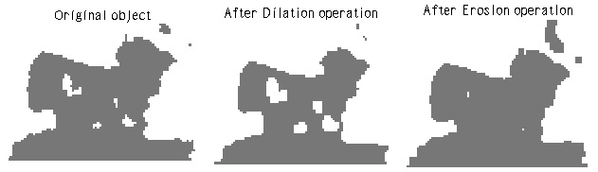
Fig. 1 Comparison of Dilation and Erosion Operations
Opening: The Opening operation consists of an Erosion operation followed by a Dilation operation. The Opening operation is often used to remove pixel noise from binary raster objects. Erosion of the shape removes thinner features, such as connections between shapes or protrusions. Then, the output of the erosion process is dilated, producing smoother edges. The center point of the square sits on the line that forms the boundary of a shape. The distance between the center point of the square and its outer edge is the amount by which the shape is first eroded and then dilated.
Closing: The Closing function also smoothes shapes, but unlike Opening, it enlarges thin or narrow features, fills narrow gaps, and eliminates small "holes" in shapes. Closing first applies the Dilation operation and then the Erosion operation. First, the shape is enlarged by the distance between the center point of the square and its outer edge. This process smoothes the shape and enlarges thinner features. Then the shape is eroded, or shrunk, by the specified distance of the structural element.
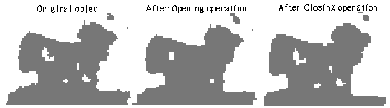
Fig. 2 Comparison of Opening and Closing Operations

Standard morphological filters available and their description are shown in the Table 1.

Filter | Description
Smooth
Contrast | 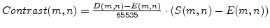-- Structural element is used here during the calculation of dilation and erosion.
Min | The new value for the point is taken as minimal one among the value of this point and eight neighbour points. In the terms of morphological operations -- this is an operation erosion with a structural element 3×3 where all the value are equal to zero
Max | The new value for the point is taken as maximal one among the value of this point and eight neighbour points. In the terms of morphological operations -- this is an operation dilation with a structural element 3×3 where all the values are equal to zero.
Dilate | Operation dilation with structural element.
Erode | Operation erosion with structural element.
Open | 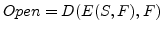
Close | 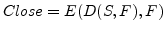
Gradient | 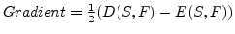
Laplace

Morphological Algorithms ^{[20]}
The implementation of the morphological transformations serves as an elementary brick in practical image analysis problem. Solving a moderately complex image analysis application by morphological methods often involves the concatenation of several tons and hundreds of elementary transformations.
Discrete grids and notations:
- G defines the neighbourhood relations between pixels. It is usually a square grid (with 4 or 8-connectivitiy) or a hexagonal grid with a connectivity of 6.
- N^{G} (P) denotes the set of neighbours on the pixel p.
- d^{G} (p, q) denotes the minimal length of the paths of G connecting p to q . This is called the discrete distance.

Chapter 2

Literature survey

2.1: 3D Segmentation in MRI of Brain Tumors: Preliminary Results

Tissue segmentation based on 2D and 3D feature map derived from high resolution MR images was performed in phantoms, normal humans and particularly those with brain tumors(four benign and two malignant). Three inputs: proton density, T2-and, as a third, TI-weight MRI, were utilized. Statistical and anisotropic diffusion filters were applied to the data and k-Nearest Neighborhood segmentation algorithm was utilized. The inclusion of TI based images into segmentation produced dramatic improvement in tissue identification. Simon technique utilizing all three inputs provided better segmentation (p < 0.001) than that based on any combination of two inputs. In benign brain tumors, [27] identified tumor volume prior to the injection of gadolinium- DTPA. In malignant tumors, up to four abnormal tissues were identified: 1) solid tumor core, 2) cyst,3) edema in white matter and 4) edema in grey matter. Subsequent neurosurgery further investigation.

2.2: A FAST DEFORMABLE REGION MODEL FOR BRAIN TUMOR BOUNDARY
EXTRACTION

Albert [28] presents a modified deformable region model for the extraction of brain tumor boundary in the 2D MR images. Deformable region model tolerates a rough initial plan when compared with the active contour model. However, it is time consuming for computing and comparing the gray level distribution of the object and its every boundary points. Using a point sampling technique, the number of boundary point processed is greatly reduced. Performance of out modified deformable region model is evaluated on MR image. The modified model is fast while similar results ate obtained.
2.3: A DEFORMABLE REGION MODEL FOR LOCATING THE BOUNDARY OF BRAIN TUMOR

Hui Zhu, Francis.H.Y.Chan, F.K.lam and Paul W.F.Poon* propose a new deformable region model to represent a brain tumor, and use a shrinking- growing method to locate its boundary from a designated initial plan. The shrinking- growing process maximizes the area of an object under the condition that the object and its boundary have the same gray level distributions. Compared to the deformable contour models (also called active contour model, or snake), [29] method does not require the initial plan to be in as close proximity to the boundary as in contour models.

2.4: A Performance Evaluation of a Hybrid Multicast Transport protocol for
A distributed Collaborative Virtual Simulation of a Brain Tumor

Hepatic interfaces have been designed for brain surgery simulation may prove to be especially useful for training surgeons to conduct minimally invasive procedures and remote surgery using tele-operators. However, it well know that collaborative, hepatic audio and visual environment (C-HAVE) suffer from setbacks due to network delay, scalability, reliability and synchronization problem when the users are geographically distributed. In this paper, Azzedine Boukerche,[30] focus upon a Brain Tumor Tele- Surgery application that is based on closely coupled and highly synchronized hepatic tasks that require a high level of coordination among the participants. Azzedine Boukerche, considered four main protocols: the Synchronous Collaboration Transport Protocol (SCTP), the Selective Reliable Multicast Transport Protocol (RMTP) and the Scalable Reliable Multicast (SRM) and presented a hybrid protocol that is able to satiny all the CVE and C-HAVE requirements and discuss its implementation using Brain Tumor Tele-Surgery application as a case study.

2.5: A Non- invasive, Multi-modality Approach Based on NIRS and MRI
Techniques for Monitoring Intracranial Brain Tumor Angiogenesis

The understanding of tumor oxygenation at the micro vascular level in an orthotropic model may provide useful insight into tumor physiology, therapeutic response and development of protocols to study tumor behavior. In this paper the vascular status and angiogenesis are studied in an orthotropic brain tumor moral using a non-invasive multi modality approach based on near infrared (NIR) diffuse optical spectroscopy (DOS) along with magnetic resonance imaging (MRI). [31] report a direct correlation between tumor size and intratumoral micro vessel density (MVD) and tumor oxygenation. The relative decrease in the oxygen saturation value with tumor growth indicates that though blood vessels infiltrate and proliferate the tumor region, a hypoxic trend is clearly present.

2.6: POSITION SENSING OF MAGNETITE GEL USING MI SENSOR FOR
BRAIN TUMOR DETECTION

A brain tumor position sensing method [32] using an MI (magneto impedance) micro magnetic sensor in combination with fine magnetic particles (FMP for short) is proposed. Sensing of magnetic field generated from FMP accumulated in the brain tumor tissue would be an effective way to accurately detect the tumor position in the surgical operation. The spatial distribution of stray fields in gel samples, in which FMP were dispersed. Were measured using an MI gradient- field sensor. The position of samples having FMP concentration of more than 0.1 g/1 was clearly detected due to the high sensitivity (2 *10 Oe for a dc field) of the sensor. The spatial distributions were analyzed by a model of aligned dipole moments. The calculation results using the model were in good agreement with experimental results. Position sensing of the tumor tissue of a rat was also carried out. It was concluded that the proposed method would be useful for not only position sensing of the brain tumor but also 3D imaging of the tumor shape.

2.7: A BRAIN TUMOR DIAGNOSTIC SYSTEM WITH AUTOMATIC
ARNING ABILITIES

In this paper, Hsin –Chu [33], purpose a medical diagnostics system BTDS – the Brain Tumors Diagnostic System. BTDS consists if an expert system and a learning system. The former can help diagnosticians in judging the causes of brain tumors according to the computed tomography pictures and the latter based upon a revised inductive learning method is especially suitable for the cases of brain tumors. By applying our learning mechanism, the initial knowledge base can be constructed and new rules can be learned from noise data in the process of inference. In the article, [33] shall first introduce the consideration and process of system implementation and then present the learning mechanism. An example will be given to illustrate BTDS, and finally the testing results will be shown to evaluate the performance of the system.

2.8: Hausdorff Distance based 3D Qualification of Brain Tumor Evolution from
MRI Images

This paper[34], presents a quantification method which can be used to quantity the evolution of a brain tumor with time. From two segmented volumes, a Local Distance Volume (LDV) based on Hausdorff Distance is computed to show the true physical local distances between them. In the case of tracking a tumor volume during a therapeutic treatment, local variations can thus be show by the LDV in particular where the tumor has regressed and where it has growled, this information can help radiologists to adapt the current treatment.

2.9: MEDICAL SIGNAL PROCESSING

(Y.Y.B.Lee, Y.Huang, W.EI- Deredy, P.J.G.Lisboa, C.Arus and P. Harris [35] suggested robust methodology for the discrimination of brain tumors from in vivo magnetic resonance spectra)

Magnetic resonance (MR) spectroscopy provides a direct non-invasive measure of tissue biochemistry, but tissue heterogeneity causes considerable mixing between tissue categories. A systematic methodology for variable selection and performance estimation, applied to 98 in vivo spectra from cysts and five categories of brain tumors is proposed. The selections of predictive variables from the spectra, and the estimation of misclassification errors, are made robust by prefiltering the irrelevant spectral components components and repeatedly applying bootstrap resampling. Three alternative approaches to the methodology were investigated, with reference to pair wise discriminate models. The first approach is applied directly to the spectral intensity values, treated as independent covariates that are interpreted as metabolite indicators, proceeding to search for the smallest number of metabolites necessary for class discrimination. The two other approaches use independent covariate that are interpreted component analysis (ICA) to separate the heterogeneous spectra into a small number of independent spectral sources of intrinsic tissue types. Given the six classes with strong inter-class mixing, the most accurate classifier based on linear discriminate models is obtained by first optimizing the discrimination between class pairs, then combining their outcome using a pair wise coupling method. Finally, the statistical and ICA pre-processing methods are compared in a retrospective study for the first class assignment pair, to separate low – and medium- grade from high-grade atrocity tumors

2.10: Diffusion Tensor Visualization with Glyph Packing

A common goal of multivariate visualization is to enable data inspection at discrete points, while also illustrating larger-scale continuous structures. In diffusion tensor visualization, glyphs are typically used to meet the first goal and methods such as texture synthesis or fiber tractography can address the second. [36] Adapt particle systems originally developed for surface modeling and anisotropic mesh generation to enhance the utility of glyph- based tensor visualizations. By carefully distributing glyphs throughout the field (either on a slice, or in the volume ) into a dense packing, using potential energy profiles shaped by the local tensor value, [36] remove undue visual emphasis of the regular sampling grid of the datum and the underlying continuous features become more apparent. The method is demonstrated on a DT-MRI scan of a patient with a brain tumor.

2.11: ROBUST METHODOLOGY FOR THE DISCRIMINATION OF
BRAIN TUMOURS FROM IN VIVO MAGNETIC RESONANCE
SPECTRA

Magnetic Resonance Spectroscopy (MRS) is a non- invasive technique representing a biochemical fingerprint of tissue composition. However, signal variation and noise cause considerable mixing between tissue categories, making class assignments unreliable. Noise filtering is investigated by benchmarking Independent Components Analysis against university T2 tests as pre- filters for variable selection, followed by an evaluation of the predictive power of the resulting models. This paper [37] examines different discrimination strategies of variable selection and classifier validation and proposes a robust methodology for the discrimination of 5 types and grades of brain tumors and cysts from 98 in vivo PROBE spectra. [37] Show that use of the bootstrap technique for the selection of subsets of predictor spectral frequencies, and for estimating bias-corrected misclassification errors, gives more reliable and robust results. Bayesian estimates of the class conditional probabilities are obtained with linear discriminate and neural network models, and the optimal classifier structure is found to consist of coupled pair wise models. The bias corrected overall classification rate achieved this study is 73%.

2.12 Segmenting Brain Tumors using Alignment-Based Features

Detecting and segmenting brain tumors in Magnetic Resonance Images (MRI) is an important but time-consuming task performed by medical experts. Automating this process is a challenging task due to the often high degree of intensity and textural similarity between normal areas and tumor areas. Several recent projects have explored ways to use an aligned spatial ‘template’ image to incorporate spatial anatomic information about the brain, but it is not obvious what types of aligned information should be used. This work quantitatively evaluates the performance of 4 different types of Alignment-Based (AB) features encoding spatial anatomic information for use in supervised pixel classiﬁcation. This is the ﬁrst work to compare several types of AB features, explore ways to combine different types of AB features, and explore combining AB features with textural features in a learning framework. Mark Schmidt, Ilya Levner, Russell Greiner [38] considered situations where existing methods perform poorly, and found that combining textural and AB features allows a substantial performance increase, achieving segmentations that very closely resemble expert annotations.

2.13: Mining Brain Tumors and Tracking their Growth Rates

Mining brain tumors and tracking their growth trends in the course of magnetic resonance imaging is an important task that assists medical professionals to describe the appropriate treatment. Nevertheless, applying conventional techniques to carry out this process manually is time-consuming and often unreliable and insufficiently accurate. Automating this process is a challenging task due to the fact of the fractal shape of tumor and its biological structure, which is often, has a high degree of intensity and textural similarity between normal areas and tumor tissues. Moreover, tumor uptake measurements are not easy given the small size of many tumors, the limitations of spatial resolution, and the change of tumor location from slice to slice across the
brain. Furthermore, the arbitrary shape of tumors makes it extremely hard, if not impossible, to adopt traditional geometric rules for tumor measurements. In this paper, Abdel-Halim Elamy [39] presents a computational approach for modeling and mining a large number of MRI data for patients with brain tumors. In this approach, [39], adopt a spatial data mining technique to extract useful information from MRI data in order to identify the size of tumors and growth trend, as well as classifying tumors of patients upon specific similarity measures.

2.14: Heating Properties of Re-entrant Resonant Applicator for Brain Tumor
By Electromagnetic Heating Modes

Y. Shindo, K. Kato, K. Tsuchiya, T. Yabuhara, T. Shigihara, R. Iwazaki, T. Uzuka, H. Takahashi and Y. Fujii discuss a new method to control the heating area of a re-entrant resonant cavity applicator for brain tumor hyperthermia treatment non-invasively. [40] have already discussed about the effectiveness of a developed system with experiments of heating an agar phantom and computer simulations. Here, in order to heat a deep brain tumor, we propose the heating method of using several electromagnetic heating modes which are transverse magnetic (TM) modes. In this method, TM010-like and TM012-like modes obtained by selecting resonant frequencies can be used to heat the deep brain tumors. To control the heating area of the modes the agar phantom is used in the heating experiments by the developed system. From these results, we found that the heating area of the agar phantom by using TM012-like mode is about 50% of the heating area of
TM010-like mode. It is found that the proposed heating system can be applicable to the hyperthermia treatment of brain tumors corresponding to the size and the position where it occurred.

2.15: Quantiﬁcation and classiﬁcation of high-resolution magic angle spinning
Data for brain tumor diagnosis

The goal of this work presented by Jean-Baptiste Poullet , M Carmen Martinez-Bisbal , Dani Valverde, Daniel Monleon, Bernardo Celda, Carles and Sabine Van Huffel [41] is to propose a complete protocol (preprocessing, processing and classiﬁcation) for classifying brain tumors with proton high-resolution magic-angle spinning (1 H HR-MAS) data. The different steps of the procedure are detailed and discussed. Feature extraction techniques such as peak integration, including also the automated quantitation method AQSES, were combined with linear (LDA) and non-linear (least-squares support vector machine or LS- SVM) classiﬁers. Classiﬁcation accuracy was assessed using a stratiﬁed random sampling scheme. The results suggest that LS-SVM performs better than LDA while AQSES performs better than the standard peak integration feature extraction method.

2.16: A Comparative Study of Biomechanical Simulators in Deformable
Registration of Brain Tumor Images

Simulating the brain tissue deformation caused by tumor growth has been found to aid the deformable registration of brain tumor images. In this paper, Evangelia I. Zacharaki , Cosmina S. Hogea, George Biros, and Christos Davatzikos [42], evaluate the impact that different biomechanical simulators have on the accuracy of deformable registration. [42] use two alternative frameworks for biomechanical simulations of mass effect in 3-D magnetic resonance (MR) brain images. The ﬁrst one is based on a ﬁnite-element model of nonlinear elasticity and unstructured meshes using the commercial software package ABAQUS. The second one employs incremental linear elasticity and regular grids in a ﬁctitious domain method. In practice, biomechanical simulations via the second approach may be at least ten times faster. Landmarks error and visual examination of the co registered images indicate that the two alternative frameworks for biomechanical simulations lead to comparable results of deformable registration. Thus, the computationally less expensive biomechanical simulator offers a practical alternative for registration purposes.

2.17: A Performance Evaluation of a Hybrid Multicast Transport Protocol for
A Distributed Collaborative Virtual Simulation of a Brain Tumor
(Tele-Surgery Class of Applications)

Haptic interfaces have been designed by Azzedine Boukerche, Haifa Maamar and Abu Hossain [43], for brain surgery simulation may prove to be especially use for training surgeons to conduct minimally invasive procedures and remote surgery using tele-operators However, it well known that collaborative, haptic audio and visual environments (C-HA VE) suffer from setbacks due to network delay, scalability reliability and synchronization problem when users are geographically distributed. In this paper we focus upon a Brain Tumor Tele-Surge application that is based on closely coupled a highly synchronized haptic tasks that require a high- level of coordination among the participants. Considered four main protocols: the Synchronous Collaboration Transport Protocol (SCTP), Selective Reliable Transmission Protocol (SRTP). The Reliable Multicast Transport Protocol (RMTP),and the Scalable Reliable Multicast (SRM) and presented a hybrid protocol that is able to satisfy the CVE and C-HAVE requirements and discuss implementation using Brain Tumor Tele-Surge application as a case study.

2.18: Efficient Multilevel Brain Tumor Segmentation With Integrated
Bayesian Model Classiﬁcation

Jason J. Corso*, Eitan Sharon, Shishir Dube, Suzie El-Saden, Usha Sinha, and Alan Yuille, [44], present a new method for automatic segmentation of heterogeneous image data that takes a step toward bridging the gap between bottom-up affinity-based segmentation methods and top-down generative model based approaches. The main contribution of the paper is a Bayesian formulation for incorporating soft model assignments into the calculation of affinities, which are
Conventionally model free. [44] integrate the resulting model-aware affinities into the multilevel segmentation by weighted aggregation algorithm, and apply the technique to the task of detecting and segmenting brain tumor and edema in multichannel magnetic resonance (MR) volumes. The computationally efficient method runs orders of magnitude faster than current state-of-the-art techniques giving comparable or improved results. Our quantitative results indicate the beneﬁt of incorporating model-aware affinities into the segmentation process for the difficult case of glioblastoma multiform brain tumor.

Chapter 3

Objectives

3.1 Objectives
- To identify the objects in the reference and the test image using watershed algorithm.
- To label out the different objects identified via step1 and calculate their properties like centroid, perimeter and area.
- To mark out points on the periphery of the objects marked.
- To construct the lattice (distance matrices – intra and inter) among the objects identified in the given above enlisted images.
- In obtaining the lattice (distance matrices) attributes such as Euclidean distance and Mahalanobis distances are taken into account.
- Comparison of the lattice of the reference and test image.
Deviation of test lattice matrix from reference lattice will indicate which region has undergone overgrowth. Furthermore amount of increase in area and perimeter of that particular region will help in identifying the stage of cancer, which functionality of tissue is going to be getting affected and other medical aspects

Chapter 4
Experimental

4.1. Algorithms Used for implementing the application
- Apply the watershed principle over reference image for separating objects from each other and objects from background.
- Converting the image to binary and labeling the various objects detected through step1.
- Calculation the regional properties of various objects detected in step1 like centroid, perimeter and area.
- Marking points on the periphery of objects detected.
- Calculate intra object lattice ie. Distance of each periphery point from the centroid for all the objects.
- Calculate inter object lattice ie. Distance between any 2 points on different objects.
- Store all the data generated in a file.
- Repeat all above 7 steps for test image.
- Subtract out the inter object lattice of reference and test image to obtain the amount of deviation of test image from reference image.
- Compute a new inter difference lattice after taking into account zooming and focusing errors plus medical relaxation provided in case of healthy tissues.
- Zero down upon the region of most deviated from the new inter difference lattice and store the result as region.
- Compute the distance lattice using mahalanobis distance for the periphery points of both reference and test image.
- Zero down upon the region of most deviated from the mahalanobis distance lattice and store the result as regionmaha.
- If region == regionmaha then go to step 15 otherwise exit stating computational error.
- Now we need to zero down upon the part of a particular region which has undergone an overgrowth.
- The percentage in area and perimeter are indicated along with the infected area.

4.2. Step wise brief explanation of above algorithm

Step1: Apply the watershed principle over reference image for separating objects from each other and objects from background^{. [23]}
Read in the Color Image and Convert it to Grayscale - Converting into gray scale is necessary because then the segmentation function (here gradient magnitude) can be computed easily and accurately.

Use the Gradient Magnitude as the Segmentation Function- The gradient is high at the borders of the objects and low (mostly) inside the objects.

Mark the Foreground Objects- A variety of procedures could be applied here to find the foreground markers, which must be connected blobs of pixels inside each of the foreground objects. In our example we'll use morphological techniques called "opening-followed by-reconstruction" and "closing-followed by-reconstruction" to "clean" up the image. These operations will create flat maxima inside each object that can be located using imregionalmax.

Compute Background markers: The background pixels are in black, but ideally we don't want the background markers to be too close to the edges of the objects we are trying to segment. We'll "thin" the background by computing the "skeleton by influence zones", or SKIZ, of the foreground of bw(binary version of closing followed by reconstruction). This can be done by computing the watershed transform of the distance transform of bw.

Compute the Watershed Transform of the Segmentation Function.

Visualize the Result

Step2: Converting the image to binary and labeling the various objects detected through step1.
After applying out the watershed and segregating out different objects within the image our aim is to identify and mark different objects.

Step 3: Calculation the regional properties of various objects detected in step1 like centroid, perimeter and area.
To compute the region properties specific to each object within an image we use ‘regionprops’ command. The regionprops command measures object or region properties in an image and returns them in a structure array. When we set the properties parameter to 'basic', the regionprops function returns three commonly used measurements, area, centroid, and bounding box, for all the objects in the label matrix.

Step4: Marking points on the periphery of objects detected.
This is an important aspect which will decide the entire accuracy of the program. We will be using regionprops (‘Extrema’) function for that implementation. It returns a 8 x 2 array containing 8 point locations on the periphery of each object. Then through plot command they are plotted.

Step 5: Calculate intra object lattice.
Computation of intra object lattice means to calculate the distance of each periphery point from the centroid. It will result in 8 X n, where n is the number of objects detected.

Step6: Calculate inter object lattice ie. Distance between any 2 points on different objects.
Calculation of inter cellular lattice will result in n C 2 matrices where n is the number of objects detected. It is this lattice which will depict the deviation from the reference case in terms of Euclidian distance.

Step7: Store all the data generated in a file.
All data computed need to be saved into the file to be used for comparison while evaluation of test images. It is this file that will be called each time for the evaluation of test cases.

Step8: Load data into current workspace and repeat all above 7 steps for test image.
All the data of reference file need to be loaded into workspace before proceeding with the test image and all previous computations need to be performed again for the test image.

Step9: Subtract out the inter object lattice of reference and test image to obtain the amount of deviation of test image from reference image.
Computation of this inter object lattice difference will result in amount deviation of test image Euclidian lattice from the reference image Euclidean lattice.

Step10: Compute a new inter difference lattice after taking into account zooming and focusing errors plus medical relaxation provided in case of healthy tissues.
To arrive at conclusion we need to convert elements to zero in difference matrix under the conditions:
We will try to find those values within the inter diff lattice which have magnitude greater than 51 (51 is precisely selected by observing the outputs from all different kind of images, this value encapsulates the errors in inter distance computation due to zooming and focusing errors and even limits the minimum changes up to which the program can compute, the value 51 can even include the variations in inter distances up to which no harmful effects are detected, or is within the range of medical error).
To do all this we need to convert
- all the values from the inter difference to their modulus values
- Then comparison with the least count of instrument ie 51
- if greater than 51 they are retained but if < 51 its converted to zero.

Step11: Zero down upon the region of most deviated from the new inter difference lattice and store the result as region.
Here a frequency matrix is used which indicates the objects which might have undergone deviation. Frequency matrix maximum element indicates the object that has undergone overgrowth.

Step12: Compute the distance lattice using mahalanobis distance for the periphery points of both reference and test image.
We need to undertake another form of distance scheme under which is based upon the correlation among the variables. It is a useful way of determining similarity of an unknown sample set to a known one.
Here we would like to compute mahalanobis distance between points of reference image and points of test image. ^{[26]}

Step13: Zero down upon the region of most deviated from the mahalanobis distance lattice and store the result as ‘regionmaha’.
Now we need to confirm the results through mahalanobis also. For that we add the distance matrix obtained row wise. Here each row is dedicated to a particular object detected. As far as correct results are concerned this must generate the similar region as indicated by Euclidean distance. Maximum value in row wise schemes gives the region which is highest deviated from the original distribution of points.

Step14: If region == regionmaha then go to step 15 otherwise exit stating computational error.
The algorithm is so designed that the further computation works only if results from both kinds of distances are in accordance with each other. If not the program quits.

Step15: Now we need to zero down upon the part of a particular region which has undergone an overgrowth.

Through various kinds of computations we finally arrive at the part of region undergone overgrowth.

Step16: The percentage change in area and perimeter are indicated along with the infected region and the part of region also.

Finally all the results involving change in area and perimeter are indicated along with infected area.

Chapter 5
Results and discussions

5.1 Hand Made Images:
Reference Case:
Description: This is our reference image through which various test image will be tested. It is supposed to be obtained from a healthy person.
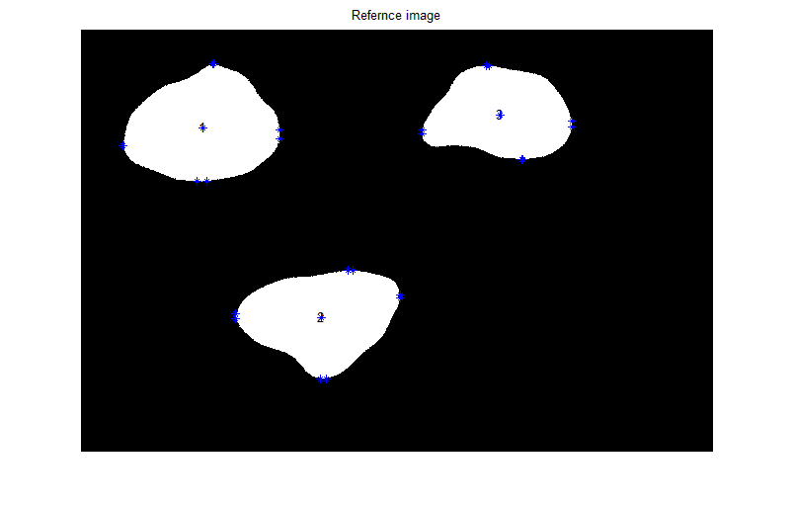
Fig:5.1 Reference image
Results:
The intra matrix of reference image is as follows
196.9389 165.4966 156.0721
197.2579 173.8304 153.5128
233.5292 247.7903 217.3471
235.8219 245.4852 219.7718
162.8304 185.8856 152.1733
163.6014 185.3479 151.2983
248.3739 259.6395 245.6686
248.1607 259.8912 243.0936
The inter matrix of reference image is as follows
interref(:,:,1) =
1.0e+003 *
0.7469 0.7558 0.9024 0.9094 1.0147 1.0091 0.7751 0.7611
0.7458 0.7547 0.9011 0.9082 1.0141 1.0085 0.7749 0.7610
0.4714 0.4786 0.6193 0.6266 0.7669 0.7640 0.5865 0.5729
0.4473 0.4549 0.5976 0.6048 0.7404 0.7373 0.5603 0.5467
0.5050 0.5186 0.6800 0.6846 0.6990 0.6904 0.4242 0.4105
0.5315 0.5454 0.7069 0.7113 0.7156 0.7064 0.4317 0.4183
0.7793 0.7933 0.9548 0.9592 0.9377 0.9266 0.6257 0.6141
0.7797 0.7938 0.9553 0.9596 0.9385 0.9274 0.6266 0.6149
interref(:,:,2) =
1.0e+003 *
0.8280 0.8380 1.1028 1.1058 0.9837 0.9818 0.6685 0.6648
0.8260 0.8360 1.1008 1.1038 0.9818 0.9799 0.6666 0.6629
0.6553 0.6649 0.8864 0.8860 0.7424 0.7404 0.4311 0.4310
0.6639 0.6734 0.8876 0.8867 0.7396 0.7376 0.4313 0.4319
0.9176 0.9269 1.1230 1.1202 0.9613 0.9593 0.6689 0.6716
0.9463 0.9556 1.1536 1.1509 0.9923 0.9903 0.6992 0.7018
1.1277 1.1375 1.3640 1.3632 1.2137 1.2117 0.9077 0.9083
1.1275 1.1373 1.3640 1.3631 1.2138 1.2118 0.9077 0.9082

interref(:,:,3) =
1.0e+003 *
0.7491 0.7548 0.8160 0.8062 0.6278 0.6262 0.4703 0.4809
0.7403 0.7458 0.8027 0.7927 0.6144 0.6127 0.4629 0.4736
0.7452 0.7488 0.7425 0.7298 0.5558 0.5544 0.4946 0.5065
0.7536 0.7572 0.7489 0.7361 0.5625 0.5611 0.5035 0.5154
1.0675 1.0721 1.0800 1.0671 0.8937 0.8923 0.7980 0.8091
1.0754 1.0801 1.0918 1.0790 0.9051 0.9038 0.8043 0.8154
1.0798 1.0868 1.1824 1.1734 0.9955 0.9937 0.7955 0.8040
1.0699 1.0770 1.1754 1.1665 0.9888 0.9870 0.7857 0.7941
Discussion: This is the reference image lattices which will be used for computation
Test Images
Case1:
Description: This is the test image. It is supposed to be obtained from a person who has come up for check up.
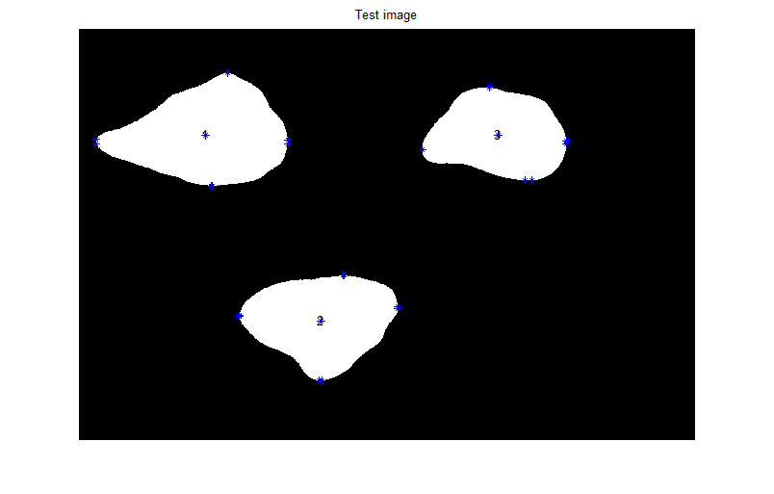
Fig: 5.2 Test image

In imshow at 181
In numbering3 at 12
The objects detected in reference image are 3
The objects detected in test image are 3
The intra matrix of test image is as follows
intratest =
205.9432 157.2816 153.0683
206.2820 158.1591 152.8820
256.7724 243.3405 212.8258
257.7556 242.3094 213.6775
160.3709 186.2713 175.1838
160.2472 186.4792 164.2232
342.6643 256.1221 244.1255
341.8501 256.3521 243.9444

The inter cellular matrix of test image is as follows
intertest(:,:,1) =
1.0e+003 *
0.7256 0.7266 0.9003 0.9051 1.0015 0.9989 0.7599 0.7559
0.7251 0.7261 0.8997 0.9045 1.0012 0.9986 0.7598 0.7558
0.4552 0.4559 0.6218 0.6268 0.7563 0.7551 0.5704 0.5665
0.4441 0.4449 0.6119 0.6168 0.7444 0.7432 0.5588 0.5549
0.4940 0.4956 0.6901 0.6934 0.6945 0.6901 0.4148 0.4109
0.4948 0.4965 0.6910 0.6942 0.6950 0.6906 0.4150 0.4111
0.8732 0.8750 1.0698 1.0726 1.0192 1.0131 0.7002 0.6972
0.8804 0.8821 1.0770 1.0799 1.0302 1.0240 0.7118 0.7087

intertest(:,:,2) =
1.0e+003 *
0.8162 0.8172 1.0773 1.0789 1.0048 0.9860 0.6496 0.6492
0.8152 0.8162 1.0763 1.0779 1.0039 0.9851 0.6486 0.6483
0.6493 0.6503 0.8690 0.8691 0.7705 0.7508 0.4181 0.4180
0.6525 0.6534 0.8690 0.8690 0.7687 0.7489 0.4174 0.4173
0.9176 0.9185 1.1138 1.1129 0.9961 0.9761 0.6629 0.6630
0.9185 0.9195 1.1148 1.1138 0.9971 0.9771 0.6639 0.6640
1.2386 1.2396 1.4670 1.4670 1.3629 1.3430 1.0152 1.0152
1.2365 1.2375 1.4670 1.4671 1.3643 1.3444 1.0156 1.0155
intertest(:,:,3) =
1.0e+003 *
0.7419 0.7425 0.8114 0.8073 0.6565 0.6387 0.4609 0.4617
0.7407 0.7413 0.8096 0.8056 0.6547 0.6369 0.4598 0.4607
0.7397 0.7401 0.7347 0.7292 0.5709 0.5565 0.4934 0.4944
0.7452 0.7456 0.7389 0.7333 0.5750 0.5607 0.4994 0.5004
1.0531 1.0536 1.0671 1.0615 0.9033 0.8889 0.7838 0.7847
1.0576 1.0581 1.0736 1.0680 0.9098 0.8953 0.7874 0.7883
1.0574 1.0581 1.1569 1.1532 1.0044 0.9863 0.7701 0.7708
1.0547 1.0554 1.1551 1.1513 1.0027 0.9846 0.7674 0.7681

The interdifference lattice from comparison of test and refernce lattice is as
interdifference(:,:,1) =
21.3279 29.2133 2.1097 4.2766 13.2157 10.1831 15.2241 5.2762
20.7302 28.5882 1.4438 3.6173 12.8325 9.8216 15.0954 5.1445
16.2344 22.6789 -2.5486 -0.2521 10.5632 8.8395 16.1609 6.3964
3.1806 9.9886 -14.2208 -12.0290 -4.0847 -5.8944 1.4718 -8.2615
11.0095 22.9826 -10.1121 -8.7720 4.5511 0.2753 9.4252 -0.3457
36.7100 48.9284 15.9364 17.1062 20.6047 15.7956 16.7160 7.1885
-93.9715 -81.6972 -114.9342 -113.4789 -81.5287 -86.4211 -74.5041 -83.1060
-100.6297 -88.3495 -121.6483 -120.2501 -91.6875 -96.6368 -85.2770 -93.8514

interdifference(:,:,2) =
11.8228 20.8241 25.5458 26.9184 -21.1233 -4.2082 18.9390 15.5982
10.8214 19.8227 24.5512 25.9276 -22.0919 -5.1787 17.9723 14.6214
5.9979 14.5749 17.4021 16.9629 -28.1838 -10.4501 13.0626 12.9940
11.4616 19.9212 18.6072 17.7311 -29.0481 -11.2722 13.9086 14.5622
0.0223 8.3191 9.1772 7.3620 -34.8075 -16.8056 6.0288 8.5595
27.7702 36.1139 38.7818 37.0400 -4.8803 13.1213 35.3388 37.7531
-110.8554 -102.0800 -103.0079 -103.8496 -149.2184 -131.2909 -107.4637 -106.8904
-109.0290 -100.2534 -103.0669 -103.9772 -150.5419 -132.6345 -107.8942 -107.3194
interdifference(:,:,3) =
7.2305 12.2555 4.6063 -1.1206 -28.6674 -12.5383 9.4255 19.1487
-0.3748 4.5041 -6.9639 -12.8465 -40.3525 -24.2212 3.0400 12.9274
5.5088 8.6853 7.7491 0.6327 -15.1455 -2.0811 1.1296 12.0325
8.4016 11.5413 9.9662 2.7739 -12.5670 0.4074 4.1133 15.0198
14.4776 18.5608 12.9269 5.5529 -9.6136 3.4477 14.1775 24.4455
17.8089 22.0099 18.2764 11.0103 -4.7159 8.4204 16.9070 27.0920
22.3844 28.7000 25.4297 20.1826 -8.9430 7.4115 25.4225 33.2395
15.1727 21.5513 20.2934 15.1865 -13.9678 2.4056 18.3253 26.0384

The new interdiffernce lattice after taking into account experimental errors and medical relaxation is
newinterdifference(:,:,1) =
0 0 0 0 0 0 0 0
0 0 0 0 0 0 0 0
0 0 0 0 0 0 0 0
0 0 0 0 0 0 0 0
0 0 0 0 0 0 0 0
0 0 0 0 0 0 0 0
93.9715 81.6972 114.9342 113.4789 81.5287 86.4211 74.5041 83.1060
100.6297 88.3495 121.6483 120.2501 91.6875 96.6368 85.2770 93.8514

newinterdifference(:,:,2) =
0 0 0 0 0 0 0 0
0 0 0 0 0 0 0 0
0 0 0 0 0 0 0 0
0 0 0 0 0 0 0 0
0 0 0 0 0 0 0 0
0 0 0 0 0 0 0 0
110.8554 102.0800 103.0079 103.8496 149.2184 131.2909 107.4637 106.8904
109.0290 100.2534 103.0669 103.9772 150.5419 132.6345 107.8942 107.3194

newinterdifference(:,:,3) =
0 0 0 0 0 0 0 0
0 0 0 0 0 0 0 0
0 0 0 0 0 0 0 0
0 0 0 0 0 0 0 0
0 0 0 0 0 0 0 0
0 0 0 0 0 0 0 0
0 0 0 0 0 0 0 0
0 0 0 0 0 0 0 0
The lattice arriving from mahalanobis distance is as
r =
1.6123 1.6155 2.6007 2.7032 1.9111 1.9061 3.1934 3.1966
0.6214 0.6253 1.7459 1.7824 3.3910 3.3390 1.6784 1.6890
0.7224 0.7239 2.1564 2.2345 3.4544 3.3437 2.5108 2.4916

The frequency matrix declares the maximum times a lattice involved in deviation
frequency =
2
1
1
Thus the region which has overqrowth has its number as ( eucledian distance)
1
Summing up the mahalanobis distance matrix and storeing its sum in g
g =

18.7390
14.8724
17.6378
The region 1 is infected with cancer(mahalanobis distance)
To check out which matrices are non zero to zero upon the infected area
nonzeromatrices =

1
2
0
0
0
0
0
0
0
0
0
0
0
0
0
0
0
0
0
0
Overgrowth is in left bottom partr
Overgrowth is in left top partr
The overgrowth can be precisely said in left direction of 1 region
The percentage change in perimeter of infected region 1 is 4.301713e+000
The percentage change in area of infected region 1 is 8.763235e+000
Discussion: As we can make up from the image itself that region 1 has gone overgrowth, so does is being indicated in the results.

Case2:
Description: This is the test image. It is supposed to be obtained from a person who has come up for check up.
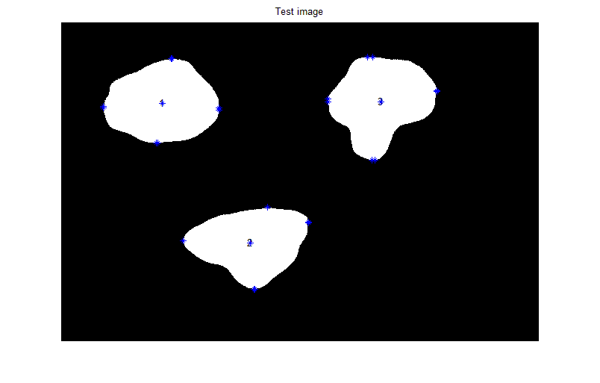
Fig: 5.3 Test image

The objects detected in reference image are 3
The objects detected in test image are 3
The intra matrix of test image is as follows
intratest =
182.0608 158.6156 188.7623
182.4758 159.0489 184.0668
229.6690 246.7529 229.8720
230.3751 245.7582 229.1061
161.5141 185.5725 236.3579
162.2249 185.4872 237.7623
235.9200 269.8329 211.7681
235.5203 269.8686 212.1025
The inter cellular matrix of test image is as follows
intertest(:,:,1) =
710.9184 711.4619 856.8250 859.1275 983.4536 983.1144 732.5742 731.5764
709.8345 710.3760 855.5425 857.8485 982.7762 982.4388 732.4459 731.4479
443.6632 444.1013 582.1039 584.4724 740.7381 740.5471 552.1096 551.1443
437.3786 437.8230 576.6004 578.9551 733.8692 733.6764 545.3549 544.3905
509.2004 510.0627 681.7133 683.1179 702.2571 701.7065 404.8024 403.8341
514.3822 515.2475 687.0262 688.4199 705.5813 705.0248 406.3410 405.3764
770.0416 770.8962 941.9575 943.4262 947.2170 946.5775 622.5400 621.6824
773.1753 774.0265 944.9021 946.3852 951.8361 951.1998 627.6942 626.8341

intertest(:,:,2) =

1.0e+003 *

0.7880 0.8080 1.0745 1.0750 0.9132 0.9034 0.6531 0.6502
0.7860 0.8060 1.0725 1.0730 0.9114 0.9016 0.6511 0.6483
0.6306 0.6495 0.8779 0.8776 0.6593 0.6489 0.4388 0.4396
0.6329 0.6518 0.8785 0.8781 0.6571 0.6467 0.4392 0.4402
0.9098 0.9283 1.1399 1.1392 0.8727 0.8618 0.7031 0.7058
0.9153 0.9339 1.1458 1.1451 0.8787 0.8677 0.7089 0.7116
1.0796 1.0993 1.3408 1.3406 1.1093 1.0985 0.9023 0.9027
1.0785 1.0982 1.3405 1.3403 1.1104 1.0996 0.9022 0.9025

intertest(:,:,3) =

1.0e+003 *

0.7264 0.7376 0.8274 0.8252 0.4706 0.4606 0.4901 0.4996
0.7258 0.7371 0.8266 0.8244 0.4697 0.4597 0.4896 0.4991
0.7063 0.7133 0.7404 0.7375 0.3651 0.3571 0.4916 0.5024
0.7091 0.7161 0.7425 0.7397 0.3671 0.3592 0.4945 0.5054
1.0376 1.0465 1.0836 1.0806 0.7075 0.7001 0.8091 0.8193
1.0380 1.0470 1.0842 1.0813 0.7082 0.7007 0.8095 0.8197
1.0458 1.0601 1.1846 1.1825 0.8341 0.8239 0.8070 0.8146
1.0451 1.0594 1.1840 1.1820 0.8337 0.8236 0.8063 0.8139

The interdifference lattice from comparison of test and refernce lattice is as
interdifference(:,:,1) =
36.0126 44.3489 45.5569 50.2734 31.2749 25.9946 42.5032 29.5576
36.0033 44.3121 45.5840 50.3068 31.2781 26.0259 42.4560 29.5074
27.7305 34.5008 37.1674 42.1024 26.1491 23.4195 34.4030 21.7475
9.8853 17.0319 21.0383 25.8465 6.4881 3.6553 14.9057 2.2868
-4.2172 8.5508 -1.6978 1.5076 -3.2235 -11.3233 19.4251 6.7082
17.1298 30.1413 19.8783 22.9204 9.9975 1.3603 25.3835 12.9082
9.2228 22.4089 12.8807 15.7239 -9.5043 -19.9438 3.1916 -7.6270
6.5734 19.7543 10.4120 13.2480 -13.3693 -23.8029 -1.1250 -11.9479

interdifference(:,:,2) =

39.9691 29.9699 28.2817 30.7845 70.5072 78.4240 15.4484 14.5508
39.9690 29.9699 28.2927 30.8000 70.3851 78.2973 15.4811 14.5813
24.7156 15.3242 8.5355 8.4843 83.0176 91.4497 -7.6307 -8.5588
31.0106 21.5646 9.1744 8.6075 82.4625 90.9226 -7.9445 -8.2959
7.8407 -1.4403 -16.8770 -18.9323 88.6057 97.5757 -34.2151 -34.2052
30.9809 21.7285 7.8238 5.8390 113.5513 122.5215 -9.7497 -9.8344
48.0720 38.1945 23.1803 22.5252 104.4740 113.2724 5.3678 5.5511
48.9793 39.0835 23.4263 22.7664 103.3521 112.1392 5.4750 5.7182

interdifference(:,:,3) =

22.7534 17.1354 -11.4761 -19.0200 157.2236 165.5858 -19.7496 -18.7473
14.4762 8.7291 -23.9385 -31.6445 144.6665 153.0398 -26.6936 -25.5347
38.8947 35.4678 2.0764 -7.7563 190.6744 197.2999 3.0057 4.0412
44.5060 41.0670 6.3529 -3.5811 195.3261 201.9221 8.9640 10.0015
29.9369 25.6116 -3.5201 -13.5214 186.1479 192.2763 -11.1354 -10.1973
37.3290 33.1125 7.6146 -2.2469 196.9099 203.0260 -5.1464 -4.2909
33.9596 26.7663 -2.1855 -9.1519 161.3919 169.7732 -11.4698 -10.6356
24.7536 17.6157 -8.6946 -15.5016 155.0758 163.4500 -20.5698 -19.8355
The new interdiffernce lattice after taking into account experimental errors and medical relaxation is
newinterdifference(:,:,1) =
0 0 0 0 0 0 0 0
0 0 0 0 0 0 0 0
0 0 0 0 0 0 0 0
0 0 0 0 0 0 0 0
0 0 0 0 0 0 0 0
0 0 0 0 0 0 0 0
0 0 0 0 0 0 0 0
0 0 0 0 0 0 0 0

newinterdifference(:,:,2) =

0 0 0 0 70.5072 78.4240 0 0
0 0 0 0 70.3851 78.2973 0 0
0 0 0 0 83.0176 91.4497 0 0
0 0 0 0 82.4625 90.9226 0 0
0 0 0 0 88.6057 97.5757 0 0
0 0 0 0 113.5513 122.5215 0 0
0 0 0 0 104.4740 113.2724 0 0
0 0 0 0 103.3521 112.1392 0 0

newinterdifference(:,:,3) =

0 0 0 0 157.2236 165.5858 0 0
0 0 0 0 144.6665 153.0398 0 0
0 0 0 0 190.6744 197.2999 0 0
0 0 0 0 195.3261 201.9221 0 0
0 0 0 0 186.1479 192.2763 0 0
0 0 0 0 196.9099 203.0260 0 0
0 0 0 0 161.3919 169.7732 0 0
0 0 0 0 155.0758 163.4500 0 0

The lattice arriving from mahalanobis distance is as
r =
1.4081 1.4121 2.3080 2.3628 1.7083 1.6891 1.2890 1.2863
0.9299 0.9316 1.6127 1.6067 2.8462 2.8396 1.8774 1.8825
1.5130 1.5037 1.7840 1.7719 6.4369 6.4921 1.5995 1.5025

The frequency matrix declares the maximum times a lattice involved in deviation
frequency =
1
1
2

Thus the region which has overqrowth has its number as ( eucledian distance)
3
Summing up the mahalanobis distance matrix and storeing its sum in g
g =
13.4637
14.5266
22.6037
The region 3 is infected with cancer(mahalanobis distance)
To check out which matrices are non zero to zero upon the infected area
nonzeromatrices =
2
3
0
0
0
0
0
0
0
0
0
0
0
0
0
0
0
0
0
0
Overgrowth is in bottom right part
Overgrowth is in bottom left part
The overgrowth can be precisely said in bottom direction of 3 region
The percentage change in perimeter of infected region 3 is 3.531082e-001
The percentage change in area of infected region 3 is 2.320372e+001
Discussion: As we can make up from the image itself that region 3 has gone overgrowth, so does is being indicated in the results.

Case3:
Description: This is the test image. It is supposed to be obtained from a person who has come up for checkup. 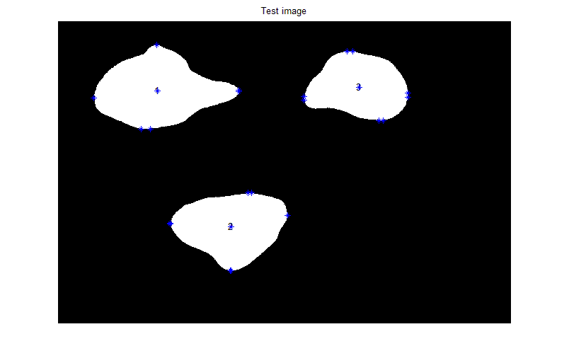
Fig: 5.4 Test image

The objects detected in reference image are 3
The objects detected in test image are 3
The intra matrix of test image is as follows
intratest =
194.1224 159.3802 159.8977
194.1098 167.4726 153.9917
344.0566 243.1857 209.7940
344.0897 242.9881 213.0413
164.4671 185.4916 175.1012
175.9689 185.5089 164.5997
270.8304 258.0603 239.3435
270.7145 258.1146 236.2637

The inter cellular matrix of test image is as follows
intertest(:,:,1) =

1.0e+003 *

0.7366 0.7456 0.9108 0.9116 1.0069 1.0066 0.7602 0.7592
0.7361 0.7451 0.9102 0.9110 1.0066 1.0063 0.7601 0.7591
0.4367 0.4385 0.5690 0.5699 0.7648 0.7648 0.6346 0.6337
0.4307 0.4325 0.5634 0.5643 0.7588 0.7588 0.6293 0.6284
0.4929 0.5071 0.6864 0.6869 0.6900 0.6895 0.4107 0.4097
0.5267 0.5413 0.7205 0.7210 0.7105 0.7100 0.4207 0.4197
0.7651 0.7796 0.9589 0.9594 0.9325 0.9319 0.6229 0.6220
0.7656 0.7801 0.9594 0.9599 0.9333 0.9327 0.6238 0.6229

intertest(:,:,2) =

1.0e+003 *

0.8065 0.8304 1.0842 1.0881 1.0119 0.9939 0.6668 0.6616
0.8055 0.8294 1.0832 1.0871 1.0110 0.9930 0.6658 0.6607
0.4881 0.5107 0.7181 0.7186 0.6260 0.6074 0.2802 0.2783
0.4902 0.5127 0.7180 0.7184 0.6248 0.6062 0.2793 0.2778
0.8947 0.9170 1.1017 1.0991 0.9867 0.9677 0.6612 0.6641
0.9320 0.9545 1.1413 1.1388 1.0266 1.0076 0.7005 0.7033
1.0903 1.1139 1.3312 1.3310 1.2296 1.2107 0.8900 0.8900
1.0901 1.1137 1.3312 1.3310 1.2297 1.2107 0.8901 0.8900

intertest(:,:,3) =

1.0e+003 *

0.7338 0.7478 0.8019 0.7915 0.6523 0.6356 0.4600 0.4728
0.7242 0.7378 0.7875 0.7769 0.6374 0.6208 0.4514 0.4645
0.7402 0.7487 0.7291 0.7149 0.5721 0.5587 0.4930 0.5078
0.7412 0.7497 0.7298 0.7156 0.5728 0.5595 0.4940 0.5088
1.0526 1.0640 1.0649 1.0508 0.9080 0.8945 0.7861 0.7999
1.0531 1.0645 1.0656 1.0516 0.9087 0.8952 0.7865 0.8003
1.0459 1.0632 1.1498 1.1403 1.0027 0.9857 0.7706 0.7809
1.0452 1.0625 1.1493 1.1398 1.0023 0.9852 0.7700 0.7802

The interdifference lattice from comparison of test and refernce lattice is as
interdifference(:,:,1) =
10.3111 10.1648 -8.4667 -2.2416 7.8432 2.5341 14.8617 1.9153
9.7400 9.5806 -9.1141 -2.8799 7.4794 2.1993 14.7618 1.8124
34.7371 40.1389 50.2819 56.6538 2.1310 -0.8347 -48.1101 -60.8408
16.5842 22.3437 34.2339 40.4666 -18.4048 -21.4759 -69.0262 -81.7215
12.1292 11.4962 -6.3438 -2.2690 9.0177 0.8580 13.5452 0.8388
4.8385 4.0867 -13.5738 -9.6479 5.0564 -3.6043 11.0345 -1.4498
14.1468 13.6719 -4.0200 -0.2267 5.1881 -5.2703 2.8351 -7.9872
14.1052 13.6315 -4.0628 -0.2631 5.1582 -5.2917 2.8185 -8.0103

interdifference(:,:,2) =

21.5576 7.5705 18.6389 17.6996 -28.2114 -12.1155 1.7217 3.1513
20.5570 6.5700 17.6463 16.7088 -29.1737 -13.0794 0.7610 2.1872
167.2169 154.1265 168.3417 167.4192 116.3368 132.9439 150.9743 152.6884
173.7601 160.6392 169.6329 168.3301 114.7753 131.4115 151.9673 154.1137
22.9283 9.8058 21.3347 21.1414 -25.3194 -8.3274 7.7387 7.5332
14.3044 1.0973 12.3055 12.0960 -34.3668 -17.3741 -1.3288 -1.4882
37.3990 23.5587 32.8101 32.1474 -15.8714 1.0733 17.6687 18.2490
37.3651 23.5228 32.7731 32.1085 -15.9132 1.0303 17.6189 18.2029

interdifference(:,:,3) =

15.3481 6.9587 14.0779 14.6868 -24.4528 -9.4582 10.3453 8.0368
16.1376 7.9704 15.1572 15.7943 -22.9906 -8.0998 11.5036 9.1227
4.9851 0.0354 13.4194 14.8563 -16.2899 -4.3058 1.5645 -1.3960
12.4813 7.5026 19.1327 20.4742 -10.2905 1.6929 9.4931 6.5358
14.9411 8.0692 15.1319 16.2541 -14.2894 -2.1843 11.8207 9.2078
22.3024 15.5372 26.2369 27.4913 -3.5572 8.5377 17.7799 15.0867
33.8908 23.6465 32.5574 33.0756 -7.2481 8.0591 24.8636 23.0987
24.6771 14.4863 26.0211 26.6877 -13.5145 1.7883 15.7495 13.8880

The new interdiffernce lattice after taking into account experimental errors and medical relaxation is
newinterdifference(:,:,1) =
0 0 0 0 0 0 0 0
0 0 0 0 0 0 0 0
0 0 0 56.6538 0 0 0 60.8408
0 0 0 0 0 0 69.0262 81.7215
0 0 0 0 0 0 0 0
0 0 0 0 0 0 0 0
0 0 0 0 0 0 0 0
0 0 0 0 0 0 0 0

newinterdifference(:,:,2) =

0 0 0 0 0 0 0 0
0 0 0 0 0 0 0 0
167.2169 154.1265 168.3417 167.4192 116.3368 132.9439 150.9743 152.6884
173.7601 160.6392 169.6329 168.3301 114.7753 131.4115 151.9673 154.1137
0 0 0 0 0 0 0 0
0 0 0 0 0 0 0 0
0 0 0 0 0 0 0 0
0 0 0 0 0 0 0 0

newinterdifference(:,:,3) =

0 0 0 0 0 0 0 0
0 0 0 0 0 0 0 0
0 0 0 0 0 0 0 0
0 0 0 0 0 0 0 0
0 0 0 0 0 0 0 0
0 0 0 0 0 0 0 0
0 0 0 0 0 0 0 0
0 0 0 0 0 0 0 0

The lattice arriving from mahalanobis distance is as
r =
2.2699 2.2697 4.7156 4.7406 1.2082 1.1324 1.5300 1.5314
1.1411 1.1459 1.3434 1.3433 2.2558 2.2521 2.2155 2.2234
1.7693 1.7553 1.3940 1.4647 1.8737 1.7942 2.2352 2.0604

The frequency matrix declares the maximum times a lattice involved in deviation
frequency =
2
1
1
Thus the region which has overqrowth has its number as ( eucledian distance)
1
Summing up the mahalanobis distance matrix and storeing its sum in g
g =

19.3977
13.9205
14.3468

The region 1 is infected with cancer (mahalanobis distance)
To check out which matrices are non zero to zero upon the infected area
nonzeromatrices =
1
2
0
0
0
0
0
0
0
0
0
0
0
0
0
0
0
0
0
0
Overgrowth is in right top partr
Overgrowth is in right bottom partr
The overgrowth can be precisely said in right direction of 1 region
The percentage change in perimeter of infected region 1 is 6.469476e+000
The percentage change in area of infected region 1 is 8.114472e+000
Discussion: As we can make up from the image itself that region 3 has gone overgrowth, so does is being indicated in the results.
Case4:
Description: This is the test image. It is supposed to be obtained from a person who has come up for check up.
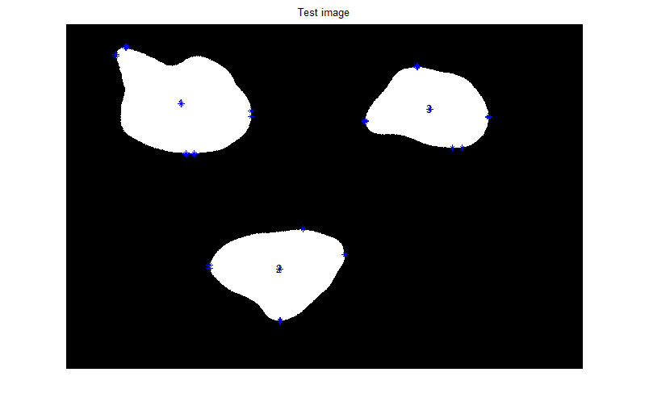
Fig: 5.5 Test image

The objects detected in reference image are 3
The objects detected in test image are 3
The intra matrix of test image is as follows
intratest =

294.5433 172.4624 164.7250
293.8439 172.9691 164.4331
262.0834 248.9239 220.3160
264.8736 248.7093 220.5845
189.6025 192.1111 186.9164
184.6096 192.1032 166.4485
300.7871 259.9885 245.9994
304.3810 260.3529 245.2733
The inter cellular matrix of test image is as follows
intertest(:,:,1) =
1.0e+003 *

0.9426 0.9433 1.1205 1.1212 1.1664 1.1660 0.8789 0.8677
0.9420 0.9426 1.1198 1.1205 1.1660 1.1655 0.8785 0.8673
0.4778 0.4782 0.6360 0.6368 0.7862 0.7860 0.6054 0.5939
0.4596 0.4600 0.6193 0.6202 0.7664 0.7662 0.5861 0.5746
0.4929 0.4938 0.6753 0.6759 0.6995 0.6990 0.4319 0.4200
0.5170 0.5179 0.6996 0.7002 0.7132 0.7127 0.4368 0.4250
0.9461 0.9468 1.1257 1.1263 1.1572 1.1567 0.8628 0.8519
0.9502 0.9509 1.1296 1.1303 1.1623 1.1618 0.8683 0.8574

intertest(:,:,2) =

1.0e+003 *

1.0844 1.0854 1.3735 1.3738 1.3038 1.2693 0.9309 0.9297
1.0834 1.0844 1.3725 1.3728 1.3028 1.2684 0.9299 0.9287
0.6367 0.6377 0.8822 0.8823 0.7939 0.7585 0.4238 0.4234
0.6422 0.6432 0.8820 0.8820 0.7907 0.7551 0.4224 0.4223
0.8893 0.8903 1.1044 1.1042 0.9962 0.9602 0.6469 0.6476
0.9164 0.9174 1.1332 1.1330 1.0252 0.9892 0.6754 0.6761
1.1187 1.1197 1.4033 1.4036 1.3297 1.2950 0.9566 0.9556
1.1189 1.1199 1.4043 1.4046 1.3313 1.2966 0.9582 0.9572

intertest(:,:,3) =

1.0e+003 *

0.7371 0.7377 0.8071 0.8060 0.6632 0.6314 0.4610 0.4645
0.7366 0.7371 0.8062 0.8052 0.6623 0.6305 0.4605 0.4640
0.7477 0.7480 0.7405 0.7391 0.5883 0.5622 0.4997 0.5036
0.7486 0.7490 0.7412 0.7398 0.5889 0.5629 0.5006 0.5046
1.0725 1.0730 1.0848 1.0834 0.9323 0.9065 0.8046 0.8083
1.0730 1.0734 1.0855 1.0841 0.9330 0.9072 0.8050 0.8087
1.0756 1.0763 1.1813 1.1804 1.0395 1.0071 0.7951 0.7979
1.0673 1.0680 1.1756 1.1747 1.0344 1.0018 0.7869 0.7896

The interdifference lattice from comparison of test and refernce lattice is as
interdifference(:,:,1) =
-195.7189 -187.5375 -218.1073 -211.7757 -151.7126 -156.8412 -103.7883 -106.5186
-196.1144 -187.9620 -218.6364 -212.2955 -151.8960 -156.9953 -103.6104 -106.3393
-6.4400 0.3679 -16.7302 -10.2650 -19.2915 -22.0779 -18.9302 -20.9643
-12.3065 -5.1320 -21.6981 -15.3637 -26.0088 -28.8967 -25.8801 -27.9052
12.0471 24.8555 4.6659 8.7186 -0.4548 -8.6482 -7.6845 -9.4815
14.4849 27.5221 7.2789 11.1767 2.3572 -6.3476 -5.0283 -6.7154
-166.8249 -153.5180 -170.8367 -167.1806 -219.4982 -230.0512 -237.1178 -237.8208
-170.4287 -157.1272 -174.3035 -170.6433 -223.8502 -234.3965 -241.7769 -242.4731

interdifference(:,:,2) =

-256.3833 -247.3812 -270.6368 -268.0310 -320.0759 -287.5418 -262.3524 -264.8823
-257.3854 -248.3833 -271.6295 -269.0187 -321.0289 -288.4968 -263.2939 -265.8332
18.5626 27.1409 4.1613 3.7459 -51.5556 -18.1066 7.3420 7.5522
21.7058 30.1702 5.6435 4.7260 -51.1008 -17.5089 8.8694 9.6421
28.2757 36.5819 18.6050 16.0571 -34.8632 -0.8658 22.0512 24.0130
29.8727 38.2219 20.4168 17.9369 -32.9305 1.0670 23.8122 25.6886
8.9978 17.7637 -39.3091 -40.4906 -116.0058 -83.2487 -48.9263 -47.3588
8.5513 17.3192 -40.3417 -41.5184 -117.5266 -84.8112 -50.5133 -48.9356

interdifference(:,:,3) =

11.9876 17.0506 8.8913 0.1135 -35.3937 -5.2166 9.2682 16.3741
3.7322 8.6484 -3.5378 -12.4789 -47.9755 -17.7954 2.3272 9.5955
-2.4804 0.7215 1.9548 -9.3545 -32.4891 -7.7308 -5.1015 2.8355
5.0225 8.1852 7.6900 -3.7271 -26.4584 -1.7153 2.8283 10.7689
-4.9490 -0.8438 -4.7408 -16.2881 -38.6135 -14.1836 -6.6929 0.8124
2.4061 6.6348 6.3550 -5.0514 -27.8939 -3.4655 -0.7307 6.6891
4.1589 10.4944 1.0424 -7.0050 -44.0219 -13.4058 0.3929 6.1335
2.5792 8.9740 -0.2943 -8.1957 -45.6096 -14.8402 -1.2075 4.4585

The new interdiffernce lattice after taking into account experimental errors and medical relaxation is
newinterdifference(:,:,1) =
195.7189 187.5375 218.1073 211.7757 151.7126 156.8412 103.7883 106.5186
196.1144 187.9620 218.6364 212.2955 151.8960 156.9953 103.6104 106.3393
0 0 0 0 0 0 0 0
0 0 0 0 0 0 0 0
0 0 0 0 0 0 0 0
0 0 0 0 0 0 0 0
166.8249 153.5180 170.8367 167.1806 219.4982 230.0512 237.1178 237.8208
170.4287 157.1272 174.3035 170.6433 223.8502 234.3965 241.7769 242.4731

newinterdifference(:,:,2) =
256.3833 247.3812 270.6368 268.0310 320.0759 287.5418 262.3524 264.8823
257.3854 248.3833 271.6295 269.0187 321.0289 288.4968 263.2939 265.8332
0 0 0 0 51.5556 0 0 0
0 0 0 0 51.1008 0 0 0
0 0 0 0 0 0 0 0
0 0 0 0 0 0 0 0
0 0 0 0 116.0058 83.2487 0 0
0 0 0 0 117.5266 84.8112 0 0

newinterdifference(:,:,3) =

0 0 0 0 0 0 0 0
0 0 0 0 0 0 0 0
0 0 0 0 0 0 0 0
0 0 0 0 0 0 0 0
0 0 0 0 0 0 0 0
0 0 0 0 0 0 0 0
0 0 0 0 0 0 0 0
0 0 0 0 0 0 0 0

The lattice arriving from mahalanobis distance is as
r =
3.8995 3.8867 3.1587 3.2997 2.1228 1.8980 3.6073 3.7483
0.8798 0.8849 2.3297 2.3354 3.8872 3.8788 1.2463 1.2558
1.1826 1.1860 2.9503 2.9656 3.5677 3.2410 1.6892 1.6249

The frequency matrix declares the maximum times a lattice involved in deviation
frequency =
2
1
1
Thus the region which has overqrowth has its number as ( eucledian distance)
1
Summing up the mahalanobis distance matrix and storeing its sum in g
g =

25.6209
16.6979
18.4072
The region 1 is infected with cancer(mahalanobis distance)
To check out which matrices are non zero to zero upon the infected area
nonzeromatrices =
1
2
0
0
0
0
0
0
0
0
0
0
0
0
0
0
0
0
0
0
Overgrowth is in top left partr
Overgrowth is in top right partr
The overgrowth can be precisely said in top direction of 1 region
The percentage change in perimeter of infected region 1 is 2.083813e+001
The percentage change in area of infected region 1 is 2.120169e+001
Discussion: As we can make up from the image itself that region 1 has gone overgrowth, so does is being indicated in the results.

Case5:
Description: This is the test image. It is supposed to be obtained from a person who has come up for check up.
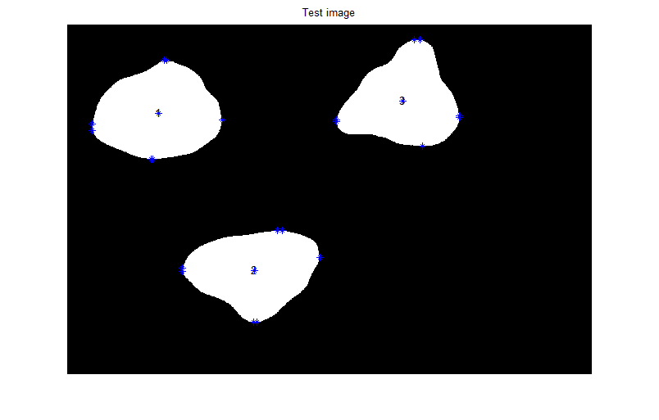
Fig: 5.6 Test image
The objects detected in reference image are 3
The objects detected in test image are 3
The intra matrix of test image is as follows
intratest =

196.0271 171.6640 228.4846
197.1488 180.7656 233.0809
235.6317 244.9303 212.5351
235.7288 244.7295 214.1955
168.6372 189.5969 181.1246
169.4689 189.3535 180.7404
248.1496 261.1780 255.8636
243.4812 261.3352 253.5694
The inter cellular matrix of test image is as follows

intertest(:,:,1) =

1.0e+003 *

0.7466 0.7562 0.9172 0.9180 1.0174 1.0135 0.7768 0.7639
0.7422 0.7516 0.9123 0.9131 1.0148 1.0110 0.7762 0.7632
0.4526 0.4604 0.6171 0.6179 0.7536 0.7517 0.5756 0.5630
0.4517 0.4595 0.6162 0.6171 0.7526 0.7507 0.5746 0.5620
0.5258 0.5406 0.7087 0.7092 0.7091 0.7027 0.4264 0.4139
0.5310 0.5459 0.7138 0.7143 0.7123 0.7059 0.4280 0.4155
0.7696 0.7846 0.9523 0.9527 0.9256 0.9179 0.6142 0.6033
0.7808 0.7956 0.9637 0.9642 0.9433 0.9357 0.6337 0.6226

intertest(:,:,2) =

1.0e+003 *

0.9162 0.9372 1.0971 1.0983 0.9942 0.9933 0.6680 0.6654
0.9083 0.9292 1.0893 1.0904 0.9866 0.9857 0.6605 0.6578
0.7611 0.7805 0.8671 0.8670 0.7385 0.7375 0.4181 0.4180
0.7615 0.7809 0.8671 0.8670 0.7384 0.7374 0.4181 0.4180
1.0529 1.0720 1.1331 1.1322 0.9881 0.9871 0.6868 0.6884
1.0583 1.0775 1.1390 1.1382 0.9941 0.9931 0.6927 0.6943
1.2232 1.2434 1.3430 1.3428 1.2084 1.2074 0.8935 0.8939
1.2171 1.2375 1.3423 1.3422 1.2098 1.2088 0.8930 0.8931

intertest(:,:,3) =

1.0e+003 *

0.8594 0.8718 0.7855 0.7823 0.6125 0.6116 0.4520 0.4590
0.8496 0.8618 0.7711 0.7679 0.5978 0.5970 0.4441 0.4512
0.8698 0.8783 0.7269 0.7227 0.5534 0.5527 0.4999 0.5078
0.8707 0.8793 0.7276 0.7234 0.5541 0.5534 0.5009 0.5088
1.1862 1.1966 1.0586 1.0543 0.8850 0.8843 0.7909 0.7983
1.1921 1.2026 1.0670 1.0628 0.8933 0.8926 0.7954 0.8028
1.2007 1.2156 1.1615 1.1586 0.9899 0.9890 0.7864 0.7920
1.1915 1.2065 1.1552 1.1523 0.9839 0.9830 0.7773 0.7829

The interdifference lattice from comparison of test and refernce lattice is as
interdifference(:,:,1) =

0.3033 -0.3532 -14.8586 -8.6258 -2.7040 -4.4121 -1.7314 -2.7226
3.6053 3.0445 -11.1903 -4.9521 -0.7566 -2.5195 -1.2682 -2.2517
18.8133 18.1828 2.2203 8.7067 13.2792 12.2719 10.9485 9.8989
-4.4218 -4.6851 -18.5958 -12.2494 -12.2647 -13.3747 -14.3357 -15.3495
-20.8010 -22.0120 -28.6467 -24.5438 -10.0256 -12.3009 -2.2042 -3.3429
0.5045 -0.5049 -6.9372 -3.0049 3.2776 0.5318 3.7058 2.7644
9.6639 8.7084 2.5851 6.4083 12.0685 8.7355 11.5459 10.7934
-1.0522 -1.8051 -8.3793 -4.5669 -4.7882 -8.2580 -7.1350 -7.7566

interdifference(:,:,2) =

-88.2316 -99.1591 5.6806 7.5320 -10.5029 -11.4654 0.4744 -0.5819
-82.2601 -93.1863 11.5652 13.4138 -4.8292 -5.7922 6.1050 5.0685
-105.7660 -115.6339 19.3138 19.0175 3.8234 2.8290 13.0638 13.0012
-97.5366 -107.5169 20.5310 19.6942 1.2043 0.2027 13.2383 13.9074
-135.2711 -145.1560 -10.0595 -12.0308 -26.7808 -27.7771 -17.8977 -16.8347
-112.0381 -121.8960 14.5955 12.6942 -1.8471 -2.8436 6.5171 7.4773
-95.4867 -105.9415 21.0017 20.3626 5.2858 4.2858 14.1763 14.4180
-89.6425 -100.1944 21.6416 20.9130 3.9797 2.9787 14.6392 15.0736

interdifference(:,:,3) =

-110.2848 -117.0311 30.5053 23.8725 15.3483 14.5228 18.3558 21.8846
-109.3371 -115.9574 31.5599 24.8220 16.5251 15.7075 18.7881 22.3602
-124.5803 -129.5844 15.5561 7.1204 2.3992 1.7379 -5.3006 -1.3478
-117.0613 -122.0962 21.2715 12.7306 8.3694 7.7232 2.6256 6.5819
-118.6988 -124.4564 21.4437 12.7764 8.6429 7.9925 7.0750 10.8202
-116.7417 -122.5342 24.8208 16.2613 11.8284 11.1644 8.9217 12.6215
-120.8998 -128.7526 20.8887 14.8204 5.6187 4.7552 9.1379 12.0247
-121.6335 -129.5348 20.1943 14.2363 4.8767 4.0066 8.3657 11.2138

The new interdiffernce lattice after taking into account experimental errors and medical relaxation is
newinterdifference(:,:,1) =
0 0 0 0 0 0 0 0
0 0 0 0 0 0 0 0
0 0 0 0 0 0 0 0
0 0 0 0 0 0 0 0
0 0 0 0 0 0 0 0
0 0 0 0 0 0 0 0
0 0 0 0 0 0 0 0
0 0 0 0 0 0 0 0

newinterdifference(:,:,2) =

88.2316 99.1591 0 0 0 0 0 0
82.2601 93.1863 0 0 0 0 0 0
105.7660 115.6339 0 0 0 0 0 0
97.5366 107.5169 0 0 0 0 0 0
135.2711 145.1560 0 0 0 0 0 0
112.0381 121.8960 0 0 0 0 0 0
95.4867 105.9415 0 0 0 0 0 0
89.6425 100.1944 0 0 0 0 0 0

newinterdifference(:,:,3) =

110.2848 117.0311 0 0 0 0 0 0
109.3371 115.9574 0 0 0 0 0 0
124.5803 129.5844 0 0 0 0 0 0
117.0613 122.0962 0 0 0 0 0 0
118.6988 124.4564 0 0 0 0 0 0
116.7417 122.5342 0 0 0 0 0 0
120.8998 128.7526 0 0 0 0 0 0
121.6335 129.5348 0 0 0 0 0 0

The lattice arriving from mahalanobis distance is as
r =
1.7558 1.7280 1.3497 1.3567 1.7826 1.7919 2.5398 2.4674
0.7883 0.7700 0.8425 0.8450 3.0177 2.9939 2.8777 2.9292
3.9661 4.0331 0.9934 1.0429 2.3611 2.3617 3.5674 3.4362

The frequency matrix declares the maximum times a lattice involved in deviation
frequency =
1
1
2

Thus the region which has overqrowth has its number as ( eucledian distance)
3
Summing up the mahalanobis distance matrix and storeing its sum in g
g =

14.7719
15.0643
21.7619

The region 3 is infected with cancer(mahalanobis distance)
To check out which matrices are non zero to zero upon the infected area
nonzeromatrices =
2
3
0
0
0
0
0
0
0
0
0
0
0
0
0
0
0
0
0
0
Overgrowth is in top left part
Overgrowth is in top right part
The overgrowth can be precisely said in top direction of 3 region
The percentage change in perimeter of infected region 3 is 2.743559e+000
The percentage change in area of infected region 3 is 1.836782e+001
Discussion: As we can make up from the image itself that region 3 has gone growth, so does is being indicated in the results.
Case6:
Description: This is the test image. It is supposed to be obtained from a person who has come up for check up.
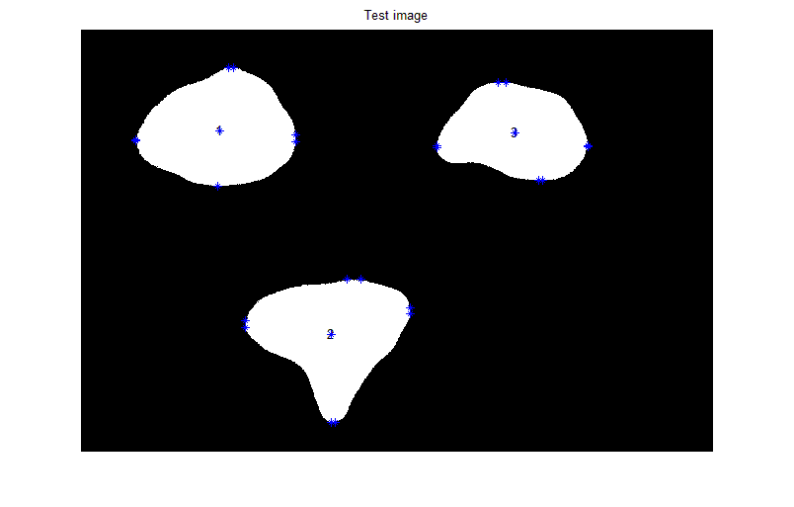
Fig: 5.7 Test image

The objects detected in reference image are 3
The objects detected in test image are 3
The intra matrix of test image is as follows
intratest =

194.6908 172.6723 162.7261
197.5775 188.6960 157.1069
231.7099 252.6573 222.3823
233.7622 247.5853 223.2855
168.2838 266.7409 166.9382
168.3082 266.5235 160.8582
254.1881 262.9678 243.8042
253.8722 265.5883 243.1182

The inter cellular matrix of test image is as follows
intertest(:,:,1) =

1.0e+003 *

0.7364 0.7583 0.9158 0.9302 1.1237 1.1203 0.7906 0.7687
0.7288 0.7500 0.9062 0.9208 1.1192 1.1160 0.7898 0.7678
0.4646 0.4807 0.6304 0.6455 0.8792 0.8777 0.6037 0.5825
0.4449 0.4616 0.6130 0.6279 0.8584 0.8568 0.5834 0.5622
0.4813 0.5167 0.6908 0.7006 0.7983 0.7930 0.4358 0.4142
0.4821 0.5176 0.6917 0.7014 0.7987 0.7934 0.4360 0.4144
0.7658 0.8020 0.9762 0.9857 1.0468 1.0399 0.6574 0.6385
0.7674 0.8036 0.9778 0.9873 1.0493 1.0424 0.6600 0.6411

intertest(:,:,2) =

1.0e+003 *

0.8212 0.8431 1.1162 1.1173 1.0147 1.0025 0.6767 0.6753
0.8052 0.8272 1.1006 1.1017 0.9997 0.9875 0.6618 0.6604
0.6367 0.6580 0.8875 0.8877 0.7636 0.7508 0.4296 0.4293
0.6423 0.6635 0.8871 0.8871 0.7601 0.7472 0.4283 0.4282
0.9081 0.9288 1.1289 1.1284 0.9862 0.9732 0.6736 0.6743
0.9091 0.9297 1.1299 1.1294 0.9872 0.9742 0.6746 0.6753
1.1141 1.1359 1.3711 1.3711 1.2410 1.2281 0.9122 0.9122
1.1137 1.1354 1.3711 1.3712 1.2413 1.2284 0.9123 0.9122

intertest(:,:,3) =

1.0e+003 *

0.7559 0.7695 0.8375 0.8351 0.6672 0.6557 0.4851 0.4884
0.7304 0.7432 0.8002 0.7977 0.6291 0.6177 0.4623 0.4658
0.7361 0.7444 0.7304 0.7270 0.5580 0.5487 0.4944 0.4983
0.7529 0.7610 0.7427 0.7393 0.5706 0.5616 0.5121 0.5161
1.1450 1.1547 1.1375 1.1338 0.9672 0.9588 0.8891 0.8928
1.1503 1.1601 1.1456 1.1420 0.9751 0.9665 0.8933 0.8970
1.0707 1.0866 1.1779 1.1755 1.0080 0.9964 0.7980 0.8007
1.0555 1.0716 1.1677 1.1655 0.9985 0.9867 0.7831 0.7857

The interdifference lattice from comparison of test and refernce lattice is as
interdifference(:,:,1) =
10.5005 -2.5117 -13.4287 -20.8211 -108.9939 -111.2124 -15.5692 -7.5597
17.0731 4.7247 -5.1124 -12.6449 -105.1598 -107.5067 -14.8740 -6.8428
6.7766 -2.0724 -11.1460 -18.9095 -112.3403 -113.7036 -17.1968 -9.5625
2.3886 -6.7651 -15.4005 -23.1196 -118.0715 -119.5020 -23.1586 -15.5416
23.7099 1.8805 -10.7935 -15.9636 -99.2458 -102.6325 -11.5568 -3.6557
49.4280 27.8176 15.2500 9.9174 -83.1458 -87.0636 -4.2492 3.8874
13.4935 -8.6974 -21.3636 -26.5567 -109.1116 -113.3129 -31.6762 -24.4405
12.3205 -9.8043 -22.4553 -27.6808 -110.8091 -115.0176 -33.4323 -26.1770

interdifference(:,:,2) =

6.8300 -5.1393 -13.4202 -11.5051 -31.0111 -20.6969 -8.2423 -10.5304
20.8066 8.8385 0.2380 2.1433 -17.8785 -7.5883 4.7785 2.5120
18.6199 6.8556 -1.1302 -1.6845 -21.2195 -10.4228 1.5440 1.7308
21.6046 9.8990 0.5877 -0.3957 -20.4559 -9.6065 2.9979 3.7404
9.4909 -1.9185 -5.9309 -8.1806 -24.8267 -13.8240 -4.6898 -2.7045
37.2433 25.8781 23.6720 21.4960 5.1005 16.1028 24.6211 26.4908
13.5637 1.6029 -7.0733 -7.9951 -27.2844 -16.3468 -4.5276 -3.8892
13.8204 1.8524 -7.1632 -8.0829 -27.5479 -16.6134 -4.6407 -4.0023

interdifference(:,:,3) =

-6.7243 -14.7010 -21.5736 -28.9646 -39.4027 -29.5075 -14.7956 -7.5353
9.8760 2.5580 2.4499 -4.9924 -14.7639 -5.0438 0.5934 7.8575
9.0729 4.3720 12.0771 2.7588 -2.2446 5.7064 0.2063 8.1493
0.7069 -3.8513 6.2115 -3.1504 -8.1713 -0.4133 -8.6520 -0.7087
-77.4739 -82.5940 -57.4568 -66.7133 -73.5234 -66.4275 -91.1020 -83.6700
-74.8929 -80.0725 -53.7711 -62.9121 -69.9497 -62.7818 -88.9748 -81.6122
9.0766 0.2204 4.4889 -2.1729 -12.5615 -2.6692 -2.4757 3.2697
14.3538 5.3369 7.6374 1.0635 -9.7254 0.2675 2.6486 8.3470

The new interdiffernce lattice after taking into account experimental errors and medical relaxation is
newinterdifference(:,:,1) =

0 0 0 0 108.9939 111.2124 0 0
0 0 0 0 105.1598 107.5067 0 0
0 0 0 0 112.3403 113.7036 0 0
0 0 0 0 118.0715 119.5020 0 0
0 0 0 0 99.2458 102.6325 0 0
0 0 0 0 83.1458 87.0636 0 0
0 0 0 0 109.1116 113.3129 0 0
0 0 0 0 110.8091 115.0176 0 0

newinterdifference(:,:,2) =

0 0 0 0 0 0 0 0
0 0 0 0 0 0 0 0
0 0 0 0 0 0 0 0
0 0 0 0 0 0 0 0
0 0 0 0 0 0 0 0
0 0 0 0 0 0 0 0
0 0 0 0 0 0 0 0
0 0 0 0 0 0 0 0

newinterdifference(:,:,3) =

0 0 0 0 0 0 0 0
0 0 0 0 0 0 0 0
0 0 0 0 0 0 0 0
0 0 0 0 0 0 0 0
77.4739 82.5940 57.4568 66.7133 73.5234 66.4275 91.1020 83.6700
74.8929 80.0725 53.7711 62.9121 69.9497 62.7818 88.9748 81.6122
0 0 0 0 0 0 0 0
0 0 0 0 0 0 0 0

The lattice arriving from mahalanobis distance is as
r =

1.9800 2.0165 2.4490 2.5803 1.6513 1.6464 1.3242 1.3247
0.7053 0.7893 1.7447 1.8267 6.9618 6.8541 1.6771 1.7385
1.0850 1.1228 2.4592 2.5064 2.9643 2.8937 2.0046 1.9420

The frequency matrix declares the maximum times a lattice involved in deviation
frequency =
1
2
1
Thus the region which has overqrowth has its number as ( eucledian distance)
2
Summing up the mahalanobis distance matrix and storeing its sum in g
g =

14.9723
22.2976
16.9779

The region 2 is infected with cancer(mahalanobis distance)
To check out which matrices are non zero to zero upon the infected area
nonzeromatrices =
1
3
0
0
0
0
0
0
0
0
0
0
0
0
0
0
0
0
0
0
Overgrowth is in bottom right partr
Overgrowth is in bottom left partr
The overgrowth can be precisely said in bottom direction of 2 region
The percentage change in perimeter of infected region 2 is 1.991717e+001
The percentage change in area of infected region 2 is 1.413624e+001
Discussion: As we can make up from the image itself that region 2 has gone growth, so does is being indicated in the results.

Case7:
Description: This is the test image. It is supposed to be obtained from a person who has come up for check up.
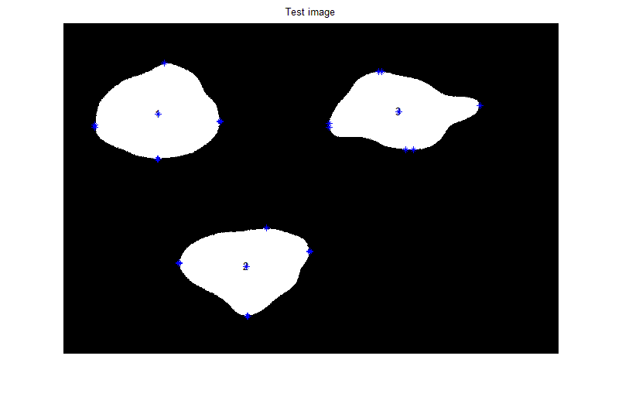
Fig: 5.8 Test image

The objects detected in reference image are 3
The objects detected in test image are 3
The intra matrix of test image is as follows
intratest =

200.5777 166.9864 174.2346
200.7002 167.4505 170.0884
239.4851 251.9007 315.5785
239.7094 251.2255 315.5022
172.8768 191.9484 157.9000
172.8840 191.9244 149.9652
249.7454 260.1335 275.8530
248.1412 260.2267 273.1807

The inter cellular matrix of test image is as follows
intertest(:,:,1) =

1.0e+003 *

0.7516 0.7521 0.9213 0.9237 1.0315 1.0312 0.7791 0.7771
0.7510 0.7516 0.9207 0.9230 1.0312 1.0309 0.7790 0.7770
0.4524 0.4528 0.6133 0.6158 0.7627 0.7625 0.5739 0.5720
0.4505 0.4509 0.6116 0.6141 0.7607 0.7606 0.5720 0.5700
0.4957 0.4965 0.6858 0.6874 0.6991 0.6986 0.4128 0.4109
0.4982 0.4991 0.6884 0.6900 0.7005 0.7001 0.4134 0.4115
0.7702 0.7711 0.9607 0.9622 0.9408 0.9402 0.6214 0.6197
0.7748 0.7757 0.9652 0.9667 0.9478 0.9472 0.6291 0.6274

intertest(:,:,2) =

1.0e+003 *

0.8317 0.8416 1.2331 1.2332 1.0212 0.9939 0.6849 0.6799
0.8307 0.8406 1.2321 1.2322 1.0203 0.9929 0.6839 0.6790
0.6462 0.6557 1.0098 1.0097 0.7583 0.7296 0.4247 0.4241
0.6468 0.6563 1.0099 1.0098 0.7580 0.7293 0.4246 0.4241
0.9188 0.9281 1.2621 1.2619 0.9876 0.9586 0.6723 0.6750
0.9216 0.9309 1.2651 1.2649 0.9906 0.9616 0.6753 0.6780
1.1208 1.1306 1.4933 1.4933 1.2362 1.2073 0.9070 0.9071
1.1191 1.1290 1.4928 1.4928 1.2369 1.2080 0.9071 0.9070

intertest(:,:,3) =

1.0e+003 *

0.7479 0.7538 0.9546 0.9541 0.6455 0.6201 0.4609 0.4728
0.7474 0.7532 0.9537 0.9532 0.6446 0.6192 0.4604 0.4723
0.7471 0.7508 0.8688 0.8682 0.5622 0.5418 0.4870 0.5008
0.7499 0.7536 0.8708 0.8701 0.5643 0.5440 0.4899 0.5038
1.0751 1.0799 1.2142 1.2135 0.9086 0.8884 0.7964 0.8092
1.0756 1.0804 1.2149 1.2142 0.9093 0.8891 0.7968 0.8096
1.0736 1.0808 1.3160 1.3155 1.0081 0.9821 0.7851 0.7946
1.0722 1.0795 1.3150 1.3146 1.0072 0.9812 0.7837 0.7932

The interdifference lattice from comparison of test and refernce lattice is as
interdifference(:,:,1) =

-4.6247 3.7304 -18.8912 -14.2511 -16.8159 -22.1237 -4.0105 -15.9593
-5.1942 3.1323 -19.5368 -14.8886 -17.1785 -22.4572 -4.1135 -16.0653
19.0387 25.8483 5.9778 10.8086 4.2018 1.4222 12.6197 0.9224
-3.2569 3.9336 -14.0091 -9.3156 -20.3482 -23.2326 -11.7088 -23.3693
9.2887 22.0775 -5.8337 -2.7944 -0.0293 -8.1867 11.4019 -0.3214
33.2912 46.3247 18.4948 21.3656 15.0304 6.3330 18.3070 6.8262
9.0482 22.2279 -5.8308 -3.0276 -3.0875 -13.5386 4.3484 -5.6260
4.9132 18.0895 -9.9020 -7.1123 -9.3528 -19.7995 -2.4936 -12.4670

interdifference(:,:,2) =

-3.6453 -3.6376 -130.2760 -127.4273 -37.4902 -12.0718 -16.3628 -15.1060
-4.6461 -4.6384 -131.2599 -128.4060 -38.4572 -13.0416 -17.3278 -16.0747
9.1287 9.1179 -123.3728 -123.6795 -15.9622 10.7217 6.4616 6.8833
17.1480 17.0237 -122.2609 -123.1130 -18.4205 8.2675 6.7265 7.8331
-1.2083 -1.2717 -139.0804 -141.7092 -26.2828 0.7033 -3.4416 -3.4396
24.6922 24.6715 -111.4432 -113.9981 1.6461 28.6320 23.9040 23.8010
6.8987 6.8480 -129.2996 -130.1024 -22.4810 4.4431 0.7136 1.1761
8.3744 8.3108 -128.8803 -129.6759 -23.1265 3.7814 0.6199 1.2081

interdifference(:,:,3) =

1.1917 0.9439 -138.6064 -147.9185 -17.6877 6.0792 9.4255 8.0622
-7.0547 -7.4415 -151.0243 -160.5004 -30.2776 -6.5062 2.5129 1.3024
-1.9064 -2.0040 -126.3324 -138.3731 -6.4225 12.5947 7.5923 5.6510
3.7305 3.6069 -121.8594 -134.0074 -1.8194 17.1352 13.5473 11.6078
-7.5906 -7.7806 -134.1410 -146.4138 -14.9692 3.9490 1.5762 -0.1081
-0.2343 -0.3073 -123.0710 -135.2026 -4.2310 14.6830 7.5343 5.7691
6.1731 5.9940 -133.5948 -142.1310 -12.6195 11.6413 10.4266 9.4360
-2.3543 -2.4777 -139.6845 -148.0600 -18.4510 5.8211 1.9778 0.8996

The new interdiffernce lattice after taking into account experimental errors and medical relaxation is
newinterdifference(:,:,1) =
0 0 0 0 0 0 0 0
0 0 0 0 0 0 0 0
0 0 0 0 0 0 0 0
0 0 0 0 0 0 0 0
0 0 0 0 0 0 0 0
0 0 0 0 0 0 0 0
0 0 0 0 0 0 0 0
0 0 0 0 0 0 0 0

newinterdifference(:,:,2) =

0 0 130.2760 127.4273 0 0 0 0
0 0 131.2599 128.4060 0 0 0 0
0 0 123.3728 123.6795 0 0 0 0
0 0 122.2609 123.1130 0 0 0 0
0 0 139.0804 141.7092 0 0 0 0
0 0 111.4432 113.9981 0 0 0 0
0 0 129.2996 130.1024 0 0 0 0
0 0 128.8803 129.6759 0 0 0 0

newinterdifference(:,:,3) =

0 0 138.6064 147.9185 0 0 0 0
0 0 151.0243 160.5004 0 0 0 0
0 0 126.3324 138.3731 0 0 0 0
0 0 121.8594 134.0074 0 0 0 0
0 0 134.1410 146.4138 0 0 0 0
0 0 123.0710 135.2026 0 0 0 0
0 0 133.5948 142.1310 0 0 0 0
0 0 139.6845 148.0600 0 0 0 0

The lattice arriving from mahalanobis distance is as
r =
1.2585 1.2573 2.1593 2.1812 2.5131 2.5055 2.1504 2.0970
0.3153 0.3157 1.3298 1.3522 4.3985 4.3939 2.4078 2.4063
0.6589 0.6394 3.6728 3.6757 3.8033 3.7615 3.7124 3.3901

The frequency matrix declares the maximum times a lattice involved in deviation
frequency =
1
1
2

Thus the region which has overqrowth has its number as ( eucledian distance)
3
Summing up the mahalanobis distance matrix and storeing its sum in g
g =
16.1222
16.9194
23.3140
The region 3 is infected with cancer(mahalanobis distance)
To check out which matrices are non zero to zero upon the infected area
nonzeromatrices =
2
3
0
0
0
0
0
0
0
0
0
0
0
0
0
0
0
0
0
0
Overgrowth is in right top part
Overgrowth is in right bottom part
The overgrowth can be precisely said in right direction of 3 region
The percentage change in perimeter of infected region 3 is 2.254724e+001
The percentage change in area of infected region 3 is 2.012633e+001
Discussion: As we can make up from the image itself that region 3 has gone growth, so does is being indicated in the results.
Case8:
Description: This is the test image. It is supposed to be obtained from a person who has come up for check up.
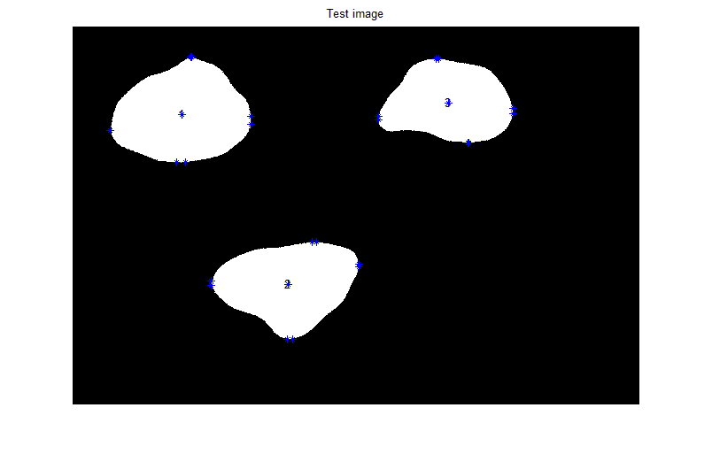
Fig: 5.9 Test image

The objects detected in reference image are 3
The objects detected in test image are 3
The intra matrix of test image is as follows
intratest =

196.9389 165.4966 156.0721
197.2579 173.8304 153.5128
233.5292 247.7903 217.3471
235.8219 245.4852 219.7718
162.8304 185.8856 152.1733
163.6014 185.3479 151.2983
248.3739 259.6395 245.6686
248.1607 259.8912 243.0936

The inter cellular matrix of test image is as follows
intertest(:,:,1) =
1.0e+003 *

0.7469 0.7558 0.9024 0.9094 1.0147 1.0091 0.7751 0.7611
0.7458 0.7547 0.9011 0.9082 1.0141 1.0085 0.7749 0.7610
0.4714 0.4786 0.6193 0.6266 0.7669 0.7640 0.5865 0.5729
0.4473 0.4549 0.5976 0.6048 0.7404 0.7373 0.5603 0.5467
0.5050 0.5186 0.6800 0.6846 0.6990 0.6904 0.4242 0.4105
0.5315 0.5454 0.7069 0.7113 0.7156 0.7064 0.4317 0.4183
0.7793 0.7933 0.9548 0.9592 0.9377 0.9266 0.6257 0.6141
0.7797 0.7938 0.9553 0.9596 0.9385 0.9274 0.6266 0.6149

intertest(:,:,2) =

1.0e+003 *

0.8280 0.8380 1.1028 1.1058 0.9837 0.9818 0.6685 0.6648
0.8260 0.8360 1.1008 1.1038 0.9818 0.9799 0.6666 0.6629
0.6553 0.6649 0.8864 0.8860 0.7424 0.7404 0.4311 0.4310
0.6639 0.6734 0.8876 0.8867 0.7396 0.7376 0.4313 0.4319
0.9176 0.9269 1.1230 1.1202 0.9613 0.9593 0.6689 0.6716
0.9463 0.9556 1.1536 1.1509 0.9923 0.9903 0.6992 0.7018
1.1277 1.1375 1.3640 1.3632 1.2137 1.2117 0.9077 0.9083
1.1275 1.1373 1.3640 1.3631 1.2138 1.2118 0.9077 0.9082

intertest(:,:,3) =

1.0e+003 *

0.7491 0.7548 0.8160 0.8062 0.6278 0.6262 0.4703 0.4809
0.7403 0.7458 0.8027 0.7927 0.6144 0.6127 0.4629 0.4736
0.7452 0.7488 0.7425 0.7298 0.5558 0.5544 0.4946 0.5065
0.7536 0.7572 0.7489 0.7361 0.5625 0.5611 0.5035 0.5154
1.0675 1.0721 1.0800 1.0671 0.8937 0.8923 0.7980 0.8091
1.0754 1.0801 1.0918 1.0790 0.9051 0.9038 0.8043 0.8154
1.0798 1.0868 1.1824 1.1734 0.9955 0.9937 0.7955 0.8040
1.0699 1.0770 1.1754 1.1665 0.9888 0.9870 0.7857 0.7941

The interdifference lattice from comparison of test and refernce lattice is as
interdifference(:,:,1) =
0 0 0 0 0 0 0 0
0 0 0 0 0 0 0 0
0 0 0 0 0 0 0 0
0 0 0 0 0 0 0 0
0 0 0 0 0 0 0 0
0 0 0 0 0 0 0 0
0 0 0 0 0 0 0 0
0 0 0 0 0 0 0 0

interdifference(:,:,2) =

0 0 0 0 0 0 0 0
0 0 0 0 0 0 0 0
0 0 0 0 0 0 0 0
0 0 0 0 0 0 0 0
0 0 0 0 0 0 0 0
0 0 0 0 0 0 0 0
0 0 0 0 0 0 0 0
0 0 0 0 0 0 0 0

interdifference(:,:,3) =

0 0 0 0 0 0 0 0
0 0 0 0 0 0 0 0
0 0 0 0 0 0 0 0
0 0 0 0 0 0 0 0
0 0 0 0 0 0 0 0
0 0 0 0 0 0 0 0
0 0 0 0 0 0 0 0
0 0 0 0 0 0 0 0

The new interdiffernce lattice after taking into account experimental errors and medical relaxation is
newinterdifference(:,:,1) =
0 0 0 0 0 0 0 0
0 0 0 0 0 0 0 0
0 0 0 0 0 0 0 0
0 0 0 0 0 0 0 0
0 0 0 0 0 0 0 0
0 0 0 0 0 0 0 0
0 0 0 0 0 0 0 0
0 0 0 0 0 0 0 0

newinterdifference(:,:,2) =

0 0 0 0 0 0 0 0
0 0 0 0 0 0 0 0
0 0 0 0 0 0 0 0
0 0 0 0 0 0 0 0
0 0 0 0 0 0 0 0
0 0 0 0 0 0 0 0
0 0 0 0 0 0 0 0
0 0 0 0 0 0 0 0

newinterdifference(:,:,3) =

0 0 0 0 0 0 0 0
0 0 0 0 0 0 0 0
0 0 0 0 0 0 0 0
0 0 0 0 0 0 0 0
0 0 0 0 0 0 0 0
0 0 0 0 0 0 0 0
0 0 0 0 0 0 0 0
0 0 0 0 0 0 0 0

The lattice arriving from mahalanobis distance is as
r =
2.1962 2.1937 1.6391 1.7552 1.2606 1.2104 1.8729 1.8718
1.1248 1.1357 1.3184 1.3019 2.3578 2.2896 2.1898 2.2818
2.2402 2.2355 1.4933 1.4788 1.2011 1.1958 2.1309 2.0243

The frequency matrix declares the maximum times a lattice involved in deviation
frequency =
0
0
0
Summing up the mahalanobis distance matrix and storeing its sum in g
g =
14.0000
14.0000
14.0000

No cancer detected but consults a doctor to be on safer side.
Discussion: As we can make up from image itself that it is identical to reference so does is been indicated in the results.
5.2 MRI Images
Reference Image
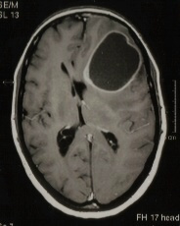
Fig: 5.10 MRI Reference image

Description: This is the reference image through which various test images will be tested. Though it is cancerous (lets suppose it to be of Stage 1) but still we are taking it as reference.

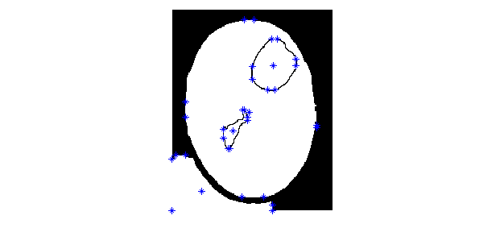
Fig: 5.11 Test image
Discussion: Here 4 objects are detected.
Test Image:
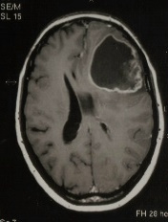
Fig: 5.12 MRI Test image

Description: This is test image. It must bifurcate into similar objects to start off with comparison with the reference image.

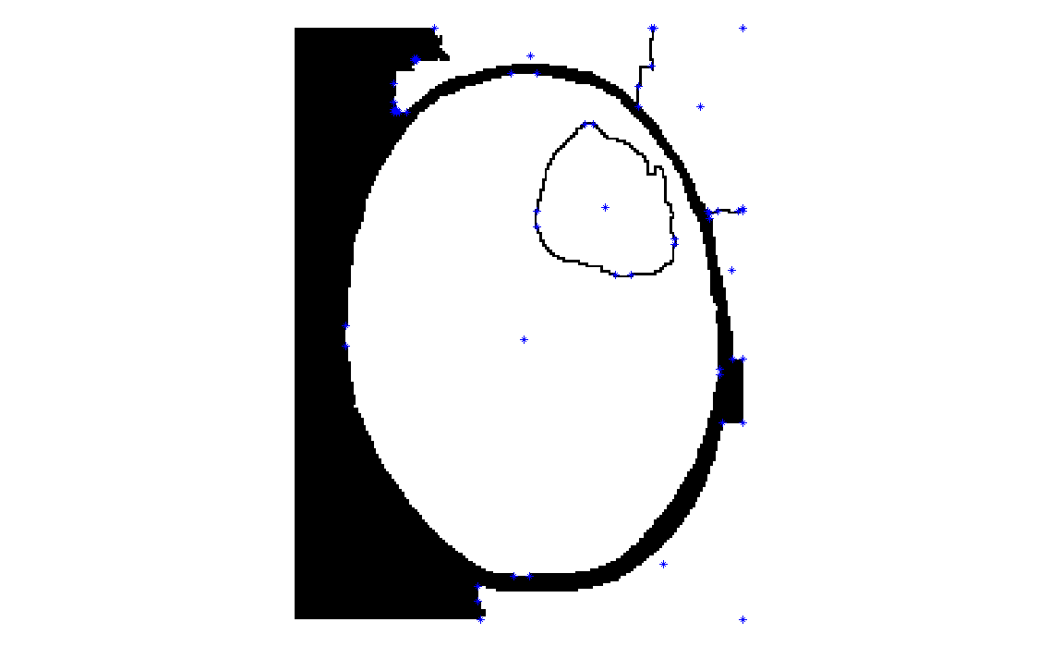
Fig: 5.13 Test image

Discussion: Here the number of objects detected was 8. Now as the number of objects and their position don’t hold any resemblance with the reference so we cannot proceed further.
Options such as trying various kinds of structuring element, grey level threshold for converting to binary were also tried to a great extent but all in vain. The bifurcation was not closed to similar of both images in any case.

Chapter 6
Summary and Conclusions

6.1 Summary
Through the above obtained results, it can be stated that though the handmade images were out quite competently but while working on realistic data a major issue of segmentation crops up. Contrast, zooming factor, lens opening of camera and distance from camera plays quite an important role in how an image will be segmented. Thus all these facts need to be kept in mind while feeding two images to the system to be compared.
To the best of our knowledge and with the best utilization of available time we have been able to come up with these results. Though for making a sincere headway in this field the effort is meager one but not worthless.

6.2 Achievements

- The given program when coupled with MRI techniques will provide comments about the status of cancerous tissue at MRI evaluation itself. Thus helping out of an situation of emergency for the time being till correct evaluation of reports take place.
- The project even aims to verify the conclusions as obtained through the doctor. Thus reducing the discrepancy on the part of doctor if any.
- The watershed principle using morphological functions is quite faster than other segmentation approaches. Thus some day after refinement if the product is used commercially it will even result in faster evaluation of data and procurements of results.
- In depth analysis and accuracy in evaluation of cancerous tissues is what is aimed at through this project.
6.3 Drawbacks:

- If two or more tissues undergo a growth simultaneously the program fails to figure out those and unexpected results are to follow.
- If a tissue overgrowth compresses the neighborhood tissues the inter distance between the two will remain same and thus cancer won’t be detected.
- The program relies on regionprops(‘Extrema’) function for generating points on the periphery of objects detected, this sometimes misses the exact point of overgrowth.
- Watershed algorithm when applied to actual MRI images or sometimes to our handmade images often result in improper segmentation or over segmentation. Thus the tissue shapes that are desired undergo severe changes.
- Unequal segmentation between test image and reference image through watershed is a common place in our project thus rendering to the failure of entire software.
- Bridge between watershed algorithm outputs and further processing of data is missing due to un identical segmentation of reference and test images.
- Focusing and zooming errors of camera can introduce severe discrepancies and could severely affect the least count of algorithm.
6.4 Proposals for future:

- An improved and faster segmentation technique will help bridge the gap between segmentation of image and further processing of data.
- A quantized approach to obtain points on periphery of objects detected will help increase the level of accuracy to manifold.
- Special cases of more than one tissue undergoing an overgrowth or one tissue overgrowth suppressing others needs to be taken care of into the software.
- Applying of above stated algorithm on more realistic data will help get a better insight into the project.

References

- National cancer Control Programme Policies and Managerial Guidelines, IInd Edition, World Health Organisation, Stener Kvinnsiand, Oslo, May 2002.
- www.who.int
- Jeffery Zhi-jie Zheng, Liang Lu, Yinfu Xie. “towards automated image analysis,” IEEE international conference on vol. issue June 2005.
- Carl J. D’Orsi , Early Detection of breast cancer : Mammography, Breast Cancer Research and Treatment, (1991), May; 18(1):107-09.
- H.S.Sheshadri and A. Kandaswamy, “detection of breast cancer tumour based on morphological watershed algorithms” ICGST-GVIP journal, Vol. 5, issue 5, May 2005.
- Jean-Philippe Thiran, Benoit Macq, “morphological feature extraction for the classification of digital images of cancerous tissues”, IEEE transaction on biomedical engineering 1996.
- Jong-Chen-Chen, Chun-Ming Yeh, Jeh-En Tzeng, “Pattern differentiation of glandular cancerous cells and normal cells with cellular automata and evolutionary learning”, Expert Systems with Applications: An International Journal 2008, Jan ; 34 (1) : 337-46.
- Laurence P. Clarke, Barbara Y. Croft, and Edward Staab, “New NCI Initiatives in Computer Aided Diagnosis”, SPIE Feb. 2000
- B.Weyn, GVan De Wouwer, M. Koprowski, A.Van Daele, K. Dhaene, P. Scheunders, W. Jacob, and E. Van Marck, “ Value of morphometry, texture analysis, densitometry and histometry in the differential diagnosis and prognosis of malignant mesothelioma,” Journal of Pathology, 180, pg 581-589, 1999
- A. Bernasconi, S.B. Antel, D.L. Collins, N Bernasconi, A. Olivier, F. Dubeau, G.B. Pike, F. Andermann and D.L. Arnold, “Texture analysis and morphological processing of magnetic resonance imaging assist detection of focal cortical dysplasia in extra-temoral partial epilepsy,” Annals of Neurology, 49, 2001.
- J.K.Shuttleworth, A.G. Todman, R.N.G.Nauib, B.M. Newman and M.K. Bennett, “Multiresolution colour texture analysis for classifying colon cancer images,” Proceddingsof the Second Joint EMBS/BMES Conference, Houston, TX, USA, 23-26 Oct 2002.
- Yuan-Lie He, Lian-Fang Tian, Chun-Mei Zhu, Ping Chen, Bin Li, Zong-Yuan Mao, “Development Of Intelligent Diagnosis and Report System Based On Whole Body Bone Spect Image” , Proceedings of the Fourth International Conference on Machine Learning and Cybernetics, Guangzhou, 18-21 August 2005.
- S. Goldenstein, C. Vogler, L. Velho, “Adaptive deformable models for graphics and vision”, Computer Graphics Forum, 24 (4) pp.729-741, 2005.
- Kass. M, Witkin. A, Terzopouls. D, “Snake: active contour models”, Proceeding of International Journal of Computer Vision, Vol.1, No.4, pp. 321–331, 1987.
- Germain. O, Refregier. P, “Edge location in SAR images: Performance of the likelihood ratio filter and accuracy improvement with an active contour approach” , IEEE Transactions on Image Processing, Vol. 10, No. 1, pp.72-78, 2001.
- Leymarie. F, Levine. M. D, “Tracking deformable objects in the plane using an active contour model”, IEEE Transl. on PAMI, Vol. 15, pp. 617–634,1993.
- Terzopoulos. D, Szeliski. R, “Tracking with Kalman snakes”, Artificial Intelligence, USA: MIT Press, pp. 3–20, 1992.
- Jin-Yong, Yi-Hui Liu, “ Human body Image segmentation based on Wavelet Aanlysis and active contours Models”, International Conference on Wavelet Analysis and Pattern Recognition, Beijing, China, 2-4 Nov. 2007.
- Dave Tahmoush, “Image differencing approaches to medical image classification”, 36th Applied Imagery Pattern Recognition Workshop
- Luc Vincent, Morphological Algorithms pg 255-287.
- www.mathworks.com/company/newsletters/news_notes/win02/watershed
- Bernhard Ganter, Formal Concept Analysis: Methods and Applications in Computer Science pg 7-36.
- www.mathworks.com/products/image/demos
- www.blogs.mathworks.com/steve/2006/06/02/cell-segmentation
- www.blogs.mathworks.com/steve/2006/11/17/labeling-labeled-objects
- Peter J. Acklam, MATLAB array manipulation tips and tricks pg 4-25
- Simon Vinitski, Ph.D., Carlos, Gonzalez, M.D., Claudio, Burnett, M.D., William
Buchheit,M.D., Feroze Mohamed., M.S., Hector Ortega, M.D., Scott Faro, M.D,” 3D
Segmentation in MRI of Brain Tumors: Preliminary Results, 1995 JEEF-EMBC and
CMBEC.
- Albert K.W. Law, F.K Lam, Francis H.Y. Chan,” A FAST DEFORMABLE REGION MODEL FOR BRAIN TUMOR BOUNDARY EXTRACTION”, Proceedings of the Second Joint EMBS/BMES Conference Houston, TX, USA* October 23-26-2002
- Hui Zhu, Francis.H.Y.Chan, F.K.lam and Paul W.F.Poon,” A DEFORMABLE REGION MODEL FOR LOCATING THE BOUNDARY OF BRAIN TUMOR”, 1995 IEEE-MBC and CMBEC.
- Azzedine Boukerche, Haifa Maamar and Abu Hossain,” A Performance Evaluation of a Hybrid Multicast Transport protocol For a distributed Collaborative Virtual Simulation of a Brain Tumor Tele- Surgery Class of Application”,
- Department of Radiology, Pediatrics and Pathology Keck School of Medicine,” A Non- invasive, Multi-modality Approach Based on NIRS and MRI Techniques for Monitoring Intracranial Brain Tumor Angiogenesis”,
- Dept. of Electrical Engineering Nagoya University, Nagoya 464-01, Japan, Dept. of Biotechnology Engineering Nagoya University, Nagoya 464-01, Japan, Dept. of Neurosurgery Medicine, Nagoya University, Nagoya 466, Japan ,” POSITION SENSING OF MAGNETITE GEL USING MI SENSOR FOR BRAIN TUMOR DETECTION “, IEE TRANSPORT IN MAGBETUCS. VOL. 33, NO. 5, SEPTEMBER 1997.
- Institute of Computer and Information Science National Chiao –Tung University Hsin –Chu, Taiwan, R.O.C.,” A BRAIN TUMOR DIAGNOSTIC SYSTEM WITH AUTOMATIC ARNING ABILITIES”
- “Hausdorff Distance based 3D Qualification of Brain Tumor Evolution from MRI Images”, Proceeding of the 29th Annual International Conference of the IEEE EMBS Cite International, Lyon, France August 23-26, 2007.
- Y.Y.B.Lee, Y.Huang, W.EI- Deredy, P.J.G.Lisboa, C.Arus and P. Harris ,” MEDICAL SIGNAL PROCESSING”.
- “Diffusion Tensor Visualization with Glyph Packing”, IEEE TRANSCTIONS ON VISUALIZATION AND COMPUTER GRAPHICS, VOL.12, NO.5, SEPTEMBER/OCTOBER 2006.
- ROBUST METHODOLOGY FOR THE DISCRIMINATION OF BRAIN TUMOURS FROM IN VIVO MAGNETIC RESONANCE SPECTRA
- Mark Schmidt, Ilya Levner, Russell Greiner, Albert Murtha, Aalo Bistritz,” Segmenting Brain Tumors using Alignment-Based Features”, Proceedings of the Fourth International Conference on Machine Learning and Applications (ICMLA’05).
- Abdel-Halim Elamy Maidong Hu,”Mining Brain Tumors and Tracking their Growth Rates “.
- Y. Shindo, K. Kato, K. Tsuchiya, T. Yabuhara, T. Shigihara, R. Iwazaki, T. Uzuka, H. Takahashi and Y. Fujii ,” Heating Properties of Re-entrant Resonant Applicator for Brain Tumor by Electromagnetic Heating Modes” Proceedings of the 29th Annual InternationalConference of the IEEE EMBS Cité Internationale, Lyon, France August 23-26, 2007.
- Jean-Baptiste Poullet , M Carmen Martinez-Bisbal , Dani Valverde , Daniel Monleon
Bernardo Celda2, Carles A, and Sabine Van Huffel, ” Quantiﬁcation and
classiﬁcation of high-resolution magic angle spinning data for brain tumor diagnosis”
Proceedings of the 29th Annual International Conference of the IEEE EMBS Cité
Internationale, Lyon, France August 23-26, 2007.
- Evangelia I. Zacharaki , Cosmina S. Hogea,George Biros, Member, IEEE, and Christos Davatzikos, Senior Member, IEEE,” A Comparative Study of Biomechanical Simulators in Deformable Registration of Brain Tumor Images”, IEEE TRANSACTIONS ON BIOMEDICAL ENGINEERING, VOL. 55, NO. 3, MARCH 2008
- Azzedine Boukerche, Haifa Maamar and Abu Hossain,” A Performance Evaluation of a Hybrid Multicast Transport Protoco for a Distributed Collaborative Virtual Simulation of a Brain Tumor Tele-Surgery Class of Applications” 2007 IEEE
- Jason J. Corso*, Member, IEEE, Eitan Sharon, Shishir Dube, Suzie El-Saden, Usha Sinha, and Alan Yuille, Member, IEEE,” Efﬁcient Multilevel Brain Tumor Segmentation With Integrated Bayesian Model Classiﬁcation”, IEEE TRANSACTIONS ON MEDICAL IMAGING, VOL. 27, NO. 5, MAY 2008

