CHAPTER 1

Introduction

Switched mode power supplies (SMPS) are being extensively used in most power processes [1]. The analysis, modeling and design process have all matured in the last few decades. Most of these developments were centered on hard switched converters, where switching frequency is limited to 10s of kHz [2].In recent years, significant research and development have been made up to come up with the cost-effective, efficient and very compact supplies. The compact switched mode power supplies demands higher switching frequency, to reduce the reactive component size and cost, and efficient SMPS demands low overall losses. The increase in switching frequency will be problematic because of direct relationship of switching losses on the operating frequency. The uses of soft switching techniques, [3] – [6] zero voltage switching (ZVS) or zero current switching (ZCS), is an attempt to substantially reduce the switching losses and hence attain high efficiency at increased switching frequency. Different techniques have been proposed to operate the switched mode power converters at high frequency.
In general, soft switching techniques can be classified into two groups: Zero Voltage Switching (ZVS) and Zero Current Switching (ZCS). The ZVS approaches are desirable for the majority carrier semiconductor devices such as MOSFETs, since the turn-on loss caused by the output capacitance is large. On the other hand ZCS approaches are suitable for the minority carrier semiconductor devices such as IGBTs, since the turn-off loss is large due to current trail characteristics. The soft-switching topologies belong to families namely resonant load converters [3], resonant switch converters [2], [4], resonant transition converters [5], [6], and most recently active clamped PWM converters [7], [8], [9]. The resonant load converters depend on the characteristics of the load to achieve soft switching. In the resonant switch converters additional resonant elements are used in the circuit to achieve soft switching. The resonant transition converters employ parasitic of the converter to achieve loss-less switching. The active clamp topology adds an active clamp network, consisting of a small auxiliary switch in series with a capacitance plus the associated drive circuitry to the traditional hard witch converters. Fig. 1.1 illustrates the classification of switch mode power supplies.

SMPS
Soft Switching
Hard Switching
Active Clamp
Resonant
Transition
Resonant
Switch
Resonant Load

Fig. 1.1 Classification of switched mode power supplies

The buck derived forward converter is one of the most popular switch mode topologies. High input to output step down or step up in voltage is easily achieved by using appropriate transformer turn ratio. Galvanic isolation is frequently needed between the supply and load grounds to supply power to isolated load or for increased safety and protection. For these and other reasons, the forward converter has become a cost effective solution to many power management needs. With its continuing proliferation, new opportunities emerge for more efficient operation, higher switching frequencies, reduced EMI and extended duty cycle operation. My dissertation work basically deals with ‘an improved ZVS-PWM active clamp/reset forward converter’. The improved ZVS-PWM active clamp/reset forward converter has the following features:
- Reduced voltage stress on the rectifier
- Constant frequency and PWM operation
- Soft-switching for all devices
- Low voltage stresses on active devices due to clamping action
The operation and idealized analysis of the ZVS-PWM active clamp/reset forward converter is presented. Parameters affecting the soft switching (ZVS) are highlighted. A computer-spread sheet is organized to design the converter. A new approach to determine the steady state stability of the current programmed active clamp dc-dc converter is presented. Prototype converters are fabricated to validate the design methodology. This report is organized as follows:
Chapter 2 of this report gives an introduction to high switching frequency and soft switching techniques. Some of the soft switching topologies are reviewed. Merits and demerits of different topologies are discussed. The problems associated with the existing active clamp/reset forward converter are highlighted, and their remedies are presented.
In chapter 3 complete steady state analysis of the proposed converter is discussed. Parameters effecting the soft switching are discussed. Design constraints are also explained. With these constraints a computer spread sheet is organized to design the converter.
In chapter 4 steady state stability of current mode control of ZVS – PWM, active clamp DC – DC converter is presented. A new approach is proposed to correctly predict the region of instability of CMC ZVS – PWM, active clamp converters. Simulation results and experimental verifications are presented in this chapter.

Finally all results are concluded in chapter 5.
Following are the contributions of this report,
- An improved ZVS – PWM active clamp/reset forward converter obtained.
- A new approach, which correctly predicts the instability region of the active clamp converters, is introduced.

CHAPTER 2

Soft switching topologies: An Overview

2.1 Introduction
Switched mode power supplies (SMPS) are being extensively used in most power conversion processes. To accommodate the ever – increasing requirements for smaller size, lighter weight and higher density power supplies, conversion frequency has been chosen as high as several hundred kilohertz. Accompanying the switching frequency, however, there are many problems associated with the switching devices in conventional PWM converters, namely high switching losses and switching stress. Recently, various kinds of soft switching techniques for switched mode power converters have been introduced in order to satisfy the requirements for smaller size, lighter weight and higher efficiency. In general, the soft switching techniques can be classified into two groups: Zero Voltage Switching (ZVS) and Zero Current Switching (ZCS). The ZVS approaches are desirable for the majority carrier semi-conductor devices such as MOSFETs, since the turn – on losses caused by the output capacitance is large. On the other hand ZCS approaches are suitable for the minority carrier semiconductor devices such as IGBTs, since the turn – off loss is large due to current trail characteristics. The sift – switching topologies belong to families namely resonant load converters, resonant switch converters, resonant transition converters and most recently active clamped PWM converters.
The problems associated with hard switching at high conversion frequency are briefly discussed in section 2.2. Some of the soft switching topologies like load converters, resonant switch converters, resonant transition converters and most recently active clamped PWM converters are reviewed in section 2.3. Finally the problems associated with existing ZVS – PWM, active clamp/reset forward converter and their remedies are presented in section 2.4.

2.2 Hard Switching
In conventional PWM converters, the semiconductor devices turn – on to full current from full voltage and turn – off to full voltage from full current. A diode clamped inductive load circuit is shown in Fig.2.1.
V_{ds}
V
D
I_{o}
S
I_{s}

Fig.2.1. Diode clamped inductive load circuit

It's ideal switching waveforms and switching trajectory is presented in Fig.2.2. Switching loss for the switching wave form is given as,
Switching loss = $\left\{\frac{1}{2}\right.V×I_{o}×t_{r}×f_{s}\left.\frac{}{}\right\}+\left\{\frac{1}{2}V×I_{o}×t_{f}×f_{s}\left.\frac{}{}\right\}\right.$ (2.1)
V = Source voltage; I_{o} = Load current f_{s} = Switching frequency
t_{r} = Rise time t_{f} = Fall time
From equation (2.1) it is seen that switching loss is proportional to the operating frequency. Hence, with hard switching at higher switching frequency of the converter decreases.
V_{ds}, I_{s}
t_{f}
t_{r}
I_{s} = I_{o}
V_{ds} = V
t
Turn off
Turn on
I_{s}
V_{ds}
Turn off
Turn on

Fig.2.2 Ideal switching waveforms and switching trajectory
Furthermore, the presence of parasitic inductances and junction capacitances in the semiconductor devices causes the power devices to operate in inductive turn – off and capacitive turn – on [13] – [14]. As the device switches off an inductive load, voltage spikes are induced by the sharp $\text{di}\text{dt}$ across the parasitic inductance. These causes turn – off voltage across the device more than full voltage. On the other hand, when the switch turns on at high voltage level, the energy stored in the device output capacitances, $\frac{1}{2}{\text{cv}}^{2}$, is trapped and dissipated inside the device. This engenders turn – on current more than load current. Fig.2.3 shows a typical switching trajectory when parasitic effects are considered. Furthermore, turn – on at high voltage level induces a severe switching noise known as Miller effect, which is coupled to drive circuit leading to significant noise and instability.
I_{s}
V_{ds}
Turn off
Turn on

Fig.2.3 Effect of parasitic inductance on switching trajectory

In order to protect the devices from the high switching stresses, snubber circuits are used [13] – [14]. There are two types of snubber circuits namely turn – off snubber and turn – on snubber.
Fig.2.4 (a) illustrates the diode clamped inductive load circuit with turn – off snubber. The turn – off snubber comprises of a resistor, capacitor and diode. During switch turn – off, the capacitor C comes across the device and limits the rate of rise of voltage. Thus over voltage during turn – off transition is snubbed. When properly designed the snubber may marginally reduce the overall losses. The diode clamped inductive load circuit with turn – on snubber is shown in Fig.2.4 (b). The turn – on snubber consists of resistor, inductor and diode. During turn – on process, the inductor L limits the rate of rise of current through the device. Thus over currents during turn – on transition are snubbed. When properly designed, turn – on snubber also reduces overall loss. Fig.2.5 shows a typical switching trajectory with snubber circuits.
V_{ds}
V
D
I_{o}
S
I_{s}
R
C
D_{s}
V_{ds}
V
D
I_{o}
S
I_{s}
L
D_{s}
R

(a) With turn – off snubber (b) With turn – on snubber

Fig.2.4 Diode clamped inductive load circuit with snubber
V_{ds}
I_{s}
Turn off
Turn on

Fig.2.5 Switching trajectory with snubber circuits
2.3 Soft Switching
The snubber circuits effectively reduce the switching stresses and if properly designed, it reduces the switching loss in one transition. During the other transition energy stored in snubber capacitor C and snubber inductor L will be dissipated in the snubber resistor. This contributes to additional losses. Moreover, snubber circuit is not so useful at high switching frequency. Therefore, at high switching frequency soft switching techniques (ZVS or ZCS) are used to achieve good efficiency and reduced switching stress. In Zero-Voltage Switching (ZVS), the voltage across device is zero just before turn – on. On the other hand in Zero-Current Switching (ZCS), the current through device is zero just before turn-off. Fig.2.6 (a) and (b) illustrate the ZVS and ZCS switching trajectory,

V_{ds}
I_{s}
Assisted Turn off
ZVS Turn on
V_{ds}
I_{s}
ZCS Turn off
Assisted Turn on

(a) ZVS trajectory (b) ZCS trajectory

Fig.2.6 Soft switching trajectory

In the last two decades many soft switching topologies have been reported in literature. Some of the well known topologies are reviewed here

1. Resonant Load Converters
The resonant load converters employ resonant circuit for power processing. They are the first soft-switched converters reported in literature. The resonant load converters can be operated in either ZVS or ZCS. To achieve ZVS, the switching frequency should be greater than resonant frequency and if ZCS is required, the switching frequency should be less than resonant frequency. The resonant load converters are classified as series loaded converters and parallel loaded converters. Reference [3] gives the detailed analysis and design of this family of converters.

2. Resonant Switch Converters
A large number of resonant switch converters have been documented in literature. In resonant switch converters, the resonant elements (L_{r} and C_{r}) are used to achieve ZVS or ZCS. They are classified based on type of the resonant switch cell (M-type or L-type). Type of switch realization (half wave or full wave) and soft switching scheme (ZVS or ZCS). A half-wave ZVS, resonant switch boost converter is shown in Fig.2.7. the detailed analysis can be seen in reference [4], [2]. This topological converter has got many drawbacks. They are enumerated here,
- Due to sinusoidal currents/voltages, the peak value of switch current or voltage is high. To achieve ZVS, peak current will be very high and in case of ZCS peak voltage will be very high.
- The conduction loss increases considerably because of increase peak current in case of ZVS scheme.
- Since the output voltage is regulated by frequency modulation, a wide range may be required to operate with wide input voltage and load range. The wide frequency range makes design optimization of the power transformer, input/output filters, and control circuit difficult.
- Due to wide range of switching frequency, designing of EMI filter is difficult.
- Control circuitry is more complex as compared to the hard switch converter.

I_{in}
L_{r}
S
C_{r}
D
V_{o}

Fig.2.7 Half-wave ZVS, resonant switch buck converter

3. Resonant Transition Converters
One common characteristic of resonant type topologies is that they all employ a resonant inductor in series with the power switch to shape the switch voltage/current waveforms to achieve soft switching. Due to the fact that the resonant elements are placed in the main power path, the resultant converters are subject to inherent problems. First, since resonant is subjected to bi-directional voltage, it generates additional voltage stress on the semiconductor deices. Second, since all the power flows through the resonant inductor, substantial circulating energy is always created, which significantly increases conduction losses. In addition, the energy stored in the resonant inductor strongly depends on the line voltage and load current. Therefore, soft switching range is sensitive to line voltage and load current. This is why most resonant converters are unable to maintain soft switching for a wide line and large range.
To eliminate the above-mentioned limitations, it is necessary to remove the resonant element from the main power path. Instead of using a series resonant network across the power switch, the shunt resonant network is used during switching transition to achieve ZVS or ZCS. When switching transition is over, the converter can achieve soft switching reverts back to the familiar PWM mode. In this way, The converter can achieve soft switching while preserving the advantages of the PWM converter. This type of converter is known as Zero Voltage Transition (ZVT) converter. Fig. 2.8 shows a zero voltage transition boost converter. Reference [5], [6] gives the detailed analysis of the resonant transition converters.
I_{in}
S
C_{s}
V_{o}
C_{r}
L_{r}
S_{A}
D₁
D₂

Fig.2.8 Zero-voltage Transition (ZVT) boost converter

The other advantages of resonant transition topology is listed below,
- Soft switching ZVS or ZCS of all devices is possible.
- Peak voltage and current stress of the devices is limited to throw voltage and pole current.
- Parasitic inductance and capacitance in the circuit can be used as the resonant elements.
- Switching frequency is constant and control is PWM. Thus optimization of transformer, input/output filters are possible.

4. Active Clamped Converters
The active clamped converters are most recently introduced family of ZVS – PWM converters. In this topology an active clamp network is added to the basic hard-switched converter to facilitate the ZVS condition. The active clamp network consists of an auxiliary switch and resonant elements (L_{r} and C_{r}). Fig.2.9 illustrates a ZVS – PWM, active clamped boost converter. The principle of operation, theoretical analysis and design can be referred from [7] – [9].

I_{in}
C_{r}
D
V_{o}
L_{r}
S
D_{c}
S_{A}
Vc

Fig.2.9 ZVS – PWM, active clamped boost converter

The active clamped converters are having the following advantages,
- PWM modulation
- Soft communication (ZVS) for the active switches.
- Low voltage stress due to clamping action.
- Besides operating at constant frequency and with reduced switching losses there is no significant increase in circulating current. Thus conduction loss is nearly same the hard-switched PWM converters.
- The dynamic performance of the active clamp converter is better than hard-switched converter [9].

2.4 ZVS – PWM Active Clamp/Reset Forward Converter
The two transformer active reset circuits presented in [10] and shown in Fig.2.10 were employed in a forward converter to operate over a wide input voltage range. These circuits recover transformer magnetizing and leakage inductance energies, reduce dc flux in the core and minimize peak voltage on the power devices.

L_{r}
S₂
V_{c}
S₁
D₁
D₂
L
C
R
V

(a)
L
L_{r}
S₂
V_{c}
S₁
D₁
D₂
C
R
V

(b)

Fig.2.10 Forward converter with transformer reset circuit

One of these circuits, Fig.2.10 (a), was employed in a flyback converter [15] to achieve soft switching too. The other circuit, Fig.2.10 (b), with some modification was employed in forward converter to achieve soft switching too. Reference [8] gives the steady state analysis of the active clamp/reset forward converter. The design consideration required for designing active clamp forward converter and flyback converter is also presented in [8].
Fig.2.10 shows the active clamp/reset forward converter. The main problems associated with this existing active clamp/reset forward converter is hard-switching of passive deices and parasitic ringing caused by the interaction of rectifier diode junction capacitance with resonant inductor L, induces high voltage stress on the passive deices. Under this condition voltage stress will be twice of the input voltage reflected to secondary side. Ideally, this parasitic ringing can be eliminated by inclusion of a clamping diode D_{c} [11], as shown in Fig2.11, limiting the voltage stress on the rectifier to the input voltage reflected to the secondary side.
L_{r}
S₂
V_{c}
S₁
D₁
D₂
L
C
R
V
D_{c}

Fig.2.11 Active clamp/reset forward converter with clamp diode

Although the voltage stress on the rectifier has been eliminated, by the inclusion of clamping diode, all the diodes still present hard switching commutation and the voltages across these devices still rise in a high $\text{dv}\text{dt}$ rate, which means electromagnetic compatibility problems and switching losses is present there. This project presents an improved (High Performance) active clamp/reset forward converter featuring clamping action, PWM and soft switching (ZVS) in both active and passive devices. The inclusion of capacitor C_{r} and clamping diode D_{c}, in the forward converter, as shown in Fig.2.12 results in reduced $\text{dv}\text{dt}$ and soft switching conditions for all devices. Therefore, the proposed converter can be designed for high operating frequency with good efficiency. The other benefit of including C_{r} is explained in the design constraints, in the next chapter. The steady state analysis of the proposed converter is presented in next chapter.

L_{r}
S₂
V_{c}
S₁
D₁
D₂
L
C
R
V
D_{c}
C_{r}

Fig.2.11 Improved (High Performance) active clamped/reset forward converter
(Proposed Converter)

CHAPTER 3

Analysis, Design and Simulation of an improved ZVS – PWM, active clamp/reset forward converter

3.1 Introduction
This chapter introduces the improved ZVS – PWM, active clamp/reset forward converter. Principle of operation is explained. Parameters affecting ZS operation and design constraints are discussed. A computer-spread sheet is organized to design the converter.
In section 3.2 idealized operation of the improved ZVS – PWM, active clamp/reset forward converter is explained. Parameters affecting ZVS operation, design constraints and computer-spread sheet organization are discussed in section 3.3. Simulation and experimental results are presented in section 3.4.

3.2 Theoretical Analysis
3.2.1 Principle of Operation
An improved ZVS – PWM, active clamp/reset forward converter (proposed converter) is shown in Fig.3.1. This improved topology is obtained from already existing active clamp/reset forward converter by introducing a clamp diode (D_{c}) and one resonant capacitor C_{r} as shown in Fig.3.1. The idealized key waveforms of the improved ZVS – PWM, active clamp/reset forward converter for one switching cycle is shown in Fig.3.2.

V
C₁
D_{c}
S₁
S₂
V_{c}
-
+
L_{r}
L_{m}
. .
D₁
D₂
C_{r}
I_{o}

Fig.3.1 Improved ZVS – PWM active clamp forward converter

DT_{s}
D/T_{s}
V_{g1}
V_{g2}
t₀
t₇=T_{s}
t₆
t₃ t₄ t₅
t₁ t₂
kI_{Lm}*
I_{Lm}*
i(t)
kI_{Lm}*
I_{Lm}*
i_{Lm}(t)
kI_{Lm}*
I_{Lm}*
i_{c}(t)
V_{p}(t)
nV

Fig. 3.2 Idealized key waeforms

The notations L_{r}, C_{r}, C₁, S₁, S₂, D₁, D₂, D_{c}, V, V_{c}, I_{o} used in the analysis throughout this chapter and/or report are referred to Fig.2.1. the following are the symbols used in analysis.
i(t) =Resonant inductor current
i_{Lm}(t) =Magnetizing current
i_{c}(t) =Clamp capacitor current
V_{p}(t) =Voltage across Cr and called as pole voltage in later discussion
n =Turn ratio
It is important to note that to simplify the theoretical analysis the following assumptions are made
- All active and passive devices are ideal.
- The output filter inductance is large enough to be considered as a current source (I_{o}).
- The clamp capacitor is selected to have sufficiently large capacitance so that the voltage V_{c} across it could be considered constant.
- Leakage inductance effect is neglected.
Operation in all intervals is sequentially explained. The switching cycle starts when switch S₁ is turned on at t_{o}. It is assumed that switch S₁ is turned on under ZVS condition. This condition will be ensured at the end of one cycle.

Interval 1 [t_{o} < t ≤ t₁ ]: Linear charging of L_{r}
Prior to t_{o} switches S₁ and S₂ are off. The voltage across both switches is zero and V+V_{c} respectively. The conduction path for interval 1 is shown in Fig.3.3. in this interval resonant induction current i(t) ramps up linearly. The initial conditions for this interval are $\begin{aligned}i(to)=i\text{Lm}(to)=−\text{kI}\text{Lm}∗Vp(to)=0\end{aligned}$ (3.1)

V
C₁
D_{c}
S₁
S₂
V_{c}
-
+
L_{r}
L_{m}
. .
D₁
D₂
C_{r}
I_{o}
i
i_{Lm}
V_{p}

Fig.3.3 Conduction path in Interval 1

The state equations describing this interval are
$\begin{aligned}i(t)=\frac{V}{Lr}t−\text{kI}\text{Lm}∗i\text{Lm}(t)=−\text{kI}\text{Lm}∗ \\ Vp(t)=0\end{aligned}$ (3.2)
This interval ends when i(t) reaches nI_{o} – kI_{Lm}* and diode D₂ is reversed biased. The length of this interval is
$T1=\frac{\text{nI}oLr}{V}$ (3.3)

Interval 2 [t₁ < t ≤ t₂ ]: Resonant interval
When diode D₂ is turned off, capacitor C_{r} and inductor L_{r} begins resonation. Fig.3.4 shows conduction path in this interval. The voltage across C_{r} rises to nV and current through L_{r} also rises. Since this interval is very small the magnetizing current is assumed to remains constant. The initial conditions for this interval are,
$i(t1)=\text{nI}o−\text{kI}\text{Lm}\text{*;}i\text{Lm}(t1)=−\text{kI}\text{Lm}\text{*;}Vp(t1)=0$ (3.4)
The state equations for this interval are
$\begin{aligned}i(t)=n\left(V\sqrt{\frac{αCr}{Lr}\text{sin}ωrt}\right)+i(t1) \\ i\text{Lm}(t)=−\text{kI}\text{lm}∗ \\ Vp(t)=α\text{nV}(1−\text{cos}ωrt)\end{aligned}$ (3.5)
Where
$\begin{aligned}α=\frac{Lm}{Lm+Lr}≃1 \\ ωr=\frac{1}{n\sqrt{LrCr}}\end{aligned}$
This stage 1 ends when V_{p}(t) reaches to the input voltage reflected to secondary side, i.e. nV and the clamping diode D_{c} is forward biased at this instant. The duration of this interval is given as
$T2=\frac{π}{2ωr}$ (3.6)

V
C₁
D_{c}
S₁
S₂
V_{c}
-
+
L_{r}
L_{m}
. .
D₁
D₂
C_{r}
I_{o}
i
i_{Lm}
V_{p}

Fig.3.4 Conduction path in Interval 2

Interval 3 [t₂ < t ≤ t₃ ]: Power transfer interval
The clamping diode D_{c} is conducting and the current through resonant inductor L_{r} is clamped in this interval. The diode D₂ is reversibly biased and power is transferred to the load. The conduction path for this interval is shown in Fig.3.5. The initial conditions for this interval are,
$i(t2)=n\left(Io+V\sqrt{\frac{Cr}{Lr}}\right)−\text{kI}\text{Lm}\text{*;}i\text{Lm}(t2)=−\text{kI}\text{Lm}\text{*;}Vp(t2)=\text{nV}$ (3.7)

V
C₁
D_{c}
S₁
S₂
V_{c}
-
+
L_{r}
L_{m}
. .
D₁
D₂
C_{r}
I_{o}
i
i_{Lm}
V_{p}

Fig.3.5 Conduction path in Interval 3

This interval is described by
$\begin{aligned}i(t)=i(t2) \\ i\text{Lm}(t)=i\text{Lm}(t2)+\frac{V}{Lm}t \\ Vp(t)=\text{nV}\end{aligned}$ (3.8)
This interval ends when switch S₁ is turned off at t=DTs. The capacitor C₁ assists the turn – off process. As the turn – off is assisted, the turn – off process is low loss switching transition. This interval duration is given as
$T3=\text{DT}s−T1−T2$ (3.9)

Interval 4 [t₃ < t ≤ t₄ ]: Linear discharging of L_{r}
Interval 4 begins when switch S₁ is switched off. It is assumed here that capacitance C₁ is instantaneously charged to V+V_{c}. Thus body diode of S₂ is forward biased instantaneously. Fig.3.6 shows the conduction path in this interval. When the body diode of S₂ is conducting, the auxiliary switch S₂ should be turned on to achieve a loss-less (ZVS) turn on. The interval 4 ends, when current i(t) ramps down to (nI_{o}+I_{Lm}*). At the end of interval 4, clamp diode D_{c} is reverse biased. The initial conditions for this interval are
$i(t3)=n\left(Io+V\sqrt{\frac{Cr}{Lr}}\right)−\text{kI}\text{Lm}\text{*;}i\text{Lm}(t3)=\frac{V}{Lm}T3−\text{kI}\text{Lm}\text{*;}Vp(t3)=\text{nV}$ (3.10)

V
C₁
D_{c}
S₁
S₂
V_{c}
-
+
L_{r}
L_{m}
. .
D₁
D₂
C_{r}
I_{o}
i
i_{Lm}
V_{p}

Fig.3.6 Conduction path in Interval 4

The following state equations are valid for this interval
$\begin{aligned}i(t)=i(t3)−\frac{\left(V+Vc\right)}{Lr}t \\ i\text{Lm}(t)=i\text{Lm}(t3)+\frac{V}{Lm}t \\ Vp(t)=\text{nV}\end{aligned}$ (3.11)
The interval duration is given as
$T4≃\frac{1}{ωr\left(1+β\right)}$ (3.12)
Where $β=\frac{Vc}{V}$and called clamp voltage ratio throughout this report.

Interval 5 [t₄ < t ≤ t₅ ]: Resonant Interval
The conduction path in this interval is shown in Fig.3.7. When the clamping diode D_{c} ends conducting, the current through L_{r} decreases and the resonant capacitor C_{r} is discharged in a resonant way. When voltage across C_{r} null, the diode D₂ becomes forward biased and starts conducting. It assumed here that C_{r} is discharged to 0 before commutation of diode D₁. This assumption will give one-design criteria. More about this will be explained in design procedure. The magnetizing current is assumed to remain constant in this small resonant interval. The initial conditions are given as
$i(t4)=\text{nI}o+I\text{Lm}\text{*;}i\text{Lm}(t4)=I\text{Lm}\text{*;}Vp(t4)=\text{nV}$ (3.13)

V
C₁
D_{c}
S₁
S₂
V_{c}
-
+
L_{r}
L_{m}
. .
D₁
D₂
C_{r}
I_{o}
i
i_{Lm}
V_{p}

Fig.3.7 Conduction path in Interval 5

The state equations describing this interval are
$\begin{aligned}i(t)=i(t4)−n(V+Vc)\sqrt{\frac{Cr}{Lr}}\text{sin}ωrt \\ i\text{Lm}(t)=i\text{Lm}(t4) \\ Vp=\text{nV}\text{cos}ωrt−\text{nV}c(1−\text{cos}ωrt)\end{aligned}$ (3.14)
This interval duration T₅ is given as,
$T5=\frac{1}{ωr}{\text{cos}}^{−1}\left(\frac{β}{1+β}\right)$ (3.15)

Interval 6 [t₅ < t ≤ t₆ ]: Linear ramp down of i(t)
Fig.3.8 shows the conduction path in interval 6. In this interval clamp voltage (-Vc) appear across the resonant inductor. Thus resonant inductor current ramps down in this interval. This interval ends, when i(t) reaches I_{Lm}* at t=t₆. At this instant diode D₁ is reversibly biased. The initial conditions for this interval are,
$i(t5)=\text{nI}o+I\text{Lm}∗−(V+Vc)\sqrt{\frac{Cr}{Lr}}\frac{\sqrt{1+2β}}{(1+β)};i\text{Lm}(t5)=I\text{Lm}\text{*;}Vp(t5)=0$ (3.16)

V
C₁
D_{c}
S₁
S₂
V_{c}
-
+
L_{r}
L_{m}
. .
D₁
D₂
C_{r}
I_{o}
i
i_{Lm}
V_{p}

Fig.3.8 Conduction path in Interval 6

The following state equations are valid for this interval
$\begin{aligned}i(t)=i(t5)−\frac{Vc}{Lr}t \\ i\text{Lm}(t)=i\text{Lm}(t5) \\ Vp(t)=0\end{aligned}$ (3.17)

This interval duration is given as
$T6=\frac{n(IoLr−V\sqrt{(1+2β)LrCr}}{Vc}$ (3.18)

Interval 7 [t₆ < t ≤ t₇ ]: Linear discharge of L_{m}
In this interval both L_{r} and L_{m} comes in series across clamp voltage. Thus i(t) ramps down with a small slope and it change its direction. The conduction path for this interval is shown in Fig.3.9. This interval ends, when S₂ is turned off at t=t₇. The initial conditions in this interval are,
$i(t6)=I\text{Lm}\text{*;}i\text{Lm}(t6)=I\text{Lm}\text{*;}Vp(t6)=0$ (3.19)
The state equations describing this interval are as follows,
$\begin{aligned}i(t)=i\text{Lm}(t)=i(t6)−\frac{Vc}{\left(Lr+Lm\right)}t \\ Vp(t)=0\end{aligned}$ (3.20)
This interval duration will be
$T7=D^{'}Ts−T4−T5−T6$ (3.21)

V
C₁
D_{c}
S₁
S₂
V_{c}
-
+
L_{r}
L_{m}
. .
D₁
D₂
C_{r}
I_{o}
i
i_{Lm}
V_{p}

Fig3.9 Conduction path in Interval 7

When S₂ is turned off, the energy stored in L_{r} is utilized to discharge capacitance C₁ from V+V_{c} to zero during t₇<t≤T_{s}. If sufficient inductive energy is available to discharge C₁, it will ensure our ZVS assumption in interval 1. Since this process is almost instantaneous. It has been neglected in idealized analysis.

3.2.2 Conversion ratio and Clamp ratio
The idealized pole voltage (V_{p}) waveform is shown in Fig.3.2. The steady state conversion ratio can be evaluated by averaging the pole voltage (V_{p}) over one switching cycle. Thus conversion ratio is given as,
$\frac{Vo}{V}=n\left(D−\frac{\text{nI}oLr}{\text{VT}s}\right)+\frac{\text{nV}}{ωrTs}\frac{\left(\sqrt{1+2β}−β\right)}{1+β}$ (3.22)
Under the assumption that the resonant frequency is much higher than the switching frequency, the above conversion ratio expression can be approximated to
$\frac{Vo}{V}=n\left(D−\frac{\text{nI}oLr}{\text{VT}s}\right)$ (3.23)
For the operation to be steady the power that flows in the clamping capacitor must be zero in a switching cycle. The voltage across clamp capacitor is constant, so average current through it must be zero. Thus application of amp-sec balance on clamp capacitor current [Fig.3.10] gives us current factor (k) and clamp voltage (V_{c}) as follows,
$k=\frac{2\left[\text{nI}o(D^{'}Ts−T7)+\frac{n^{2}\text{VC}r(1−2β)}{2(1+β)}−\text{nV}\sqrt{\frac{(1+2β)Cr}{Lr}}T6−\frac{Vc}{2Lr}T6^{2}\right]}{I\text{Lm}T7}+1$ (3.24)
$\text{Vc}=\frac{(k+1)(Lr+Lm)}{T7}I\text{Lm}∗$ (3.25)
kI_{Lm}*
I_{Lm}*
i_{c}(t)
T₆
T₇

Fig.3.10 Clamp Capacitor Current

3.3 Designing for Zero Voltage Switching (ZVS)

3.3.1 Parameters effecting ZVS
Due to presence of C1, the main switch (S1) and auxiliary switch (S2) are turned off with low-losses in a ZVS way. However, S1 and S2 will turned on with no losses, only if the there is enough inductive energy available to achieve soft commutation. Also, a proper time delay is required to trap the capacitive energy from switch out capacitance before applying gate pulse to it.

1. Time Delay
For theoretical analysis in the previous section we assumed ideal switches. But in practical case to achieve ZVS, some delay is required between turn-off of S₁ and turn-on of S₂ and vice versa. A typical gate pulse waveform is shown in Fig.3.11

t₀
t_{d2}
t_{d1}
DT_{s}
D
T_{s}
V_{g1}
V_{g2}

Fig.3.11 Delay between two complementary switch S₁ and S₂

At t=t₃, it is necessary to charge C₁ from zero to V+V_{c} in order to achieve ZVS turn-on for S₂, thus a minimum time delay of t_{d2} [as shown in Fig.3.11] should be provided between turn-off of S₁ and turn-on of S₂. Fig.3.12 shows the conduction path in this charging interval. This minimum time delay is given as,
$td2=\frac{(V+Vc)C1}{n\left(Io+\sqrt{\frac{Cr}{Lr}}\right)−\text{kI}\text{Lm}∗}$ (3.26)

V
C₁
D_{c}
S₁
S₂
V_{c}
-
+
L_{r}
L_{m}
. .
D₁
D₂
C_{r}
I_{o}
i
i_{Lm}
V_{p}

Fig.3.12 Conduction path in charging interval
At t=t₇, it is necessary to discharge C₁ from V+V_{c} to zero in order to achieve ZVS turn-on of S₂. Thus a minimum time delay of t_{d1} [as shown in Fig.3.11] is required between turn-off of S₂ and turn-on of S₁. This discharging process of C₁ occurs in two sub-intervals.
In the first sub-interval energy associated with both magnetizing inductor and resonant inductor [as shown in Fig.3.12] is utilized to discharge C₁ from V+V_{c} to V. This time interval is given as,
$ts1=\frac{\left(\frac{π}{2}−φ\right)}{ωm}$ (3.27)
where
$$φ={\text{tan}}^{−1}$$
$$ωm=\frac{1}{\sqrt{(Lr+Lm)C1}}$$
In the second sub-interval diode D₁ starts conducting, so magnetizing current is transferred to load. Thus energy associated with only resonant inductor current is available to discharge C₁. The conduction path for this sub-interval is shown in Fig.3.14. This sub-interval duration will be,
$ts2=\frac{1}{ωl}{\text{sin}}^{−1}$ (3.28)

where
$ωl=\frac{1}{\sqrt{LrC1}}$
Thus minimum time delay t_{d1} is given as,
t_{d1}=t_{s1}+t_{s2} (3.29)
In this sub-interval if we solve for voltage across C₁, we get
$Vc1(t)=V−\text{kI}\text{Lm}∗\sqrt{\frac{Lr}{C1}}\text{sin}ωlt$ (3.30)

The above equation gives a condition for ZVS turn-on of S₁, and it is
$\text{kI}\text{Lm}∗\frac{Lr}{C1}>V$ (3.31)

V
C₁
D_{c}
S₁
S₂
V_{c}
-
+
L_{r}
L_{m}
. .
D₁
D₂
C_{r}
I_{o}
i
i_{Lm}
V_{p}

Fig.3.13 Conduction path in sub-interval 1
V
C₁
D_{c}
S₁
S₂
V_{c}
-
+
L_{r}
L_{m}
. .
D₁
D₂
C_{r}
I_{o}
i
i_{Lm}
V_{p}

Fig.3.14 Conduction path in sub-interval 2

From above equation we observe that, there are other parameters affecting ZVS turn on of S₁. They are resonant inductances (L_{r}), effective switch output capacitance (C₁) and negative peak of magnetizing current (kI_{Lm}*). The choice of various parameters is a trade-off between switching loss and conduction loss. The following section exlains about the various parameters affecting ZVS.

2. Resonant inductance
Higher resonant inductance means more energy is available to discharge the switch output capacitance. Thus resonant inductor aids ZVS. But increase in L_{r} decreases the effective duty cycle. Hence installed components utilization is reduced. It also leads to increase in conduction loss.

3. Effective switch output capacitance
Higher value output capacitance assists the turn-off switching. But it demands more inductive energy to be stored in resonant inductor and magnetizing inductance.

4. Magnetizing current
It is seen that magnetizing current [Fig.3.12] is in the direction to discharge switch output capacitance. Hence the negative peak magnetizing current aids ZVS. This negative peak increases with increase in load current.

3.3.2 Design constraints and computer-spread sheet organization
For a ZVS – PWM, active clam converters resonant frequency should be much greater than switching frequency [9]. Thus one design constraints is given as
$ωr\text{>>}2πfs$ (3.32)
If we see the converter operation in interval 2 and interval 3 [section 3.2], the initial current in claming diode D_{c} should be sufficient to supply change in magnetizing current and output ripple current reflected to primary side. Thus we have,
$\text{nV}\sqrt{\frac{Cr}{Lr}}>\frac{\text{VD}\text{max}Ts}{Lm}+nΔIo$ (3.33)
Where
ΔI_{o}, is output current ripple.
In interval 5 we have assumed that resonant capacitor C_{r} is discharged to null before commutation of D₁. For this assumption to be valid, we have
$n\left(Io−V\sqrt{\frac{(1+2β)Cr}{Lr}}\right)≥I\text{Lm}∗$ (3.34)
For the ZVS turn-on of switch S₁, equation (3.31) should be satisfied.
$\text{kI}\text{Lm}∗\sqrt{\frac{Lr}{C1}}>V$ (3.35)

A computer-spread sheet is organized to design a 280kHz/30W and 400kHz/33W ZVS, active clamp/reset forward converter. The complete specification of the converter is given in Table 3.1 and Table 3.2. The complete spreadsheet is given in Table 3.3 and Table 3.4.

Input Voltage | 40 – 50V
Output Voltage | 15V
Output Power | 33W
Switching Frequency | 280kHz

Table 3.1 Specification of the forward converter

Input Voltage | 60 – 70V
Output Voltage | 15V
Output Power | 33W
Switching Frequency | 400kHz

Table 3.2 Specification of the forward converter

Spread Sheet
Organization
Quantity | Symbols |  |  | Units
Turns Ratio | n | 0.7 | 0.7
Inductor Current | I | 2.2 | 2.2 | A
Input Voltage | V | 66 | 72 | V
Magnetizing Inductance | L_{m} | 1.60E-04 | 1.60E-04 | H
Resonant Inductor | L_{r} | 1.00E-05 | 1.00E-05 | H
Resonant Capacitor 1 | C₁ | 1.50E-10 | 1.50E-10 | F
Resonant Capacitor 2 | C_{r} | 2.00E-09 | 2.00E-09 | F
Resonant Frequency r/s | ω₁ | 2.58E+07 | 2.58E+07 | rad/sec
Resonant Frequency r/s | ω_{r} | 7.07E+06 | 7.07E+06 | rad/sec
Resonant Frequency Hz | f_{R} | 1.11E+07 | 1.11E+07 | Hz
Switching Frequency | f_{S} | 2.80E+05 | 2.80E+05 | Hz
Switching Period | T_{S} | 3.57E-06 | 3.57E-06 | sec
Design Constraint, Equation (3.34) | ω_{r}T_{S} | 25.25 | 25.25
Magnetizing Current (Guessed value) | kImp | 0.33 | 0.34 | A
Clamp Voltage (Guessed Value) | V_{c} | 42.00 | 41.00 | V
Magnetizing Current (Calculated value) | kImp | 0.33 | 0.33 | A
Clamp Voltage (Calculated Value) | V_{c} | 41.59 | 41.12 | V
Duty Ratio | D | 0.4 | 0.38
S1 ON Time | DT_{S} | 1.43E-06 | 1.36E-06 | sec
Dbar | 1 – D | 0.6 | 0.62
Interval 1 | T₁ | 2.33E-07 | 2.14E-07 | sec
 | T₁/T_{S} | 6.53% | 5.99%
Interval 2 | T₂ | 6.08E-08 | 6.08E-08 | sec
 | T₂/T_{S} | 1.70% | 1.70%
Interval 3 | T₃ | 1.13E-06 | 1.08E-06 | sec
 | T₃/T_{S} | 31.76% | 30.31%
 | Imp | 0.14 | 0.15 | A
Time Delay between S₁ OFF and S₂ ON | Td₂ | 7.39E-09 | 7.52E-09 | sec
Interval 5 | T₄ | 8.64E-08 | 9.01E-08 | sec
 | T₄/T_{S} | 2.42% | 2.52%
Interval 6 | T₅ | 4.54E-08 | 4.65E-08 | sec
 | T₅/T_{S} | 1.27% | 1.30%
Design Constraint, Equation (3.36) | I_{Lr} | 0.56 | 0.50 | A
Interval 7 | T₆ | 9.93E-08 | 8.55E-08 | sec
 | T₆/T_{S} | 2.78% | 2.39%
Interval 8 | T₇ | 1.91E-06 | 1.99E-06 | sec
 | T₇/T_{S} | 5.35E-01 | 5.58E-01
phi | phi | 1.452 | 1.458
Interval 9 | T_{S1} | 1.89E-08 | 1.79E-08 | sec
Interval 10 | T_{S2} | 3.43E-08 | 3.72E-08 | sec
Time Delay between S₂ OFF and S₁ ON | Td₁ | 5.32E-08 | 5.51E-08 | sec
Total Period | T_{S} | 3.57E-06 | 3.57E-06 | sec
Current after T₅ | I(T₅) | 0.56 | 0.50
Q4 | Q4 | 1.0457E-07 | 1.0813E-07
Q5 | Q5 | 6.5104E-08 | 6.6291E-08
Q6 | Q6 | 1.3698E-08 | 1.2574E-08
Current Factor | k | 2.39 | 2.28
Output Voltage | V_{o} | 15.46 | 16.13 | V
Design Constraint, Equation (3.37) |  | 85.21 | 87.79 | V
Check C_{r}2 |  | 0.65 | 0.71 | A
Change in I_{Lm} |  | 0.47 | 0.49 | A
Design Constraint, Equation (3.35) |  | 0.00942608 | 0.04967586 | A

Table 3.3 Spread Sheet for 33W/280kHz, forward converter

Spread Sheet
Organization
Quantity | Symbols |  |  | Units
Turns Ratio | n | 0.7 | 0.7
Inductor Current | I | 2.2 | 2.2 | A
Input Voltage | V | 66 | 72 | V
Magnetizing Inductance | L_{m} | 1.20E-04 | 1.20E-04 | H
Resonant Inductor | L_{r} | 9.00E-06 | 9.00E-06 | H
Resonant Capacitor 1 | C₁ | 1.50E-10 | 1.50E-10 | F
Resonant Capacitor 2 | C_{r} | 1.60E-09 | 1.60E-09 | F
Resonant Frequency r/s | ω₁ | 2.72E+07 | 2.72E+07 | rad/sec
Resonant Frequency r/s | ω_{r} | 8.33E+06 | 8.33E+06 | rad/sec
Resonant Frequency Hz | f_{R} | 1.31E+07 | 1.31E+07 | Hz
Switching Frequency | f_{S} | 4.00E+05 | 4.00E+05 | Hz
Switching Period | T_{S} | 2.50E-06 | 2.50E-06 | sec
Design Constraint, Equation (3.34) | ω_{r}T_{S} | 20.83 | 20.83
Magnetizing Current (Guessed value) | kImp | 0.33 | 0.34 | A
Clamp Voltage (Guessed Value) | V_{c} | 46.00 | 47.00 | V
Magnetizing Current (Calculated value) | kImp | 0.35 | 0.35 | A
Clamp Voltage (Calculated Value) | V_{c} | 46.48 | 45.05 | V
Duty Ratio | D | 0.42 | 0.4
S1 ON Time | DT_{S} | 1.05E-06 | 1.00E-06 | sec
Dbar | 1 – D | 0.58 | 0.6
Interval 1 | T₁ | 2.10E-07 | 1.93E-07 | sec
 | T₁/T_{S} | 8.40% | 7.70%
Interval 2 | T₂ | 5.77E-08 | 5.77E-08 | sec
 | T₂/T_{S} | 2.31% | 2.31%
Interval 3 | T₃ | 7.82E-06 | 7.50E-06 | sec
 | T₃/T_{S} | 31.29% | 29.99%
 | Imp | 0.10 | 0.11 | A
Time Delay between S₁ OFF and S₂ ON | Td₂ | 7.79E-09 | 8.07E-09 | sec
Interval 5 | T₄ | 7.07E-08 | 7.26E-08 | sec
 | T₄/T_{S} | 2.83% | 2.90%
Interval 6 | T₅ | 4.22E-08 | 4.28E-08 | sec
 | T₅/T_{S} | 1.69% | 1.71%
Design Constraint, Equation (3.36) | I_{Lr} | 0.59 | 0.52 | A
Interval 7 | T₆ | 9.52E-08 | 7.85E-08 | sec
 | T₆/T_{S} | 3.81% | 3.14%
Interval 8 | T₇ | 1.24E-06 | 1.31E-06 | sec
 | T₇/T_{S} | 4.97E-01 | 5.22E-01
phi | phi | 1.422 | 1.423
Interval 9 | T_{S1} | 2.06E-08 | 2.05E-08 | sec
Interval 10 | T_{S2} | 3.51E-08 | 3.84E-08 | sec
Time Delay between S₂ OFF and S₁ ON | Td₁ | 5.57E-08 | 5.88E-08 | sec
Total Period | T_{S} | 2.50E-06 | 2.50E-06 | sec
Current after T₅ | I(T₅) | 0.59 | 0.52
Q4 | Q4 | 8.5564E-07 | 8.7126E-08
Q5 | Q5 | 5.8211E-08 | 5.8628E-08
Q6 | Q6 | 9.5458E-08 | 8.621E-09
Current Factor | k | 3.46 | 3.15
Output Voltage | V_{o} | 15.52 | 16.28 | V
Design Constraint, Equation (3.37) |  | 80.83 | 83.28 | V
Check C_{r}2 |  | 0.62 | 0.67 | A
Change in I_{Lm} |  | 0.43 | 0.45 | A
Design Constraint, Equation (3.35) |  | 0.00974311 | 0.04612885 | A

Table 3.4 Spread Sheet for 33W/400kHz, forward converter

3.4 Simulation and Experimental Results

3.4.1 Simulation results
The above designed converter (280kHz/33W) is simulated using, MATLAB, a circuit simulation tool converter designed. Simulated circuit is shown in Fig. 3.15.

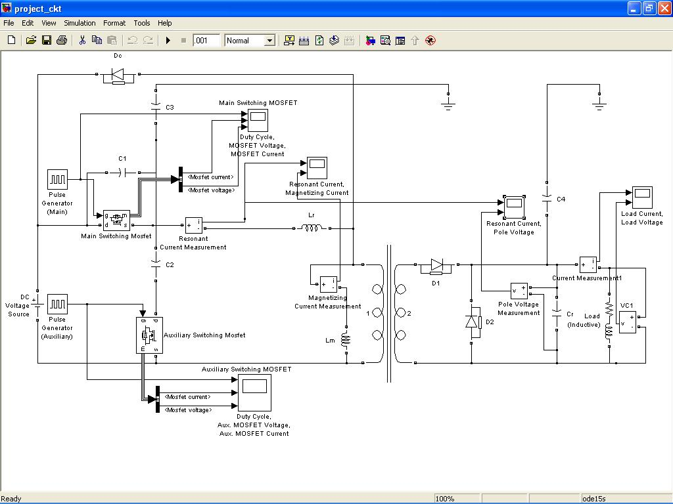

Fig. 3.15 Project circuit simulated in MATLAB

The simulation results are presented below. Fig. 3.16. and Fig. 3.17 shows the output wave shapes of Main and auxiliary MOSFETs, respectively. Fig. 3.18 shows the resonant inductor current i(t) and magnetizing current i_{Lm}(t). The resonant inductor current and pole voltage V_{p}(t) is shown in Fig. 3.19. Fig. 3.20 shows the load current i_{o}(t) and load voltage V_{o}(t). The simulation results are very closely agreeing with the idealized waveforms explained in section 3.2.

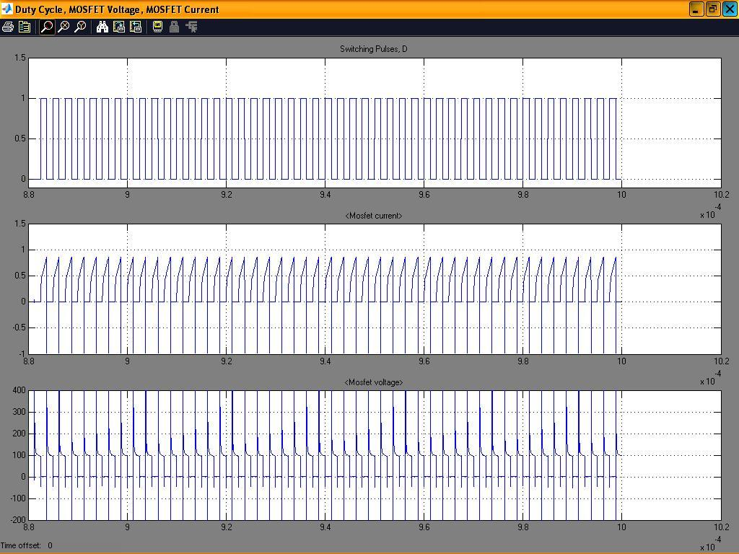

Fig. 3.16 Simulation results for Main switching MOSFET

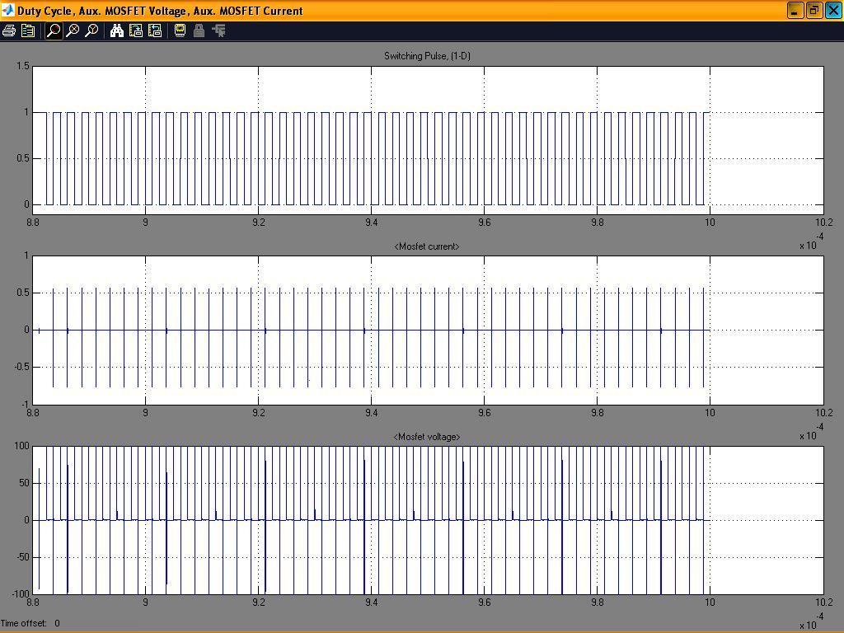

Fig. 3.17 Simulation results for Auxiliary switching MOSFET

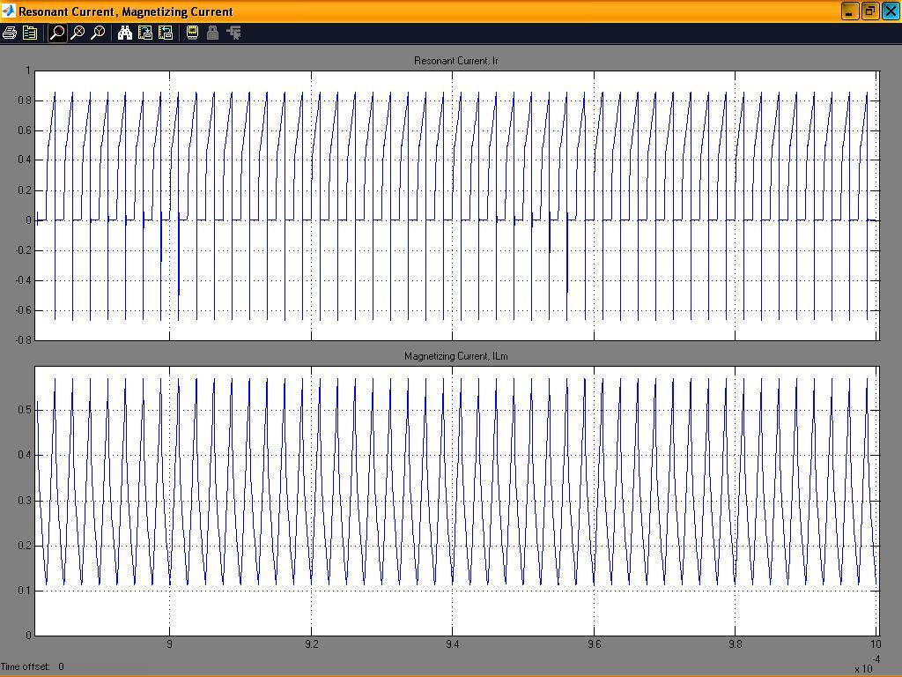

Fig. 3.18 Simulation results for resonant inductor current i(t) and magnetizing current i_{Lm}(t).

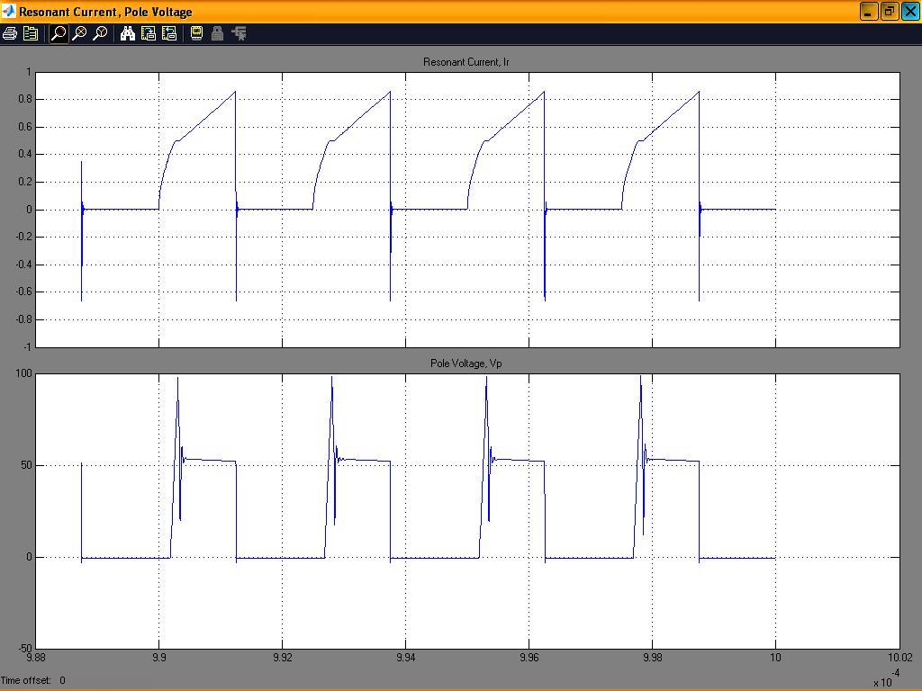

Fig. 3.19 Simulation results for resonant inductor current i(t) and Pole voltage V_{p}(t).

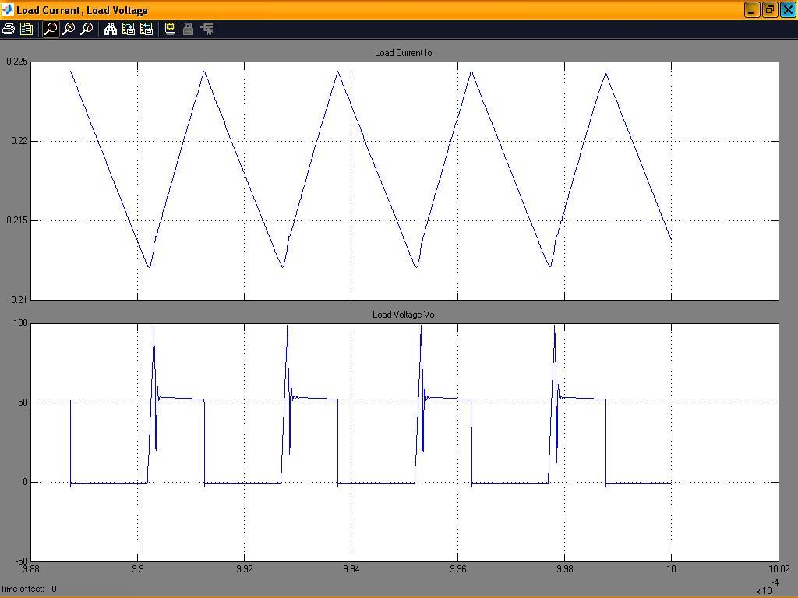

Fig. 3.20 Simulation results for load current i_{o}(t) and load voltage V_{o}(t).

3.4.2 Experimental results

The above specified forward converters prototype is designed and simulated. The results obtained are given above. For 280kHz/33W converter, the resonant inductor i(t) and voltage across the main switch S₁ is shown in Fig. 3.16. It can be observed that resonant inductor current is negative when switch voltage falls to zero. Thus, if we properly adjust the delay between turn-off of switch S₁ and turn-on of switch S₂, we can get ZVS condition for the main switch. From Fig.3.17, also ZVS operation for the auxiliary switch can be seen. Fig.3.16 shows the gate pulse and the voltage across the main switch. It is clear that the voltage across main switch falls to null just before applying the control pulse. This indicates ZVS of the switch S₁ during turn-on transition. It can be observed that turn-off transition is assisted ZVS.

Fig. 3.17 shows the current i_{s2} through the auxiliary switch S₂ and voltage V_{ds2} across it. From this figure it is clear that if we apply gate pulse after switch voltage falls to zero, ZVS condition can be achieved for auxiliary switch too. This condition can be easily set by put a delay between turn-off of main switch and turn-on of auxiliary switch. For switch S₂, ZVS operation can be observed from Fig. 3.17. It is clear that the voltage across switch S₂ falls before applying the gate pulse. This indicates the ZVS operation of S₂. It can be observe that turn-off transition of S₂ is capacitance assisted ZVS.

The converter pole voltage is shown in Fig.3.19. It is observed that there is some ringing in pole voltage. This is due to the leakage inductance. The pole voltage and resonant inductor current is given 1n Fig3.19. The same converter with planer magnetic can also be built; with planer magnetic pole voltage ringing is reduced appreciably.

Another forward converter with the specification mentioned in Table 3.2 (400 kHz/33W) has also designed and simulated. It has been found that the simulation results are satisfactory in this case also.

3.6 Conclusion

The theoretical analysis of the ZVS-PWM active clamp/reset forward converter is presented in this chapter. Later the circuit is simulated using MATLAB and results are obtained. Operation of the converter is explained by seven intervals. Parameters affecting the ZVS condition are highlighted. The design constraints are explained. A computer-spread sheet is organized to design the converter. Circuit simulation is carried out to tune the design. Prototype for two operating frequencies are designed and simulated. Efficiency close to 90% is obtained in both cases. The results obtained in the previous section allow us to conclude that soft switching (ZVS) is obtained. High efficiency is obtained at high frequency.

CHAPTER 4

Current Mode Control of ZVS-PWM, Active Clamp DC-DC Converters

4.1 Introduction
Current programming has become the regulation scheme of choice in DC-DC converters owing to its advantages over duty-ratio programming such as better line-noise rejection, automatic overload protection, easy paralleling of multiple converters, and especially designed flexibility in improving the small-signal dynamics.
This chapter introduces the steady state stability analysis of current mode controlled (CMC) ZVS-PWM, active clamp converters. A unified model for this family converter has been introduced in [14]. On account of the loss-less damping inherent in the active clamp converters, it appears that stability range in these converters may get extended to$D<\left[0\text{.}5+\frac{T1−T4}{Ts}\right]$. However, it is observed that, the active clamp converters also exhibit sub-harmonic oscillation for D>0.5. The conventional graphical approach [12], [2], [14], fails to assess the stability of CMC active clamp converters. This is due to coupling between filter inductor current and resonant inductor current. Another graphical approach, which takes into account the presence of this coupling, is presented to establish the stability condition. This method correctly predicts the stability condition. A simple expression for the maximum duty cycle for sub-harmonic free operation is obtained. The effect of artificial ramp compensation is also presented. The ZVS-PWM, active clamp non-isolated buck converter as shown in Fig.4.1 is taken as an example to explain the stability analysis.
In section 4.2, sub-harmonic instability is analyzed with conventional graphical approach. The proposed approach is presented in section 4.3. The effect of slope compensation is explained in section 4.4. Simulation and experimental results are presented in section 4.5.

4.2 Conventional Approach
Fig.4.2 illustrates the control pulse for main switch S₁ and a generic filter inductor current waveform in continuous conduction mode. In this analysis resonant intervals are neglected. The inductor current i_{L}(t) ramps up with a slope m₁ and falls down with a slope m₂. For the basic non-isolated converters, the slope m₁ are given by
Buck Converter
$m1=\frac{V−Vo}{L};m2=\frac{−Vo}{L}$ (4.1)
Boost Converter
$m1=\frac{V}{L};m2=\frac{V−Vo}{L}$ (4.2)
Buck-Boost Converter
$m1=\frac{V}{L};m2=\frac{−Vo}{L}$ (4.3)
V
C_{r}
D_{c}
S₁
S₂
V_{c}
-
+
L_{r}
D
C
L
R
Q R

Q S
+
-
_
I_{sense}
I_{ref}

Fig. 4.1 Circuit diagram of the current mode controlled ZVS, active clamp buck converter
T₃
S₁, D ON
S₁, D_{c} ON
S₂, D_{c} ON
S₂, D ON
S₁, D ON
dT_{s}
d′T_{s}
V_{gs1}
I_{ref}
m₁
m₂
T₁
d_{c}T_{s}
d′_{c}T_{s}
i_{L}(0)
i_{L}(T_{s})
i_{L}(t)

Fig. 4.2 Control pulse and Filter inductor current of CMC active clamp converter

With the knowledge of the slopes m₁ and m₂, we can determine a general relationship between steady state slopes and effective duty cycle. During the power transfer subinterval (S₁, Dc ON), the inductor current i_{L(t)} increases with slope m₁, until it reaches the control reference I_{ref}. Hence,

$I\text{ref}=iL(0)+m1(\text{dT}s−T1)$ (4.4)

After turning off the main switch, the filter inductor current increases for a small time T₄ with the same slope. Thus peak of the inductor current is given as

$Ip=I\text{ref}+m1T4=iL(0)+m1(\text{dT}s+T4−T1)$ (4.5)

In similar manner, for the subintervals S₂, D ON and S₁, D ON we can write

$iL(Ts)=Ip+m2(\text{dT}s−T4+T1)$ (4.6)
In steady state, i_{L}(0)=i_{L}(T_{s}) ,m₁=M₁, m₂=M₂ and dT_{s}-T₁+T₄=DT_{s}-T₁₊T4=DcT_{s}.
From equation (4.5), (4.6) and above steady state condition, we have
$\frac{−M2}{M1}=\frac{\text{DT}s+T4−T1}{\text{DT}s−T4+T1}=\frac{\text{DcT}s}{Dc^{'}Ts}$ (4.7)

Where Dc is called the effective duty ratio throughout the report and it is given as DcT_{s}=DT_{s}+T₄-T₁

In order to assess the stability of the current mode controller, a small perturbation δi_{L}(0) in filter inductor current is considered [shown in fig. 4.3], by determining whether this perturbation eventually decays to zero. To do so, the propagation of small disturbance δi_{L}(0) is evaluated after n switching periods, δi_{L}(nT_{s}), and determine whether this δi_{L}(nT_{s}) tends to zero for large n. The steady state and perturbed wave forms are shown in Fig.3.3. On following the procedure given in [2], [14], one can easily established that,
$δiL(Ts)=\left(\frac{m2}{m1}\right)δiL(0)$ (4.8)
If the converter is operating very closed to steady state, then from equation (4.7) and (4.8),
$δiL(Ts)=\left(\frac{\text{Dc}}{Dc^{'}}\right)δiL(0)$ (4.9)
T₄
I_{ref}
m₁
m₂
T₁
d_{c}T_{s}
d′_{c}T_{s}
i_{L}(0)
i_{L}(t)
δ_{iL}(0)
δ_{iL}(T_{s})

Fig.4.3Effect of small perturbation on filter inductor current
After n switching periods, the perturbation become
$δiL(\text{nT}s)={\left(\frac{\text{Dc}}{Dc^{'}}\right)}^{n}δiL(0)$ (4.10)
For oscillation free operation, we need
$\frac{\text{Dc}}{Dc^{'}}<1$ ⇨ $\frac{\text{DT}s+T4−T1}{D^{'}Ts−T4+T1}<1$ (4.11)

On simplification, equation (4.11) gives the condition $D<\left[0\text{.}5+\frac{T1−T4}{Ts}\right]$for sub-harmonic oscillation free operation in CMC active clamp converters. However, experiments show that the sub-harmonic instability boundary is at 0.5 for active clamp converters as well. It is therefore the conventional approach is erroneous. To correctly predict the stability, it is necessary to take into account the presence of the resonant inductor as well in the analysis. An analysis, which takes into account the coupling between resonant inductor current and filter inductor current, is presented in the next section.

4.3 Proposed Approach
In this section, the proposed approach is explained. The steady state and the perturbed waveforms of filter inductor current i_{L}(t) and resonant inductor current i(t) are illustrated in Fig.4.4. The resonant intervals are assumed to negligibly small as compared switching period. It is assumed that converters operate close to steady state such that slope m₁, m₂, m_{r1} and m_{r2} remain unchanged. For the basic non-isolated converters, the slope m₁ and m₂ have been presented above [equation (4.1), (4.2) and (4.3)]. The slope m_{r1} and m_{r2} for the above three basic non-isolated active clamp converters are given by
Buck converter
$mr1=\frac{V}{Lr};mr2=\frac{−Vc}{Lr}$ (4.12)

Boost converter
$m1=\frac{Vo}{Lr};m2=\frac{−Vc}{Lr}$ (4.13)

Buck-Boost converter
$m1=\frac{Vo}{Lr};m2=\frac{Vo+Vc}{Lr}$ (4.14)
The effect of coupling between i_{L}(t) and i(t) cannot be seen by considering the small perturbation in current and then evaluating its propagation in the successive cycle. The coupling effect can be evaluated by considering a small time error δt(0) as shown in Fig.4.4. The CMC active clamp converters will be stable if this error, δt(0), eventually decays to zero. To do so, the propagation of error is evaluated after n switching periods, δt(nTs), and determine whether δt(nTs) tends to zero for large n. In steady state starting from i_{L}(T₄), on equating i_{L}(t) and i(t) at t=T_{s}+T_{1,} we get
$iL(T4)+m2(d^{'}Ts−T4+T1)=i(T4)+mr2(d^{'}Ts−T4)+mr1T1$ (4.15)
Since i_{L}(T₄)=i(T₄), on simplifying above equation, we get
$T1=\frac{mr2−m2}{m2−mr1}(d^{'}Ts−T4)$ (4.16)
Similarly for perturbed waveform, again starting from i_{L}(T4), on equating i_{L}(t) and i(t) at t=T_{s}+T₁′, we get
$T1'=\frac{mr2−m2}{m2−mr1}\left(d^{'}Ts−T4+δt(0)\right)$ (4.17)
From equation (4.16) and (4.17), we have
$δT1=T1\text{'-T}1=\frac{m\text{r2}\text{-m}2}{m2\text{-m}\text{r1}}δt(0)$ (4.18)

T₄
S₁, D ON
S₁, D_{c} ON
S₂, D_{c} ON
S₂, D ON
S₁, D ON
S₁, D_{c} ON
dT_{s}
d′T_{s}
dT_{s}
V_{gs1}
I_{ref}
m_{r1}
δt(0)
i_{L}(T₄)
m₁
i_{L}(t)
m₂
i(t)
mr₂
T₁
T′₁
T₂
T′₂
δt(T_{s})

Fig.4.4 Steady state and perturbed waveform of i_{L}(t) and i(t)

The steady state and perturbed filter inductor has the same initial condition (i_{L}(T₄)) and both reaches control reference at t=T_{s}+T₁+T₂ and t=T_{s}+T₁+T₂ respectively. Thus from above condition, we get
$iL(T4)+m2(d^{'}Ts−T4+T1)+m1T2=iL(T4)+m2(d^{'}Ts−T4+T1+δt(0)+m1T2'$ (4.19)
From equation (4.18), we have
$T2'−T2=\frac{−m2}{m1}\left(\frac{mr2−m2}{m2−mr1}+1\right)δt(0)$ (4.20)
The time error after one switching period is given as
$δt(Ts)=T2'−T2+(T1'−T1)$ (4.21)
From equation (4.18), (4.20) and (4.21) we have an expression for δt(T_{s})
$δt(Ts)=\left[\frac{−m2}{m1}+\underset{\text{coupledterm}}{\underbrace{\frac{mr2−m2}{m2−mr1}\left(1−\frac{m2}{m1}\right)}}\right]δt(0)$ (4.22)

The volt-second balance across resonant inductor gives
$\frac{−mr2}{mr1}=\frac{T1}{\text{dT}s}$ (4.23)
For the active clamp converters we can show that
$mr1,mr2\text{>>}m2$ (4.24)
If the converter is operating sufficiently close to the quiescent operating point, then –m₂/m₁ is given approximately by equation (4.7). From equation (4.7), (4.22), (4.23) and (4.24) we have
$δt(Ts)=\left[\frac{Dc}{Dc'}+\underset{\text{coupledterm}}{\underbrace{\frac{T1}{\text{DT}s}\left(1+\frac{Dc}{Dc'}\right)}}\right]δt(0)$ (4.25)
After n switching periods, the time error becomes
$δt(\text{nT}s)={\left[\frac{Dc}{Dc'}+\underset{\text{coupledterm}}{\underbrace{\frac{T1}{\text{DT}s}\left(1+\frac{Dc}{Dc'}\right)}}\right]}^{n}δt(0)=(α)^{n}δt(0)$ (4.26)
The evaluation of time error is determined by the characteristic value
$α=\left[\frac{Dc}{Dc'}+\underset{\text{coupledterm}}{\underbrace{\frac{T1}{\text{DT}s}\left(1+\frac{Dc}{Dc'}\right)}}\right]$ (4.27)
The time error tends to zero provided that the characteristic value α has value less than one:
$|δt(\text{nT}s)|→\left\{\begin{matrix}0 \\ ∞\end{matrix}\begin{matrix}\text{when} \\ \text{when}\end{matrix}\begin{matrix}\left|α\right| \\ \left|α\right|\end{matrix}\right.\begin{matrix} \\ \end{matrix}\begin{matrix}1 \\ 1\end{matrix}$ (4.28)
On simplifying the above equation, we get the condition D<0.5 for stable operation. The characteristic value α has two terms. The first term is same as obtained by conventional approach. The second part is the coupled term, which brings down the stability limit to D<0.5. Therefore, the instability region for current programmed ZVS-PWM, active clamp converters is correctly predicted by proposed approach.
The current programmed controller can rendered stable for D>0.5 by addition of artificial ramp to the sensed current waveform. The effect of artificial ramp compensation is explained in next section.

4.4 Artificial ramp compensation
The stabilization of current programmed controller by addition of an artificial ramp to the sensed current waveforms is a well known technique. For hard switch converters two common choices of artificial ramp slope (m_{c}) is m_{c}=m₂/2 or m_{c}=m₂. The first choice is the minimum value of compensation that leads to stability for all duty cycle. The second choice of the compensation removes any error after one switching period. This behavior is commonly known as deadbeat control.
However, in the case of ZVS-PWM, active clamp converters, the coupling between filter inductor current and resonant inductor current may lead to some different behavior. We can again determine the stability of the current programmed controller by analyzing the change in time error over one complete cycle. Fig.4.5 illustrates the steady state and perturbed waveforms of i_{L}(t) and i(t). As obtained in previous section we can write,
$δT1=T1\text{'-T}1=\frac{m\text{r2}\text{-m}2}{m2\text{-m}\text{r1}}δt(0)$ (4.29)
From steady state waveforms in Fig. 4.5 we can write
$I\text{ref}+mc\text{dT}s+m1T4+m2(d'Ts−T4=T1)+m1t2=I\text{ref}+mc\text{dT}s$ (4.30)
or,
$mc\text{dT}s+m1T4m2(\text{dT}s−T4+T1)+m1T2=0$ (4.31)

T₄
S₁, D ON
S₁, D_{c} ON
S₂, D_{c} ON
S₂, D ON
S₁, D ON
S₁, D_{c} ON
dT_{s}
d′T_{s}
dT_{s}
V_{gs1}
I_{ref}
m_{r1}
δt(0)
m₁
i_{L}(t)
m₂
i(t)
mr₂
T₁
T′₁
T₂
T′₂
δt(T_{s})
dT_{s}
d′T_{s}

Fig. 4.5 Steady state and perturbed wave forms, in the presence of an artificial ramp

Similarly for perturbed waveform we can write
$I\text{ref}+mc(\text{dT}s−δt(0))+m1T4+m2(d^{'}Ts−t4+T1'+δt(0))+m1T2'=I\text{ref}+mc(\text{dT}s+δt(Ts))$ (4.32)
Or,
$−mc(δt(0)+δt(Ts))+m2(d^{'}Ts−T4+T1'+δt(0))+m1(T2'+T4)=0$ (4.33)
From equation (4.32) and (4.33) we have
$T2\text{'-T}2=\frac{\text{-m}2}{m1}δT1−\frac{m2−mc}{m1}δt(0)+\frac{mc}{m1}δt(Ts)$ (4.34)
The time error after one switching cycle is given as
$δt(Ts)=T2\text{'-T}2+δT1$ (4.35)

From equation (4.29), (4.34) and (4.35) we can write an expression for δt(T_{s}) as,
$δt(Ts)=\left[−\left(\frac{m2−mc}{m1−mc}\right)+\underset{\text{oupledterm}}{\underbrace{\left(\frac{mr2−m2}{m2−mr1}\right)\left(\frac{m1−m2}{m1−mc}\right)}}\right]δt(0)$ (4.36)

On applying the condition m_{r1}, m_{r2}>>m₂, we get
$δt(Ts)=\left[−\left(\frac{m2−mc}{m1−mc}\right)+\underset{\text{oupledterm}}{\underbrace{\left(−\frac{mr2}{mr1}\right)\left(\frac{m1−m2}{m1−mc}\right)}}\right]δt(0)$ (4.37)
After n switching periods, the time error becomes
$δt(\text{nT}s)={\left[−\left(\frac{m2−mc}{m1−mc}\right)+\underset{\text{oupledterm}}{\underbrace{\left(−\frac{mr2}{mr1}\right)\left(\frac{m1−m2}{m1−mc}\right)}}\right]}^{n}δt(0)={\left(α\right)}^{n}δt(0)$ (4.38)
The evaluation of time error is determined by characteristic value
$α=\left[−\left(\frac{m2−mc}{m1−mc}\right)+\underset{\text{oupledterm}}{\underbrace{\left(−\frac{mr2}{mr1}\right)\left(\frac{m1−m2}{m1−mc}\right)}}\right]$ (4.39)
The time error tends to provided that the characteristic value ‘a’ has value less than one:
$|δt(\text{nT}s)|→\left\{\begin{matrix}0 \\ ∞\end{matrix}\begin{matrix}\text{when} \\ \text{when}\end{matrix}\begin{matrix}\left|α\right| \\ \left|α\right|\end{matrix}\right.\begin{matrix} \\ \end{matrix}\begin{matrix}1 \\ 1\end{matrix}$ (4.40)
Therefore, for stable operation, we need to choose the artificial ramp slope m_{c} such that the characteristic value α has magnitude less than one. Hence, proper artificial ramp slope selection can be utilized to stabilize the system for duty cycle greater than 0.5.
In the conventional voltage regulator application, the output voltage is well regulated by the converter control system, so value of m₂ is known accurately. Therefore, we can eliminate the slope m₁ from above equation, and thereby express the characteristic value in terms of known slope m₂ and steady state actual (D) and effective (D_{c}) duty cycle:
$α=\left(\frac{1−\frac{mc}{m2}}{\frac{Dc'}{Dc}−\frac{mc}{m2}}\right)+\underset{\text{coupledterm}}{\underbrace{\left(\frac{T1}{\text{DT}s}\right)\left(\frac{\frac{Dc'}{Dc}−1}{\frac{Dc'}{Dc}−\frac{mc}{m2}}\right)}}$ (4.41)
From characteristic value α we can observe that actual duty cycle (D) comes in the denominator of the coupled term, so we cannot stabilize the controller for all duty cycle. One common choice of artificial ramp slope can be
m_{c}=m₂
This causes the characteristic value α to become zero for duty cycle (D) less than 1-T₁/T_{s}. This upper limit on duty cycle can be understood from circuit operations also. To maintain volt-sec balance across the resonant inductor we have to provide sufficient time during turn-off time of main switch S₁, otherwise clamp voltage increase to very high value. But if we allow voltage across switch to go beyond greater than 2V, the converter can be operated for still higher duty cycle. In that case more compensation is required.

4.5 Simulation and experimental results
The circuit simulation and experimental results for the ZVS-PWM, active clamp buck converter is presented in this section. To verify the stability condition, a controlled, ZVS-PWM, active clamp buck converter is designed and fabricated. The converter specification is given in the following table.

Input Voltage | 40-50V
Output Voltage | 15V
Output Power | 45W
Switching frequency | 300kHz

CMC ZVS-PWM, active clamp buck converter specification

4.5.1 Simulation results
The circuit simulation tool, MATLAB. is used to simulate the current mode controlled active clamp converter. For simulation of the above the above the converter parameters are modified for 200kHz switching frequency. Thus, simulation results presented in this section are for 200kHz.
Fig. 4.6 shows the resonant inductor current and pole voltage for duty cycle less than 0.5. It can be seen that, there is no sub-harmonic oscillation for duty cycle D<0.5. Under same condition filter inductor current and pole voltage is given in Fig.4.7. Therefore, current programmed control, ZVS-PWM, active clamp converters are stable for D<0.5.
Fig. 4.8 shows resonant inductor current and pole voltage for D>0.5. It is clear that for D>0.5 there is sub-harmonic oscillation in the current programmed active clamed converter. Filter inductor current and pole voltage for the same condition is given in Fig.4.9. From the simulation results it is clear that CMC active clamp converters are unstable for D>0.5. To validate the mathematical analysis and simulation results, experimental results are presented in the section.

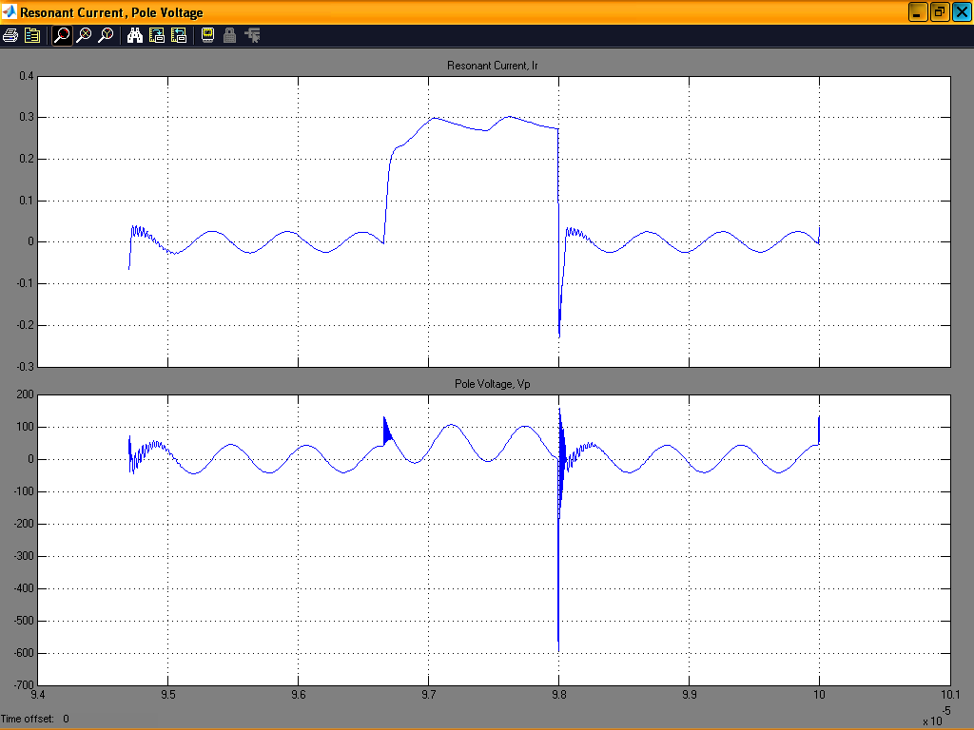

Fig 4.6 Resonant inductor current and pole voltage for D<0.5
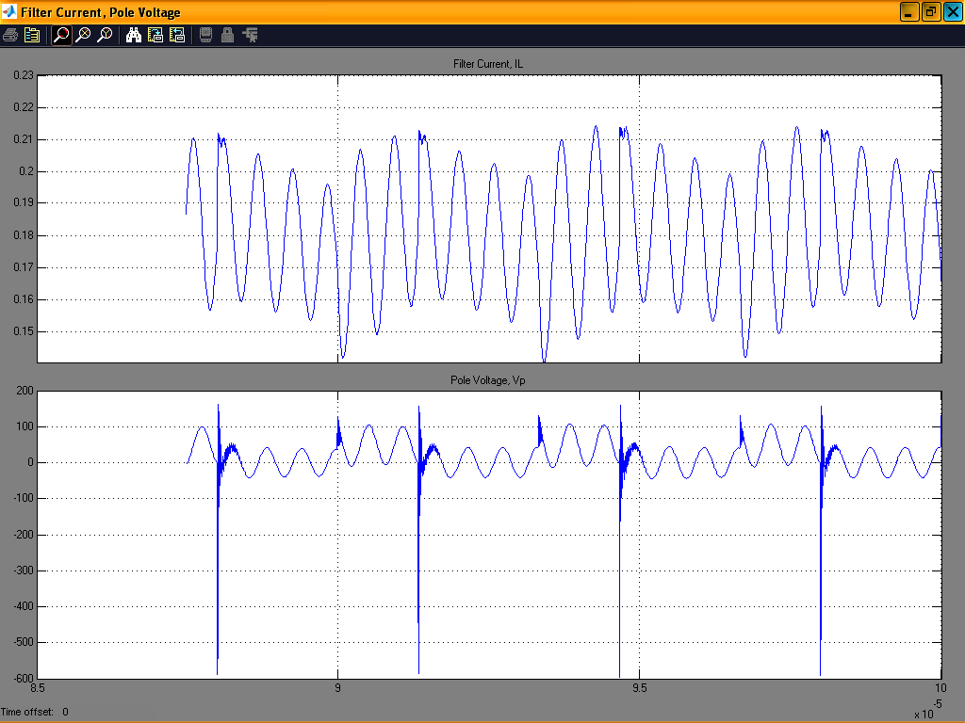

Fig. 4.7 Filter inductor current and pole voltage for D<0.5

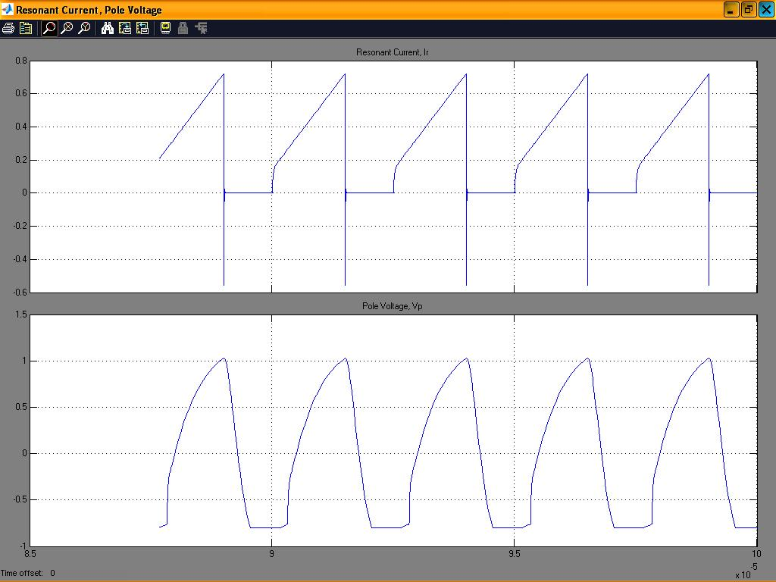

Fig.4.8 Resonant inductor current and pole voltage for D>0.5

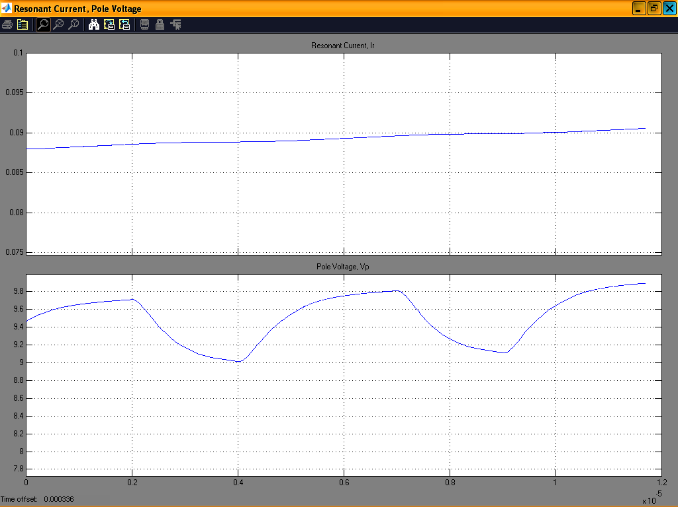

Fig.4.9 Filter inductor current and pole voltage for D>0.5

4.6 Conclusion

The results of this study allow us to conclude that, steady state stability of current mode controlled active clamp converters can be investigated by the conventional graphical approach. The study state analysis, which takes into account the presence of resonant inductor presented in this report, correctly predicts the instability region. It is observed that, the family of active clamp converters also exhibits sub-harmonic oscillation for D>0.5. This condition is not obvious from conventional approach. A simple expression for the maximum duty cycle for sub-harmonic free operation is obtained. It is also established that with artificial ramp compensation, active clamp converter cannot be stabilized for all duty cycle with any amount of compensation. Simulation and experimental results are presented to validate the theoretical analysis.

CHAPTER 5

Conclusion and Scope of Future Work

The objective of the work presented in this report is to develop an improved ZVS–PWM, active clamp/reset forward converter. Then proved active clamp forward uses one extra clamping diode and a resonant capacitor, the additional clamping diode limits the voltage stress on the rectifier diode. Soft switching is obtained for active and passive switches. Based in the proposed topology, a prototype is designed and simulated using MATLAB. All waveforms are in agreement with the theoretical waveforms. Only pole voltage is observed to have some ringing. The ZVS-PWM, active clamp/reset power converter rated 30 watt, 280 KHZ achieves efficiency close to 90%.

A new approach to investigate the sub harmonic oscillation in current program, ZVS-PWM, active clamp converter is presented. The proposed approach correctly predicts the stability or otherwise of the current programmed active clamp converters. It is observed that the family of active clamp converters also exhibits sub harmonics oscillations for D>0.5. It is also established that the artificial ramp compensation, active clamp converters cannot be stabilized for all duty cycle with any amount of compensation.

The contributions made in this report are:

- An improved ZVS-PWM, active clamp/reset forward converter is obtained. Idealized analysis and design constants for the host converters are discussed.
- A new approach to investigate the steady state stability of current programmed, active clamp converter is obtained.

Future scope of the work is to use synchronous rectifier on the secondary side. Planer integrated magnetic (PIM) can be used to reduce the overall size of the converter. The approach used to improve forward converter can be applied to flyback converter.

References:

- Philip T. Krien, “Elements of Power Electronics”, Oxford University Press, 1992.
- Robert W. Erickson, “Fundamentals of Power Electronics”, Chapman & Hall, 1997.
- Biju S. Nathan, “Analysis, Simulation and Design of Series Resonant Converters for High Voltage Applications”, M.Sc. (Engg.) Thesis, Indian Institute of Sciences, India, December 1999.
- I. Barbi, J. C. O. Bolacell, D. C. Martins and F. B. Lobano, “Buck Quasi-Resonant Converter Operating at Constant Frequency: Analysis, Design and Experimentation”, IEEE Transaction on Power Electronics, vol.5, No. 3, pp.276-283, July 1990.
- G. Hua, X. Yang, Y. Jiang and F. C. Lee, “ Novel Zero-Voltage Transition PWM Converter”, IEEE Transaction on Power Electronics, vol.9, pp.213-219, March 1994.
- A. Rajapandian, “A Constant Frequency Resonant Transition Converter”, M.Sc. (Engg.) Thesis, Indian Institute of Sciences, India, August 1995.
- C. M.C. Duarte and I. Barbi, “ A New Family ZVS-PWM, Active Clamping dc-to-dc Boost Converters: Synthesis, Analysis, and Experimentation”, IEEE Transaction on Power Electronics, vol.2, No. 5, September 1997.
- W. Andreycak, “Active Clamp and Reset Technique Enhanced Forward Converter Performance”, Unotrode Power Supply Design Seminar SEM-1000, 1994.
- N. Lakshminarasamma, B. Swaminatha, V. Ramanarayanan, “A Unified Model for ZVS dc-dc Converters with Active Clamp”, IEEE Power Electronics Specialist Conference, 2004 Record, (IEEE Publication).

- B.CartSen, “Design techniques for transformers active reset circuits at high frequencies and power levels,” in Proc. HFPC 1990, pp, pp. 235 -246.
- M. M. Jovnovic. “A Technique for reducing rectifier reverse-recovery losses in high-voltage, high-power boost converters,” in Proc. APEc. 1997, pp. 1000-1007.
- Shi-Ping Hsu, Art Brown, Loman Rcnsik and R.D.Middlebrook, “Modeling and Analysis of switching dc-dc conveners in constant frequency current programmed mode,” IEEE Power Electronics Specialist Conference, 1987 Record, pp. 20-30 (IEEE Publication).
- N. Mohan, Undeland, Robbins, “Power Electronics: Converters, Applications and Design,” John Wiley & sons.
- V. Ramanarayanan, “Class Notes: E6: 221 Switched mode power conversion,” Department of Electrical Engineering, Indian Institute of Science, India.
- R. Watson, F.C.Lee and G.C.Hua, “Utilization of an active clamp circuit to achieve soft switching in flyback converters,” in IEEE Power Electronics Specialist Conference Record 1994, pp. 909-916.

