COLOR AND TEXTURE BASED IMAGE RETRIEVAL

A Dissertation Submitted In Partial Fulfillment Of The Requirement For The Award Of The Degree Of
Master of Engineering
In
Computer Technology and Application
By
Bhawna Singh
College Roll No. - 01/CTA/07
University Roll No. -12201
Under the esteemed guidance of
Mrs.Rajni Jindal

Department of Computer Engineering
Delhi College of Engineering
University of Delhi
June 2009

CERTIFICATE
DELHI COLLEGE OF ENGINEERING
(Govt. of National Capital Territory of Delhi)
BAWANA ROAD, DELHI – 110042

Date: ___________

This is to certify that dissertation entitled “Color And Texture Based Image Retrieval” has been completed by Bhawna Singh (01/CTA/07) in partial fulfillment of the requirement of Master in Engineering in Computer Technology & Application.

This is a record of her work carried out by her under my supervision and guidance during the academic session 2008 -2009.

Mrs. Rajni Jindal
Assistant Professor
Dept. of Computer Engineering.
Delhi College of Engineering,
Delhi

ACKNOWLEDGEMENT

At times our own light goes out and is rekindled by a spark from another person. Each of us has a cause to think with deep gratitude of those who have lighted the flame within us."
–Albert Schweitzer

It is distinct pleasure to express my deep sense of gratitude and indebtedness to my learned supervisors Mrs. Rajni Jindal, Department of Computer Engineering, Delhi College of Engineering, for their invaluable guidance, encouragement and patient reviews. Her continuous inspiration only has made me complete this project. She kept on boosting me time to time for putting an extra ounce of effort to realize this work.
I would also like to thank Dr. Daya Gupta, HOD, Department of Computer Engineering, for providing facilities for this dissertation.
Finally, I would like to thank my classmates for their unconditional support and motivation during this work.

Bhawna Singh
01/CTA/07
Master In Engineering
(Computer Technology & Application)

ABSTRACT

Content Based Image Retrieval is an interesting and most emerging field in the area of ‘Image Search’, finding similar images for the given query image from the image database. Current approaches include the use of color, texture and shape information. Considering these features in individual, most of the retrievals are poor in results and sometimes we are getting some non relevant images for the given query image.
So, this dissertation proposes a method in which combination of color and texture features of the image is used to improve the retrieval results in terms of its accuracy. For color, color histogram based color correlogram technique and for texture wavelet decomposition technique is used. Color and texture based image retrieval computes image features automatically from a given query image and these are used to retrieve images from database.

Contents

Certificate………………………….………………………………………….ii
Acknowledgement…………………………………………………………....iii
Abstract…………………………………………………………………….....iv
1) Introduction……………………………………………………………….1
1.1 Motivation…………………………………………………………………………..1
1.2 Problem Definition…………………………………………………………………2
1.3 Scope………………………………………………………………………………...2
1.4 Organization of Thesis……………………………………………………………..2
2) Content Based Image Retrieval…………………………………………..3
2.1 Prior-Work…………………………………………………………………………4
2.2 Content comparison techniques………………………………………………......5
2.3 Similarity/Distance measures …….……………….………………………………8
2.4 Query Comparison techniques…………………………………………………..10
2.5 Fields of Application……………………………………………………………...12
3) Overview of CBIR Technique…………………………………………..14
4) Color Representation……………………………………………...….....21
4.1 Color Spaces……………………………………………………………………....22
4.2 Color Conversion………………………………………………………………....25
4.3 Color Quantization……………………………………………………………….26
4.4 Images……………………………………………………………………………..26
5) Texture Representation……………………………………………….....29
5.1 Texture Features………………………………………………………………….29
5.1.1 Co-Occurrence Matrix………………………………………………………...30
5.1.2 Tamura Features. ……………………………………………………………..33
5.1.3 Wavelet Transform…………………………………………………………….33

6) Proposed method for CBIR using color and texture………………….36
6.1 Color Features……………………………………………………………….……36
6.1.1 Color algorithm………………………………………………………………37
6.1.2 Similarity measurement for color…………………………………………....39
6.2 Texture Features………………………………………………………………….40
6.2.1 Texture Algorithm………………………………………………………........40
6.2.2 Similarity measurement for texture……………………………………….....41
7) Experimental Results…………………………………………………...42
7.1 Development Environment……………………………………………………….42
7.2 Experimental Setup………………………………………………………………43
7.3 Obtained Results……………………………………………………………….....47
8) Conclusion and Future Work……………………………………….…..50
8.1 Conclusion………………………………………………………………………...50
8.2 Future work……………………………………………………………………….51

Appendix ……………………………………………………………..….....51
References……………………………………………………………….…..52
List of Figures

Figure 2.1:Content Based Image retrieval System……………………………………3
Figure 2.2: Different types of texture………………………………………………….7
Figure 2.3: Boundary-based & Region-based…………………………………………8
Figure 5.1: Image example……………………………………………………………..31
Figure 5.2: Classical Co-occurrence matrix…………………………………………..31
Figure 5.3: Haar Wavelet Example……………………………………………………34
Figure 5.4: Daubechies Wavelet Example…………………………………………….35
Figure 6.1 :(i)Image (ii)Its Histogram(iii)Its Equalized Histogram…………………38
Figure 6.2: Correlogram of Bins Vs Subdivision……………………………………..39
Figure 7.1: Graphical User Interface………………………………………………….43
Figure 7.2: To Insert Image into the database………………………………………..44
Figure 7.3 :(i) Query image (ii) After completion of insertion of image
into the database…………………………………………………………..45
Figure 7.4: GUI at runtime…………………………………………………………….46
Figure 7.5: (i) Query Image (ii) Top five retrieved images using color only………..47
Figure 7.6: (i) Query Image (ii) Top five retrieved images using
color and texture ………………………………………………………….48
Figure 7.7: (i) Query Image (ii) Top five retrieved images using
color and texture…………………………………………………………..49

Chapter 1
Introduction

  - Motivation
Now a day, more and more attention is focused on content based image retrieval (CBIR) due to the tremendous growth of the number and sizes of digital image and video collections on web. So, it becomes necessary to develop power tools for retrieving this unconstrained imagery. In addition, CBIR is also the key technology for improving the interface between user and computer.

Most conventional image databases are text annotated .As a result, image retrieval is based on keyword searching. Text annotated images are simple and easy to manipulate. However, there are two major problems with this method. First, creating keywords for large number of images is time consuming. Moreover, the keywords are inherently subjective and not unique. Due to these disadvantages, automatic indexing and retrieval based on image content becomes more desirable for developing large volume image retrieval applications.

Research on multimedia systems and CBIR has been given tremendous importance during last decades. The reason behind this is the fact that multimedia databases deal with text, audio, video and image data which could provide us with enormous amount of information and which has affected our life style for the better. CBIR is a bottleneck of the access of multimedia databases simply because there is a vast difference in the perception capacity between a human and computer.

One of the primary challenges in the digital libraries is the problem of providing intelligent search mechanism for multimedia collections while there are good tools for searching text collections, images are much more difficult. If the images are annotated by hand, a textual search can be used, however, this approach is too laborious to scale up with large digital libraries. Automated methods for searching large database of images are therefore necessary. This in turn requires effective image features for comparing images based on their overall appearance.

1.2 Problem Definition
Color has been extensively used in image matching and retrieval. But color retrieval alone does not give good results. In this thesis we consider the texture of the image along with the color to improve the efficiency. Color and texture features are combined in our retrieval system to compute the similar images for the given query image from the database.

1.3 Scope
The scope of this research is circumscribed to CBIR system based on color and texture features of images to improve the efficiency of the CBIR system. We have computed the image features described in Chapter 6 on mixed natural database and implemented color and texture feature approach on that .Using color and texture feature, we retrieved images from the databases for the given query image.

1.4 Organization of Report
This thesis is organized as follows:
General Description of the working of a conventional CBIR System is described in Chapter 2.Overview of CBIR techniques is discussed in Chapter 3.Basics of color representation is discussed in Chapter 4.Basics of texture representation is discussed in Chapter 5.Chapter 6 describes proposed color and texture based image retrieval algorithm and computation of these features from images. Chapter 7 describes the experimental results of this project and finally conclusion and future work is mentioned in Chapter 8.
In appendix, we included the instructions to run the project.

Chapter 2
Content Based Image Retrieval

In content-based image retrieval systems (Figure 1), the visual contents of the images in the database are extracted and described by multi-dimensional feature vectors. The
feature vectors of the images in the database form a feature database. To retrieve images, users provide the retrieval system with example images or sketched figures. The system then changes these examples into its internal representation of feature vectors. The similarities /distances between the feature vectors of the query example or sketch and those of the images in the database are then calculated and retrieval is performed with the aid of an indexing scheme. The indexing scheme provides an efficient way to search for the image database. Recent retrieval systems have incorporated users' relevance feedback to modify the retrieval process in order to generate perceptually and semantically more meaningful retrieval results.
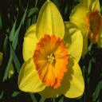
Extract
Features
Image Database
Feature Database

Results
Similarity
Measurement
Figure 2.1:Content Based Image Retrieval System

2.1 Prior-Work

Early work on image retrieval can be traced back to the late 1970s. In 1979, a conference on Database Techniques for Pictorial Applications [6] was held in Florence. Since then, the application potential of image database management techniques has attracted the attention of researchers. Early techniques were not generally based on visual features but on the textual annotation of images. In other words, images were first annotated with text and then searched using a text-based approach from traditional database management systems.

Text-based image retrieval uses traditional database techniques to manage images. Through text descriptions, images can be organized by topical or semantic hierarchies to facilitate easy navigation and browsing based on standard Boolean queries. However, since automatically generating descriptive texts for a wide spectrum of images is not feasible, most text-based image retrieval systems require manual annotation of images. Obviously, annotating images manually is a cumbersome and expensive task for large image databases, and is often subjective, context-sensitive and incomplete. As a result, it is difficult for the traditional text-based methods to support a variety of task-dependent queries.

In the early 1990s, as a result of advances in the Internet and new digital image sensor technologies, the volume of digital images produced by scientific, educational, medical, industrial, and other applications available to users increased dramatically. The difficulties faced by text-based retrieval became more and more severe. The efficient management of the rapidly expanding visual information became an urgent problem. This need formed the driving force behind the emergence of content-based image retrieval techniques. In 1992, the National Science Foundation of the United States organized a workshop on visual information management systems to identify new directions in image database management systems. It was widely recognized that a more efficient and intuitive way to represent and index visual information would be based on properties that are inherent in the images themselves. Researchers from the communities of computer vision, database management, human-computer interface, and information retrieval were attracted to this field. Since then, research on content-based image retrieval has developed rapidly [1]. Since 1997, the number of research publications on the techniques of visual information extraction, organization, indexing, user query and interaction, and database management has increased enormously. Similarly, a large number of academic and commercial retrieval systems have been developed by universities, government organizations, companies, and hospitals.

2.2 Content Comparison Techniques
There are some common methods for extracting content from images so that they can be easily compared. The methods outlined are not specific to any particular application domain.
Color Retreival
Color is the most extensively used visual content for image retrieval. Its three dimensional values make its discrimination potentiality superior to the single dimensional gray values of images. Before selecting an appropriate color description, color space must be determined first. Retrieving images based on color similarity is achieved by computing a color histogram for each image that identifies the proportion of pixels within an image holding specific values. The first order (mean), the second order (variance) and the third order (skew ness) color moments have been proved to be efficient and effective in representing color distributions of images.

A different way of incorporating spatial information into the color histogram, color coherence vectors (CCV), was proposed. Each histogram bin is partitioned into two types, i.e., coherent, if it belongs to a large uniformly-colored region, or incoherent, if it does not. Another method called color correlogram expresses how the spatial correlation of pairs of colors changes with distance.

Texture Retrieval

Texture is a widely used and intuitively obvious but has no precise definition due to its wide variability. Visual texture in most cases is defined as a repetitive arrangement of some basic pattern. This repetition may not be random. However, a texture pattern normally has some degree of randomness due to randomness in basic pattern as well as due to randomness in the repetition of basic pattern. To quantify texture, this randomness is measured by some means over a small rectangular region called window.Thus, texture in an image turns out to be a local property and depends on the shape and size of the window .Identifying a patch in an image as having uniform texture or discriminating different visual textures obeys the law of similarity. In this case, the texture property is used to produce similarity groupings.

Basically, texture representation methods can be classified into two categories: structural and statistical. Structural methods, including morphological operator and adjacency graph, describe texture by identifying structural primitives and their placement rules. They tend to be most effective when applied to textures that are very regular. Statistical methods, including Fourier power spectra, co-occurrence matrices, shift-invariant principal component analysis (SPCA), Tamura feature, Wold decomposition, Markov random field, fractal model, and multi-resolution filtering techniques such as Gabor and wavelet transform, characterize texture by the statistical distribution of the image intensity.

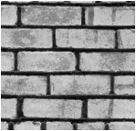
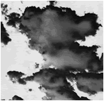
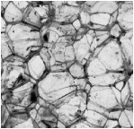
(a) Clouds
(b) Bricks
(c) Rocks

Figure 2.2: Different types of texture

Shape Retieval

Shape may be defined as the characteristic surface configuration of an object; an outline or contour. It permits an object to be distinguished from its surroundings by its outline Shape representations can be generally divided into two categories:
- Boundary-based, and
- Region-based.
Boundary-based shape representation only uses the outer boundary of the shape. This is done by describing the considered region using its external characteristics; i.e., the pixels along the object boundary. Region-based shape representation uses the entire shape region by describing the considered region using its internal characteristics; i.e., the pixels contained in that region

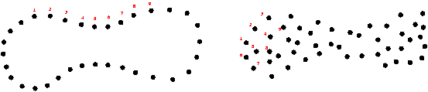

Figure 2.3: Boundary-based & Region-based shape representation

2.3 Similarity/Distance Measures
Instead of exact matching, content-based image retrieval calculates visual similarities between a query image and images in a database. Accordingly, the retrieval result is not a single image but a list of images ranked by their similarities with the query image. Many similarity measures have been developed for image retrieval based on empirical estimates of the distribution of features in recent years. Different similarity/distance measures will affect retrieval performances of an image retrieval system significantly. In this section, we will introduce some commonly used similarity measures. We denote D (I, J) as the distance measure between the query image I and the image J in the database; and fi (I) as the number of pixels in bin i of I.

Minkowski-Form Distance
If each dimension of image feature vector is independent of each other and is of equal importance, the Minkowski-form distance L_{a} is appropriate for calculating the
distance between two images. This distance is defined as:

D (I, J) = ª√ (∑_{i}‌‌‌‌‌₌₁│f_{i} (I)-f_{i} (J) ‌‌│ª)

When a=1, 2, and ∞, D (I, J) is the L1, L2 (also called Euclidean distance), and L∞ distance respectively. Minkowski-form distance is the most widely used metric for image retrieval .Netra [13] used Euclidean distance for color and shape feature, and L1 distance for texture feature.

The Histogram intersection can be taken as a special case of L1 distance, which is
Used by Swain and Ballard [22] to compute the similarity between color images. The
Intersection of the two histograms of I and J is defined as:
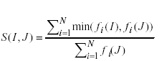

It has been shown that histogram intersection is fairly insensitive to changes in image
resolution, histogram size, occlusion, depth, and viewing point.

Quadratic Form (QF) Distance
The Minkowski distance treats all bins of the feature histogram entirely independently and does not account for the fact that certain pairs of bins correspond to features which are perceptually more similar than other pairs. To solve this problem, quadratic form distance is introduced:
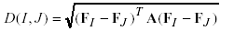
Where A= [aij] is a similarity matrix, and aij denotes the similarity between bin i and j.
F_{I} and F_{J} are vectors that list all the entries in fi(I) and fi(J). Quadratic form distance has been used in many retrieval systems [21] for color histogram-based image retrieval. It has been shown that quadratic form distance can lead to perceptually more desirable results than Euclidean distance and histogram intersection method as it considers the cross similarity between colors.

Mahalanobis Distance
The Mahalanobis distance metric is appropriate when each dimension of image feature vector is dependent of each other and is of different importance. It is defined as:

D (I, J) =√ ((F_{I}-F_{J})^{T}-C⁻¹(F_{I}-F_{J}))
Where C⁻¹= is the covariance matrix of the feature vectors.
The Mahalanobis distance can be simplified if feature dimensions are independent.
In this case, only a variance of each feature component, ci, is needed.

Kullback-Leibler (KL) Divergence and Jeffrey-Divergence (JD)
The Kullback-Leibler (KL) divergence measures how compact one feature distribution can be coded using the other one as the codebook. The KL divergence between two images I and J is defined as:
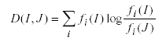
The KL divergence is used as the similarity measure for texture [. The Jeffrey-divergence (JD) is defined by:

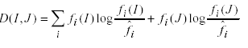

2.4 Query techniques
Different implementations of CBIR make use of different types of user queries.

Query by example
In this technique a user provides examlpe image to the CBIR system for which it wants to search similar images .In this case search is based on some common attributes that provided image sharing with the searched image.

There are many ways by which a user can provide query image:
- An image already in the database can be supplied by the user or it can chose from a random set.
- The user can draw a rough approximation of the image they are looking for, for example with blobs of color or general shapes.For example 30% red ,40% green etc.
This query technique removes the difficulties that can arise when trying to describe images with words.

Semantic retrieval
The ideal CBIR system from a user perspective would involve what is referred to aa semantic retrieval, where the user makes a request like "find pictures of lion" or even "find pictures of Abraham Lincoln". This type of open-ended task of searching is very difficult for computers to perform - pictures of chihuahuas and Great Danes look very different, and Lincoln may not always be facing the camera or in the same pose. Current CBIR systems therefore generally make use of lower-level features like texture, color, and shape, although some systems take advantage of very common higher-level features like faces). Not every CBIR system is generic.

Other query methods
Other query methods include browsing for example images, navigating customized/hierarchical categories, querying by image region (rather than the entire image), querying by multiple example images, querying by visual sketch, querying by direct specification of image features, and multimodal queries (e.g. combining touch, voice, etc.) .
CBIR systems can also make use of relevance feedback, where the user progressively refines the search results by marking images in the results as "relevant", "not relevant", or "neutral" to the search query, then repeating the search with the new information.

2.5 Field of Application

Content based has the following field of applications:
- Intellectual property
- Medical diagonisis
- Crime prevention
- The military
- Architectural and engineering design
- Jounalism nd advertising
- Home entertainment
- WWW searching
- Education and training
- Geographical information and remote sensing systems

We will discuss two of these fields of applications:
  - The WWW
  - Photobooks,as an application for customers.

The World Wide Web
The contrast between nowadays Internet and the internet as it was at its launch is enormous.More and more digital multi modal information sourcesare used;especially,images dominate the WWW with an average between 14.38 and 21.04 images per page.In principle,CBIR can be used to retrieve these images from the WWW. However, CBIR on the (urestricted) WWW suffers from time, computational, and storage(or space)complexity.A substantial effort has to be made before these are tackled.

Photobook
More than a decae ago,one of the early CBIR systems was launched Photobook[14].Its name illustrates its intended domain of application:photocollections.Nowadays,a still increasing ,vast amount of people has a digital photo/video-camera.The ease of makig digital photos led to an explosion in digital image and video material.The excahnge of these materials is facilitated through both internet and mobile telephones.In addition ,the costs for storing them have declined rapidly in the last years.The explored amount of digital image material is treansported and stored on CDs ,DVDs and hard disks.In contrast,only a deacde ago everybody used paper photo books to manage their phto-collection.The need emerged for digital photobooks and subsequently,range of them was developed and computers and their operting systems were adapted to facilitae in handling(e.g.,processing and browsing)multimedia information.However,where in paper photobooks people wrote small texts and placed dates accompanying photos ,in their digital counterparts this effort is not not made.Not in the last place ,this will be due to the vast amount of digital images compared to analog oones,made in the recent past.The latter is due to the factthat (i) People tend to take an image without hesitating and (ii) there are no developing and publishing costs.As a consequence,the amount of digital photos in private photo collections is much larger than with their nalog coumterparts.Since the digital image collections are not or poorely annoted ,text based image retrieval cannot be applied.Manual searching is a frequently used alternative but becomes less attractive with the incresing size of the private,digital photo collections.

The WWW and large professional databases suffer fro a computational burden,due to the large amount of image material.No such problems are present with with private image colections.Where private iamge collections can be too large for manual searchimg,they are small compared to most proffessional databses.So,CBIR systems can provide a substantial contribution in managing private photo collections.

Chapter 3
Overview of CBIR technique

In many areas of commerce, government, academia, and hospitals, large collections of digital images are being created. Many of these collections are the product of digitizing existing collections of analogue photographs, diagrams, drawings, paintings, and prints. Usually, the only way of searching these collections was by keyword indexing, or simply by browsing. Digital images databases however, open the way to content-based searching. In the content based searching contents of image are provided and similar images whose content matches with the provided content are retrieved. Specification of which images to retrieve from the database can be done in many ways. One way is to browse through the database one by one. Another way is to specify the image in terms of keywords, or in terms of image features that are extracted from the image, such as a color histogram. Yet another way is to provide an image or sketch from which features of the same type must be extracted as for the database images, in order to match these features. There are several classes of features that are used to specify queries: color, texture, shape, spatial layout, and faces. Color features are often easily obtained directly from the pixel intensities, e.g. color histogram over the whole image, over a fixed subimage, or over a segmented region is often used. Although a precise definition of texture is untraceable, the notion of texture generally refers to the presence of a spatial pattern that has some properties of homogeneity. In particular, the homogeneity cannot result from the presence of only a single color in the regions, but requires interaction of various colors. There is no universal definition of what shape is either. Impressions of shape can be conveyed by color or intensity patterns, or texture, from which a geometrical representation can be derived.

Several systems have been proposed in recent years in the research and community for content based information retrieval:
1). Chabot by University of California, Berkeley, U.S.A
2).ImageMiner by Technologie-Zentrum Informatik, Univerity of Bremen, Germany.
3).ImageRover by Department of Computer Science, Boston University, MA
4). Jacob by Computer Science & Artificial Intelligence Lab, University of Palermo, Italy
5). NETRA by Department of Electrical and Computer Engineering, University of California, Santa Barbara,CA.
6). Photobook by Vision and Modeling Group, MIT Media Laboratory, Cambridge,MA.
7). QBIC by IBM Almaden Research Center, San Jose, CA.
8). VIR Image Engine by Virage Inc.
9) WebSeer by Department of Computer Science, University of Chicago, Illinois, USA
10).VisualSEEk by Image and Advanced Television Lab, Columbia University, NY.

Chabot[5] was one of the early systems, it aimed at combining text based descriptions with image analysis in retrieving images from a collection of photographs of the California Department of Water Resources. The system made use of an existing text description database of the collection, adding other types of textual information for querying such as the shooting date, the picture location, and the perspective of the photo. For each image a color histogram containing only 20 bins is computed. For querying purpose user is presented with a list of search criteria (such as keywords, photographer, film format, shooting date, perspective, location, and colors). The images and associated data are stored in the database POSTGRES, developed at the University of California, Berkley.

ImageMiner[7] makes use of color, texture and contours of the image for feature extraction. . A color segmentation of the image is done by first computing a color histogram for all grid elements of homogenous size that the image is divided into and then grouping the grid elements according to their most frequent color in the histogram. The texture segmentation is similarly given by the bounding rectangles of the grids grouped according to their similar texture. For representing texture, a statistical approach is adopted. The contour-based shape description is obtained by first detecting the edge points using a gradient method and then connecting these points to form contours. Retrieval is performed by the IBM Search Manager text searcher.

Image Rover[8] is an image search engine for the WWW. The features used for querying are color and texture orientation. Image color histograms are computed in the CIE Luv color space and each histogram quantizes the color space into 64 bins. The texture direction distribution is calculated using steerable pyramids. At each of the four levels of the pyramid, texture direction and strength for each pixel is calculated resulting in an orientation histogram, quantized to 16 bins. The user can start a query session by specifying a set of keywords related to the desired images. From the set of images displayed, the user can find and mark one or more images which are similar to what she/he is looking for. Apart from selecting relevant images, the user can deselect one or more of the query images before reiterating a new query. There is no limit to the number of iterations in providing relevance feedback, nor in the number of example images. An optimized kD tree is used for indexing and the search algorithm in this structure employs an approximation factor. The user can select through the search accuracy button one of the three values for this approximation factor.

Jacob[10] system makes queries based on color and texture features. Color is represented by means of a histogram in the RGB space. Texture features used are two measures extracted from the grey-level co-occurrence matrix, the maximum probability and the uniformity the queries may be direct or by example. A direct query is made by inserting a few values representing the color histogram and/or the texture features. For a query by example, the user must give an image. The system returns the best matching frames in a similarity order. The number of returned frames is chosen by the user. The matching of images is used for querying video databases.

The NETRA[13] system consists of 2,500 images from the Corel photo collection, organized in 25 categories, with 100 images in each category. One can select any one of them as the query image. All images in the database have been segmented into homogeneous regions. Of those regions, the following features are extracted: color, texture, shape, and spatial location. One can click on one of the regions and select one of the four image attribute color, spatial location, texture, and shape. Instead of using an image example, you can also directly specify the color and spatial location. On the basis of a training set of images, the RGB color space is quantized, and represented by a color codebook of 256 colors, the centroids of the quantization cells. Texture is represented by a feature vector ft containing the normalized mean and standard deviation of a series of Gabor wavelet transforms of the image. Shape feature is based on curvature function of the contour centroid distance function, complex coordinate function

The Photobook[14] system is a set of interactive tools for browsing and searching images.The key idea behind this suite of tools is semantics preserving image compression,which rduces an image to a small set of perceptually signifiacant coefficients.Photobook consists of three sub-books.there are the Appearance Photobook,Shape photobook and texture photobook,which can extract the face,shape and texture,respectively.Users can query an image based on the corresponding features in each of the three sub books,or an a combination of different mechanisms with a text-based description.Other systems provide querying based on global coor,color layout,shape,texture and semantic contentspatial relationship querying of image regions is the main.Even though the above content basd image rtrival system provide many features for image querying,none of them combine global color,color region,color senstation,shape and qualitative spatial relation features to query an image

QBIC[15] was the first commercial system developed by Flickner .Color features computed in it are: the 3D average color vector of an object or the whole image in RGB, YIQ, Lab, and Munsell color space and a 256-dimensional RGB color histogram. The texture features used in QBIC are modified versions of the coarseness, contrast, and directionality features proposed by Tamura. The shape features consist of shape area, circularity, eccentricity, major axis orientation and a set of algebraic moment invariants. QBIC allows queries based on example images, user constructed sketches or/and selected color and texture patterns. In the last case, the user chooses colors or textures from a sampler. The percentage of a desired color in an image is adjusted by moving sliders. QBIC was one of the first systems that applied multidimensional indexing to enhance the speed performance of the system.

The VIR Image Engine[16] is an extensible framework for building content based image retrieval systems. It provides a set of general primitives, such as global color, local color, texture and shapes. Apart from these, various domain specific primitives can be created when developing an application. When defining such a primitive, the developer supplies a function for computing the primitive’s feature data from the raw image. The VIR Image Engine provides a set of GUI tools necessary for the development of a user interface. These include facilities for image insertion, image query, weight adjustment for re-query, inclusion of keywords, and support for several popular image file formats system was integrated into databases from Sybase, Object Design, and Objectivity, and added as a component to the Oracle DBMS. The AltaVista Photofinder and Illustra’s Visual Intelligence system are two applications of Virage technology.

VisualSEEk[17] supports color and spatial location matching features In the database population step, each image is automatically decomposed into regions of equally dominant colors. For each region, feature properties and spatial properties are retained for the subsequent queries. A query consists of finding the images that contain the most similar arrangements of similar regions. To start a query, the user sketches a number of regions, positions and dimensions them on the grid and selects a color for each region. Also, the user can indicate boundaries for location and size and/or spatial relationships between regions. After the system returns the thumbnail images of the best matches, the user is allowed to search by example using the returned images. . For the indexing of the minimum bounding rectangles, R-tree is used.

Excalibur Visual Retrieval Ware The Excalibur Visual Retrieval Ware Software Developers Kit (SDK) is an open application development environment distributed by Excalibur Corp. The SDK is a developer's toolkit, which provides a set of tools for building content-based image applications. The SDK includes three API's, C, C++ and Java, for image processing, a Tcl/Tk interpreter, sample programs, source code and reference documentation. The toolkit includes several examples that demonstrate what can be built using the SDK. One of these sample programs is the CST (Color, Shape, and Texture) demo. The CST demo allows queries by example based on HSV color histograms, relative orientation, curvature and contrast of lines in the image, and texture attributes, that measure the flow and roughness in the image. The user first defines the desired visual similarity by specifying the relative importance of the above image attributes, and then selects one of the displayed images as query. The software has been used in the Image Surfer system, which was used by the Yahoo! And InfoseekWWW search engines.

Other Systems

WebSEEk[18] is developed at Image and Advanced Television Lab, Columbia University, NY. It makes text-based and color based queries through a catalogue of images and videos collected from the Web. The user initiates a query by choosing a subject from the available catalogue or entering a topic. The results of the query may be used for a color query in the whole catalogue or for sorting the result list by decreasing color similarity to the selected item. The user has the possibility of selecting positive and negative examples from the result of a query in order to reformulate the query . WebSeer[19] an another system is developed at Department of Computer Science, University of Chicago, Illinois, USA. The images collected from the Web are submitted to a number of color tests in order to separate photographs from drawings. Some simple tests measure the number of different colors in the image, the fraction of pixels which have one of the N most frequent colors for a given threshold N, the fraction of pixels with transition value greater than a threshold T, the fraction of pixels with saturation level greater than a threshold T, and the ratio of the image dimensions. A more elaborate test creates first an average color histogram for graphics, Hg, and one for photographs,Hp, using two large sets of images.. The user gives keywords describing the contents of the desired images, and optionally specifies some image characteristics such as dimensions, file size or whether he is looking for photographs or drawings. In the case the user is looking for people, he must indicate the number of faces as well as the size of the portrait. To classify an image as photograph or graphics, the color tests are combined using multiple decision trees constructed using a training set of hand-classified images.

Chapter 4

Color Representation

Color is the brains reaction to a specific visual stimulus. Although we can precisely describe color by measuring its spectral power distribution (the intensity of the visible electro-magnetic radiation at many discrete wavelengths) this leads to a large degree of redundancy. The reason for this redundancy is that the eye’s retina samples color using only three broad bands, roughly corresponding to red, green and blue light. The signals from these color sensitive cells (cones), together with those from the rods (sensitive to intensity only), are combined in the brain to give several different “sensations” of the color.

- Brightness: the human sensation by which an area exhibits more or less light.
- Hue: the human sensation according to which an area appears to be similar to one, or to proportions of two, of the perceived colors red, yellow, green and blue.
- Colorfulness: the human sensation according to which an area appears to exhibit more or less of its hue.
- Lightness: the sensation of an area’s brightness relative to a reference white in the scene.
- Chroma: the colorfulness of an area relative to the brightness of a reference white.
- Saturation: the colorfulness of an area relative to its brightness.

The tri-chromatic theory describes the way three separate lights, red, green and blue, can match any visible color – based on the eye’s use of three color sensitive sensors. This is the basis on which photography and printing operate, using three different colored dyes to reproduce color in a scene. It is also the way that most computer color spaces operate, using three parameters to define a color.

4.1 Color Spaces
A color space is a method by which we can specify, create and visualize color. As humans, we may define a color by its attributes of brightness, hue and colorfulness. A computer may describe a color using the amounts of red, green and blue phosphor emission required to match a color. A printing press may produce a specific color in terms of the reflectance and absorbance of cyan, magenta, yellow and black inks on the printing paper. A color is thus usually specified using three co-ordinates, or parameters. These parameters describe the position of the color within the color space being used. They do not tell us what the color is, that depends on what color space is being used.

One can describe color spaces using the notion perceptual uniformity. Perceptually uniform means that two color spaces that are equally distant in the color space are perceptually equally distant. Perceptual uniformity is a very important notion when a color space is quantized. When a color space is perceptually uniform, there is less chance that the difference in color value due to the quantization will be noticeable on a display or on a hard copy.

YUV and YIQ color space
The YUV and YIQ color spaces used for television broadcastThey encode a color image or video taking human perception into account, allowing reduced bandwidth for chrominance components, thereby typically enabling transmission errors or compression artifacts to be more efficiently masked by the human perception than using a "direct" The The Y'UV color model is used in the NTSC, PAL, and SECAM composite color video standards. Previous black-and-white systems used only luma (Y') information. Color information (U and V) was added separately via a sub-carrier so that a black-and-white receiver would still be able to receive and display a color picture transmission in the receivers native black-and-white format. Y' stands for the luma component (the brightness) and U and V are the chrominance (color) components; luminance is denoted by Y and luma by Y' – the prime symbols (') denote gamma compression with "luminance" meaning perceptual (color science) brightness, while "luma" is electronic (voltage of display) brightness. YIQ is same as YUV, employed mainly in North and Central America and Japan.I stands for in-phase, while Q stands for quadrature, referring to the components used in quadrature amplitude modulation. In YUV, the U and V components can be thought of as X and Y coordinates within the color space. I and Q can be thought of as a second pair of axes on the same graph, rotated 33°; therefore IQ and UV represent different coordinate systems on the same plane[23].
HSx color space
The HSV, HSI, HSL ,HSB color spaces(HSx) are more closely related to human color perception than the RGB color space,but are still not perceptually uniform. The axes from the HSx color spaces rpresent hue,saturation and lightness(also called value,brightness and intensity)color characterstics[4].The difference between the different HSx color spaces is their transformation from the RGB color space.They are usually represented by different shapes(e.g. cone,cylinder).Hue describes the actual wavelength of a color by represnting the color,s name,for eample,green,red or blue.Saturation is a measure of the purity of a color.For instance,the color red is a 100% saturated color,but pink is a low saturation color due to amount o white in it.Intensity indicates the lightness of a color.It ranges from black to white.

Hue is the color component of the HSx color spaces. Hue is the angle between a refrence line and the color point in RGB space,the range of this value is between 0 and 360,for example blue is 240.According to the CIE(Commission Internationale de1 Eclairage),hue is the attribyte of a visual sensation according to which an area appaers to be similar to one of the perceived colors,red,yellow, green and blue or a combination of two of them.In other words ,hue is color type,such as red or green. Also according to CIE,saturation is the colorfulness of an area judged in proportion to its brightness.In the cone,saturation is the distance from the centre of a circular cross-cestion of the cone,the height where this cross section is taken is dtermied by the value, which is the distance from the pointed end of te cone.The value is the brightness or the luminanceo a color,this is defined by the CIE as the attribte of a visual sensation according to which an area appears to emit more or less light.When saturatin is set to 0, Hue is undfined.The value axes represents the gray scale image.

The HSV color space can be easily quantized, the hue is the most significant characterstics of the color so ths art gets most part of quantization. In the hue circle,the primary colors red,green and blue are separated by 120.The secondary colors, yellow, magenta and cyan are also separated by 120 and are 60 away from the two nearest primary colors.

CMY and CMYK color space
The CMY and CMYK color spaces are often used in color printing. A CMY color space uses cyan, magenta, and yellow (CMY) as its primary colors. Red, green, and blue are the secondary colors. The CMYK model works by partially or entirely masking certain colors on the typically white background (that is, absorbing particular wavelengths of light). Such a model is called subtractive because inks “subtract” brightness from white. In additive color models such as RGB, white is the “additive” combination of all primary colored lights, while black is the absence of light. In the CMYK model, it is just the opposite: white is the natural color of the paper or other background, while black results from a full combination of colored inks. To save money on ink, and to produce deeper black tones, unsaturated and dark colors are produced by substituting black ink for the combination of cyan, magenta and yellow.

CIE color space
There are two CIE based color spaces, CIELuv and CIELab. They are nearly linear with visual perception, or at least as close as any color space is expected to sensibly get. Since they are based on the CIE system of color measurement, which is itself based on human vision, CIELab and CIELuv is device independent but suffer from being quite unintuitive despite the L parameter having a good correlation with perceived lightness. To make them more user friendly, the CIE defined two analogous spaces - CIELhs or CIELhc where h stands for hue, s for saturation and c for chroma. In addition CIEluv has an associated two-dimensional chromaticity chart which is useful for showing additive colour mixtures, making CIELuv useful in applications using CRT displays. CIELab has no associated two dimensional chromaticity diagrams and no correlate of saturation. CIELhs can therefore not be defined.
RGB color space
The RGB Color space is the most widely used color space for computer graphics.Note that R,G,B stand here for intensities of the red,green,blue guns in the CRT, not for primaries as meantin CIE RGB space. It is an aditive color space :red,green and blue light are combined to create other colors. It is not perceptually uniform.The RGB color spave can be visualized as cube.
The RGB color space is the prevalent choice for digital images[4] because color-CRTs(computer display) use red,green and blue phosphors to create the desired color.Also,it is easy for programmers to understand and program since this color space has been widely used for a number of years.However,a major drawback of the RGB space is that it is senseless.The user finds it dificult to understand or get a sense of what a color R=100,G=50 and B=80 is and the diffreence between R=100,G=50and b=50 ad R=100,G=150 and B=150.

Each color-axis(R,G,B)is equally imporatnt.herefore, each axis should be quantized with he same precision. So, when the RGB color space is quantized, the number of bins should always be a cube of an integer.
4.2 Color conversion
In order to use a good color space for a specific application, color conversion is needed between color spaces. Color translation, or color space conversion, is the translation of the representation of a color from one color space to another. This calculation is required whenever data is exchanged inside a color-managed chain. Transforming profiled color information to different output devices is achieved by referencing the profile data into a standard color space. It is easy to convert colors from one device to a selected standard and from that color space to the colors of another device. By ensuring that the reference color space covers the many possible colors that humans can see, this concept allows one to exchange colors between many different color output devices. The good color space for image retrieval system should preserve the perceived color differences. In other words, the numerical Euclidean difference should approximate the human perceived.

4.3 Color quantization
Many people don't have full-color (24 bit per pixel) display hardware. Inexpensive display hardware stores 8 bits per pixel, so it can display at most 256 distinct colors at a time. To display a full-color image, the computer must choose an appropriate set of representative colors and map the image into these colors. This process is called "color quantization”. So, color quantization or color image quantization is a process that reduces the number of distinct colors used in an image, usually with the intention that the new image should be as visually similar as possible to the original image. Clearly, color quantization is a lossy process.

Since JPEG is a full-color format, displaying a color JPEG image on 8-bit-or-less hardware requires color quantization. The speed and image quality of a JPEG viewer running on such hardware is largely determined by its quantization algorithm. On the other hand, a GIF image has already been quantized to 256 or fewer colors.

4.4 Images
A digital image is composed of pixels which can be thought of as small dots on the screen. A digital image is an instruction of how to color each pixel. A typical size of an image is 512-by-512 pixels. Later on in the course you will see that it is convenient to let the dimensions of the image to be a power of 2. For example, 2⁹=512. In the general case we say that an image is of size m-by-n if it is composed of m pixels in the vertical direction and n pixels in the horizontal direction.
Let us say that we have an image on the format 512-by-1024 pixels. This means that the data for the image must contain information about 524288 pixels, which requires a lot of memory. Hence, compressing images is essential for efficient image processing. You will later on see how Fourier analysis and Wavelet analysis can help us to compress an image significantly. There are also a few "computer scientific" tricks (for example entropy coding) to reduce the amount of data required to store an image.

Intensity image (gray scale image)
This is the equivalent to a "gray scale image" and this is the image we will mostly work with in this course. It represents an image as a matrix where every element has a value corresponding to how bright/dark the pixel at the corresponding position should be colored. There are two ways to represent the number that represents the brightness of the pixel: The double class (or data type). This assigns a floating number ("a number with decimals") between 0 and 1 to each pixel. The value 0 corresponds to black and the value 1 corresponds to white. The other class is called uint8 which assigns an integer between 0 and 255 to represent the brightness of a pixel. The value 0 corresponds to black and 255 to white. The class uint8 only requires roughly 1/8 of the storage compared to the class double. On the other hand, many mathematical functions can only be applied to the double class.

Binary image
This image format also stores an image as a matrix but can only color a pixel black or white (and nothing in between). It assigns a 0 for black and a 1 for white.

Indexed image
This is a practical way of representing color images. An indexed image stores an image as two matrices. The first matrix has the same size as the image and one number for each pixel. The second matrix is called the color map and its size may be different from the image. The numbers in the first matrix is an instruction of what number to use in the color map matrix.

RGB image
This is another format for color images. It represents an image with three matrices of sizes matching the image format. Each matrix corresponds to one of the colors red, green or blue and gives an instruction of how much of each of these colors a certain pixel
Chapter 5

Texture Representation

Texture provides a rich source of information about the natural scene. For designers, a texture adds richness to a design. For computer scientists, a texture is attractive not only because it is an important component in image analysis for solving a wide range of applied recognition, segmentation and synthesis problems, but also it provides a key to understanding basic mechanisms that underlie human visual perception.
A fundamental goal of texture research in computer vision is to develop automated computational methods for retrieving visual information and understanding image content based on textural properties in images. The critical issues in realizing the goal include understanding human texture perception and deriving appropriate quantitative texture descriptions.

5.1 Texture Features
In many machine vision and image processing algorithms, simplifying assumptions are made about the uniformity of intensities in local image regions. However, images of real objects often do not exhibit regions of uniform intensities. For example, the image of a wooden surface is not uniform but contains variations of intensities which form certain repeated patterns called visual texture. The patterns can be the result of physical surface properties such as roughness or oriented strands which often have a tactile quality, or they could be the result of reflectance differences such as the color on a surface.
Image texture, defined as a function of the spatial variation in pixel intensities (gray values), is useful in a variety of applications and has been a subject of intense study by many researchers. One immediate application of image texture is the recognition of image regions using texture properties. For example, based on textural properties, we can identify a variety of materials such as cotton canvas, straw matting, raffia, herringbone weave, and pressed calf leather. Texture is the most important visual cue in identifying these types of homogeneous regions. This is called texture classification. The goal of texture classification then is to produce a classification map of the input image where each uniform textured region is identified with the texture class it belongs to.
For optimum classification purposes, what concern us are the statistical techniques of characterization. This is because it is these techniques that result in computing texture properties. The most popular statistical representations of texture are:
- Co-occurrence Matrix
- Tamura Texture
- Wavelet Transform

5.1.1 Co-occurrence Matrix
Originally proposed by R.M. Haralick, the co-occurrence matrix representation of texture features explores the grey level spatial dependence of texture [2]. A mathematical definition of the co-occurrence matrix is as follows [4]:
- Given a position operator P(i,j),
- let A be an n x n matrix
- Whose element A[i][j] is the number of times that points with grey level (intensity) g[i] occur, in the position specified by P, relative to points with grey level g[j].
- Let C be the n x n matrix that is produced by dividing A with the total number of point pairs that satisfy P. C[i][j] is a measure of the joint probability that a pair of points satisfying P will have values g[i], g[j].
- C is called a co-occurrence matrix defined by P.
Examples for the operator P are: “i above j”, or “i one position to the right and two below j”, etc. [4]
This can also be illustrated as follows… Let t be a translation, then a co-occurrence matrix C_{t} of a region is defined for every grey-level (a, b) by [1]:
Here, C_{t}(a, b) is the number of site-couples, denoted by (s, s + t) that are separated by a translation vector t, with a being the grey-level of s, and b being the grey-level of s + t.
For example; with an 8 grey-level image representation and a vector t that considers only one neighbour, we would find [30]:
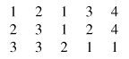
Figure 5.1: Image example

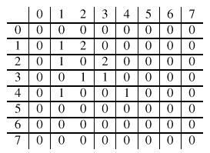
Figure 5.2: Classical Co-occurrence matrix
At first the co-occurrence matrix is constructed, based on the orientation and distance between image pixels. Then meaningful statistics are extracted from the matrix as the texture representation [2]. Haralick proposed the following texture features [10]:
- Angular Second Moment
- Contrast
- Correlation
- Variance
- Inverse Second Differential Moment
- Sum Average
- Sum Variance
- Sum Entropy
- Entropy
- Difference Variance
- Difference Entropy
- Measure of Correlation 1
- Measure of Correlation 2
- Local Mean
Hence, for each Haralick texture feature, we obtain a co-occurrence matrix. These co-occurrence matrices represent the spatial distribution and the dependence of the grey levels within a local area. Each (i,j) ^{th} entry in the matrices, represents the probability of going from one pixel with a grey level of 'i' to another with a grey level of 'j' under a predefined distance and angle. From these matrices, sets of statistical measures are computed, called feature vectors [11].

5.1.2Tamura Texture
By observing psychological studies in the human visual perception, Tamura explored the texture representation using computational approximations to the three main texture features of: coarseness, contrast, and directionality [2, 28]. Each of these texture features are approximately computed using algorithms.
- Coarseness is the measure of granularity of an image [28], or average size of regions that have the same intensity [27].
- Contrast is the measure of vividness of the texture pattern. Therefore, the bigger the blocks that makes up the image, the higher the contrast. It is affected by the use of varying black and white intensities [28].
- Directionality is the measure of directions of the grey values within the image [28].

5.1.3 Wavelet Transform
Textures can be modeled as quasi-periodic patterns with spatial/frequency representation. The wavelet transform transforms the image into a multi-scale representation with both spatial and frequency characteristics. This allows for effective multi-scale image analysis with lower computational cost [2]. According to this transformation, a function, which can represent an image, a curve, signal etc., can be described in terms of a coarse level description in addition to others with details that range from broad to narrow scales [29].
Unlike the usage of sine functions to represent signals in Fourier transforms, in wavelet transform, we use functions known as wavelets. Wavelets are finite in time, yet the average value of a wavelet is zero [2]. In a sense, a wavelet is a waveform that is bounded in both frequency and duration. While the Fourier transform converts a signal into a continuous series of sine waves, each of which is of constant frequency and amplitude and of infinite duration, most real-world signals (such as music or images) have a finite duration and abrupt changes in frequency. This account for the efficiency of wavelet transforms. This is because wavelet transforms convert a signal into a series of wavelets, which can be stored more efficiently due to finite time, and can be constructed with rough edges, thereby better approximating real-world signals [26]. Examples of wavelets are Coiflet, Morlet, Mexican Hat, Haar and Daubechies. Of these, Haar is the simplest and most widely used, while Daubechies have fractal structures and are vital for current wavelet applications [2]. These two are outlined below:

Haar Wavelet
The Haar wavelet family is defined as [2]:
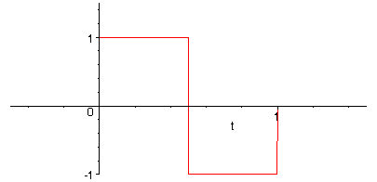
Figure 5.3: Haar Wavelet Example

Daubechies Wavelet
The Daubechies wavelet family is defined as [2]:
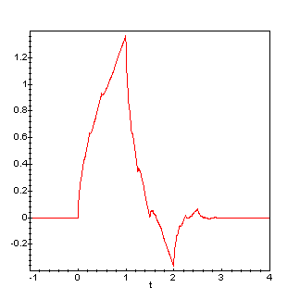
Figure 5.4: Daubechies Wavelet Example

Chapter 6

Proposed Scheme for CBIR Using Color and Texture

The management of a large number of images in a multimedia database has received much attention in recent years. Most of the earlier works are largely focused on techniques to extract useful information (such as color, texture or shape) that represents images. Rapid retrieval is becoming important issue as image databases continue to grow in size and a slow will no longer be acceptable to the user community.
In this chapter we present retrieval system that supports color and texture features. In our system image is represented by set of features that are extracted by using color and texture properties of image which are described in this chapter. These extracted features are then compared with the stored images features in the database. The retrieved images are ranked and top results are then displayed.

6.1 Color features
Color histogram is widely used for color based image retrieval in content-based image retrieval (CBIR). A color histogram describes the global color distribution of an image. It is very easy to compute and is insensitive to small changes in viewing positions. However, the histogram is not robust to large appearance changes and it also gives different results as colors are same in the images. On the other hand, color Correlogram is efficiently used for image indexing in content-based image retrieval. Color Correlogram extracts not only the color distribution of pixels in images like color histogram, but also extracts the spatial information of pixels in the images. So, we use the image bin separation technique followed by extracting maxima of frequencies and constructing its Correlogram.

6.1.1 Color Algorithm
.
1. Calculate the histogram of an image.
2. After that calculate the flat histogram of an image i.e. equalized histogram.
3. Divide the calculated histogram into four equal sized bins.
4. Further sub-divide each calculated equal sized bins into four more bins.
5. Calculate the correlogram and construct it.
6. Calculate the distance between constructed correlogram of query image and database image.
As we all know that RGB and indexed images carry high values that require more computation time. In this project we have used 8-bit images and hence values lie in the range 0-255. Therefore reduction in the computation time and power required for extracting features from an image. The resulting image undergoes histogram equalization in order to enhance contrast of values of an image by generating its flat histogram.

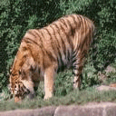

(i)

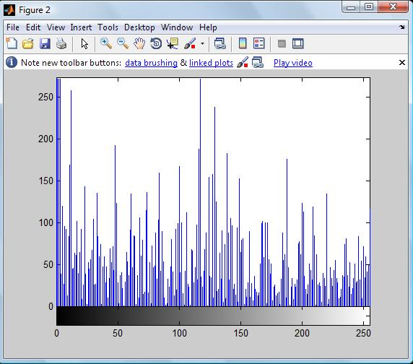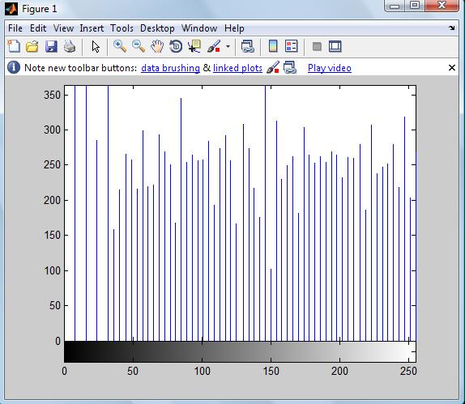
(ii) (iii)

Figure 6.1 :(i)Image (ii)Its Histogram(iii)Its Equalized Histogram

The histogram equalized image is split into four fixed bins in order to extract more distinct information from it. The frequencies of 256 values of images are split into four bins carrying 64 values each (0~63, 64~127, 128~191, and 192~255). This is done by turning off the gray values of image which do not lie between the four bins.

This provides a better illustration of image segments and simplifies the computation of features for the distinct portion of image. The bins produced are further subdivided into four fixed ranges carrying 16 values each. For example, for the first bin carrying value range of 0 to 63, four sub-divisions of the frequency values will be 0~15, 16~31, 32~ 47, and 48~63. Similar procedure is repeated for rest of the bins.
The information from bins and sub-divisions are stored in the form of a Correlogram as shown below
Sub-Division | 1 | 2 | 3 | 4
Bin1 | 1024 | 455 | 567 | 543
Bin2 | 789 | 888 | 390 | 234
Bin3 | 557 | 459 | 890 | 567
Bin4 | 689 | 890 | 598 | 897

Figure 6.2: Correlogram of Bins Vs Subdivision

6.1.2 Similarity Measurement for Color
- Calculate the flat histogram of image.
- Get the correlogram of the query image.
- For every image i in the database obtain the correlogram.
- Calculate the Euclidean distance between the two sets of correlogram that is between query image and image i in the database.
- Increment i. Repeat from step 3.

The distance measurement process comprises of three steps. The Correlogram matrices are subtracted, at first, under simple subtraction rules. Secondly, the sum of the matrix components is calculated. Finally, the third step comprises of sorting the absolute values of the sums obtained in the second. For Example for two images A and B let their corresponding correlograms be 4 row and 4 column matrices. Let, Correlogram of image A be Corr(A).Similarly, let the Correlogram of image B be Corr(B). According to Euclidean distance algorithm described above, let:
Distance (A, B) = Corr(A)-Corr(B)
Where, Distance (A, B) is a vector containing the result of difference calculation as described in equation. The components of the resulting matrix are summed together and the absolute value of this sum is considered

6.2 Texture Features:
We used a method called the pyramid-structured wavelet transform for texture classification. Its name comes from the fact that it recursively decomposes sub signals in the low frequency channels. It is mostly significant for textures with dominant frequency channels. For this reason, it is mostly suitable for signals consisting of components with information concentrated in lower frequency channels [2]. Due to the innate image properties that allows for most information to exist in lower sub-bands, the pyramid-structured wavelet transform is highly sufficient.
Using the pyramid-structured wavelet transform, the texture image is decomposed into four sub images, in low-low, low-high, high-low and high-high sub-bands. At this point, the energy level of each sub-band is calculated .This is first level decomposition. Using the low-low sub-band for further decomposition, we reached fifth level decomposition, for our project. The reason for this is the basic assumption that the energy of an image is concentrated in the low-low band. For this reason the wavelet function used is the Daubechies wavelet.

6.2.1 Texture Algorithm
1. Decompose the image into four sub-images
2. Calculate the energy of all decomposed images at the same scale, using [2]:
Where M and N are the dimensions of the image, and X is the intensity of the pixel located at row i and column j in the image map.
3. Repeat from step 1 for the low-low sub-band image, until index ind is equal to 5. Increment ind.
Using the above algorithm, the energy levels of the sub-bands were calculated and further decomposition of the low-low sub-band image. This is repeated five times, to reach fifth level decomposition. These energy level values are stored to be used in the Euclidean distance algorithm.

6.2.2 Similarity measurement for texture
We have used Euclidean Distance Algorithm for comparing distance between texture features of query image and database images .And the algorithm is as follows
- Decompose query image.
- Get the energies of the first dominant k channels.
- For image i in the database obtain the k energies.
- Calculate the Euclidean distance between the two sets of energies, using [2]:
- Increment i. Repeat from step 3.
Using the above algorithm, the query image is searched for in the image database. The Euclidean distance is calculated between the query image and every image in the database. This process is repeated until all the images in the database have been compared with the query image. Upon completion of the Euclidean distance algorithm, we have an array of Euclidean distances, which is then sorted and top results are then displayed.

Chapter 7
Experimental Results

This Chapter deals with the results of retrieving images from the databases using the method which is discussed in previous chapters of this thesis. In our built application we have used color and texture features of the image for forming feature database.

7.1 Development Environment

We have developed our application in MATLAB which is a high-performance language for technical computing. It integrates computation, visualization, and programming in an easy-to-use environment where problems and solutions are expressed in familiar mathematical notation. MATLAB is an interactive system whose basic data element is an array that does not require dimensioning. This allows us to solve many technical computing problems, especially those with matrix and vector formulations. It takes a fraction of the time to write a program in a scalar non interactive language such as C and FORTRAN. MATLAB features a family of add-on application-specific solutions called toolboxes. Very important to most users of MATLAB, toolboxes allow us to learn and apply specialized technology. Toolboxes are comprehensive collections of MATLAB functions (M-files) that extend the MATLAB environment to solve particular classes of problems. Areas in which toolboxes are available include signal processing, control systems, neural networks, fuzzy logic, wavelets, simulation, and many others.

The MATLAB system consists of five main parts:
1. Development Environment
2. The MATLAB Mathematical Function Library
3. The MATLAB Language
4. Graphics
5. The MATLAB Application Program Interface (API

7.2 Experimental Setup

We have created Graphical user interface in matlab using GUIDE(GUI Builder) which provides user a interface by which one can select query image from the database and can find similar images for that. We have also provided an option through which we can insert or add images for future requirement. Operating System used is Windows Xp, with 3.0 GHz CPU. We have taken more than 800 mixed natural images as a database.
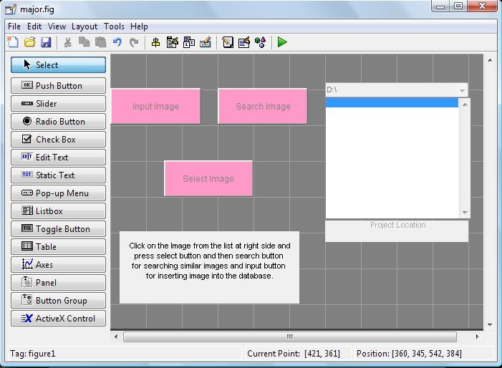

Figure 7.1: Graphical User Interface

Now after building graphical user interface we have to insert images into the database and for this we have provided option to insert image into the database. First of all we have to click input image to database and then press select button and then image to be inserted is displayed as the query image shown below. After this we have to press input image button by which a message box is displayed which confirms the insertion of image into the database as shown below.

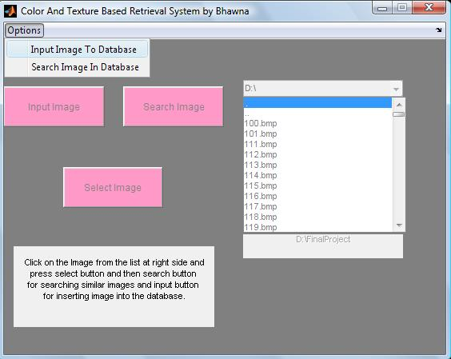
Figure7.2: To Insert Image into the database
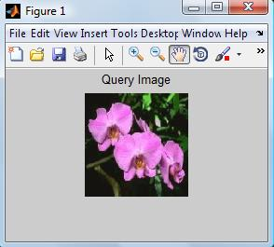
(i)

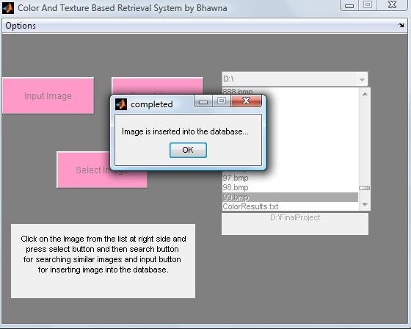
(ii)
Figure7.3: (i) Query image (ii) After completion of insertion of image into the database

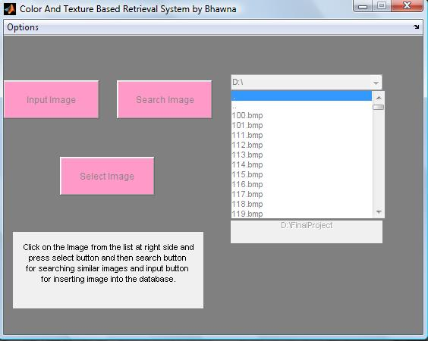
Figure7.4: GUI at runtime
7.3 Obtained Result

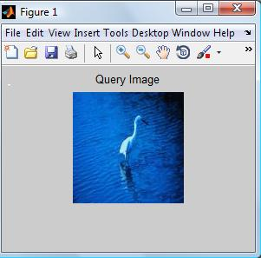

(i)

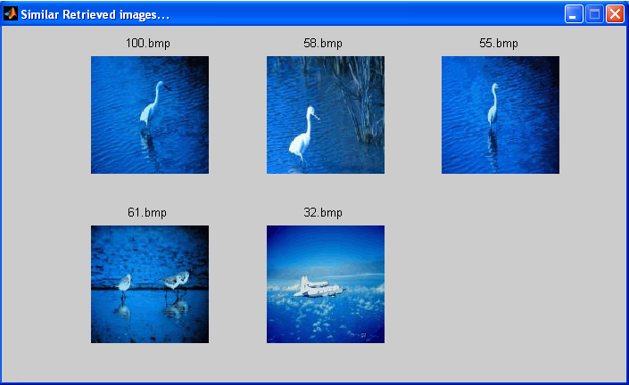
Figure 7.5 :(i) Query image (ii) Top five retrieved images using color feature only

(i)

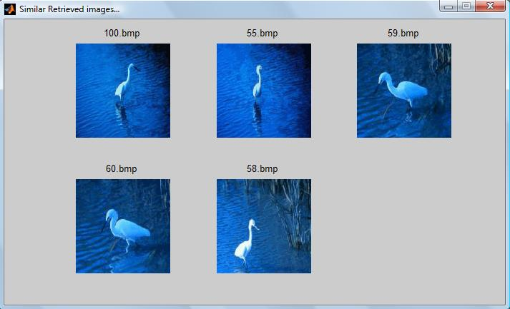
(ii)
Figure7.6: (i) Query Image (ii) Top five retrieved images using color and texture

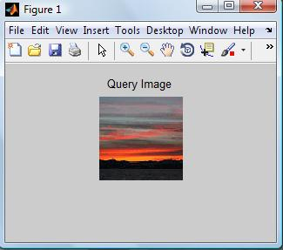
(i)
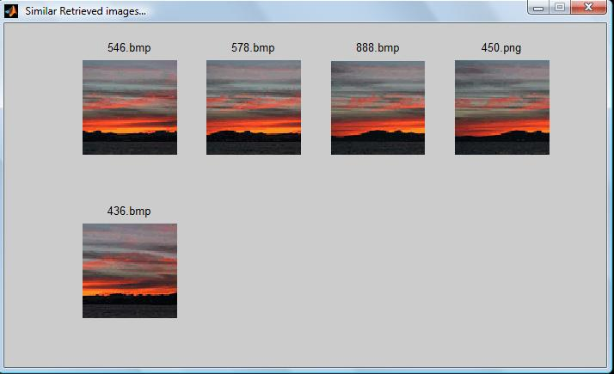
Figure7.7: (i) Query Image (ii) Top five retrieved images using color and texture

Chapter 8
Conclusion and Future Work

8.1 Conclusion
The dramatic rise in the sizes of images databases has stirred the development of effective and efficient retrieval systems. The development of these systems started with retrieving images using textual connotations but later introduced image retrieval based on content. This came to be known as CBIR or Content Based Image Retrieval. Systems using CBIR retrieve images based on visual features such as color, texture and shape, as opposed to depending on image descriptions or textual indexing. In this project, we have researched various modes of representing and retrieving the image properties of color, texture and shape. The application performs a simple color-based search in an image database for an input query image, using color histogram based correlogram. It then compares the color correlogram of different images using the Euclidean Distance Equation. Further enhancing the search, the application performs a texture-based search in the color results, using wavelet decomposition and energy level calculation. It then compares the texture features obtained using the Euclidean Distance Equation. And it is shown that our method gives better results than taking color only.

8.2 Future Work
The results Of CBIR system presented in this thesis are based on color and texture features, meaning that a simple color based search is done first followed by texture and these two combined to form feature vector and are used for image retrieval. The results may be improved if we consider shape along with color and texture and we can also use some indexing scheme for better retrieved results and performance.
Appendix
The following are the instructions to run the Project
1. Copy the files to a folder named D:\MajorProject\
Note: If you do not do so, then make sure you make the necessary changes in the file "major.m" for the directory...
2.Change the MatLab Current Directory to C:\Project\... using cd('D:\MajorProject\').
3. Run the application, by typing major in the command window
4. In the running applicaion, select the option you want to have (input or search).
5. Select the image bitmap file you want to search for in the database.
6. Press Select for displaying query image
7. Press Search for searching similar images for the given query image.

References
[1] Fuhui Long, Hongijang Zhang, David Dagan Feng, “Fundamentals of Content Based Image Retrieval”.
http://research.microsoft.com/asia/dload_files/group/mcomputing/2003P/ch01_Long_ v40-proof.pdf

[2] Sharmin Siddique, “A Wavelet Based Technique for Analysis and Classification of Texture Images,” Carleton University, Ottawa, Canada, Project Report 70.593, April 2002.

[3] Chin Chen-Chaur, Ting Chu Hsueh, “Similarity Measurement between Images”, IEEE Annual International Computer Software and Applications Conference (COMPSAC’05), pp.207-248, 2005.

[4] Timothy K.Shih,Jung-yao Huang,Ching-Sheng Wang,Jason C.Hung And Chuan-Ho Kao, “ An intelligent content-Based image retrieval System based on color ,Shape and spatial relations” Proceedings Natl.Si.Counc.Roc(A), volume 25,No.4, pp.231- 243,2001.

[5] Virginia E. Ogle and Michael Stonebraker, “Chabot: Retrieval from a relational database of images”, IEEE Computer, 28(9), pp.40–48, September 1995.

[6] A. Blaser, “Database Techniques for Pictorial Applications”, Lecture Notes in Computer Science, Springer Verlag GmbH, Volume 81,1979.

[7] J. Kreyss, M. R¨oper, P. Alshuth, Th. Hermes, and O. Herzog, “Video retrieval by still image analysis ImageMiner”, In Proceedings of IS&T/SPIE’s Symposium on Electronic Imaging: Science & Technologies, pp.8-14 Feb. ’97, San Jose, CA, 1997.

[8] S. Sclaroff, L. Taycher, and M. La Cascia, “ Imagerover: A content-based image browser for the world wide web”, In Proceedings IEEE Workshop on Content-based Access of Image and Video Libraries, June ’97, 1997.

[9] Leonid Taycher, Marco La Cascia, and Stan Sclaroff, “Image digestion and relevancefeedback in the ImageRover WWW search engine”, In Proceedings of the 2nd International Conference on Visual Information Systems, San Diego, December ’97, pp 85–94, 1997.

[10] M. La Cascia and E. Ardizzone, “Jacob: Just a content-based query system for video databases”, In Proceedings of IEEE International Conference on Acoustics, Speech, and Signal Processing (ICASSP96),May 7-10, ’96, Atlanta, Georgia, 1996.

[11] MichaelOrtega,Yong Rui, Kaushik Chakrabarti, Sharad Mehrotra, and Thomas
S. Huang, “Supporting similarity queries in MARS”, In Proceedings of the 5th ACM International Multimedia Conference, Seattle, Washington, 8-14 Nov. ’97, pages 403–413, 1997.

[12] A. B. Benitez, M. Beigi, and S.-F. Chang, “ Using relevance feedback in content-
based image metasearch”, IEEE Internet Computing, 2(4):59–69, July/August 1998.

[13] Wei-Ying Ma and B. S. Manjunath, “ Netra: A toolbox for navigating large image databases”,Multimedia Systems, 7(3):184–198, 1999.

[14] Alex Pentland, RosalindW. Picard, and Stanley Sclaroff, “Photobook: Content-based manipulation of image databases”, International Journal of Computer Vision, 18(3):233–254, June 1996.

[15] W. Niblack, R. Barber, W. Equitz, M. Flickner, E. Glasman, D. Petkovic, P. Yanker,
C.Faloutsos, and G. Taubin, “The qbic project: Quering images by content using color, texture, and shape”, In Proceedings of the SPIE Conference on Storage and Retrieval for Image and Video Databases, 2-3 February ’93, San Jose, CA, pages 173–187, 1993.

[16] J. Bach, C. Fuller, A. Gupta, A. Hampapur, B. Gorowitz, R. Humphrey, R. Jain, and
C.Shu, “ Virage image search engine: an open framework for image management”, In Proceedings of the SPIE, Storage and Retrieval for Image and Video Databases IV, San Jose, CA, pages 76–87, February 1996.

[17] J. R. Smith and S.-F. Chang, “ Querying by color regions using the VisualSEEk content-based visual query system”, In M. T. Maybury, editor, Intelligent Multimedia Information Retrieval. AAAI Press, 1997.

[18] J. R. Smith,”Integrated Spatial and Feature Image Systems: Retrieval, Compression and Analysis” PhD thesis, Graduate School of Arts and Sciences, Columbia University, February 1997.

[19] Michael J. Swain, Charles Frankel, and Vassilis Athitsos, “WebSeer: An image search engine for the world wide web”, Technical Report TR-96-14, Deptartment of Computer Science, University of Chicago, July 1996.

[20] J.Hafner, et al., “Efficient color histogram indexing for quadratic form distance functions”, IEEE Trans. on Pattern Analysis and Machine Intelligence, Volume 17, No. 7, pp. 729-736, July 1995.

[21] W. Niblack et al., “Querying images by content, using color, texture, and shape”, SPIE Conference on Storage and Retrieval for Image and Video Database, Volume 1908, pp.173-187, April 1993.

[22] M. J. Swain, and D. H. Ballard, “Color indexing”, International Journal of Computer Vision, Vol. 7, No. 1, pp.11-32, 1991.

[23] Y.Deng, B.Majnunath, C.Kenney, M.Moore and Y.shin, “An efficient color representation for image retrieval”,IEEE transaction .Image Processing,10(1):140- 147,Jan 2001.

[24] M. Tuceryan and A. K. Jain, ``Texture Analysis,'' In the Handbook of Pattern Recognition and Computer Vision (2nd Edition), by C. H. Chen, L. F. Pau, P. S. P. Wang (eds.)

[25] Arnold W.M. Smeulders, Marcel Worring, Simone Santini, Amarnath Gupta, and Ramesh Jain, “Content-based image retrieval at the end of the early years,” IEEE Transactions of Pattern Analysis and Machine Intelligence, vol. 22, No. 12, pp. 1349- 1380, December 2000.

[26] FOLDOC, Free On-Line Dictionary Of Computing, “wavelet,” May 1995, [Online Document], Available at: http://foldoc.doc.ic.ac.uk/foldoc/foldoc.cgi?query=wavelet

[27] Bjorn Johansson, “QBIC (Query By Image Content)”, November 2002

[28] Pravi Techasith, “Image Search Engine,” Imperial College, London, UK, Project Report, July 2002.

[29] G. D. Magoulas, S. A. Karkanis, D. A. Karras and M. N. Vrahatis, “Comparison
Study of Textural Descriptors for Training Neural Network Classifiers”, in Proceedings of the 3rd IEEE-IMACS World Multi-conference on Circuits, Systems, Communications and Computers, vol. 1, 6221-6226, Athens, Greece, July 1999.

[30] Barbeau Jerome, Vignes-Lebbe Regine, and Stamon Georges, “A Signature based on Delaunay Graph and Co-occurrence Matrix,” Laboratoire Informatique et. Systematique, Universiyt of Paris, Paris, France, July 2002.

