CHAPTER 3

Parameter Optimization Of CNC Turning Using D.O.E. & R.S.M.

3.1 Introduction
This chapter is all about the steps and procedures used to optimize turning parameters using Taguchi’s design of experiment. In this chapter objectives of the study were set and according to the objectives of the study different factors were selected. After that experimental work was carried out on CNC turning machine according to L₂₇ orthogonal array. The values of response factor i.e. surface roughness are then recorded according to orthogonal array. [27]
3.2 Brainstorming
When physical experiments are used, it is sometimes impossible or very expensive to carry out an experiment according to the set-up. Thus it becomes necessary to first study and discuss about the process and process parameters. A good knowledge about the work to be done, process and optimization technique may be very helpful to get expected results. Important steps that are to be considered are as follows:
- Objectives of Study and Evaluation Criteria
- Factors
- Noise Factors
- Factor Levels
- Interaction between Factors
- Scopes of Studies
- Additional Items
3.2.1 Objectives of Study and Evaluation Criteria
- What are the criteria of evaluation?
- How are each of these criteria measured?
- How are these criteria combined into a single number?
- What is the common characteristic of these criteria?
- What is the relative influence these criteria exhibit?
3.2.2. Design Factors
- What are the factors that influence the performance criteria?
- Which factors are more important than others?
3.2.3 Noise Factors
- Which factors can't be controlled in real life?
- Is the performance dependent on the application environment?
3.2.4 Factor Levels
- What are the ranges of values the factors can assume within
practical limits?
- How many levels of each factor should be used for the study?
- What is the tradeoff for a higher level?
3.2.5 Interaction between Factors
- Which factors are most likely to interact?
- How many interactions can be studied?
3.2.6 Scopes of Studies
- How many experiments can we run?
- When do we need the results?
- How much does each experiment cost?
3.2.7 Additional Items
- What do we do with factors that are not included in the study?
- In what order do we run these experiments?
- Who will do these experiments?
3.3 Types of Optimization Problems
3.3.1 Static Problems
Generally, a process to be optimized has several control factors, which directly decide the target or desired value of the output. The optimization then involves determining the best control factor levels so that the output is at the target value. Such a problem is called as a "STATIC PROBLEM".
This is best explained using a P-Diagram, which is shown below ("P" stands for Process or Product). Noise is shown to be present in the process but should have no effect on the output. The primary aim of the Taguchi experiments is to minimize variations in output even though noise is present in the process. The process is then said to have become robust.
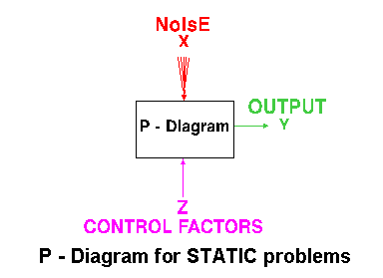
Figure 3.1(P-Diagram for Static Problems) www.ee.iitb.ac.in

3.3.2 Dynamic Problems
If the product to be optimized has a signal input that directly decides the output, the optimization involves determining the best control factor levels so that the "input signal / output" ratio is closest to the desired relationship. Such a problem is called as a "DYNAMIC PROBLEM". The difference between dynamic and static problem is that in dynamic problems we study the effects on output due to noise also which are not considered in static problems. This is best explained by a P-Diagram, which is shown below. Again, the primary aim of the Taguchi experiments - to minimize variations in output even though noise is present in the process- is achieved by getting improved linearity in the input/output relationship.
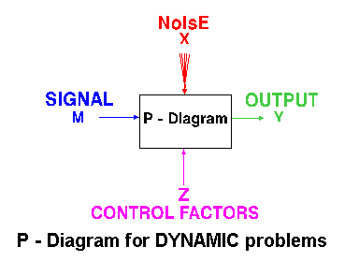
Figure 3.2 (P-Diagram for Dynamic Problems) www.ee.iitb.ac.in

3.4 Batch Process Optimization
There are 3 Signal-to-Noise ratios of common interest for the purpose of optimization;
3.4.1 Smaller-The-Better [27]
n = -10 Log₁₀ [mean of sum of squares of measured data]
This is usually the chosen S/N ratio for all undesirable characteristics like "defects, surface roughness" etc. for which the ideal value is zero. Also, when an ideal value is finite and its maximum or minimum value is defined (like maximum purity is 100% or minimum time for making a telephone connection is 1 sec) then the difference between measured data and ideal value is expected to be as small as possible. The generic form of S/N ratio then becomes,
n = -10 Log₁₀ [mean of sum of squares of {measured - ideal}]
3.4.2 Larger-The-Better
n = -10 Log₁₀ [mean of sum squares of reciprocal of measured data]
This case has been converted to SMALLER-THE-BETTER by taking the reciprocals of measured data and then taking the S/N ratio as in the smaller-the-better case.
3.4.3 Nominal-The-Best
Square of mean
n = 10 Log₁₀ -----------------
variance
This case arises when a specified value is MOST desired, meaning that neither a smaller nor a larger value is desirable.
3.5 Steps in Taguchi Methodology
Taguchi method is a scientifically disciplined mechanism for evaluating and implementing improvements in products, processes, materials, equipment, and facilities. These improvements are aimed at improving the desired characteristics and simultaneously reducing the number of defects by studying the key variables controlling the process and optimizing the procedures or design to yield the best results.
The method is applicable over a wide range of engineering [3, 18, 20, 31, 35] fields that include processes that manufacture raw materials, sub systems, products for professional and consumer markets. In fact, the method can be applied to any process be it engineering fabrication, computer-aided-design, banking and service sectors etc. Taguchi method is useful for 'tuning' a given process for 'best' results.
Taguchi proposed a standard 8-step procedure for applying his method for optimizing any process. These are: [37]
Step1: formulation of the problem – the success of any experiment is dependent
on a full understanding of the nature of the problem. It is important to establish just what the experiment is aiming to solve.
Step2: Determine the objective:-Identify the output characteristics (responses) to be studied and eventually optimized and determine the method of measurement. To establish measurement reliability, a separate experiment may be required
Step 3: Identification of control factors, noise factors and signal factors (if any). Control factors are those which can be controlled under normal production conditions. Noise factors are those which are either too difficult or too expensive to control under normal production conditions. Signal factors are those which affect the mean performance of the process. Taguchi believes that it is generally preferable to consider as many factors (rather than many interactions) as it is economically feasible for the initial screening.
Step 4: selection of factor levels, possible interactions and the degrees of freedom associated with each factor and the interaction effects. Assign the controllable factors and their interactions to the columns of the inner array, and the noise factors to the columns f the outer array.
Step 5: Conduct the experiment: Perform the experimental trials and collect the experimental data.
Step 6: Analyze the data: Evaluate the performance measures (TPM and NPM) for each trial run of the inner array and analyze them using the appropriate statistical analysis technique
Step 7: Interpret the results: Identify the variability control factors (VCF) and target control factors (TCF) and select their optimal levels. For the VCF’s the optimal levels are those, which maximize the NPM (minimize variability in the response), and for the TCF’s they are those, which bring the mean response nearest to the target value.
Step 8: Run a confirmatory Experiment: It is necessary to confirm, by some follow up experimental trials. A successful confirmation can alleviate concerns about the possibilities of a wrong choice for factor levels and experimental design.
If predicted results are not confirmed, or otherwise unsatisfactory, additional experiments may be required and a repetition of step no. 3 to 8 may be necessary.
3.6 Response surface methodology (RSM) [1]
Experimentation and making inferences are the twin features of general scientific methodology. Statistics as a scientific discipline is mainly designed to achieve these objectives. Planning of experiments is particularly very useful in deriving clear and accurate conclusions from the experimental observations, on the basis of which inferences can be made in the best possible manner. The methodology for making inferences has three main aspects. First, it establishes methods for drawing inferences from observations when these are not exact but subject to variation, because inferences are not exact but probabilistic in nature. Second, it specifies methods for collection of data appropriately, so that assumptions for the application of appropriate statistical methods to them are satisfied. Lastly, techniques for proper interpretation of results are devised.
The advantages of design of experiments as reported by Adler et al (1975) and Johnston
(1964) are as follows.
(1) Numbers of trials are reduced.
(2) Optimum values of parameters can be determined.
(3) Assessment of experimental error can be made.
(4) Qualitative estimation of parameters can be made.
(5) Inference regarding the effect of parameters on the characteristics of the process can be made.
Cochran & Cox (1962) quoted Box and Wilson as having proposed response surface methodology for the optimization of experiments. In many experimental situations, it is possible to represent independent factors in quantitative form. Then these factors can be thought of as having a functional relationship or response:
Y = φ(X1,X2, . . . ,Xk) ± e_{r} ,
between the response Y and X1,X2, . . . Xk of k quantitative factors. The function φ is called response surface or response function. The residual er measures the experimental error. For a given set of independent variables, a characteristic surface responds. When the mathematical form of φ is not known, it can be approximated satisfactorily within the experimental region by a polynomial. The higher the degree of the polynomial the better is the correlation, though at the same time the costs of experimentation become higher.
The methodology may be applied for developing the mathematical models in the form
of multiple regression equations correlating the dependent parameters such as cutting force, power consumption, surface roughness, tool life etc. with three independent parameters, viz. cutting speed, feed rate and depth of cut, in a turning process. In applying the response surface methodology, the dependent parameter is viewed as a surface to which a mathematical model is fitted. For the development of regression equations related to various quality characteristics of turned parts, the second-order response surface may be assumed as:

Y = b₀ + b₁x₁+b₂x₂+b₃x₃+b₄x₁²+b₅x₂²+b₆x₃²+b₇x₁x₂+b₈x₁x₃+b₉x₂x₃+e ...1

This assumed surface Y contains linear, squared and cross-product terms of variables Xi ’s. In order to estimate the regression coefficients a number of experimental design techniques are available. Box & Hunter (1957) have proposed that the scheme based on central composite design fits the second-order response surfaces very accurately. Lambert & Taraman (1973) developed an adequate mathematical model for the cutting force acting on a carbide tool while machining SAE 1018 cold-rolled steel in a turning operation and then utilized the model in the selection of the levels of the machining variables of cutting speed, feed rate, and depth of cut, such that the rate of metal-removal could be at the highest possible value without violating some given force restriction. By using response surface methodology the three independent variables (cutting speed, feed rate and depth of cut) could be investigated simultaneously to study their effects on the cutting force, resulting in considerable saving in time and money over traditional methods of analysis.
Taraman (1974) investigated multi-machining output multi-independent variable turning research by response surface methodology. The purpose of this research was to develop a methodology that would allow determination of the cutting conditions (cutting speed, feed rate and depth of cut) such that the specified criterion for each of several machining-dependent parameters (surface finish, tool force and tool life) could be achieved simultaneously. To accomplish this, first mathematical models were developed representing the relationship between the dependent and independent variables of the process. A central composite design was used to develop the models in order to minimize the amount of experimentation. The models were represented by response surfaces and contours of these surfaces were obtained at different levels of each of the independent variables in planes of the other independent variables. By superimposing the contours, a proper combination of the cutting speed, feed rate and depth of cut can be selected to satisfy some specified criteria. Disposable inserts of tungsten carbide were used to turn SAE1018 cold-rolled steel.
Hassan & Suliman (1990) presented mathematical models for the prediction of surface roughness, tool vibration, power consumption and cutting time, when turning medium carbon steel using tungsten carbide tools under dry conditions. The functional relationships of these variables and the machining-independent variables (cutting speed, feed rate and depth of cut) were established by a second-order polynomial multi-regression analysis. The surface roughness model developed was used as an objective function to establish the optimum cutting conditions while the tool vibration level, power consumption and cutting time were considered the functional constraints.
El Baradie (1993) presented a study of the development of a surface roughness model for turning grey cast iron (154 BHN) using tipped carbide tools under dry conditions and for a constant depth of cut (d = 1.00mm). The mathematical model utilizing the response surface methodology was developed in terms of cutting speed, feed rate and nose radius of the cutting tool. These variables were investigated using design of experiments and utilization of the response surface methodology. The turning operation was performed on a 10 h.p. lathe. The work pieces were cast in the form of cylindrical bars 200mm in diameter and approximately 500mm in length. The cutting tests were carried out using a tungsten carbide insert (grade K10). Surface roughness measurements were made using a Taylor–Hobson Surtronic surface roughness measuring instrument. A first-order model covering the cutting speed range of 110–350 m/min and a second-order model covering the cutting speed range of 80–495 m/min are presented in this study. Contours of the surface roughness outputs were obtained in planes containing two of the independent variables. These contours were further developed to select the proper combination of the cutting speed and feed rate to increase the metal removal rate without sacrificing the quality of the surface roughness produced. Table 1 summarizes the traditional and latest optimization techniques discussed in §§ 2 and 3 for the optimization of process variables in metal machining.
3.7 Experimentation Work [47]
Turning is a very important machining process in which a single-point cutting tool removes material from the surface of a rotating cylindrical work piece. The cutting tool is fed linearly in a direction parallel to the axis of rotation. Turning is carried out on a lathe that provides the power to turn the work piece at a given rotational speed and to feed the cutting tool at a specified rate and depth of cut therefore, three cutting parameters, i.e. cutting speed, feed rate, and depth of cut, need to be determined in a turning operation. Here the application of force during the machining operation can play an important role to evaluate cutting performance in a turning operation. In addition, surface roughness is another important index to evaluate cutting performance. Basically, force and surface roughness correlated strongly with cutting parameters such as cutting speed, feed rate, and depth of cut. Proper selection of the cutting parameters can result in less application of force and better surface roughness. Hence, design optimization of the cutting parameters based on the Taguchi method is adopted for force and the surface roughness in a turning operation.
In this work experiments are conducted to find out the effect of different factors and their levels on surface roughness and force. The roughness is measured by surface roughness meter (Stylus Type) and the force is measured by dynamometer .The results are then recorded to analyze the effect of different parameters and their levels on surface roughness and force.

3.8 Measurement of Surface Roughness
Inspection and assessment of surface roughness of machined work pieces can be carried out by means of different measurement techniques. These methods can be ranked into the following classes:
- Direct measurement methods
- Comparison based techniques
- Non contact methods

3.8.1 Direct Measurement Methods
Direct methods access surface finish by means of stylus type devices. Measurements are obtained using a stylus drawn along the surface to be measured. The stylus motion perpendicular to the surface is registered. This registered profile is then used to calculate the roughness parameters. The parameter Ra is used here.
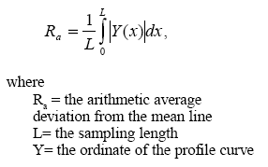
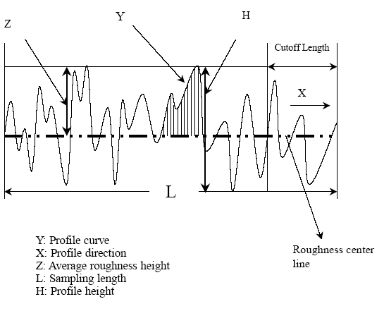
Figure 3.3(Measurement of Surface roughness by Stylus)
3.8.2 Comparison Based Techniques
Comparison techniques use specimens of surface roughness produced by the same process, material and machining parameters as the surface to be compared. Visual and tactile senses are used to compare a specimen with a surface of known surface finish. This method is useful for surface roughness Ra>1.6 micron.

3.8.3 Non Contact Methods

In it a rough surface is illuminated by a monochromatic plane wave with an angle of incidence with respect to the normal to the surface. The photo sensor of a camera placed in the focal plane of a Fourier lens is used for recording speckle patterns. Then the surface roughness can be defined and calculated
In these experiments direct measurement method has been used i.e. stylus type surface roughness meter was used to measure the surface roughness of the specimen. There were two main reasons behind selecting stylus type surface roughness; one is its easy availability and other is the ease with which it can be operated. The instrument used in these experiments is a product of precision devices.
The tool used was cemented carbide insert type. The geometry of tool is: Rake angle 6⁰ (+ve), 5⁰ (+ve) clearance angle, 60⁰ (+ve) major cutting edge angle, 60⁰ (+ve) included angle and 0⁰ cutting edge inclination angle. The work piece material was AISI 1040 type with the chemical composition as under:
TABLE3.1 (Chemical Composition of Work Piece)
Element | Weight %
Cu | 0.15-0.4
Mg | 0.7-1.2
Si | 0.4-0.8
Fe | 0.7 max
Mn | 0.2-0.8
Other | 0.4

3.9 Factors and their Levels [47]
The factors and their levels have been selected on the basis of tool, work piece material, machine parameters and by studying different research papers and data hand books. Different cutting parameters and their level are shown in table:

Table 3.2(Process Parameters and Their Levels)
Process parameters | Process designation | Levels
Process parameters | Process designation | -1 | 0 | 1
Speed (m/min) | A | 2400 | 2600 | 2800
Feed (mm/rev) | B | 40 | 50 | 60
Depth of cut (mm) | C | 0.5 | 0.75 | 1
According to Taguchi Design of Experiment we have to conduct only nine experiments. This includes three parameters along with its levels and interactions.

Table 3.3 Orthogonal Array of L₂₇ [18]
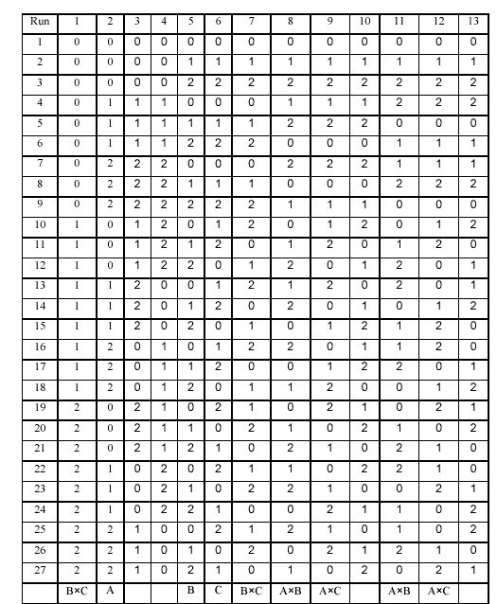
Table 3.4 (Experimental results)
Speed(rpm) | Feed(mm/min) | Depth of Cut(mm) | surface roughness(micron) | S/N Ratio Roughness | Mean Roughness(micron)
2400 | 40 | 0.5 | 0.625 | 4.0824 | 0.625
2400 | 40 | 0.75 | 0.640 | 3.8764 | 0.640
2400 | 40 | 1 | 0.997 | 0.0261 | 0.997
2400 | 50 | 0.5 | 1.133 | -1.0846 | 1.133
2400 | 50 | 0.75 | 0.933 | 0.6024 | 0.933
2400 | 50 | 1 | 1.120 | -0.9844 | 1.120
2400 | 60 | 0.5 | 1.753 | -4.8756 | 1.753
2400 | 60 | 0.75 | 2.607 | -8.3228 | 2.607
2400 | 60 | 1 | 2.880 | -9.1878 | 2.880
2600 | 40 | 0.5 | 1.260 | -2.0074 | 1.260
2600 | 40 | 0.75 | 0.692 | 3.1979 | 0.692
2600 | 40 | 1 | 0.750 | 2.4988 | 0.750
2600 | 50 | 0.5 | 0.940 | 0.5374 | 0.940
2600 | 50 | 0.75 | 1.187 | -1.4890 | 1.187
2600 | 50 | 1 | 1.680 | -4.5062 | 1.680
2600 | 60 | 0.5 | 1.847 | -5.3293 | 1.847
2600 | 60 | 0.75 | 3.120 | -9.8831 | 3.120
2600 | 60 | 1 | 3.160 | -9.9937 | 3.160
2800 | 40 | 0.5 | 0.700 | 3.0980 | 0.700
2800 | 40 | 0.75 | 0.793 | 2.0145 | 0.793
2800 | 40 | 1 | 1.036 | -0.3072 | 1.036
2800 | 50 | 0.5 | 1.095 | -0.7883 | 1.095
2800 | 50 | 0.75 | 1.120 | -0.9844 | 1.120
2800 | 50 | 1 | 1.120 | -0.9844 | 1.120
2800 | 60 | 0.5 | 2.850 | -9.0969 | 2.850
2800 | 60 | 0.75 | 3.280 | -10.3175 | 3.280
2800 | 60 | 1 | 3.573 | -11.0607 | 3.573

Table 3.5 Orthogonal Array, L-15 of Factors A, B, C,A*B, A*C, and B*C[MINITAB]
StdOrder | RunOrder | Blocks | A | B | C
1 | 1 | 1 | -1 | -1 | 0
2 | 2 | 1 | 1 | -1 | 0
10 | 3 | 1 | 0 | 1 | -1
13 | 4 | 1 | 0 | 0 | 0
5 | 5 | 1 | -1 | 0 | -1
9 | 6 | 1 | 0 | -1 | -1
12 | 7 | 1 | 0 | 1 | 1
14 | 8 | 1 | 0 | 0 | 0
7 | 9 | 1 | -1 | 0 | 1
8 | 10 | 1 | 1 | 0 | 1
15 | 11 | 1 | 0 | 0 | 0
6 | 12 | 1 | 1 | 0 | -1
4 | 13 | 1 | 1 | 1 | 0
3 | 14 | 1 | -1 | 1 | 0
11 | 15 | 1 | 0 | -1 | 1

3.10 Summary
In this chapter selection of factors and their levels was done. Experiments were carried out according to the orthogonal array of L₂₇ and L₁₅.The surface roughness was measured by stylus type surface roughness meter. The experimental results were then recorded according to the orthogonal array. Now this data obtained will be used to find the optimum surface roughness required by using Taguchi design of experiment and RSM the results will be cross examined by using various techniques.

