A
Dissertation
On
An Approach To Remove Lexical Ambiguity In Text Mining

Submitted in Partial fulfillment of the requirement
for the award of the degree of

MASTER OF ENGINEERING
(Computer Technology & Applications)

Submitted By:
VIVEK TRIPATHI
College Roll No: 18/CTA/07
University Roll No. 12215

Under the esteemed Guidance of:
Mr. MANOJ KUMAR

DEPARTMENT OF COMPUTER ENGINEERING
DELHI COLLEGE OF ENGINEERING
DELHI UNIVERSITY
2007-2009

CERTIFICATE
DELHI COLLEGE OF ENGINEERING
(Govt. of National Capital Territory of Delhi)
BAWANA ROAD, DELHI – 110042

Date: ___________

This is certified that the major project report entitled An Approach to Remove Lexical Ambiguity in Text Mining is a work of Vivek Tripathi (University Roll No- 12215) a student of Delhi College of Engineering. This work is completed under my direct supervision and guidance and forms a part of master of engineering (Computer Technology and Application).course and curriculum. He has completed his work with utmost sincerity and diligence.
The work embodied in this major project has not been submitted for the award of any other degree to the best of my knowledge.

Mr Manoj Kumar
Assistant Professor & Project Guide
Dept. Of Computer Engineering
Delhi College of Engineering,
University of Delhi, India
Acknowledgement

It is a great pleasure of mine to have the opportunity to extend my heartiest felt gratitude to everybody who helped me throughout the course of this project.

It is distinct pleasure to express my deep sense of gratitude and indebtedness to my learned supervisor Mr. Manoj Kumar Assistant Professor, Computer Department for his invaluable guidance, encouragement and patient reviews. His continuous inspiration only has made me complete this dissertation. Without his help and guidance, this dissertation would have been impossible. He provided the conceptions and theoretical background for this study as well as suggested us the rational approach. He remained a pillar of help throughout the project.
With his continuous inspiration only, it becomes possible to complete this dissertation.
I would also like to take this opportunity to present my sincere regards to my teachers Dr. Daya Gupta, Mrs. Rajini Jindal, Mr. Vinod Kumar, Dr. S.K.Saxena, Mr. Manoj Sethi and the other staff of computer engineering department for providing me unconditional and any time access to the resources and guidance.
I am grateful to my parents for their moral support all the time; they have been always around to cheer me up, in the odd times of this work. I am also thankful to my classmates for their unconditional support and motivation during this work. Last but not least, I special thanks to the crowd who are active in the field of Text Mining and Ambiguity issues.

VIVEK TRIPATHI
Master in Engineering
(Computer Technology & Application)
College Roll No. 18/CTA/07
University Roll No. 12215
Department of Computer Engineering
Delhi College of Engineering, Delhi-110042

ABSTRACT:

Text mining, also known as text data mining or knowledge discovery from textual databases refers to the process of extracting interesting and non-trivial patterns or knowledge from unstructured text documents from a fixed domain. Text Mining tasks include text categorization, text clustering, concept/entity extraction, document summarization, and entity relation modeling. In this work, the focus is given to concept/entity extraction only. The major challenging issue in extracting concept/entity from texts is natural language words are always ambiguous. Up to now, not much research in text mining especially in concept/entity extraction has focused on the ambiguity problem.

Ambiguity problem occur when a sentence could be interpreted in more than one meaning here we addresses ambiguity issues in natural language texts, and presents a new technique for resolving ambiguity problem in extracting concept/entity from texts. The approach is developed by utilizing natural language processing, possibility theory, fuzzy set, and knowledge about the context to lexical semantics.

TABLE OF CONTENTS

Certificate …………………………………………………………………………i
Abstract …………………………………………………………………………...ii
Acknowledgement………………………………………………………………...iii
Table of contents………………………………………………………………….iv
List of figures……………………………………………………………………..vii
1. Introduction
1.1 Introduction……………………………………………..…………….1
1.2 Related work…………………………………………..………………2
1.3 proposed work………………………………………………………...3
1.4 Need of the project ……………………………………….….………3
1.5 Organization of work …………………………………………...…..5

2. Text Mining and Ambiguity
2.1 Introduction to text mining ………………………………......……6
2.2 What is Ambiguity? ...................................................................7
2.2.1 Lexical ambiguity ………………………..….…………..…..8
2.2.2 Semantic ambiguity………………………….…..…………..…8
2.2.3 Syntactic ambiguity ...……………………………………..…8

3. Possibility Theory and Fuzzy Set
3.1 Possibility Theory……………….…………………………………...10
3.2 Fuzzy Set ……………………….…………………………………...12
3.3 Applying Possibility Theory and fuzzy sets on lexical
semantics…………………………………………………….…………15

4. Methodology
4.1 Flow of process……………………………………………..………...17
4.2 Context diagram …………………………………………………….18
4.2 Class diagram ………………………………………………...…….19
4.3 sequence diagram ………………………………………………….20

5. Text processing
5.1 Natural Language Processing………………………………..….…22
5.1.2 Syntactic Analysis ……………………………………...…23
5.1.2 Semantic Analysis …………………………………..........25

6. Implementation of possibility theory ………………………….27
7. Hardware And Software requirements…………………………31
8. Conclusion and future work …...………………………………..32
9. Item description….………………………………………………..43
10. References…………………………..…………………………….44

List of Figures

FIGURE 2.1 text mining……………………………………………..…...6
FIGURE 4.1 flow of process …………………………………………17
FIGURE 4.2 BLOCK DIAGRAM ………………………………..………18
FIGURE 4.3 class diagraM …………………………………..…….19
FIGURE 4.4 CONTEXT DIAGRAM…………………………………..……20
FIGURE 4.5 SEQUENCE DIAGRAM …………………………….…..…....21
FIGURE 5.1 a parse tree of a sentence ‘I put chickens in
the pen’………………….…………………………….…….23
FIGURE 5.2 WORKING OF PARSER………………………………………24
FIGURE 8.1 PARSER WINDOW…………………………………………...32
FIGURE 8.2 PARSER LOADIND WINDOW……………………………....33
FIGURE 8.3 PARSER OUTPUT FOR GIVEN SENTENCE…………...…..35
FIGURE 8.4 TAGGER WINDOW…………………………………………..37
FIGURE 8.5 TAG DISCRIPTION…………………………………………..37
FIGURE 8.6 TAGGER OUTPUT……………………………………...……38
FIGURE 8.7 WORDNET 2.1 BROWSER…………………………………..39
FIGURE 8.8 OUTPUT FOR LEXICAL PEN………………………………..40
FIGURE 8.9 PROGRAM OUTPUT FOR INPUT LEXICAL………………41
FIGURE 8.10 PROGRAM OUTPUT FOR CONTEXT……………………..41
FIGURE 8.11 EXACT MEANING IS DISPLAYED ……………………….42

TABLES:

6.1. FUZZY SEMANTIC DATABASE FOR LIVESTOCK CONTEXT …. .27
6.2 FUZZY SEMANTIC DATABASE FOR WRITE CONTEXT ……...…. .28
7.1 HARDWARE AND SOFTWARE REQUREMENTS …………….…..34

Chapter 1
Introduction

1.1 Introduction
Machines can reason with relational data since schemas are explicitly available. Free text, however, encode all semantic information within natural language. Our text mining algorithms, then, must make some sense out of this natural language representation. Humans are great at doing this, but this has proved to be a problem for a machine. The major objective is to address ambiguity issue in natural language texts, and present a new technique for resolving ambiguity problem in extracting concept-entity from texts. The technique is developed by applying possibility theory, fuzzy set and knowledge about the context to lexical semantics. Thus text mining tools could be technologies are capable of answering sophisticated questions and performing text searches with an element of intelligence. Text mining should be distinguished from
• Data mining, which is concerned with extracting predictive patterns from predominantly numerical data
• Information retrieval, where we search for something that is already known but may be hidden in a mass of irrelevant material
• Information extraction, which filters text for small, structured items such as names, addresses, etc.Current approaches to text mining fall into two camps
• Natural language processing, which is generally thought to be many years away from feasibility
• Statistically based approaches, which treat documents as bags of words

Text mining is well motivated, due to the fact that most worlds’ data can be found in free text form (newspaper, article, email, literature, etc.). Text mining tasks include text categorizing, text clustering, concept /entity extraction, document summarization, and entity relation modeling. Here the focus is given to concept/entity extraction only. The major challenging issue in extracting concept entity from text is natural language words are always ambiguous. Up to now not much research in text mining especially in concept entity extraction has focused on the ambiguity problem. Here we address ambiguity issues in natural language texts, and presents a new approach to deal with this problem in extracting concept entity from texts.

1.2 Related Work:

Research in text mining has been carried out since the mid -80s when the US academic, Prof Don Swanson, realized that by combining information sliced from seemingly unrelated medical articles, it was possible to deduce new hypotheses. Since then the work on text mining has been carried out by researchers for different kinds of domains.
These include bioinformatics [7]. Machine Translation [8] , information security [9], and so on. There is lot of information available to mine. Technically text mining approach is composed of natural language processing and information extraction techniques. The former technique focuses on text processing while the latter focuses on extracting information from actual texts. Once extracted information can then be stored in database to be queried, data mined, and summarized in natural language and so on.
Since a decade, ambiguity and uncertainty has been a major problem in natural language texts. Although some work like Handling Grammatical Errors, Ambiguity and Impreciseness in GIS Natural Language Queries [1], A collaborative behavior based approach for handling ambiguity, uncertainty, and vagueness in robot natural language interfaces, Engineering Applications of Artificial Intelligence [5], Word Sense Disambiguation in Information Retrieval Revisited [6] have been trying to resolve the ambiguity problem, the work is still immature and the proposed approach is for a specific domain.

1.3 Proposed work:

Up to now not much research in text mining especially in concept /entity extraction has focused on the ambiguity problem. Here I have developed new technique for resolving ambiguity problem. I address here ambiguity issue in natural language text and present a technique for resolving ambiguity problem in extracting concept entity from texts. The technique is developed by applying possibility theory, fuzzy set, and knowledge about the context to lexical semantics.

1.4 Need of the project
Unstructured text is very common, and in fact may represent the majority of information available to a particular research or data mining project.

Biomedical applications: A range of text mining applications in the biomedical literature has been described .One example is PubGene that combines biomedical text mining with network visualization as an Internet service. Another example, which uses ontology with text mining, is GoPubMed.org.

Software and applications: Research and development departments of major companies, including IBM and Microsoft, are researching text mining techniques and developing programs to further automate the mining and analysis processes. Text mining software is also being researched by different companies working in the area of search and indexing in general as a way to improve their results.
Analyzing open-ended survey responses. In survey research (e.g., marketing), it is not uncommon to include various open-ended questions pertaining to the topic under investigation. The idea is to permit respondents to express their "views" or opinions without constraining them to particular dimensions or a particular response format. This may yield insights into customers' views and opinions that might otherwise not be discovered when relying solely on structured questionnaires designed by "experts." For example, you may discover a certain set of words or terms that are commonly used by respondents to describe the pro's and con's of a product or service (under investigation), suggesting common misconceptions or confusion regarding the items in the study.
Automatic processing of messages, emails, etc. Another common application for text mining is to aid in the automatic classification of texts. For example, it is possible to "filter" out automatically most undesirable "junk email" based on certain terms or words that are not likely to appear in legitimate messages, but instead identify undesirable electronic mail. In this manner, such messages can automatically be discarded. Such automatic systems for classifying electronic messages can also be useful in applications where messages need to be routed (automatically) to the most appropriate department or

agency; e.g., email messages with complaints or petitions to a municipal authority are automatically routed to the appropriate departments; at the same time, the emails are screened for inappropriate or obscene messages, which are automatically returned to the sender with a request to remove the offending words or content.
Analyzing warranty or insurance claims, diagnostic interviews, etc. In some business domains, the majority of information is collected in open-ended, textual form. For example, warranty claims or initial medical (patient) interviews can be summarized in brief narratives, or when you take your automobile to a service station for repairs, typically, the attendant will write some notes about the problems that you report and what you believe needs to be fixed. Increasingly, those notes are collected electronically, so those types of narratives are readily available for input into text mining algorithms. This information can then be usefully exploited to, for example, identify common clusters of problems and complaints on certain automobiles, etc. Likewise, in the medical field, open-ended descriptions by patients of their own symptoms might yield useful clues for the actual medical diagnosis.

Academic applications: The issue of text mining is of importance to publishers who hold large databases of information requiring indexing for retrieval. This is particularly true in scientific disciplines, in which highly specific information is often contained within written text. Therefore, initiatives have been taken such as Nature's proposal for an Open Text Mining Interface (OTMI) and NIH's common Journal Publishing Document Type Definition (DTD) that would provide semantic cues to machines to answer specific queries contained within text without removing publisher barriers to public access.

1.5 Organization of Thesis:

The remainder of thesis is organized as
In section 2 we need to have introduction of text mining fundamental and ambiguity definition and types of ambiguity like lexical ambiguity, syntactic ambiguity, semantic ambiguity and pragmatic ambiguity, is defined and some typical application of text mining are also defined in brief
In section 3 we cover the introduction of possibility theory, fuzzy set. In this section we also describe how we apply Possibility Theory and Fuzzy Sets on lexical semantics. Section 4 deals with block diagram, flow diagram, context diagrams are shown.
In section 5 we deal with natural language processing, text processing, syntactic processing and semantic analysis.
Section 6 covers implementation details with different classes which I have implemented in JAVA, it shows various module communicate with each other.
During the period of working on this project I interacted with professionals in the field of nlp and ambiguity we incorporated their views.
Section 7 covers the conclusion and future work done by us. We finally culminate thesis showing different references including research papers websites and books that I have gone through during my project.

Chapter 2
Text Mining and Ambiguity

2.1 INTRODUCTION TO TEXT MINING
Text mining, sometimes alternately referred to as text data mining, roughly equivalent to text analytics, refers generally to the process of deriving high-quality information from text. High-quality information is typically derived through the dividing of patterns and trends through means such as statistical pattern learning. Text mining usually involves the process of structuring the input text (usually parsing, along with the addition of some derived linguistic features and the removal of others, and subsequent insertion into a database), deriving patterns within the structured data, and finally evaluation and interpretation of the output. 'High quality' in text mining usually refers to some combination of relevance, novelty, and interestingness.
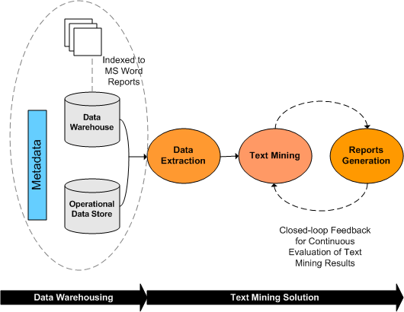
Figure 2.1: Text Mining

Typical text mining tasks include text categorization, text clustering, concept/entity extraction, production of granular taxonomies, sentiment analysis, document summarization, and entity relation modeling (i.e., learning relations between named entities).
TEXT MINING = NATURAL LANGUAGE PROCESSING
+
INFORMATION EXTRACTION
Labour-intensive manual text-mining approaches first surfaced in the mid-1980s, but technological advances have enabled the field to advance swiftly during the past decade. Text mining is an interdisciplinary field which draws on information retrieval, data mining, machine learning, statistics, and computational linguistics. As most information (over 80%) is currently stored as text, text mining is believed to have a high commercial potential value. Increasing interest is being paid to multilingual data mining: the ability to gain information across languages and cluster similar items from different linguistic sources according to their meaning.
The difference between regular data mining and text mining is that in text mining the patterns are extracted from natural language text rather than from structured databases of facts. Many researchers think it will require a full simulation of how the mind works before we can write programs that read the way people do.
2.2 What Is Ambiguity?

Ambiguity means the capability of being understood in two or more possible senses or ways. Ambiguity gives natural language its flexibility and usability, and consequently, it can not be entirely eliminated from the natural language.
Identification of ambiguous words and phases is a crucial aspect in text processing applications. It can be classified in to many different types and using various different classification schemes. In computer science, a grammar is said to be an ambiguous grammar if there is some string that it can generate in more than one way (i.e., the string has more than one parse tree or more than one leftmost derivation). A language is inherently ambiguous if it can only be generated by ambiguous grammars. The most widely used classification is probably the one which divides the ambiguity in to lexical ambiguity, syntactic ambiguity, semantic ambiguity, and pragmatic ambiguity.

2.2.1 Lexical Ambiguity of a word or phrase consists in its having more than one meaning in the language to which the word belongs. "Meaning" hereby refers to whatever should be captured by a good dictionary.
For instance, the word “bank” has several distinct lexical definitions, including “financial institution” and “edge of a river”.Ambiguity in entity extraction or named entity relation extraction is a problem of lexical ambiguity.

2.2.2 Syntactic Ambiguity arises when a complex phrase or a sentence can be parsed in more than one way. “He ate the cookies on the couch,” for example, could mean that he ate those cookies which were on the couch (as opposed to those that were on the table), or it could mean that he was sitting on the couch when he ate the cookies.

2.2.3 Semantic Ambiguity arises when a word or concept has an inherently diffuse meaning based on widespread or informal usage. This is often the case, for example, with idiomatic expressions whose definitions are rarely or never well-defined, and are presented in the context of a larger argument that invites a conclusion.

For example, “You could do with a new automobile. How about a test drive? ” The clause “You could do with” presents a statement with such wide possible interpretation as to be essentially meaningless. Lexical ambiguity is contrasted with semantic ambiguity. The former represents a choice between a finite number of known and meaningful context-dependent interpretations. The latter represents a choice between any number of possible interpretations, none of which may have a standard agreed-upon meaning. This form of ambiguity is closely related to vagueness.

Lexical ambiguity occurs when a word may have more than one interpretation “it is difficult to find word that has only one meaning and an isolated sentence separated from its context, is more often that, not ambiguous” . Let us consider the following sentence:

[1] (a) I put chicken in the pen.
(b) I put ink cartridge in the pen.
[2] (a) She runs the company.
(b) She runs the marathon.
[3] (a) She prepares dishes for dinner.
(b) She washes dishes for dinner.
[4] (a) The hunter holds the bat with his hand.
(b) The man holds the bat with his hand.
Although the sentences in the examples are short and easy to be interpreted by human, it is difficult enough for system to interpret the exact meaning of the given words as each words may have many possible meanings. The words pen, dishes, bat, and runs can be interpreted into a different meaning in a different context. A human interpretation is usually context based interpretation. Thus knowledge about the system should be presented to a system to enable the system attaches accurate semantics to the given words. Not all ambiguities can be easily identified some of them require deep linguistic analysis [3].

Chapter 3
Possibility Theory and Fuzzy Set

3.1 Possibility Theory

Possibility theory is a mathematical theory for dealing with certain types of uncertainty and is an alternative to probability theory. Professor Lotfi Zadeh first introduced possibility theory in 1978 as an extension of his theory of fuzzy sets and fuzzy logic.
For simplicity, assume that the universe of discourse Ω is a finite set, and assume that all subsets are measurable. A distribution of possibility is a function from Ω to [0, 1] such that:
Axiom 1:
Axiom 2:
Axiom 3: for any disjoint subsets U and V.
It follows that, like probability, the possibility measure on finite set is determined by its behavior on singletons:
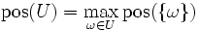
provided U is finite or countable infinite.
Axiom 1 can be interpreted as the assumption that Ω is an exhaustive description of future states of the world, because it means that no belief weight is given to elements outside Ω.
Axiom 2 could be interpreted as the assumption that the evidence from which was constructed is free of any contradiction. Technically, it implies that there is at least one element in Ω with possibility 1.
Axiom 3 corresponds to the additivity axiom in probabilities. However there is an important practical difference. Possibility theory is computationally more convenient because Axioms 1-3 imply that:
for any subsets U and V.
Because one can know the possibility of the union from the possibility of each component, it can be said that possibility is compositional with respect to the union operator. Note however that it is not compositional with respect to the intersection operator. Generally:

Possibility theory as an imprecise probability theory:
There is an extensive formal correspondence between probability and possibility theories, where the addition operator corresponds to the maximum operator.
A possibility measure can be seen as a consonant plausibility measure in Dempster–Shafer theory of evidence. The operators of possibility theory can be seen as a hyper-cautious version of the operators of the transferable belief model, a modern development of the theory of evidence.
Possibility can be seen as an upper probability: any possibility distribution defines a unique set of admissible probability distributions by
This allows one to study possibility theory using the tools of imprecise probabilities.
3.2 Fuzzy sets:

Fuzzy sets are sets whose elements have degrees of membership. Fuzzy sets have been introduced by Lotfi A. Zadeh (1965) as an extension of the classical notion of set. In classical set theory, the membership of elements in a set is assessed in binary terms according to a bivalent condition — an element either belongs or does not belong to the set. By contrast, fuzzy set theory permits the gradual assessment of the membership of elements in a set; this is described with the aid of a membership function valued in the real unit interval [0, 1]. Fuzzy sets generalize classical sets, since the indicator functions of classical sets are special cases of the membership functions of fuzzy sets, if the latter only take values 0 or 1. Classical bivalent sets are in fuzzy set theory usually called crisp sets.
The notion central to fuzzy systems is that truth values (in fuzzy logic) or membership values (in fuzzy sets) are indicated by a value on the range [0.0, 1.0], with 0.0 representing absolute Falseness and 1.0 representing absolute Truth. For example, let us take the statement:
"Jane is old."
If Jane's age was 75, we might assign the statement the truth value of 0.80. The statement could be translated into set terminology as follows:
"Jane is a member of the set of old people."
This statement would be rendered symbolically with fuzzy sets as:

mOLD(Jane) = 0.80
where m is the membership function, operating in this case on the fuzzy set of old people, which returns a value between 0.0 and 1.0.
At this juncture it is important to point out the distinction between fuzzy systems and probability. Both operate over the same numeric range, and at first glance both have similar values: 0.0 representing False (or non-membership), and 1.0 representing True (or membership). However, there is a distinction to be made between the two statements: The probabilistic approach yields the natural-language statement, "There is an 80% chance that Jane is old," while the fuzzy terminology corresponds to "Jane's degree of membership within the set of old people is 0.80." The semantic difference is significant: the first view supposes that Jane is or is not old (still caught in the Law of the Excluded Middle); it is just that we only have an 80% chance of knowing Šwhich set she is in. By contrast, fuzzy terminology supposes that Jane is "more or less" old, or some other term corresponding to the value of 0.80. Further distinctions arising out of the operations will be noted below.
The next step in establishing a complete system of fuzzy logic is to define the operations of EMPTY, EQUAL, COMPLEMENT (NOT), CONTAINMENT, UNION (OR), and INTERSECTION (AND). Before we can do this rigorously, we must state some formal definitions:
Definition 1: Let X be some set of objects, with elements noted as x. Thus, X = {x}.
Definition 2: A fuzzy set A in X is characterized by a membership function mA(x) which maps each point in X onto the real interval [0.0, 1.0]. As mA(x) approaches 1.0, the "grade of membership" of x in A increases.
Definition 3: A is EMPTY iff for all x, mA(x) = 0.0.
Definition 4: A = B iff for all x: mA(x) = mB(x) [or, mA = mB].
Definition 5: mA' = 1 - mA.
Definition 6: A is CONTAINED in B iff mA <= mB.
Definition 7: C = A UNION B, where: mC(x) = MAX(mA(x), mB(x)).
Definition 8: C = A INTERSECTION B where: mC(x) = MIN(mA(x), mB(x)).
It is important to note the last two operations, UNION (OR) and INTERSECTION (AND), which represent the clearest point of departure from a probabilistic theory for sets to fuzzy sets. Operationally, the differences are as follows:
For independent events, the probabilistic operation for AND is multiplication, which (it can be argued) is counterintuitive for fuzzy systems. For example, let us presume that x = Bob, S is the fuzzy set of smart people, and T is the fuzzy set of tall people. Then, if mS(x) = 0.90 and uT(x) = 0.90, the probabilistic result would be:
mS(x) * mT(x) = 0.81
whereas the fuzzy result would be:
MIN(uS(x), uT(x)) = 0.90
The probabilistic calculation yields a result that is lower than either of the two initial values, which when viewed as "the chance of knowing" makes good sense.
However, in fuzzy terms the two membership functions would read something like "Bob is very smart" and "Bob is very tall." If we presume for the sake of argument that "very" is a stronger term than "quite," and that we would correlate "quite" with the value 0.81, then the semantic difference becomes obvious. The probabilistic calculation would yield the statement If Bob is very smart, and Bob is very tall, then Bob is a quite tall, smart person. The fuzzy calculation, however, would yield If Bob is very smart, and Bob is very tall, then Bob is a very tall, smart person.
Another problem arises as we incorporate more factors into our equations (such as the fuzzy set of heavy people, etc.). We find that the ultimate result of a series of AND's approaches 0.0, even if all factors are initially high. Fuzzy theorists argue that this is wrong: that five factors of the value 0.90 (let us say, "very") AND'ed together, should yield a value of 0.90 (again, "very"), not 0.59 (perhaps equivalent to "somewhat").
Similarly, the probabilistic version of A OR B is (A+B - A*B), which approaches 1.0 as additional factors are considered. Fuzzy theorists argue that a sting of low membership grades should not produce a high membership grade instead, the limit of the resulting membership grade should be the strongest membership value in the collection.
What fuzzy logic does propose is to establish a formal method of operating on these values, once the primitives have been established.
3.3 Applying possibility theory and fuzzy sets on lexical semantics

Fuzzy set F is equivalent to giving reference set Ω into [0,1], the unit interval. F is a subset of Ω. μ _{F} (w), for w ε Ω, μ is interpreted as the degree of membership w is compatible with concept F.

The possibility distribution function measures possibilities for a variable w to take a specific value. Fuzzy set F is then seen as a possibility distribution which express the preference for possible values of poorly known variable w. resolving lexical ambiguity is part of selecting the most possible meaning /semantic for a word from a set of predefine possibilities. Most words have many possibilities meanings. By having knowledge about the context, the possibility distribution function may help us to find the most possible meaning for a word.

We denote Ω as a set of lexical or word (we use lexical and word interchangeably), Fc denote fuzzy set of Ω with subject to the context (c). Variable x is a lexical may be restricted by fuzzy set Fc. We denote such restriction as ∏(x, Fc ), and call Fc the restricting fuzzy set of x. The possibility distribution function, ∏^{x}_{Fc} (μ) denotes the possibility for x to take μ under restriction of Fc. Numerically, the distribution function x restriction of Fc is defined to be equal to the membership function of Fc. That is

∏^{x}_{Fc} (μ) = μ _{Fc} (x) …………….. V μ ε Ω (1)

Now we consider the lexical semantics of a word ‘pen’. Based on WordNet the lexical pen, has five semantics; which can be written as

Pen = { A writing implement with a point from which ink flows ,
An enclosure for confining livestock,
A portable enclosure in which babies may be left to play,
A correctional institution for those convicted of major crime ,
Female swan }

If pen is x , then lexical semantics of x can be formalized as
X =(m_{i}, m_{i+1}………….mj) …………….. (2)

Where m_{i} is the first semantic, and mj is the last semantic and its membership function (from equ(1)) is

μ _{Fc} (x) = (v_{i}, v_{i+1},………vj)…………… (3)

where v is a plausibility value, and is context dependent , and is context dependent . when x is applied in different context , v may take different values. The most plausible value (P) of (x) is obtained by using maximum (max) operator. Thus
P = (max (v_{i}, v_{i+1},………vj)) ………….. (4)

Once P is obtained, the most possible semantic can be attached to x. In this way, the lexical ambiguity is resolved, consequently, the system is able to give the most accurate meaning or semantic of a given word.

Chapter 4
Architecture

The software architecture of a program or computing system is the structure or structures of the system, which comprise software components, the externally visible properties of those components, and the relationships between them. The term also refers to documentation of a system's software architecture. Documenting software architecture facilitates communication between stakeholders, documents early decisions about high-level design, and allows reuse of design components and patterns between projects
Sentence Segmentation

Sentence
Syntactic Processing
(NLP)

Ambiguous Structure

Semantic Processing
(NLP + FUZZY)

Unambiguous Structure
Fact Uncertainty

Context Based Fact Disambiguation processing

(Fuzzy + Context Knowledge Based)

Unambiguous and certain fact
Unambiguous Fact

Figure 4.1: Flow of Process
Block diagram is a diagram of a system, in which the principal parts or functions are represented by blocks connected by lines, that show the relationships of the blocks. They are heavily used in the engineering world in hardware design, software design, and process flow diagrams.
PARSE TREE
WORDNET
MEANING
FUZZY SET & POSSIBILITY THEORY
SYNSET
NOUN EXTRACTED
PARSER
TAGGED DOCUMENT
TAG DOC
TAGGER
SENTENCE
Figure 4.2: Block Diagram For Removal Of Lexical Ambiguity

The block diagram is typically used for a higher level, less detailed description aimed more at understanding the overall concepts and less at understanding the details of implementation. Contrast this with the schematic diagram and layout diagram used in the electrical engineering world, where the schematic diagram shows the details of each electrical component and the layout diagram shows the details of physical construction.
Context Diagram: System Context Diagram are diagrams used in systems design to represent all external entities that may interact with a system. This diagram pictures the system at the center, with no details of its interior structure, surrounded by all its interacting systems, environment and activities. The objective of a system context diagram is to focus attention on external factors and events that should be considered in developing a complete set of system requirements and constraints

CORRECT MEANING OF WORD
USER
PARSER
TAGGER
WORDNET
USER
POSSIBELITY THEORY
SOURCE

figure – 4.3

System context diagrams are related to Data Flow Diagram, and show the interactions between a system and other actors with which the system is designed to interface. System context diagrams can be helpful in understanding the context which the system will be part of.
class diagram:

In software engineering, a class diagram in the Unified Modeling Language (UML), is a type of static structure diagram that describes the structure of a system by showing the system's classes, their attributes, and the relationships between the classes.
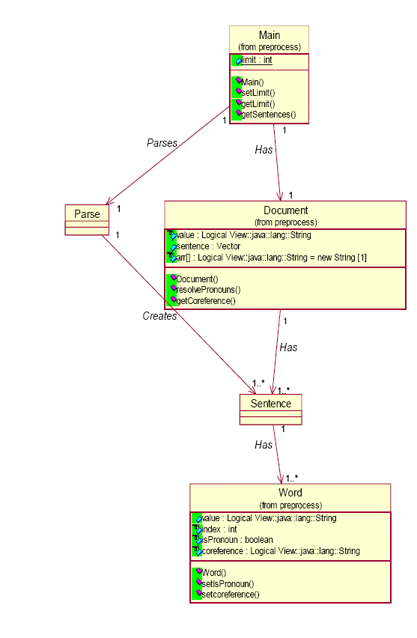
figure-4.4

3.3 sequence diagram:

A sequence diagram shows, as parallel vertical lines ("lifelines"), different processes or objects that live simultaneously, and, as horizontal arrows, the messages exchanged between them, in the order in which they occur. This allows the specification of simple runtime scenarios in a graphical manner.

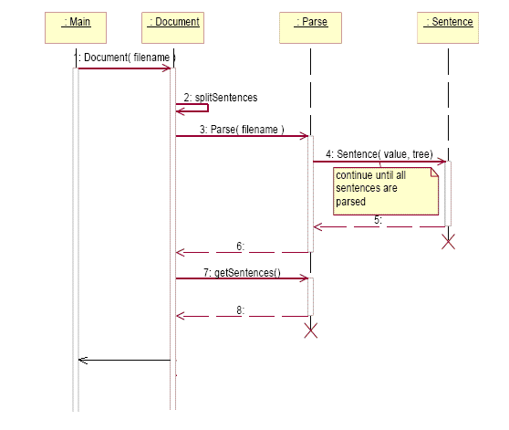

FIGURE 4.5

Some systems have simple dynamic behavior that can be expressed in terms of specific sequences of messages between a small, fixed number of objects or processes. In such cases sequence diagrams can completely specify the system's behavior. Often, behavior is more complex, in such cases, sequence diagrams cannot completely describe the system's behavior, but they can specify typical use cases for the system, small details in its behavior, and simplified overviews of its behavior.

Chapter 5
Text Processing

5.1 Natural language processing (NLP) is a field of computer science and linguistics concerned with the interactions between computers and human (natural) languages. Natural language generation systems convert information from computer databases into readable human language. Natural language understanding systems convert samples of human language into more formal representations such as parse trees or first order logic that are easier for computer programs to manipulate. Many problems within NLP apply to both generation and understanding; for example, a computer must be able to model morphology (the structure of words) in order to understand an English sentence, and a model of morphology is also needed for producing a grammatically correct English sentence.
NLP has significant overlap with the field of computational linguistics, and is often considered a sub-field of artificial intelligence. The term natural language is used to distinguish human languages (such as Spanish, Swahili or Swedish) from formal or computer languages (such as C++, Java or LISP). Although NLP may encompass both text and speech, work on speech processing has evolved into a separate field.
Natural-language processing is a very attractive method of human-computer interaction. Early systems such as SHRDLU, working in restricted "blocks worlds" with restricted vocabularies, worked extremely well, leading researchers to excessive optimism, which was soon lost when the systems were extended to more realistic situations with real-world ambiguity and complexity.

Natural-language understanding is sometimes referred to as an AI-complete problem, because natural-language recognition seems to require extensive knowledge about the outside world and the ability to manipulate it. The definition of "understanding" is one of the major problems in natural-language processing.
In resolving lexical ambiguity, two major steps in natural language understanding are involved; syntactic and semantic analysis.

5.1.1 Syntactic Analysis:
The purpose of syntactic analysis is to identify the part of speech of word and a structure of given sentences. As an example how a syntactic analysis can assign the word “pen” to a part-of-speech noun category. The major process in syntactic analysis is sentence parsing. During parsing processing, a sentence is broken down into phrases and subphrases until an actual grammar structure of a sentence is recognized. This process requires a natural language grammar and a lexicon. Grammar (G) is a formal specification of the structure allowable in the language used and is represented as
G = ( V_{N} , V_{T} , P , S )
Where G represents natural language grammar, V_{N} denotes a set of non terminal symbols, V_{T} a set of terminal symbols, P is a set of production rules, and S represents a sentence.
S
NOUN PHRASE

PRONOUN VERB PHRASE

VERB PREPOSITION PHRASE
NOUN PHRASE

NOUN PREP NOUN PHRASE

ARTICLE NOUN

I PUT CHICKENS IN THE PEN

a parse tree of a sentence ‘I put chickens in the pen’
figure: 5.1
A non terminal is a symbol that does not appear in an input string but is defined in G. example of V_{N} are NP (noun phrase), VP (verb phrase), PP (preposition phase), and so on.
Source String
Tokens

Parse Tree
Output

PARSER
Lexical Analysis
(Create Tokens)
Syntactic Analysis
(Create Tree)
Compiler Interpreter or Translator

FIGURE 5.2 : WORKING OF PARSER
A terminal symbol is a symbol that represents a class of primitive symbols in input strings; it represents a class of primitive symbols in input strings; it represents a part-of-speech symbol. Example of terminal symbols are Verb, Noun, Preposition (prep), Adverb, Adjective, Article (Determiner), Conjunction and Interjection. However, in this work, our grammar rules do not include conjunction and interjection yet.
A production rule can be formalized as a →b, where a is a non terminal symbol, and b represents a non terminal or terminal symbol.
When a sentence is successfully parsed, a structure so called a parse tree which represents an actual structure of a sentence generated. As an example, a parse tree of a sentence ‘I put chickens in the pen’ is illustrated in FIGURE: 7. During the parsing processing process, the word “pen” is ambiguous to the system as it has multiple semantics.
5.1.2 Semantic Analysis:
Parsing only verifies that the program consists of tokens arranged in a syntactically valid combination .But in semantic analysis, where we delve even deeper to check whether they form a sensible set of instructions in the programming language. Whereas any old noun phrase followed by some verb phrase makes a syntactically correct English sentence, a semantically correct one has subject-verb agreement, proper use of gender, and the components go together to express an idea that makes sense. For a program to be semantically valid, all variables, functions, classes, etc. must be properly defined, expressions and variables must be used in ways that respect the type system, access control must be respected, and so forth. Semantic analysis is the front end’s penultimate phase and the compiler’s last chance to weed out incorrect programs.

A large part of semantic analysis consists of tracking variable/function/type declarations and type checking. In many languages, identifiers have to be declared before they’re used. As the compiler encounters a new declaration, it records the type information assigned to that identifier. Then, as it continues examining the rest of the program, it verifies that the type of an identifier is respected in terms of the operations being performed. For example, the type of the right side expression of an assignment statement should match the type of the left side, and the left side needs to be a properly declared and assignable identifier. The parameters of a function should match the arguments of a function call in both number and type. The language may require that identifiers be unique, thereby forbidding two global declarations from sharing the same name. Arithmetic operands will need to be of numeric—perhaps even the exact same type (no automatic int-to-double conversion, for instance). These are examples of the things checked in the semantic analysis phase.

Some semantic analysis might be done right in the middle of parsing. As a particular construct is recognized, say an addition expression, the parser action could check the two operands and verify they are of numeric type and compatible for this operation. In fact, in a one-pass compiler, the code is generated right then and there as well. In a compiler that runs in more than one pass (such as the one we are building for Decaf), the first pass digests the syntax and builds a parse tree representation of the program. A second pass traverses the tree to verify that the program respects all semantic rules as well. The single-pass strategy is typically more efficient, but multiple passes allow for better modularity and flexibility (i.e., can often order things arbitrarily in the source program).

semantic analysis is a process of converting a parse tree into a semantic representation that is precise and unambiguous. Semantic processing can be conducted in two steps: context independent interpretation, and context dependent interpretation. Context independence interpretation concerns with the meaning of words in a sentence without considering in what context a word are applied to.
Context dependent interpretation concerns how context affects the interpretation of the sentence. The context of the sentence includes the situation, in which sentence is used, the immediately preceding sentence and so on.
Semantic processing is conducted by using semantic attachment technique [2]. In semantic attachment, each grammar rule is attached with semantic expression:
A → a1,a2,a3,……,an {a1.sem,…………..,an.sem} ………….. (5)

Where the expression in {} is the semantic attachment, ai.sem is the semantics of the I constituent in a grammar rule, and { is a function that constructs the semantics of A out of the semantics of the constituents on the right hand side if the grammar rule. The semantics for constituents are represented using λ expressions. Basically an important operation in the semantic attachment is the replacement of the variable by the constant that have been evaluated. A constant refers to a specific object such as “pen”. Syntactically the general form of λ expression is
λ x P(x) ……………………… …………... (6)
Where P is a predicate containing one or more variables x, informally semantic attachment to the grammar rule can be formalized as
λ→a1a,2,……,an{ λx1, λx2, ……..λxn P(x1,x2,……,xn)}……… (7)

Now possibility theory can be implemented.

Chapter 6
Implementation of possibility theory

To apply possibility approach to the technique, a fuzzy semantics database is created. The fuzzy semantics database is a table ∏ with three elements, ∏{x[sem_{i,i+1,….j} v _{i,i+1,………,j}]},where sem is semantic and v is in a range of (0,1] based on the context. The values are generated manually by using common sense. Literally, an example of fuzzy semantic database is presented in table 1.

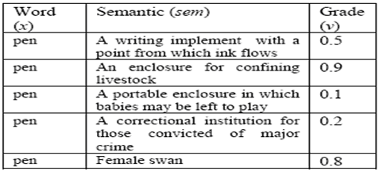

Table :6.1 Fuzzy Semantic Database for “livestock” context

In the “livestock” context a possibility of a word “pen” to have a semantic of “an enclosure for confining livestock” is 0.9 and “female swan” is 0.8. It is very unlikely for the pen to be “a portable enclosure in which babies may be left to play” , thus the possibility value is 0.1.
If the given context is “baby”, its possibility value might be 0.9.

In this project I have stored the data in Microsoft Office Access for each lexical in the following form and assign the grade according to the context. As illustrated in table 6.2 below this data base is created for PEN and meaning for different context is collected through WordNet 2.1. Here table is created for context WRITE.

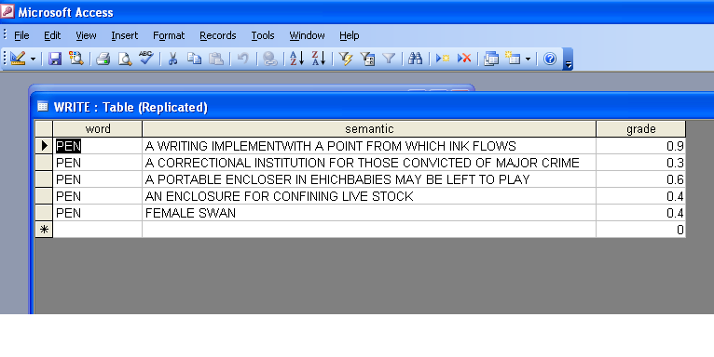
Table:6.2 Fuzzy Semantic Database for “ Write ” context

PORGRAM IS GIVEN TO EXTRACT THE EXACT SEMENTICS -

import java.sql.*;

public class Text
{
public static void main(String args[])
{
Connection con=null;
Statement stmt;
ResultSet rs=null;
try{
Class.forName("sun.jdbc.odbc.JdbcOdbcDriver");
}
catch(Exception e){System.out.println("forName");}
try{
con=DriverManager.getConnection("jdbc:odbc:Test");
stmt=con.createStatement();

rs=stmt.executeQuery("select SEMANTIC from LIVESTOCK
where GRADE =select MAX(GRADE)from LIVESTOCK");
while(rs.next())
{
System.out.print(rs.getString("Semantic"));
}
}
catch(Exception e)
{
System.out.println("Connection");
}
finally
{
try{
con.close();
}
catch(Exception ae)
{
System.out.println("con close");
}
}

}
}

To resolve an ambiguous word “pen” for the parse tree in figure 5.1 the most plausible value(P) is calculated using max operator. Based on the example given in table 6.1 (or figure 6.2) the P is obtained by simply replacing v in equation (4) with a real value using fuzzy semantic database in table 6.1, P is equal to 0.9. Thus the word “word” pen is interpreted as “an enclosure for confining livestock”. When the most plausible semantic is identified, the semantic attachment is conducted.

Chapter 7
Hardware and Software Requirement

TABLE 7.1
COMPONENT | MINIMUM REQUIRED | RECOMMENDED
Operating system | any operating system supporting JAVA run time environment | Windows Xp service pack2 SuSE 9 or higher
Platform | JavaTM2 run time environment, version 1.5 update 3 or higher. Perl (preferably active Perl 5.8) | Java TM2 run time environment, version 1.5 update 3 or higher. Perl (preferably active Perl 5.8)
Processor | A 1.5 gigahertz (MHz) processor, such as an Intel Pentium IV or Advanced Micro Devices (AMD) processor | A 2.4 gigahertz (MHz) processor or faster
RAM | 256 MB | 512 MB or higher
Free hard disk space | 100 MB | 100 MB
MONITOR | Super VGA (800 x 600) resolution | Same as required configuration or higher resolution.
Other Packages | Word Net | Same as required package

Chapter 8
Item Description

The GUI of PARSER is shown below. In the menu bar there are options for loading file and loading parser. In the lower panel the status of parser is shown (loaded or not).

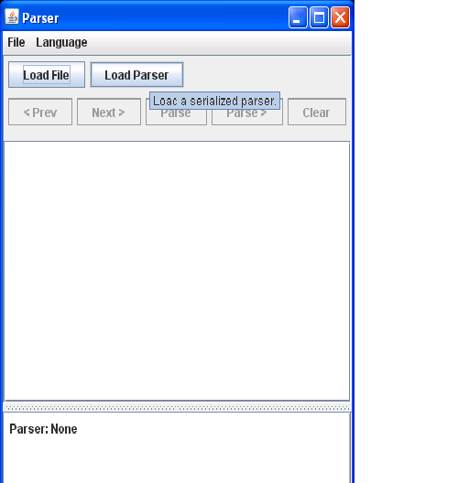

figure 8.1

When we load the parser (English PCGF) from the directory , window look like as follows.

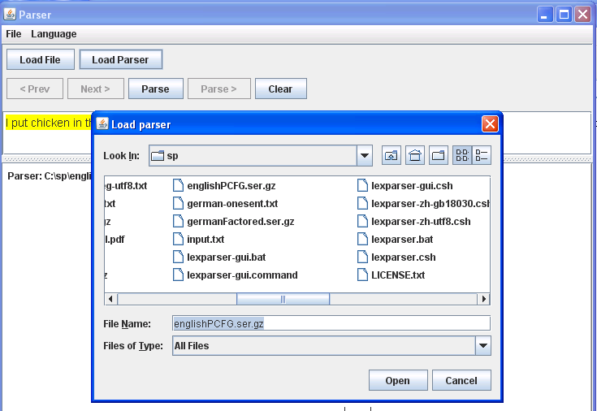

figure 8.2

SAMPLE CODE FOR PARSER

import java.util.*;
import edu.stanford.nlp.trees.*;
import edu.stanford.nlp.parser.lexparser.LexicalizedParser;

class ParserDemo {
public static void main(String[] args) {
LexicalizedParser lp = new LexicalizedParser("englishPCFG.ser.gz");
lp.setOptionFlags(new String[]{"-maxLength", "80", "-retainTmpSubcategories"});

String[] sent = { "This", "is", "an", "easy", "sentence", "." };
Tree parse = (Tree) lp.apply(Arrays.asList(sent));
parse.pennPrint();
System.out.println();

TreebankLanguagePack tlp = new PennTreebankLanguagePack();
GrammaticalStructureFactory gsf = tlp.grammaticalStructureFactory();
GrammaticalStructure gs = gsf.newGrammaticalStructure(parse);
Collection tdl = gs.typedDependenciesCollapsed();
System.out.println(tdl);
System.out.println();

TreePrint tp = new TreePrint("penn,typedDependenciesCollapsed");
tp.printTree(parse);
}
}

A simple example for a parsing, when file and parser both are loaded. The whole sentence is taken as ROOT and then divided in to noun phrase NP and verb phrase VP and so on division is continue till whole sentence is parsed according to grammar rule. Status bar (Done) shows that parsing is complete for the sentence.

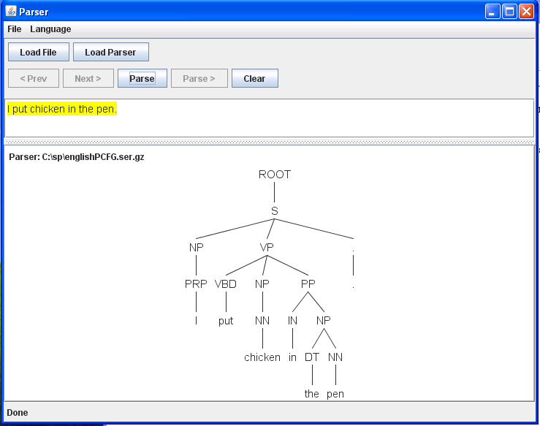

figure 8.3

maximum entrpy part of speech tagger

A Part-Of-Speech Tagger (POS Tagger) is a piece of software that reads text in some language and assigns parts of speech to each word (and other tokens), such as noun, verb, adjective, etc. Generally computational applications use more fine-grained POS tags like 'noun-plural'. This software is a Java implementation of the log-linear part-of-speech (POS) taggers, Enriching the Knowledge Sources Used in a Maximum Entropy Part-of-Speech Tagger.

import java.util.List;
import java.io.BufferedReader;
import java.io.FileReader;
import edu.stanford.nlp.ling.Sentence;
import edu.stanford.nlp.ling.TaggedWord;
import edu.stanford.nlp.ling.HasWord;
import edu.stanford.nlp.tagger.maxent.MaxentTagger;
class TaggerDemo {
public static void main(String[] args) throws Exception {
if (args.length != 2) {
System.err.println("usage: java TaggerDemo modelFile fileToTag");
return;
}
MaxentTagger tagger = new MaxentTagger(args[0]);
@SuppressWarnings("unchecked")
List<Sentence<? extends HasWord>> sentences = MaxentTagger.tokenizeText(new BufferedReader(new FileReader(args[1])));
for (Sentence<? extends HasWord> sentence : sentences) {
Sentence<TaggedWord> tSentence = MaxentTagger.tagSentence(sentence);
System.out.println(tSentence.toString(false));
}
}}
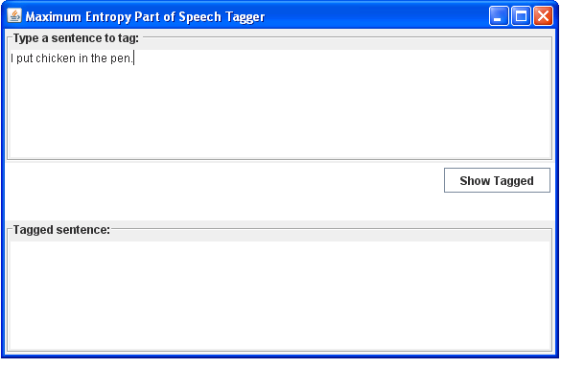
figure 8.4

we can type that sentence in the upper panel which we want to tag then press the show tagged button and the tagged out put comes as follows. Tagged output comes in the lower panel.

figure 8.5
For example:
INPUT: I put chicken in the pen.
OUTPUT: I/PRB put/VBD chicken/NN in/IN the/DT pen./NN

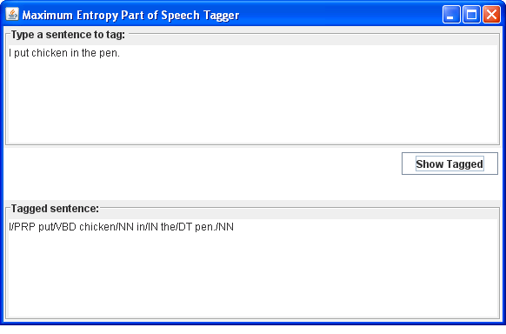

figure 8.6

wordnet:

WordNet is a lexical database for the English language. It groups English words into sets of synonyms called synsets, provides short, general definitions, and records the various semantic relations between these synonym sets. The purpose is twofold: to produce a combination of dictionary and thesaurus that is more intuitively usable, and to support automatic text analysis and artificial intelligence applications. The database and software tools have been released under a BSD style license and can be downloaded and used freely. The database can also be browsed online

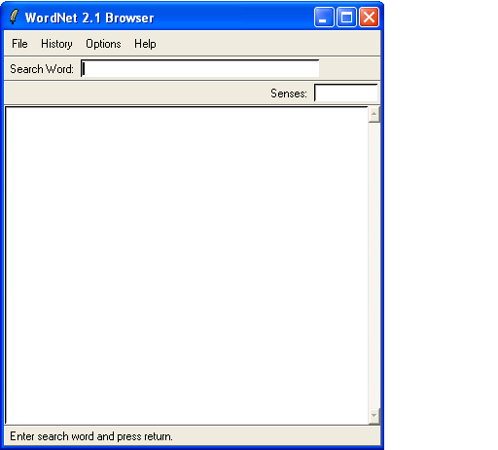

figure 8.7 an example out put for pen by wordnet

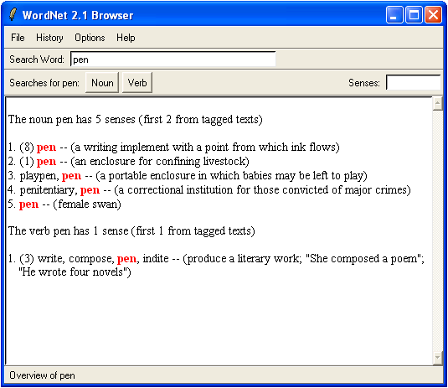

FIGURE 8.8

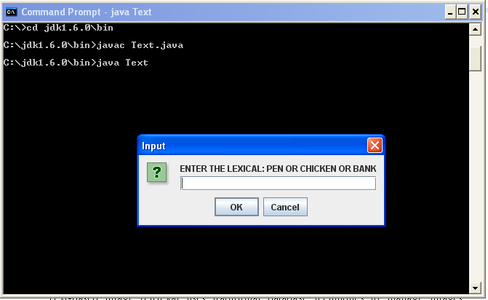
FIGURE 8.9

We need to enter the lexical for that we want to remove ambiguity. Like here we take example of PEN , Then the following window will appear.

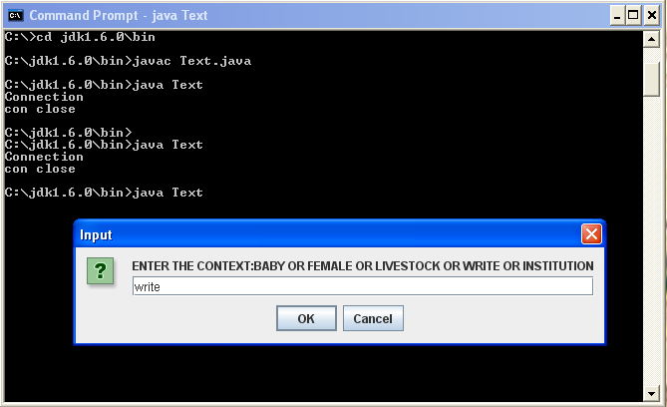
FIGURE 8.10

In the text box we can enter the context in which pen is used like here option available are baby, female, livestock write and institution. Here we have taken write for example and exact meaning of pen is displayed on the screen.

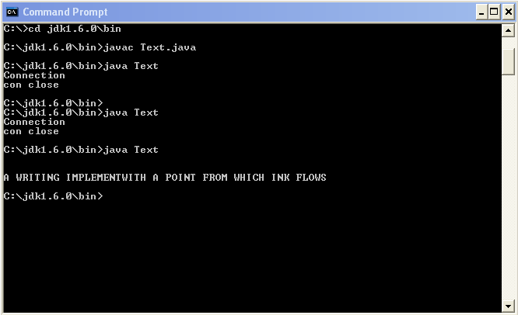
FIGURE 8.11

Chapter 9
Conclusion and Future Work

In implementing the proposed technique, WordNet is used as a reference in building a fuzzy semantic database.
As the grammar itself is also ambiguous, this has caused syntactic ambiguity, consequently semantic ambiguity. When parsing process is conducted, more than one parse tree is generated. At this moment we ignore the problem as our technique focus on resolving lexical ambiguity based on the identified context. Furthermore, the syntactic ambiguity does not give impact on the lexical ambiguity. In this work, the context is predefined, and the possibility value is generated manually.

In the future, we are looking at identifying context based on a sentence and preceding sentences, and generate possibility values dynamically. The implementation work has been conducted in JAVA language on WINDOWS Operating System.

As a summary, this work has introduced a new technique of resolving a lexical ambiguity.
The technique is based on possibility and fuzzy set theories, and knowledge about the context. Human common sense is applied to the technique. This paper reports a part of our on going research in ambiguity for text mining.

10. references:

[1] F. Wang, Handling Grammatical Errors, Ambiguity and Impreciseness in GIS Natural Language Queries, Transaction in GIS, Vol. 7, No. 1, pp 103-121, 2003.

[2] D.Jurasky and J. H. Martin, Speech and Language Processing, Prentice Hall, United States of America, 2000.

[3] N. Kiyavitskaya, N. Zeni, L. Mich, and D.M. Berry, Requirements for Tools for Ambiguity Identification and Measurement in Natural Language Requirements Specifications, In Proceedings of WER2007- 19th Workshop on Requirements Engineering, Toronto Canada, 17-18 May 2007.

[4] E. Kamsties, Surfacing Ambiguity in Natural Language Requirements, PhD Thesis, Fraunhofer- Institue für Experimentelles Software Engineering, Kaiserslautern, Germany, 2001.

[5] F. Wang, S. Jusoh, and S.X. Yang, A collaborative behaviorbased approach for handling ambiguity, uncertainty, and vagueness in robot natural language interfaces, Engineering Applications of Artificial Intelligence, Vol. 19, No. pp 939-951, 2006.

[6] C. Stokoe, M.P.Oakes, and J. Tait, Word Sense Disambiguation in Information Retrieval Revisited, In SIGIR’03, ACM, Toronto Canada, July 28-August 1, 2003.

[7] F. Janssens, W. Glänzel, and De Moor, Dynamic hybrid clustering of bioinformatics by incorporating text mining and citation analysis. In Proceedings of the 13th ACM SIGKDD international Conference on Knowledge Discovery and Data MiningSan Jose, California,
USA, August 12 - 15, 2007.

[8] G. Grefenstette, Y. Qu, and D. A. Evans, Mining the Web to Create a Language Model for Mapping between English Names and Phrases and Japanese. In Proceedings of the 2004 IEEE/WIC/ACM international Conference on Web intelligence September 20 - 24, 2004.

[9] J.J. García Adeva and J. M Pikatza Atxa, Intrusion detection in web applications using text mining , Enggineering Application
Intelligence ,Vol. 20, No. 4, pp 555-566 , 2007.

