Chapter1

MOTIVATION

The World Wide Web was conceived and designed as an open information space defined by the hyperlink mechanism that linked documents together. The technology enabled anyone to link to any other document from hyperlinks on a published Web page- A page anyone could see, and link to in turn. Open network access enables a potentially infinite resource, for people both to contribute to and use. It offers better utilization of the incredible richness of material on the Web, and in the diversity of ways.

The Web had the twin goals of interactive interoperability and creating an evolvable technology. It had the goal that it should not only be useful for human-to-human communication but also support rich human-machine and machine-machine interaction. The intent was that machines would be able to participate fully and helps in the access and manipulation of this information space as automated agent. The core values in web design follows the principle of universality of access irrespective of hardware or software platform, network in infrastructure language, culture, geographical location or physical or mental impairment.

One of the fundamental obstacles to this vision has been the fact that most information on the Web is designed for human consumption. Even if derived from a database with well defined meaning for its columns, the structure of the data is rarely evident to a robot browsing it. Actually, human do both: first decoding the syntactical representation, then applying built-in semantic rules and context inferences to interpret the meaning of the data. For machines to ‘read’ in this way, they also need semantic rules and inference logic.

To make Web a universal medium for exchange of data. To achieve this goal, existing web content needs to be augmented with data to facilitate its handling by computers, and with documents that are intended solely for computers and software agents.

Semantic Web is an immediate approach to develop languages and codified relationships for expressing information in a machine process able form. The machine must be able to do more than simply decode the data representations on the syntactical level; they must be able to perform logical processing and inference on well-defining meanings of the information token parsed from the data. It is envisioned that the resulting infrastructure, transforming the Web into the Semantic Web, will spur the development of automated Web services to fulfill a wide variety of purposes. Computer will be able to discern the meaning of semantic data by following hyperlinks to term definition and rule sets. Thus armed, they can reason about content logically and make decisions that are relevant to the context and to user expectations.

The concept of a ‘Semantic Web’ supposes a plan for achieving a set of connected application for the Web in such way as to form a consistently readable logical Web of data.
Link
Resource
Resource
Resource
Resource
Resource
Resource
Resource

Link

Link Link Link Link Link Link

Figure 1. Syntactic Web
Has People Has HR Has People Colleagues Human Resources Has People Has Services Has Product
ORGANIZATION
HR
SERVICES
PRODUCT
Product
People
People
Product

Has Product

Has Product

Figure 2. Evolution of the Web: Semantic Web

Chapter 2
BACKGROUND INFORMATION

  - Introduction to World Wide Web

‘The Web’ to consist of a Syntactic, a Semantic, and a Pragmatic web:

- The Syntactic Web: In this first generation of Web technology, a simple markup language (HTML) is used to define content at a high level of detail at a syntactic level that controls the appearance of information. Information producers define content, font selection, layout, and colors. Information consumers have limited control over representations in their browser, including adjusting the size of fonts, and enabling/disabling animations and plug-ins. It consists of interrelated syntactic information resources, such as documents and web pages linked by HTML references. These resources describe many different domains.[1]

- The Semantic Web: It consists of a collection of semantic resources about the Syntactic Web, mainly in the form of ontologies. The ontologies contain semantic networks of concepts, relations, and rules that define the meaning of particular information resources. According to Tim Berners-Lee, the Semantic Web will “radically change the nature of the Web”. The formal nature of representation languages such as the eXtensible Markup Language (XML) and the Resource Description Framework (RDF) make Web-based information readable not only to humans, but also to computers. For instance, semantic-enabled search agents will be able to collect machine-readable data from diverse sources, process it and infer new facts. Unfortunately, the full benefits of the Semantic Web may be years away and will be reached only when a critical mass of semantic information is available. Critics of the Semantic Web point out the enormous undertaking of creating the necessary standardized information ontologies to make information universally processable.

- The Pragmatic Web: In contrast to the Syntactic and Semantic Web the Pragmatic Web is not about form or meaning of information but about how information is used. The Pragmatic Web consists of a set of pragmatic contexts of semantic resources. We consider a pragmatic context to consist of a common context and a set of individual contexts. A common context is defined by the common concepts and conceptual definitions of interest to a community, the communicative interactions in which these concepts are defined and used, and a set of common context parameters (relevant properties of concepts, joint goals, communicative situation, and so on). Each community member also has an individual context, consisting of individual concepts and definitions of interest and individual context parameters.[2]
Figure 3.Concept of Web

  - Introduction to Semantic Web

The Semantic Web initiative has an ambitious Programme to bring existing work on knowledge representation and reasoning to bear on the Web. These concepts were traditionally developed within the Artificial Intelligence community, and this has given the impression that the activity is of largely academic interest. A common misconception is that it is an attempt to bring AI to the Web. However, the Semantic Web has a less ambitious and more immediately realizable goal of making the Web machine processable, making it in practice more like database and information systems management, but extended to the database of the whole Web. The application and potential of this work is enormous. [1]
In the present world, almost our entire work is done on internet. Internet provides a vast number of useful applications. Information retrieval is one of the largest demanded services.
A number of technologies are there in the scenes which are capable enough to make the search possible even from more complex and redundant database. But is it possible to retrieve the information in a manner it should be available? The answer is NO because regarding present scenario, we can make the search on the basis of syntax not on the basis of meaning of the search keyword. So to make the search syntactic, concept of semantic web came into existence. Our aim is to enable the present search engine do the search with more semantics added to it. We can achieve it using concept of Semantic web.
Most of the web’s content today is designed for human to read, not for computer programs to manipulate meaningfully. Computers can adeptly parse web pages for layout and routine processing but computers have no reliable way to process the semantics. Semantic web is now to be implemented to resolve this problem of ordinary search. The main question arises here is that what is semantic web?
The word semantic stands for the meaning of. The semantic of something is the meaning of something. The Semantic Web is a web that is able to describe things in a way that computers can understand.

    - Structure of Semantic Web (Layered Approach)

The semantic Web identifies a set of technologies, tools, and standards which form the basic building blocks of an infrastructure to support the vision of the Web associated with meaning. The semantic Web architecture is composed of a series of standards organized into a certain structure that is an expression of their interrelationships. This architecture is often represented using a diagram first proposed by Tim Berners-Lee (Berners-Lee, Hendler et al. 2001). Figure 4 illustrates the different parts of the semantic Web architecture. It starts with the foundation of URIs and Unicode. On top of that we can find the syntactic interoperability layer in the form of XML, which in turn underlies RDF and RDF Schema (RDFS). Web ontology languages are built on top of RDF(S). The three last layers are the logic, proof, and trust, which have not been significantly explored. Some of the layers rely on the digital signature component to ensure security.
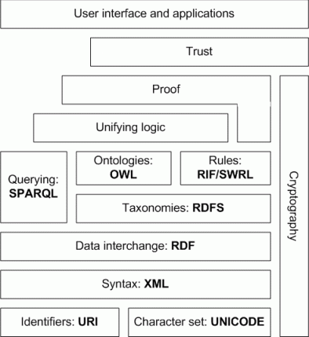
Figure 4.Semantic Web stack
a) URI (Identifiers) and Unicode (Character set)
A Universal Resource Identifier (URI) is a formatted string that serves as a means of identifying abstract or physical resource. A URI can be further classified as a locator, a name, or both. Uniform Resource Locator (URL) refers to the subset of URI that identifies resources via a representation of their primary access mechanism. A Uniform Resource Name (URN) refers to the subset of URI that is required to remain globally unique and persistent even when the resource ceases to exist or becomes unavailable.

Unicode provides a unique number for every character, independently of the underlying platform, program, or language. Before the creation of unicode, there were various different encoding systems. The diverse encoding made the manipulation of data complex. Any given computer needed to support many different encodings. There was always the risk of encoding conflict, since two encodings could use the same number for two different characters, or use different numbers for the same character.

b) XML (Syntax)
XML is accepted as a standard for data interchange on the Web allowing the structuring of data on the Web but without communicating the meaning of the data. It is a language for semi-structured data and has been proposed as a solution for data integration problems, because it allows a flexible coding and display of data, by using metadata to describe the structure of data.
In contrast to HTML, with XML it is possible to create new markup tags, such as <first_name>, which carry some semantics. However, from a computational perspective, a tag like <first_name> is very similar to the HTML tag <h1>. While XML is highly helpful for a syntactic interoperability and integration, it carries as much semantics as HTML. Nevertheless, XML solved many problems which have earlier been impossible to solve using HTML, i.e. data exchange and integration.
While XML has gained much of the world’s attention it is important to recognize that XML is simply a way of standardizing data formats. But from the point of view of semantic interoperability, XML has limitations. One significant aspect is that there is no way to recognize the semantics of a particular domain because XML aims at document structure and imposes no common interpretation of the data. Another problem is that XML has a weak data model incapable of capturing semantics, relationships, or constraints.
While it is possible to extend XML to incorporate rich metadata, XML does not allow for supporting automated interoperability of system without human involvement. Even though XML is simply a data-format standard, it is part of the set of technologies that constitute the foundations of the semantic Web.
c) RDF (Data Interchange)
At the top of XML, the World Wide Web Consortium (W3C) has developed the Resource Description Framework (RDF) language to standardize the definition and use of metadata. Therefore, XML and RDF each have their merits as a foundation for the semantic Web, but RDF provides more suitable mechanisms for developing ontology representation languages like OIL.
RDF uses XML and it is at the base of the semantic Web, so that all the other languages corresponding to the upper layers are built on top of it. RDF is a formal data model for machine understandable metadata used to provide standard descriptions of Web resources. By providing a standard way of referring to metadata elements, specific metadata element names, and actual metadata content, RDF builds standards for XML applications so that they can interoperate and intercommunicate more easily, facilitating data and system integration and interoperability. At first glance it may seem that RDF is very similar to XML, but a closer analysis reveals that they are conceptually different. If we model the information present in a RDF model [10] using XML, human readers would probably be able to infer the underlying semantic structure, but general purpose applications would not.
RDF is a simple general-purpose metadata language for representing information in the Web and provides a model for describing and creating relationships between resources. A resource can be a thing such as a person, a song, or a Web page. With RDF it is possible to add pre-defined modeling primitives for expressing semantics of data to a document without making any assumptions about the structure of the document. RDF defines a resource as any object that is uniquely identifiable by a Uniform Resource Identifier (URI). Resources have properties associated to them. Properties are identified by property-types, and property-types have corresponding values. Property-types express the relationships of values associated with resources. The basic structure of RDF is very simple and basically uses RDF triples in the form of subject, predicate, object.

- subject: a thing identified by its URL
- predicate: the type of metadata, also identified by a URL (also called property)
- object: the value of this type of metadata

Very good examples of real world systems that use RDF are the applications developed under the Mozilla project (Mozilla 2005). Mozilla software applications use various different pieces of structured data, such as bookmarks, file systems, documents, and sitemaps. The creation, access, query, and manipulation code for these resources is completely independent. While the code is completely independent, there is considerable overlap in the data model used by all these different structures. Therefore, Mozilla uses RDF to build a common data model shared by various applications, such as viewers, editors, and query mechanisms.

d) RDF Schema (Taxonomies)
The RDF Schema (RDFS 2004) provides a type system for RDF. The RDFS is technologically advanced compared to RDF since it provides a way of building an object model from which the actual data is referenced and which tells us what things really mean. The RDF Schema (RDFS) allows users to define resources with classes, properties, and values. The concept of RDF class is similar to the concept of class in object-oriented programming languages such as Java and C++. A class is a structure of similar things and inheritance is allowed. This allows resources to be defined as instances of classes, and subclasses of classes. For example, the RDF Schema allows resources to be defined as instances of one or more classes. In addition, it allows classes to be organized in a hierarchical fashion. For example the class First_Line_Manager might be defined as a subclass of Manager which is a subclass of Staff, meaning that any resource which is in class Staff is also implicitly in class First_Line_Manager as well.

An RDFS property can be viewed as an attribute of a class. RDFS properties may inherit from other properties, and domain and range constraints can be applied to focus their use. For example, a domain constraint is used to limit what class or classes a specific property may have and a range constraint is used to limit its possible values. With these extensions, RDFS comes closer to existing ontology languages. RDFS is used to declare vocabularies, the sets of semantics property-types defined by a particular community. As with RDF, the XML namespace mechanism serves to identify RDFS.
The rdfs:Class is similar to the notion of a class in object-oriented programming languages. When a schema defines a new class, the resource representing that class must have an RDF:type property whose value is the resource rdfs:Class. Anything described by RDF expressions is called a resource and is considered to be an instance of the class rdfs:Resource. Other elements of RDFS are illustrated in Figure 9 and described bellow.
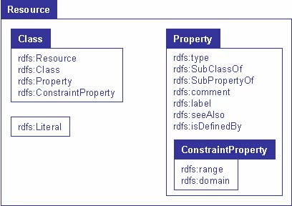
Figure 5. Relationships between the concepts of RDF Schema
- rdfs:Datatype is the class of data types and defines the allowed data types.
- rdfs:Literal is the class of literal values such as strings and integers.
- rdfs:subClassOf is a transitive property that specifies a subset-superset relation
- between classes.
- rdfs:subPropertyOf is an instance of rdf:Property used to specify that one property
- is a specialization of another.
- rdfs:comment is a human-readable description of a resource.
- rdfs:label is a human-readable version of a resource name and it can only be a
- string literal.
rdfs:seeAlso specifies a resource that might provide additional information about
- the subject resource.
- rdfs:isDefinedBy is a subproperty of rdfs:seeAlso and indicates the resource
- defining the subject resource.
- rdfs:member is a super-property of all the container membership properties
- rdfs:range indicates the classes that the values of a property must be members of.
- rdfs:domain indicates the classes on whose member a property can be used.
- rdfs:Container is a collection of resources.
- rdfs:ContainerMemberShipProperty is a class that is used to state that a resource
- is a member of a container.

e) Ontologies (OWL)
An ontology is an agreed vocabulary that provides a set of well-founded constructs to build meaningful higher level knowledge for specifying the semantics of terminology systems in a well defined and unambiguous manner. For a particular domain, an ontology represents a richer language for providing more complex constraints on the types of resources and their properties. Compared to a taxonomy, ontologies enhance the semantics of terms by providing richer relationships between the terms of a vocabulary. Ontologies are usually expressed in a logic-based language, so that detailed and meaningful distinctions can be made among the classes, properties, and relations. Ontologies can be used to increase communication either between humans
and computers. The three major uses of ontologies are:

1. To assist in communication between humans.
2. To achieve interoperability and communication among software systems.
3. To improve the design and the quality of software systems.

In the previous sections, we have established that RDF/S was one of the base models and syntax for the semantic Web. On the top of the RDF/S layer it is possible to define more powerful languages to describe semantics. The most prominent markup language for publishing and sharing data using ontologies on the Internet is the Web Ontology Language . Web Ontology Language (OWL) is a vocabulary extension of RDF and is derived from the DAML+OIL language, with the objective of facilitating a better machine interpretability of Web content than that supported by XML and RDF. OWL adds a layer of expressive power to RDF/S, providing powerful mechanisms for defining complex conceptual structures, and formally describes the semantics of classes and properties used in Web resources using, most commonly, a logical formalism known as Description Logic.

Limitations of RDF/S to identify the extensions that are needed:

- RDF/S cannot express equivalence between properties. This is important to be able to express the equivalence of ontological concepts developed by separate working groups.
- RDF/S does not have the capability of expressing the uniqueness and the cardinality of properties. In some cases, it may be necessary to express that a particular property value may have only one value in a particular class instance.
- RDF/S can express the values of a particular property but cannot express that this is a closed set. For example, an enumeration for the values for the gender of a person should have only two values: male and female.
- RDF/S cannot express disjointedness. For example, the gender of a person can be male or female. While it is possible in RDF/S to express that John is a male and Julie a female, there is no way of saying that John is not a female and Julie is not a male.

f) SPARQL(Query Language)
SPARQL has been designed to meet the requirements and design goals as described in the W3C RDF Data Access Working Group (DAWG) document “RDF Data Access Use Cases and Requirements”.
SPARQL provides functionalities to
• extract information represented as literals, blank nodes, and URIs
• gather RDF subgraphs, and
• build new RDF graphs upon information achieved from the queried graphs.

SPARQL offers many of the basic features desired in an RDF based query language. It provides a subset of operations on plain literals, XSD integers and XSD floats and 26 operators such as comparison of numeric values, functions on string values casting, comparison of duration, time and date values.

g) Logic, Proof and Trust

The purpose of this layer is to provide similar features to the ones that can be found in First Order Logic . The idea is to state any logical principle and allow the computer to reason by inference using these principles. For example, a university may decide that if a student has a GPA higher than 3.8, then he will receive a merit scholarship. A logic program can use this rule to make a simple deduction: “Shyam has a GPA of 3.9, therefore he will be a recipient of a merit scholarship.”
Inference engines, also called reasoners, are software applications that derive new facts or associations from existing information. Inference and inference rules allow for deriving new data from data that is already known. Thus, new pieces of knowledge can be added based on previous ones. By creating a model of the information and relationships, we enable reasoners to draw logical conclusions based on the model. The use of inference engines in the semantic Web allows applications to inquire why a particular conclusion has been reached, i.e. semantic applications can give proof of their conclusions. Proof traces or explains the steps involved in logical reasoning.

    - Ontologies
An ontology is a formal representation of a set of concepts within a domain and the relationships between those concepts. It is used to reason about the properties of that domain, and may be used to define the domain.
Common components of ontologies include:
- Individuals: instances or objects (the basic or "ground level" objects)
- Classes: sets, collections, concepts or types of objects^{[1]}
- Attributes: properties, features, characteristics, or parameters that objects (and classes) can have
- Relations: ways that classes and objects can be related to one another
- Function terms: complex structures formed from certain relations that can be used in place of an individual term in a statement
- Restrictions: formally stated descriptions of what must be true in order for some assertion to be accepted as input
- Rules: statements in the form of an if-then (antecedent-consequent) sentence that describe the logical inferences that can be drawn from an assertion in a particular form
- Axioms: assertions (including rules) in a logical form that together comprise the overall theory that the ontology describes in its domain of application. This definition differs from that of "axioms" in generative grammar and formal logic. In these disciplines, axioms include only statements asserted as a priori knowledge. As used here, "axioms" also include the theory derived from axiomatic statements.
- Events: the changing of attributes or relations

Need for Ontology

Ontology is a description of a domain in terms of entities and relationships that exist between those entities. Ontologies provide a precise understanding of the domain, i.e., they provide an unambiguous and consistent interpretation of the domain in all scenarios. Also ontologies enables web to share knowledge and provide reasoning support, i.e., verification of formalisms and rules (Checking for constraint violations in knowledge shared through the ontology can be automated).

Chapter 3

A Targeted Advertising model for E-Business using Pragmatic Patterns and Semantic web

3.1 Problem Definition

E-Business is creating a marketing revolution. Internet advertising plays a major source of revenue in electronic commerce. Internet advertising is done in two ways: Web advertising and targeted advertising. Web advertising can be viewed as giving advertisements on the websites. Target advertising on the other hand is more focused on delivering appropriate advertisements according to each user’s preference and interests. It can be therefore believed that it will be driving force for the next phase of electronic commerce. The main problem is that amount of product information available to customer is ever increasing. Therefore, there is a need of a system which though target small portion of customer but provides accurate and efficient search to customers based on their need and past preferences.
The thesis intent to propose a conceptual model that utilizes the concept of pragmatic patterns and semantic web for targeted advertising of products. It acts as a broker providing a web service that maximizes precision of advertising by using contextual elements like the community of use, its objectives, communicative interactions etc. In particular, it mediates in meaning negotiation between sellers and prospective buyers by putting ontologies in context using pragmatic patterns matching which results in efficient searching. It then becomes possible to better deal with partial, contradicting, and evolving ontologies.

  - Introduction

    - Internet Advertising

In traditional approach, we perform targeted advertising by manually analyzing a historical database of previous transactions and identify a list of those customers who are most likely to respond to the advertisement of the product.
In new technologies, targeted advertising adopts personalization technologies such as Information filtering and Web mining to determine target users for an advertisement. The purpose of information filtering is to obtain information relevant to users, this enables advertisers to determine target users based on their interests. It consists of two kinds of filtering methods: Content-based filtering and Collaborative filtering. Content based filtering determines relevant information for users by calculating similarity between objects and user profiles. This approach is inappropriate for a product whose content is not electronically available, or is based on subjective factors such as quality, style or point of view. On the other hand, collaborative filtering selects objects according to the recommendation of other users with similar preferences. Whilst this approach has demonstrated usefulness in many applications, it still has a limitation such as an inability to advertise newly introduced products that have yet to be rated by customers. Web mining aims to discover useful information on the web using traditional data mining techniques. The term Web mining has been used in two ways: Web content mining and Web usage mining. Web content mining discovers information from the contents of websites whereas web usage mining obtains useful information by analyzing user’s browsing and access pattern.
Nowadays semantic structures and models are becoming very important in the information technologies field and web applications. So we propose a conceptual model, which is based on Web Mining target advertising model. Web Content Mining discovers information based on pragmatic patterns and individual context ontologies of various sellers or buyers depending on the user and after that Web Usage Mining acts as an intelligent agent analyzing the negotiation, done to match the heterogeneous context ontologies of buyers and sellers and regularly updates the common context ontology and pragmatic pattern for future searches.

    - Pragmatic Web and Semantic Web

The Semantic Web is a Web of actionable information—information derived from data through a semantic theory for interpreting the symbols. Any knowledge item, a document, object, concept or an event of the real world is a resource in Semantic Web. Each resource has a Unique Resource Identifier (URI) enabling universal identification. URI provides the grounding for both our objects and relations. URI have global scope and are interpreted consistently across contexts. Associating a URI with a resource means that anyone can link to it, refer to it, or retrieve a representation of it. These resources are annotated with metadata expressed in Web Ontology Language (OWL) enabling inference and entailment of information. Using a global naming convention provides the global network effects that drive the Web’s benefits. The semantic web’s main aim is to enable information to be shared across the web. But when it comes to practicality and priority of process, interaction between the provider and consumer, the semantic web is unable to capture context oriented processing properly.[2]
The best hope for the semantic web is to encourage the emergence of communities of interest and practices that develop their own consensus knowledge on the basis of which they will standardize their representation [6]. This is well satisfied with Pragmatic web because its main mission is to transform existing information to relevant information of practical consequences. To implement this there should be a communicative system between the provider and consumer of the service and the communication is done on the basis of context. Contextual elements stresses on objectives of the users, their roles, processes involved etc.

3.2.3 Context Complexity: Use of Pragmatic Patterns

When we implement processing on the basis of context, the number of elements to be analyzed increases favorably than if the processing is done on the basis of meaning of those resources. This is because there are many dimensions which should be considered in pragmatic context. It becomes harder to formalize pragmatic context elements as they may use different ontologies to define meaning of a particular concept. Therefore, De Moor explained the usage of Pragmatic patterns to deal with pragmatic complexity [9]. He provided concept of pragmatic constructs that are essential to reach joint objectives. And meaning negotiation between different ontologies is done by balancing individual and common requirements. Patterns are based on ontology and help to allows conflict and heterogeneity in the domain. These conflicts are clarified by intelligent meaning negotiation between pragmatic patterns.

3.3 Target Advertising Model

The target advertising model is based on core pragmatic patterns proposed by De Moor [9]. These patterns are utilized in meaning representation and negotiation.

Various pragmatic pattern and context ontologies used are as follows:

1) Common Context: Common context is composed of complete set of common meaning patterns relevant to the community. It defines common context parameters and common context ontology.

2) Individual Context: Individual context is composed of complete set of meaning patterns relevant to the individual. It defines the individual community members and their individual context ontology.

In our conceptual model, there is a Web service which acts as a broker between sellers and buyers. Each seller and buyer registers to the advertiser with its own individual context ontology and pragmatic pattern which depicts their area of interest and is based on their ontological structure. The Advertiser has its own common context ontology which is based on the common interest shared between the users. As the common ontology keeps on changing with precise requirement of user, it is required to regularly update it. Now if a user comes to find suitable customers for its product or vice versa, it gives a Query reflecting its pragmatic pattern. This query is formalized by query preprocessor into a Pragmatic pattern and then search is made on all the registered individual context patterns which are matching with the registered user’s patterns. The search is based on the roles, communication context also. Firstly, exact matches are searched and information about them is retrieved. As we know heterogeneous ontologies can lead to same meaning, search is made more accurate by using meaning negotiation between closely matching patterns. The requested pattern is also decomposed into sub patterns and then matched with the registered individual context pragmatic patterns. The search is further refined by replacing the terms in Pragmatic Patterns with their synonyms and then matched. After this complete matching procedure, the result is shown to the user. If the agent responsible for common context updation finds a new pattern during the match making, it updates the common context ontology and adds the pattern in the common pragmatic patterns.
So we can view our model as a common platform shared by communities having common interest to advertise their products or requests depending on their role and the required matching is done by the advertiser. Each individual community has their own ontological structure but advertiser acts as middleware between producer and consumer. Advertiser can use a single domain or multiple domains for providing advertising service. As domain size will increase the possible pragmatic patterns will increase, but as context has the information about the domain, information can be managed easily.
QUERY
ANALYSIS/
PROCESSING

COMMON CONTEXT ONTOLOGY/ COMMON PRAGMATIC PATTERN
REPOSITORY

INDIVIUAL CONTEXT ONTOLOGY
&
INDIVIUAL PRAGMATIC PATTERN
ADAPTION PROCESS
FILTERING PROCESS/
MATCH MAKING
ADVERTISEMENT SELECTION PROCESS
USER
USER
BASED ON RESULT
RESULT
BASED ON SEMNATIC WEB AND PRAGMATIC PATTERNS
Fig 6.Overall Target Advertising Model

  - A Practical Scenario for the explanation of working

In a real scenario, there is a site Fashion ADS which a web service that maximizes precision of advertising. In particular, it mediates in meaning negotiation between sellers and prospective buyers by intelligent use of pragmatic pattern matching. The framework is explained using a situation in which there is a company BABYWEARS that manufacture clothes for kids. It wants to advertise in Fashion ADS for promotion of its new collection of frocks for baby girls and exploring new market.

T
Com_Role
CONCEPT
Com_process
Age Limit
Consumer
Inquiry
Material_used
Cost
Max
Min
Seller
Advertise
Object for Sale
Age Group
Fig.7 Fashion ADS community context ontology

A most relevant concept in any clothes advertising process is the Dress. One important property of these objects, which is often discussed in the business negotiations of this particular community, is the age group for the dress being offered and also age limit, which has two important limit indicators, are the min and the max of the age limit. Two communication roles are the seller and the consumer, referring to the parties who can play the speaker or hearer-roles. The community using the Fashion ADS service distinguishes two types of communication processes inquiring about objects for sale, initiated by customers, and advertising objects, initiated by producers.
Babywears own corporate ontology specifying the Frock and age limit concepts. This is imported into the individual context ontology of Babywears for the Fashion ADS service. It also adds the Gender (girl) concept, since that is what he wants to focus his particular potential customer search on. Since the frocks are for baby girls, it adds to his individual context ontology the required pattern that to be of interest for an advertisement girls for whom the frocks are purchased should be in infant age group. The Ritswears is a well-known outlet that provides various dresses of different brands for children.

T
CONCEPT
Frock
Baby
Gender
Age limit
Girl
Boy
Max (2years)

Fig. 8. Individual Context Ontology of Babywears for the Fashion ADS Service.

Frock
Baby
Girl
Age limit(0-2years)

Fig. 9. Required Pattern. This figure shows the pragmatic pattern of Babywears for advertising its product and get potential customers
T
Age Group
Gender
Baby
Teenagers
Girl
Boy
Fig. 10. Individual Context Ontology of Ritswears for the Fashion ADS Service.

Object for Sale
Baby
Girl
Fig. 11. Required Pattern. This figure shows the pragmatic pattern of Ritswears for advertising its requirement to get potential providers

Now when Babywears uses Fashion ADS for getting potential customer, it gives query as shown in figure6.

Frock
Baby
Girl
Age limit (0-2years)
Fig. 12. Query. This figure shows the query that is given by Babywears agent in Fashion ADS search engine to find potential customers for its product.
Then Fashion ADS searches all the individual context ontology of the registered services to get the correct customer. When it matches with Ritswear context ontology, it found that it’s not matched properly and so gives a null result. When agent of Babywears finds the result is not coming appropriately, he modifies query to b general as shown in figure7

Frock
Baby
Girl
Fig. 13. Generalized Query. This figure shows the simpler query that is given by Babywears agent in Fashion ADS search engine to find potential customers for its product

Now Fashion ADS match it with Ritswear’s ontology and gets a match. Then to give more results it mines semantic web by using different synonyms and found that baby and infant are synonyms of each other and modifies search for infants. Then it found a new customer Kukoon that is especially for kid’s wear, therefore demand that any sales offer in an advertisement concerns with kids only.

T
CONCEPT
Infant
Age-Limit (0-2years)
Fig. 14. Kukoon ontology on semantic web

Infant
Girl
AgeLimit (0-2years)
Fig. 15. Semantic pattern query. This figure shows the semantic pattern of Kukoon in Semantic Web

Mining the semantic web, Fashion ADS concludes that there is common pattern, which should be added to common context ontology. And thus negotiation process is undertaken. And in return the Babywears gets two customers from the fashion ADS. This meaning negotiation regularly updates the common context ontology and makes it more powerful to mine the search and also creates a virtual social network where all users of common concept, interest are grouped and provided with their desired products. And this updated ontology again mines the web to find better results.

Baby
Girl
AgeLimit (0-2years)
Fig. 16.Common pattern added to the common context ontology. This figure shows the updating of the common context ontology of Fashion ADS after meaning negotiation.

3.5 CONCLUSION AND FUTURE SCOPE

Internet provides a strong ability for advertisers to target users on the internet with the aid of information technology. Targeted advertising refers to delivering the appropriate advertisements to the users and is considered as the trends of internet advertising. In the study, we present an intelligent agent based targeted advertising model. Our target advertisement model adopts pragmatic pattern and semantic web to mine user’s request.
We summarize the future direction as follows: A target advertising system needs to collect user context ontology. Yet, in general, the websites are not developed using RDF/OWL and so do not have ontologies. The vision of the Pragmatic Web is thus to augment human collaboration effectively by appropriate technologies, such as systems for ontology negotiations, for ontology based business interactions, and for pragmatic ontology-building efforts in communities of practice.

Chapter 4

Important Code and Screenshots (Simulation of the Approach)

As explained earlier, in approach we are creating a social network by using three hypothetical sites which share common approach of selling or buying clothes. These companies have different individual ontologies which are represented by rdfs. Fashion Ads which is acting as a broker act as a middleman knowing interests of all the users with their individual ontologies. And thus it helps in giving sellers links of potential users and vice versa.
To stimulate the environment we have made three virtual sites (Babywears, Ritswear, and Fashion Ads)
Roles played by them are:
- Babywears is a manufacture of clothes for kids.
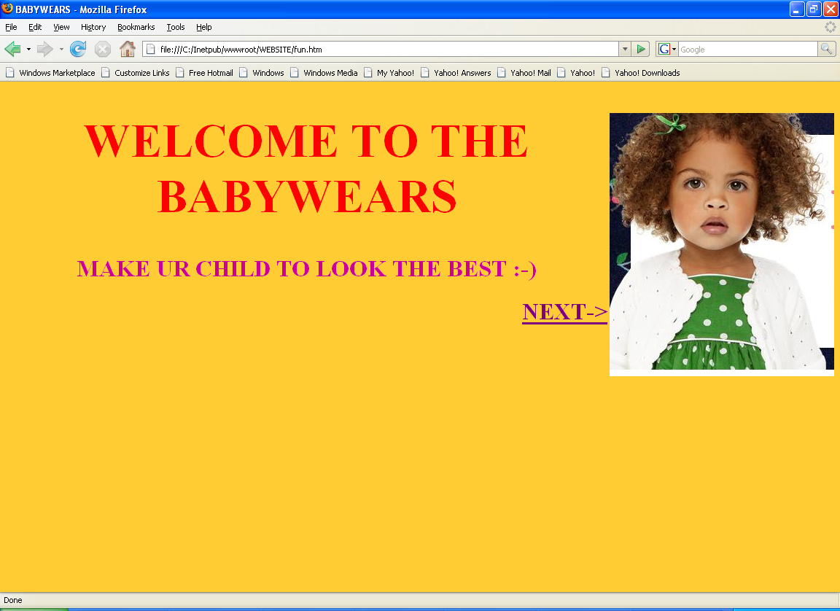
- Fashion Ads is advertising site
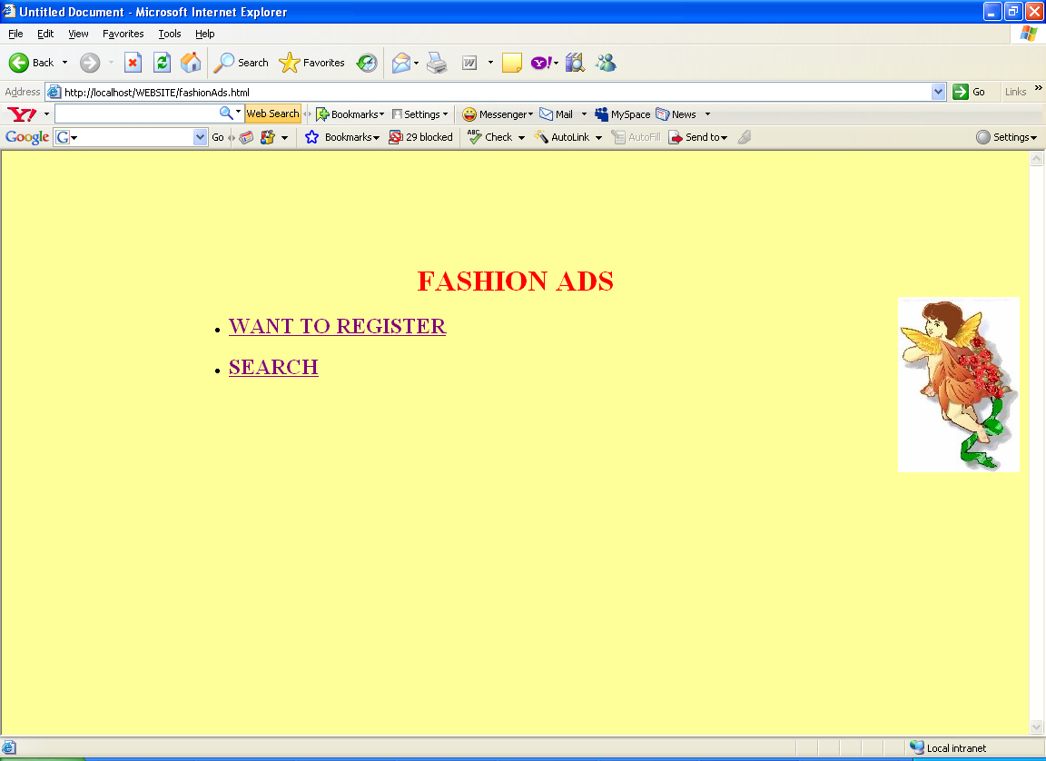
- Ritswear is a customer for the wholesale sellers for clothing

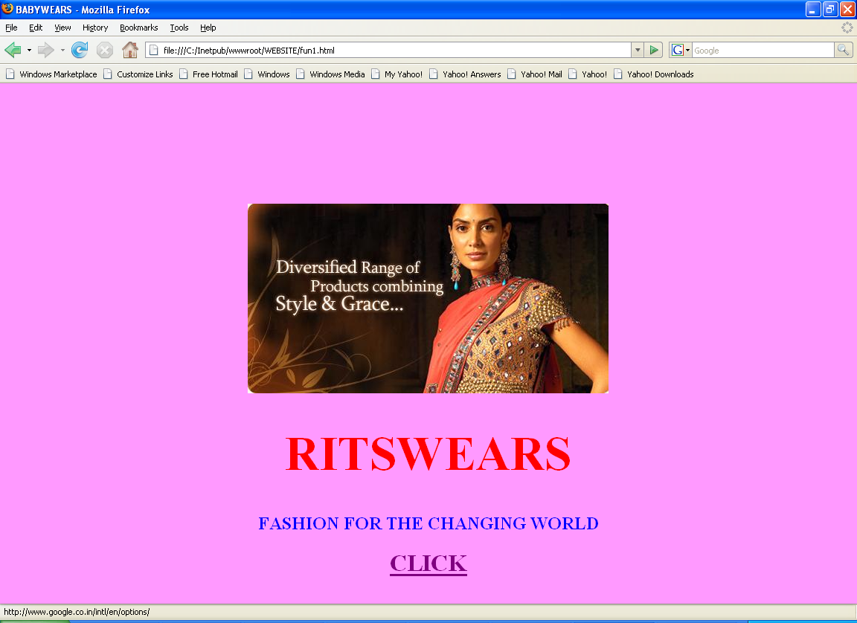
FashionAds Site Description

1) Welcome page which has two choices
a) Register as new user (want to be a member for Fashion Ads)
b) Enter query showing your interests

2) Registration Page

This page allows user to enter his individual ontology which defines its own structure and further helps broker site to match it with other’s requirement.
It allows adding their own concepts also with their relationship with the main concept.
Here, Object for sale is related with Material, Age group, Cost, Age limit.
Clicking Submit button will add the values into the FashionAds.mdb
Where there are two tables representing individual ontology and registered user.

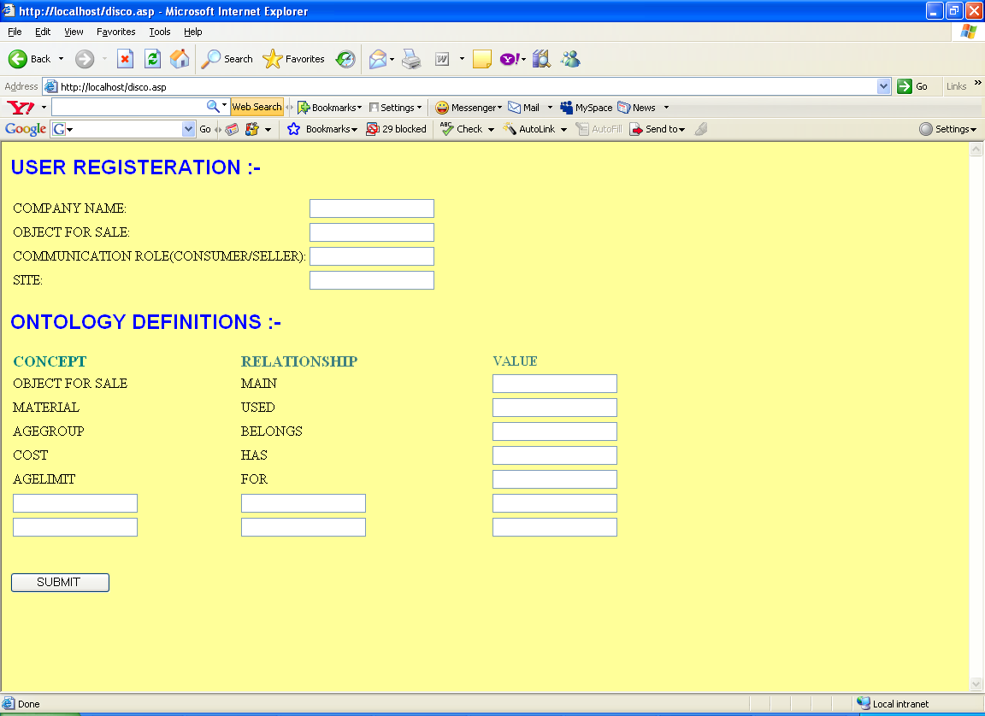

3) Query Page

This page allows user to enter his pattern which defines its requirement and this further matched with other ontologies stored in databases.

Depending on the pattern it is matched with the ontologies registered in site and mind within the semantic web to produce accurate results.

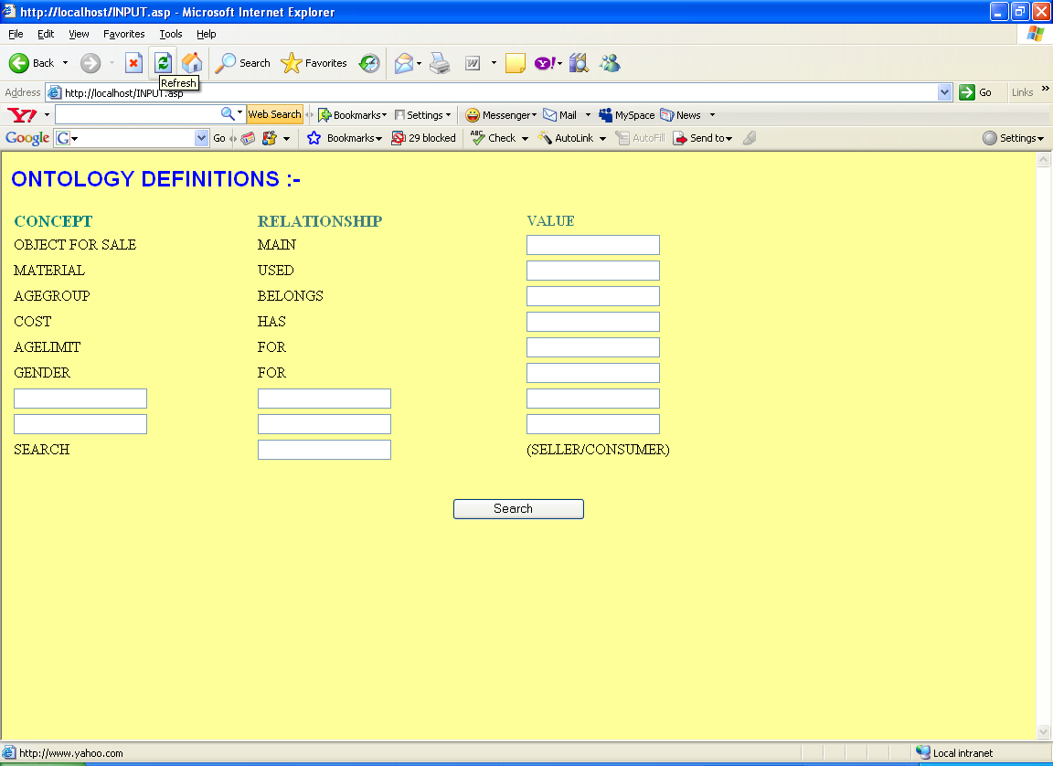

4) Registering completed Page
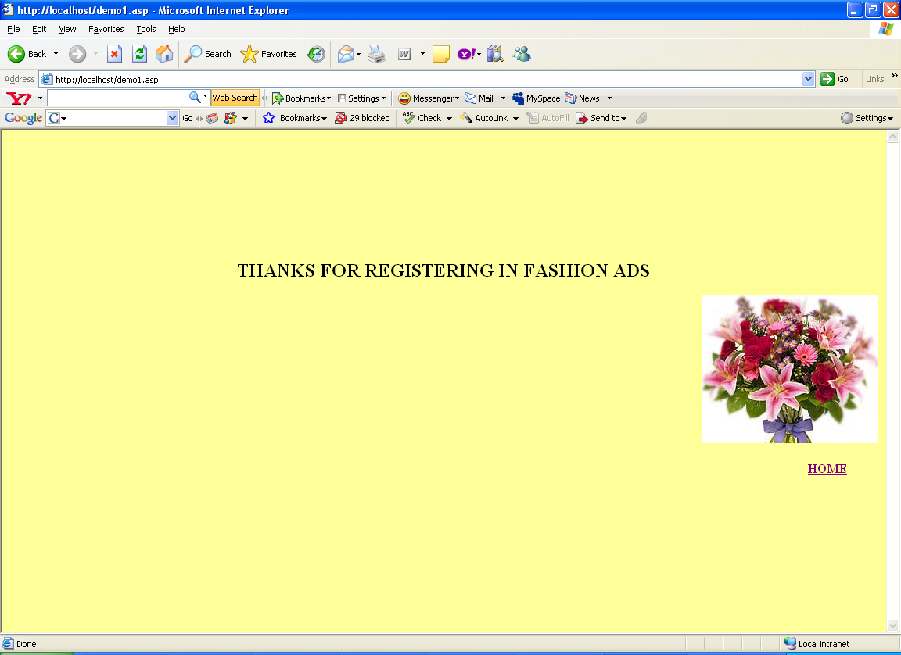

5) Showing the result
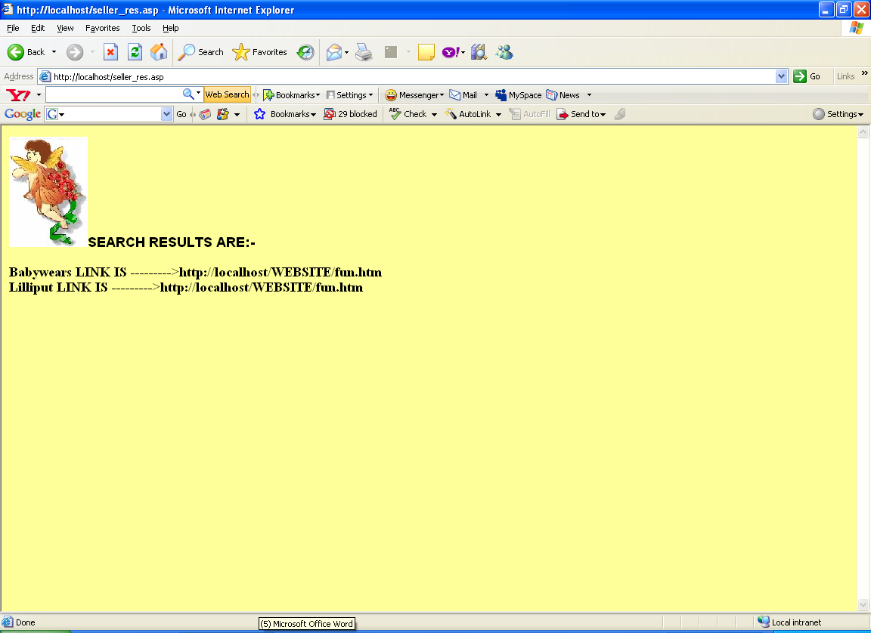

Babywears site description:

1) Welcome Page

2) Rdf files depicting Babywears individual ontology
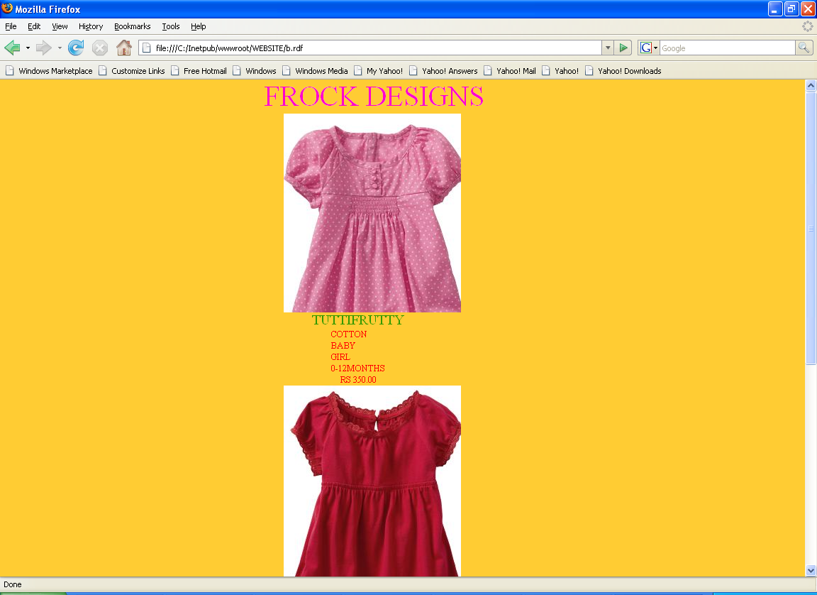
EXAMPLE OF RDF FILE IN BABYWEARS

<?xml version="1.0" encoding="ISO-8859-1"?>
<?xml-stylesheet type="text/css" href="cd_catalog.css"?>

<rdf:RDF
xmlns:rdf="http://www.w3.org/1999/02/22-rdf-syntax-ns#"
xmlns:frock="http://www.babywears/frock#">

<frock:HEADING>FROCK DESIGNS</frock:HEADING>
<frock:IMAGE></frock:IMAGE>

<rdf:Description
rdf:about="http://www.babywears/frock/tuttifrutty">
<frock:NAME>TUTTIFRUTTY</frock:NAME>
<frock:MATERIAL>COTTON</frock:MATERIAL>
<frock:AGE_GROUP>BABY</frock:AGE_GROUP>
<frock:GENDER>GIRL</frock:GENDER>
<frock:AGE_LIMIT>0-12MONTHS</frock:AGE_LIMIT>
<frock:cost>RS 350.00</frock:cost>

</rdf:Description>

<frock:IMAGE1></frock:IMAGE1>

<rdf:Description
rdf:about="http://www.babywears/frock/ANGEL">
<frock:NAME>ANGEL</frock:NAME>
<frock:MATERIAL>COTTON</frock:MATERIAL>
<frock:AGE_GROUP>BABY</frock:AGE_GROUP>
<frock:GENDER>GIRL</frock:GENDER>
<frock:AGE_LIMIT>0-12MONTHS</frock:AGE_LIMIT>
<frock:cost>RS 200.00</frock:cost>
</rdf:Description>

<frock:IMAGE2></frock:IMAGE2>

<rdf:Description
rdf:about="http://www.babywears/frock/CHECKBOX">
<frock:NAME>CHECKBOX</frock:NAME>
<frock:MATERIAL>COTTON</frock:MATERIAL>
<frock:AGE_GROUP>KID</frock:AGE_GROUP>
<frock:GENDER>GIRL</frock:GENDER>
<frock:AGE_LIMIT>0-12MONTHS</frock:AGE_LIMIT>
<frock:cost>RS 500.00</frock:cost>
</rdf:Description>

</rdf:RDF>

Ritswears site description:
1) Welcome Page

2)Rdf files depicting Ritswears individual ontologies
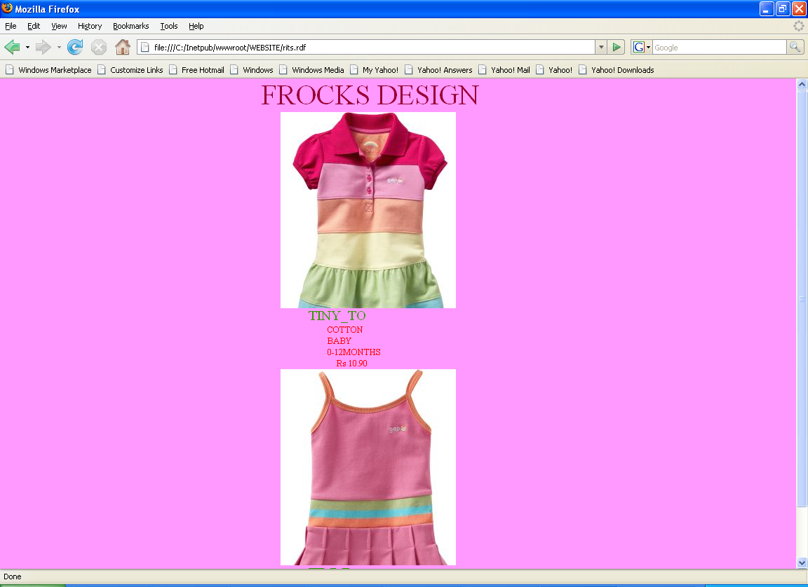
EXAMPLE OF RDF FILE IN RITSWEARS

<?xml version="1.0" encoding="ISO-8859-1"?>
<?xml-stylesheet type="text/css" href="cd_catalog1.css"?>

<rdf:RDF
xmlns:rdf="http://www.w3.org/1999/02/22-rdf-syntax-ns#"
xmlns:frocks="http://www.Ritswears/frocks#">

<frocks:HEADING>FROCKS DESIGN</frocks:HEADING>
<frocks:IMAGE1></frocks:IMAGE1>

<rdf:Description
rdf:about="http://www.Ritswears/frocks/tiny_to">
<frocks:NAME>TINY_TO</frocks:NAME>
<frocks:MATERIAL>COTTON</frocks:MATERIAL>
<frocks:AGE_GROUP>BABY</frocks:AGE_GROUP>
<frocks:AGE_LIMIT>0-12MONTHS</frocks:AGE_LIMIT>
<frocks:COST>Rs 10.90</frocks:COST>

</rdf:Description>

<frocks:IMAGE2></frocks:IMAGE2>

<rdf:Description
rdf:about="http://www.Ritswears/frocks/TIMMI">
<frocks:NAME>TIMMI</frocks:NAME>
<frocks:MATERIAL>COTTON</frocks:MATERIAL>
<frocks:AGE_GROUP>BABY</frocks:AGE_GROUP>
<frocks:AGE_LIMIT>0-12MONTHS</frocks:AGE_LIMIT>
<frocks:COST>Rs 20.90</frocks:COST>
</rdf:Description>
</rdf:RDF>

Chapter 5

SEMANTIC WEB APPROACH IN SOFTWARE ENGINEERING

  - Problem Definition

Software engineering is a knowledge-intensive process. With ontologies as formal knowledge representation scheme for product and process domains, knowledge-based software engineering environment is realizable using Semantic Web technology. The aim of the paper is to develop an architecture which can provide an environment for ontology mapping, knowledge update and semantic search so that Software engineering activities such as domain modeling, code generation or project audit can be improved.

As earlier explained that Ontology is a formal specification of a conceptualization. A conceptualization being a simplified, abstract way of perceiving a segment of the world, for which we agree to recognize the existence of a set of objects and their interrelations, as well as the terms we use to refer to them and their agreed meanings and properties. Thus, ontologies represent a consensual, shared description of the pertinent objects considered as existing in a certain domain of knowledge. They constitute a special kind of software artifact conveying a certain view of the world, specifically designed with the purpose of explicitly expressing the intended meaning of a set of agreed existing objects.

Ontologies could play an important role in Software Engineering, as they can provide a source of precisely defined terms that can be communicated across people, organizations and applications. It offers a consensual shared understanding concerning the domain of discourse and helps to render explicit all hidden assumptions concerning the objects pertaining to a certain domain of knowledge. Using ontologies for product and process domains, a knowledgebase is built by accumulating the software engineering knowledge as instances of ontological categories. This knowledgebase effects information dissemination for software developers, who are distributed across multiple locations, through a semantic search engine. It provides input for knowledge applications to automate code generation from the structured domain model stored as product ontology or automates process execution based on the process structure defined as software process ontology.[14]

5.2 Introduction

5.2.1 Semantic Web and Knowledge management

The Semantic Web is a Web of actionable information that is information derived from data through a semantic theory for interpreting the symbols. The semantic theory provides an account of “meaning” in which the logical connection of terms establishes interoperability between systems. Semantic Web provides a complementary vision as a knowledge management environment.
Knowledge management generally deals with several activities relevant in knowledge life cycle identification, acquisition, development, dissemination, use and preservation of organization’s knowledge.
Any knowledge item, be it a document, object, concept or an event of the real world is a resource in Semantic Web. Each resource has a Unique Resource Identifier (URI) enabling universal identification. URI provides the grounding for both our objects and relations. Using a global naming convention provides the global network effects that drive the Web’s benefits. URI have global scope and are interpreted consistently across contexts. Associating a URI with a resource means that anyone can link to it, refer to it, or retrieve a representation of it. These resources are annotated with metadata expressed in Web Ontology Language (OWL) enabling inference and entailment of information. This principle is applied in developing a knowledge-based tool for software engineering encompassing explicit and tacit knowledge.

5.2.2 Semantic Web based knowledge management and software engineering

Software engineering is the “application of a systematic, disciplined, quantifiable approach to the development, operation, and maintenance of software”. Explicit knowledge items utilized in software engineering are documents such as project documents, plans, process structure and package, technical guidelines and manuals. These resources can be easily added as instances to the respective ontological categories. The tacit knowledge is the implicit knowledge of an organization. Each tacit knowledge item is considered as a knowledge thread, because it is fluid and is stabilized gradually with intertwining of many threads of the same concept under distinct ontological categories into explicit knowledge. Knowledge threads are obtained from various phases of software engineering activities.
A system specification can provide knowledge threads that update concepts and their relationships about an application domain in its ontology. Use cases from requirements specification are the threads, which update the features of the system in domain ontology. Problem resolution records of project execution or project closure reports presenting problem/solution cases are the threads, which enhance process ontologies. The built-in knowledgebase using Semantic Web framework with explicit project documents or implicit knowledge threads is resourceful for the developers to have access to instant information from anywhere and at any time.[14]

5.2.3 Ontologies in the software engineering lifecycle

1) Analysis and Design and Requirement engineering

a) Analysis and Design
Within software analysis and design, the main task is Requirement engineering. Requirements engineering can benefit from ontologies in terms of knowledge representation and process support.
b) Requirements engineering
The phase of requirements engineering deals with gathering the desired system functionality from the customers. Since the involved software engineers are often no domain experts, they must learn about the problem domain from the customers. A different understanding of the concepts involved may lead to an ambiguous, incomplete specification and major rework after system implementation. Therefore it is important to assure that all participants in the requirements engineering phase have a shared understanding of the problem domain. Moreover, change of requirements needs to be considered because of changing customer’s objectives. Ontology can be used for both, to describe requirements specification documents and formally represent requirements knowledge. In most cases, natural language is used to describe requirements, e.g. in the form of use cases. However, it is possible to use normative language or formal specification languages which are generally more precise and pave the way towards the formal system specification. Because the degree of expressiveness can be adapted to the actual needs, ontologies can cover semi-formal and structured as well as formal representation. Advantages of ontologies are that they seem to be well suited for an evolutionary approach to the specification of requirements and domain knowledge. Moreover, ontologies can be used to support requirements management and traceability Automated validation and consistency checking are considered as a potential benefit compared to semi-formal or informal approaches providing no logical formalism or model theory. Finally, formal specification may be a prerequisite to realize model-driven approaches in the design and implementation phase.

2) Implementation
A critical step in the development process is moving from analysis and design to implementation. Ontologies can play a vital role by overlapping of software modeling with ontology languages and the run-time usage of ontologies in applications.

a) Integration with Software Modeling Languages
Software modeling languages and methodologies can benefit from the integration with ontology languages such as RDF and OWL in various ways, e.g. by reducing language ambiguity, enabling validation and automated consistency checking .Ontology languages provide better support for logical inference, integration and interoperability.

b) Coding Support
In object-oriented software development, the concept of encapsulation demands the decoupling of the interface specification from its implementation in order to make requesting applications independent from internal modifications. Nowadays, developers face a large number of frameworks and libraries they have to access through application programming interfaces. Thus, the documentation of APIs has become an important issue. Some IDEs like Eclipse use this information to enhance developer productivity by providing auto completion of method calls. However, many operations require several calls to an API. While developers could benefit from formalized knowledge about the interrelations of method calls in the API in a similar way to auto-completion, there is currently no support for this. Description of approach: The SmartAPI approach suggests enriching APIs with semantic information. Since the semantics of string parameters like "username" or "password" is only clear for users, but not for machines, they must be annotated with the concept "database user name". The authors propose to store those annotations via a public web service to enable a collaborative knowledge acquisition effort. Besides the easier location of API interfaces and methods, the authors present how a suitable sequence of method calls can be automatically generated, given a desired goal state.
In the SmartAPI scenario, the main advantage of ontologies is that they provide a globally unique identifier for concepts. While at the programming level it is convenient to have a limited set of data "types" like strings that can be used for multiple purposes, ontology enables developers to annotate.

3) Testing
Software tests are an important part of quality assurance. However, the writing of test cases is an expensive endeavor that does no directly yield business value. It is also not a trivial task, since the derivation of suitable test cases demands a certain amount of domain knowledge.
Ontologies could help to generate basic test cases since they encode domain knowledge in a machine processable format.

5.3 THE PROPOSED ARCHITECTURE

The architecture is designed in the following three layers:

A) The Data layer comprises all domain ontologies of the environment regarding product and process as described above. Each project is represented by a distinct ontology. This sets the environment for a project by tailoring and linking product and process ontologies with concepts and terminologies pertaining to a specific project.

B) The Semantic middleware layer is assembled using multi-agent architecture for Semantic Web. Sophisticated middleware infrastructure like application servers, shield lot of complexity from the application developer, but creates challenging tasks for the administrator. Issues like interdependencies between modules or legal constraints make the management of middleware systems a cumbersome task. The middleware consists of a set of agents, which do independent tasks like cooperating, competing or coexisting with one another.

These agents are grouped into three categories.
1. Coordination agent receives all requests from the application layer and processes the requests by identifying the task. It also splits tasks into subtasks and allocates them to domain agents. After execution or termination of each task, it sends the result to the application layer.

2. Domain Agents accomplish specialized tasks on behalf of the domain ontology such as formulating queries, a specific domain solution or communicating with other agents. Separate domain agents represent product, process and project.

3. Interface Agent creates ontology models and interacts with middleware for ontology modeling, reasoning or updating of instance data.

C) The application layer consists of front-end tools that enable acquisition and manipulation of knowledge threads. Each application is an independent entity, which interacts with the middleware by requesting for a service and getting a response. For instance, in the Semantic Search engine, user input is parsed and eliminating aliens identifies the key tokens. Mapping with concepts and properties of the selected domain does this identification. Based on the number of tokens and possible combination of terms with regard to concepts and properties, queries are formed in RDQL and are executed with the help of query engine. As part of code generation technique .Ontology mapping technique is used to convert OWL classes to object-oriented classes.

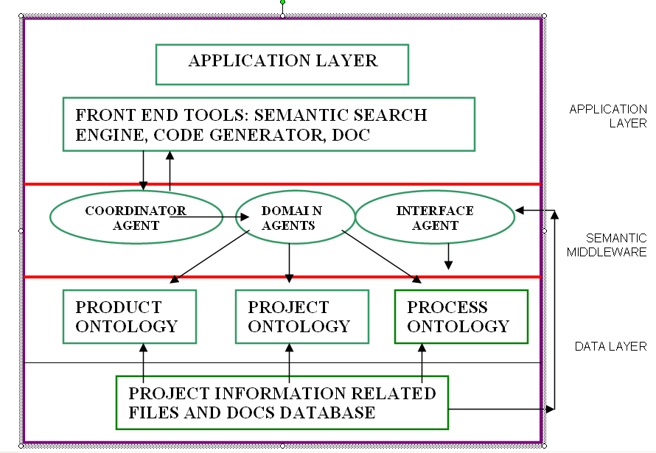
Figure 11 A Semantic Web approach for Knowledge-based Software Engineering

5.4 CONCLUSION AND FUTURE SCOPE
Ontologies can be utilized in Software Engineering lifecycle, as it acts as a source of precisely defined terminology that can be shared across people, organizations and applications. The development of “software engineering domain ontology” will allow us to share and reuse all knowledge accumulated until now in the Software Engineering field and open news avenues to automatic interpretation of this knowledge, using information systems or intelligent software agents.

Chapter 6
Generation of Ontology for a Hospital Management System
(Initial Designing of Application with the help of Protégé)
Important Code and Screenshots

As explained in earlier that Ontologies could play an important role in Software Engineering, as they can provide a source of precisely defined terms that can be communicated across people, organizations and applications. It offers a consensual shared understanding concerning the domain of discourse and helps to render explicit all hidden assumptions concerning the objects pertaining to a certain domain of knowledge. Using ontologies for product and process domains, a knowledgebase is built by accumulating the software engineering knowledge as instances of ontological categories.

In this Chapter we are generating Ontology for a Hospital management system, which in turn help to analyze and design the application. As it clearly describes the information about classes, entities and their relations with each other, we have used protégé software for generating ontology. This ontology is tested and validated and can be further utilized for designing, coding etc phases of Software Engineering.

  - A Brief Introduction about Web Ontology Language (OWL)
OWL was proposed by the W3C Web Ontology Working Group as an extension to RDF with the aim of overcoming the limitations of RDF like lack of support to express class relations, lack of local restrictions on property values and lack of constructs to express property relations. OWL [13] is heavily influenced by RDF, RDF schema and the ontology description language DAML+OIL. OWL is similar to RDF schema in that it structures the knowledge in a class-subclass hierarchy. Additionally, OWL allows classes to be specified as logical combination (conjunction, disjunction and intersection) of classes or as enumerations (list, union, etc.) of specific objects. OWL extends the hierarchy to properties allowing relations between properties and sub-properties. OWL also allows domain and range constraints to be localized. [10]
6.1.1 Sub-Languages of OWL
To balance between expressivity and computational complexity of OWL defined three sub-languages of OWL are:
- OWL Lite: It restricts the OWL constructs set to provide efficient and inexpensive reasoning support at the cost of losing expressive power. OWL Lite does not allow the use of the constructs, owl:oneOf, owl:unionOf, owl:complementOf, owl:hasValue, owl:disjointWith and owl:dataRange OWL-Guide.

- OWL DL: It guarantees computational completeness and decidability and is not fully compatible with RDF. It requires that classes in OWL as a set to be disjoint from the set of individuals. Semantically, an owl:class in OWL DL is a subclass of rdfs:class. Another important restriction applied by OWL DL is the disjointedness of object properties and datatype properties. OWL DL also requires all OWL DL ontologies to form well formed documents (every start tag must have a corresponding tag).

- OWL Full: OWL Full represents the complete OWL language. OWL Full allows the use of any construct specified in OWL as well as all RDF and RDFS constructs. It is a true extension of RDF in that its interpretation of RDF constructs is consistent with their interpretation in RDF. This means that constructs such as rdfs: class is treated as an owl:class resource. Therefore, any legal RDF document is also a legal OWL Full document and any valid RDF/RDFS inference is also a valid OWL Full inference.
Subsumption in OWL is enabled through the RDFS construct rdfs:subclassOf. Its semantics in OWL is consistent with that of RDFS. A subclass is said to be a specialization of a more general class. Subclasses also play an important role in property declaration. Properties are assigned to OWL classes using anonymous subclass declarations. OWL allows for two distinct types of class properties namely, object properties and datatype properties.
- Object properties are binary relations that have both domain and range in the set of classes or class instances.

- Datatype properties are binary relations that have domain in the set of classes and range in the set of OWL datatypes. Datatypes are another area OWL borrows heavily from XML schemas .
One of the advantages of OWL over RDF is that it lets users impose restrictions on properties individually for each property declaration. This allows for a more refined form of property declaration, as opposed to RDF where property attributes must be declared globally. Restrictions can be imposed on both the range of the property and its cardinality. Cardinality restrictions are imposed using the constructs owl:cardinality, owl:minCadinality and owl:maxCardinality. Range restrictions are imposed using the constructs owl:someValuesFrom, owl:hasValue and owl:AllValuesFrom.
  - A Brief Introduction about Protégé
Protégé -2000 is a platform for developers and domain experts to build conceptual domain models and knowledge bases using a graphical user interface.With the plug-in facility, Protégé -2000 can be extended with new plug-ins for file import and export in different formats or new visualization techniques. The models can also be accessed from stand-alone applications via the Protégé API .
Protégé-2000 is typically used to model classes (domain concepts), their properties and relationships. It is used to create instances of these classes to build knowledge bases with defined semantics and logical behavior and to ask questions of these. It uses its own data model to represent the ontology internally. Filters are provided to import ontologies from and export to other representations languages like RDF, UML and DAML+OIL. Protégé-2000 supports multiple inheritance so that a concept can have more than just one parent. Like in object oriented programming instances can be created only from concrete concepts, not from abstract concepts. The properties are called slots and have a name and a value.
Protégé-2000 without additional plug-ins provides four different tabs that display different parts of the ontology. The classes tab displays the concepts of inheritance hierarchy in a two dimensional tree and the properties and relationships for a selected concept in the tree. The properties and relationships of the concepts can be edited in the slot panel. The instance tab shows the concepts in a two-dimensional tree view like in the classes tab and the instances of the selected concept are displayed. When selecting an instance the properties of it are displayed and can be edited. In the forms tab the user can edit the forms presented when editing the properties of the concepts.

  - Overall Structure of the Hospital Management System

( Based on Requirements and acts as a foundation for the Ontology Development)

HOSPITAL
MANAGEMENT
OPD
OPERATION THEATURE
DISPENCERY
DIAGNOSIS
CENTER
ACCOUNTS OFFICE
PERSON
PATIENTS
DOCTORS
VISITORS
STAFF
NURSES
WARD BOYS
INCOMING
OUTGOING

Figure18:- Entity Diagram for Hospital Management

  - Screenshots from Protégé

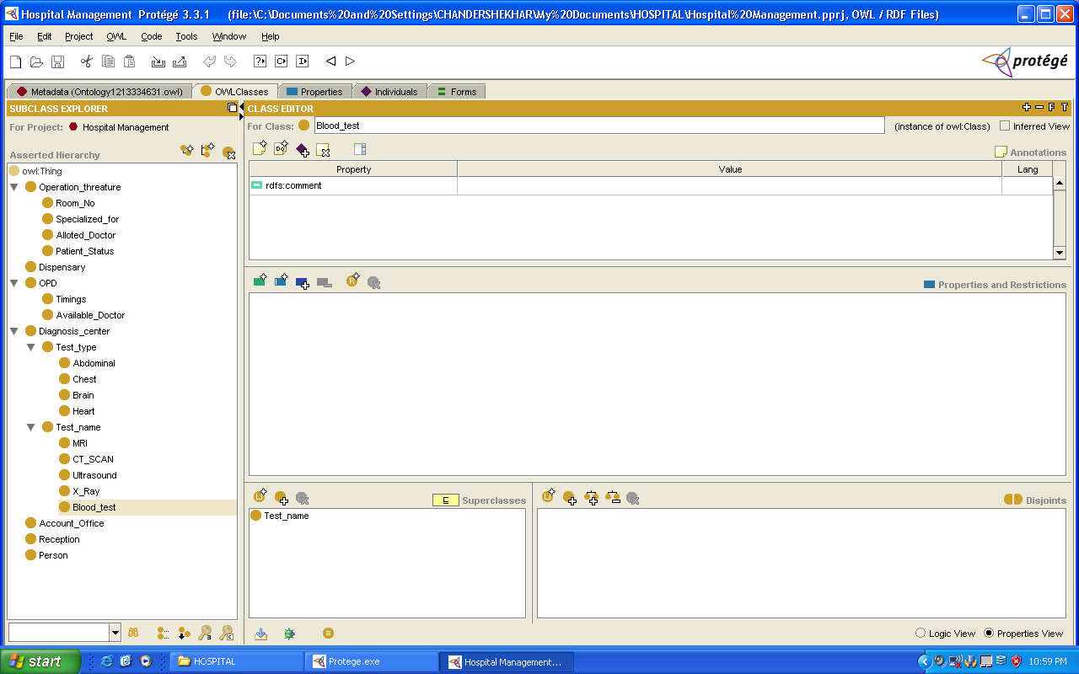

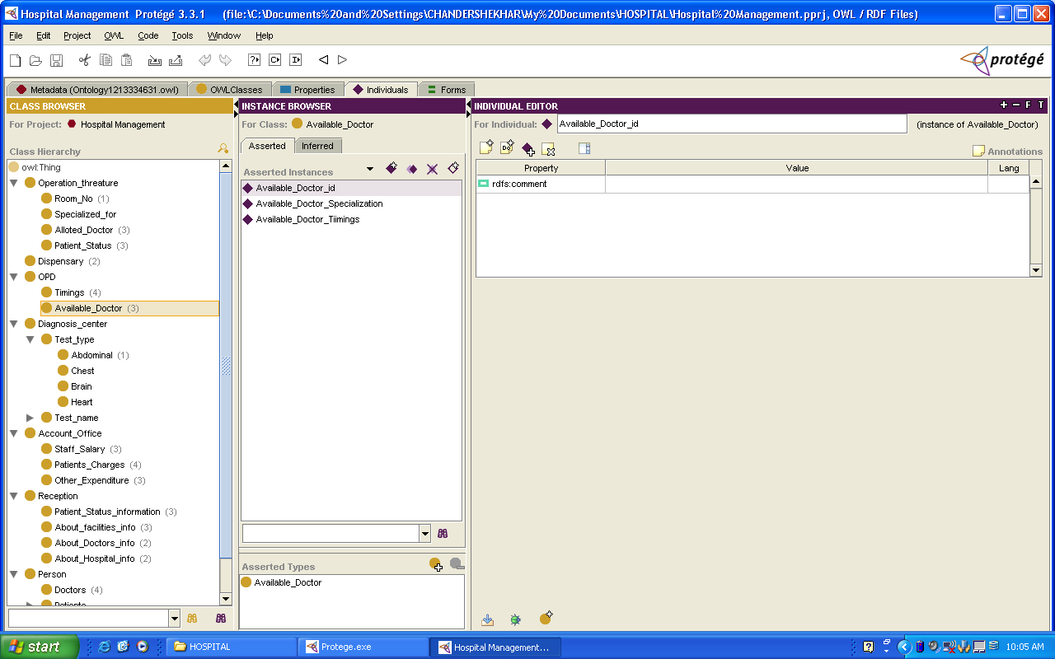
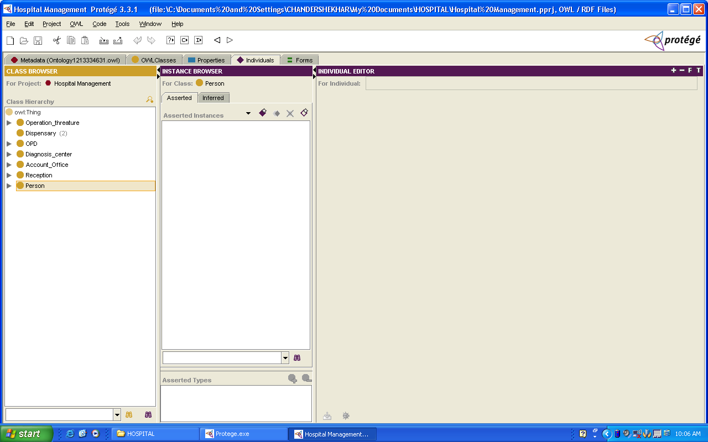

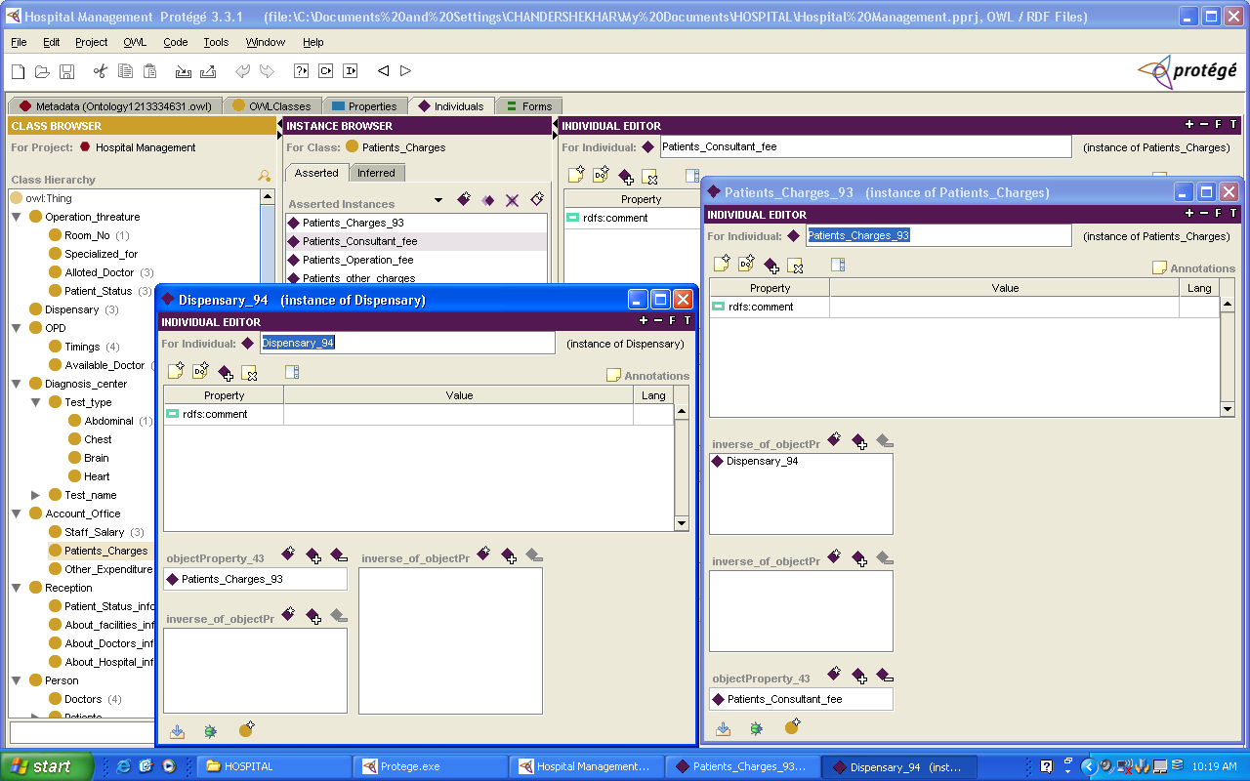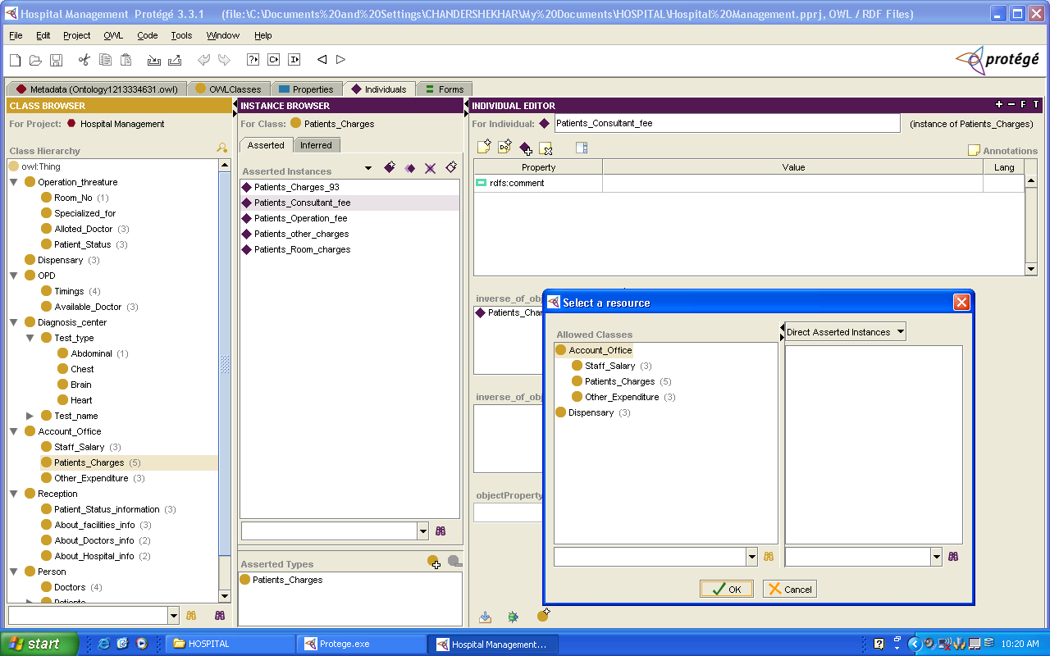

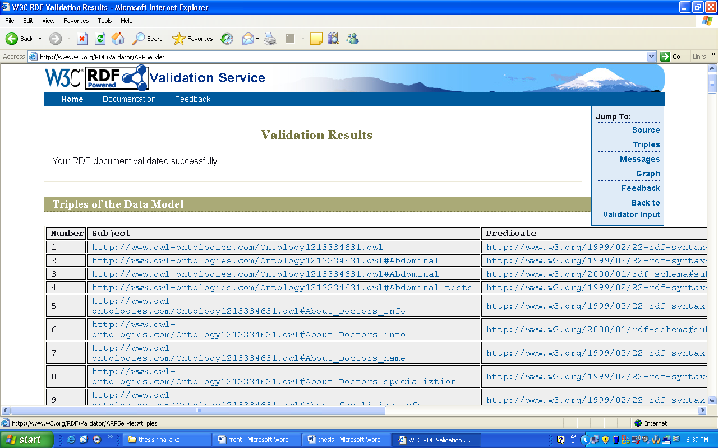

6.5 Source Code of Hospital Management System Ontology

<?xml version="1.0"?>

<!DOCTYPE rdf:RDF [
<!ENTITY owl "http://www.w3.org/2002/07/owl#" >
<!ENTITY xsd "http://www.w3.org/2001/XMLSchema#" >
<!ENTITY rdfs "http://www.w3.org/2000/01/rdf-schema#" >
<!ENTITY rdf "http://www.w3.org/1999/02/22-rdf-syntax-ns#" >
]>

<rdf:RDF xmlns="http://www.owl-ontologies.com/Ontology1213334631.owl#"
xml:base="http://www.owl-ontologies.com/Ontology1213334631.owl"
xmlns:xsd="http://www.w3.org/2001/XMLSchema#"
xmlns:rdfs="http://www.w3.org/2000/01/rdf-schema#"
xmlns:rdf="http://www.w3.org/1999/02/22-rdf-syntax-ns#"
xmlns:owl="http://www.w3.org/2002/07/owl#">
<owl:Ontology rdf:about=""/>
<owl:Class rdf:ID="Abdominal">
<rdfs:subClassOf rdf:resource="#Test_type"/>
</owl:Class>
<Abdominal rdf:ID="Abdominal_tests"/>
<owl:Class rdf:ID="About_Doctors_info">
<rdfs:subClassOf rdf:resource="#Reception"/>
</owl:Class>
<About_Doctors_info rdf:ID="About_Doctors_name"/>
<About_Doctors_info rdf:ID="About_Doctors_specializtion"/>
<owl:Class rdf:ID="About_facilities_info">
<rdfs:subClassOf rdf:resource="#Reception"/>
</owl:Class>
<About_facilities_info rdf:ID="About_facilities_info_78"/>
<owl:Class rdf:ID="About_Hospital_info">
<rdfs:subClassOf rdf:resource="#Reception"/>
</owl:Class>
<About_Hospital_info rdf:ID="About_Hospital_Management"/>
<About_Hospital_info rdf:ID="About_Hospital_Name"/>
<owl:Class rdf:ID="Account_Office"/>
<owl:Class rdf:ID="Alloted_Doctor">
<rdfs:subClassOf rdf:resource="#Operation_threature"/>
</owl:Class>
<Alloted_Doctor rdf:ID="Alloted_Doctor_id"/>
<Alloted_Doctor rdf:ID="Alloted_Doctor_Name"/>
<Alloted_Doctor rdf:ID="Alloted_Doctor_staff"/>
<owl:ObjectProperty rdf:ID="annotationProperty_92">
<rdf:type rdf:resource="&owl;AnnotationProperty"/>
<rdf:type rdf:resource="&owl;SymmetricProperty"/>
<rdfs:domain rdf:resource="#Incoming"/>
<rdfs:range rdf:resource="#Incoming"/>
<owl:inverseOf rdf:resource="#annotationProperty_92"/>
<rdfs:label xml:lang="en">patient status</rdfs:label>
</owl:ObjectProperty>
<owl:Class rdf:ID="Available_Doctor">
<rdfs:subClassOf rdf:resource="#OPD"/>
</owl:Class>
<Available_Doctor rdf:ID="Available_Doctor_id"/>
<Available_Doctor rdf:ID="Available_Doctor_Specialization"/>
<Available_Doctor rdf:ID="Available_Doctor_Tiimings"/>
<About_facilities_info rdf:ID="Available_doctors"/>
<owl:Class rdf:ID="Blood_test">
<rdfs:subClassOf rdf:resource="#Test_name"/>
</owl:Class>
<owl:Class rdf:ID="Brain">
<rdfs:subClassOf rdf:resource="#Test_type"/>
</owl:Class>
<owl:Class rdf:ID="Chest">
<rdfs:subClassOf rdf:resource="#Test_type"/>
</owl:Class>
<owl:Class rdf:ID="CT_SCAN">
<rdfs:subClassOf rdf:resource="#Test_name"/>
</owl:Class>
<owl:DatatypeProperty rdf:ID="datatypeProperty_42"/>
<Patient_Status_information rdf:ID="date_of_admission"/>
<owl:Class rdf:ID="Diagnosis_center"/>
<Other_Expenditure rdf:ID="Different_bills"/>
<owl:Class rdf:ID="Dispensary"/>
<Dispensary rdf:ID="Dispensary_94">
<objectProperty_43 rdf:resource="#Patients_Charges_93"/>
</Dispensary>
<Dispensary rdf:ID="Dispensary_bill_no"/>
<Dispensary rdf:ID="Dispensary_window_no"/>
<owl:Class rdf:ID="Doctors">
<rdfs:subClassOf rdf:resource="#Person"/>
</owl:Class>
<Doctors rdf:ID="Doctors_Contact_no"/>
<Doctors rdf:ID="Doctors_id"/>
<Doctors rdf:ID="Doctors_Name"/>
<Doctors rdf:ID="Doctors_specialization"/>
<Other_Expenditure rdf:ID="Food"/>
<owl:Class rdf:ID="Going">
<rdfs:subClassOf rdf:resource="#Patients"/>
</owl:Class>
<owl:Class rdf:ID="Heart">
<rdfs:subClassOf rdf:resource="#Test_type"/>
</owl:Class>
<About_facilities_info rdf:ID="Hospital_facilities"/>
<owl:Class rdf:ID="Incoming">
<rdfs:subClassOf rdf:resource="#Patients"/>
</owl:Class>
<owl:ObjectProperty rdf:ID="inverse_of_objectProperty_43">
<rdf:type rdf:resource="&owl;TransitiveProperty"/>
<rdfs:domain>
<owl:Class>
<owl:unionOf rdf:parseType="Collection">
<owl:Class rdf:about="#Account_Office"/>
<owl:Class rdf:about="#Dispensary"/>
</owl:unionOf>
</owl:Class>
</rdfs:domain>
<rdfs:range>
<owl:Class>
<owl:unionOf rdf:parseType="Collection">
<owl:Class rdf:about="#Account_Office"/>
<owl:Class rdf:about="#Dispensary"/>
</owl:unionOf>
</owl:Class>
</rdfs:range>
</owl:ObjectProperty>
<owl:ObjectProperty rdf:ID="inverse_of_objectProperty_43_">
<rdfs:domain>
<owl:Class>
<owl:unionOf rdf:parseType="Collection">
<owl:Class rdf:about="#Account_Office"/>
<owl:Class rdf:about="#Dispensary"/>
</owl:unionOf>
</owl:Class>
</rdfs:domain>
<rdfs:range>
<owl:Class>
<owl:unionOf rdf:parseType="Collection">
<owl:Class rdf:about="#Account_Office"/>
<owl:Class rdf:about="#Dispensary"/>
</owl:unionOf>
</owl:Class>
</rdfs:range>
<owl:inverseOf rdf:resource="#objectProperty_43"/>
</owl:ObjectProperty>
<owl:Class rdf:ID="MRI">
<rdfs:subClassOf rdf:resource="#Test_name"/>
</owl:Class>
<owl:ObjectProperty rdf:ID="objectProperty_43">
<rdf:type rdf:resource="&owl;FunctionalProperty"/>
<rdf:type rdf:resource="&owl;InverseFunctionalProperty"/>
<rdfs:domain>
<owl:Class>
<owl:unionOf rdf:parseType="Collection">
<owl:Class rdf:about="#Account_Office"/>
<owl:Class rdf:about="#Dispensary"/>
</owl:unionOf>
</owl:Class>
</rdfs:domain>
<rdfs:range>
<owl:Class>
<owl:unionOf rdf:parseType="Collection">
<owl:Class rdf:about="#Account_Office"/>
<owl:Class rdf:about="#Dispensary"/>
</owl:unionOf>
</owl:Class>
</rdfs:range>
<owl:inverseOf rdf:resource="#inverse_of_objectProperty_43_"/>
</owl:ObjectProperty>
<owl:Class rdf:ID="OPD"/>
<owl:Class rdf:ID="Operation_threature"/>
<owl:Class rdf:ID="Other_Expenditure">
<rdfs:subClassOf rdf:resource="#Account_Office"/>
</owl:Class>
<Patient_Status_information rdf:ID="Patient_concerning_problem"/>
<Patient_Status rdf:ID="Patient_id"/>
<Patient_Status rdf:ID="Patient_Name"/>
<Patient_Status_information rdf:ID="Patient_name"/>
<Patient_Status rdf:ID="Patient_problem"/>
<owl:Class rdf:ID="Patient_Status">
<rdfs:subClassOf rdf:resource="#Operation_threature"/>
</owl:Class>
<owl:Class rdf:ID="Patient_Status_information">
<rdfs:subClassOf rdf:resource="#Reception"/>
</owl:Class>
<owl:Class rdf:ID="Patients">
<rdfs:subClassOf rdf:resource="#Person"/>
</owl:Class>
<owl:Class rdf:ID="Patients_Charges">
<rdfs:subClassOf rdf:resource="#Account_Office"/>
</owl:Class>
<Patients_Charges rdf:ID="Patients_Charges_93">
<objectProperty_43 rdf:resource="#Patients_Consultant_fee"/>
<inverse_of_objectProperty_43_ rdf:resource="#Dispensary_94"/>
</Patients_Charges>
<Patients_Charges rdf:ID="Patients_Consultant_fee">
<inverse_of_objectProperty_43_ rdf:resource="#Patients_Charges_93"/>
</Patients_Charges>
<Patients_Charges rdf:ID="Patients_Operation_fee"/>
<Patients_Charges rdf:ID="Patients_other_charges"/>
<Patients_Charges rdf:ID="Patients_Room_charges"/>
<owl:Class rdf:ID="Person"/>
<owl:Class rdf:ID="Reception"/>
<Room_No rdf:ID="Room_id"/>
<owl:Class rdf:ID="Room_No">
<rdfs:subClassOf rdf:resource="#Operation_threature"/>
</owl:Class>
<owl:Class rdf:ID="Specialized_for">
<rdfs:subClassOf rdf:resource="#Operation_threature"/>
</owl:Class>
<owl:Class rdf:ID="Staff">
<rdfs:subClassOf rdf:resource="#Person"/>
</owl:Class>
<owl:Class rdf:ID="Staff_Salary">
<rdfs:subClassOf rdf:resource="#Account_Office"/>
</owl:Class>
<Staff_Salary rdf:ID="Staff_Salary_allownces"/>
<Staff_Salary rdf:ID="Staff_Salary_basic"/>
<Staff_Salary rdf:ID="Staff_Salary_increment"/>
<owl:Class rdf:ID="Test_name">
<rdfs:subClassOf rdf:resource="#Diagnosis_center"/>
</owl:Class>
<owl:Class rdf:ID="Test_type">
<rdfs:subClassOf rdf:resource="#Diagnosis_center"/>
</owl:Class>
<owl:Class rdf:ID="Timings">
<rdfs:subClassOf rdf:resource="#OPD"/>
</owl:Class>
<Timings rdf:ID="Timings_Afternoon"/>
<Timings rdf:ID="Timings_Emergency"/>
<Timings rdf:ID="Timings_Evening"/>
<Timings rdf:ID="Timings_Morning"/>
<Other_Expenditure rdf:ID="transportation"/>
<owl:Class rdf:ID="Ultrasound">
<rdfs:subClassOf rdf:resource="#Test_name"/>
</owl:Class>
<owl:Class rdf:ID="Visitors">
<rdfs:subClassOf rdf:resource="#Person"/>
</owl:Class>
<owl:Class rdf:ID="X_Ray">
<rdfs:subClassOf rdf:resource="#Test_name"/>
</owl:Class>
</rdf:RDF>

Bibliography

SEMANTIC WEB

[1] Berners-Lee, T., Hendler, J. and Lassila, O. (2001), The Semantic Web,
Scientific American, May 2001: pp 35-43

[2] McCool, R. Rethinking the Semantic Web, Part 1. IEEE Internet Computing
(Nov.–Dec.2005), 86–88.v

PRAGMATIC WEB

[3] de Moor, A., Keeler, M. and Richmond, G. (2002), Towards a Pragmatic Web. In
Proc. Of the 10th Intl. Conference On Conceptual Structures (ICCS 2002),
Borovets, Bulgaria, July 2002, LNAI 2393. Springer, Berlin, pp. 235-249.

[4] Fillies, C., Wood-Albrecht, G. and Weichhardt, F. (2003), Pragmatic Applications
of the Semantic Web Using SemTalk, Computer Networks, 42: 599-615.

[5] Repenning, A. and Sullivan, J. (2003), The Pragmatic Web: Agent-Based
Multimodal Web Interaction with no Browser in Sight. In Human-Computer
Interaction - INTERACT'03. IOS Press, IFIP, pp. 212-219

[6] Singh, M. P. (2002a), The Pragmatic Web, IEEE Internet Computing, May/June:
4-5

[7] Singh, M. P. (2002b), The Pragmatic Web: Preliminary Thoughts. In Proc. of the
NSF-EU Workshop on Database and Information Systems Research for Semantic
Web and Enterprises, April 3-5, Amicalolo Falls and State Park, Georgia.

[8] Spyns, P. and Meersman, R. A. (2003), From Knowledge to Interaction: from the
Semantic to the Pragmatic Web. Technical Report STAR-2003-05, STARLab ,
Brussels

[9] de Moor(2005),Patterns of the web. Invited paper, Proc. of the 13th International
Conference on Conceptual Structures (ICCS 2005), Kassel, Germany, July 2005,
LNAI. Springer Verlag, Berlin, pp.1-18

ONTOLOGIES

[10] Dieter Fensel, Ontologies: Silver Bullet for Knowledge Management and
Electronic Commerce

[11] Spyns, P., Meersman, R. A. and Jarrar, M. (2002), Data Modelling versus
Ontology Engineering, ACM SIGMOD Record, 31(4): 12-17

SEMANTIC WEB AND ECOMMERCE

[12] Wan-Shiou Yang *, Jia-Ben Dia(2007), Discovering cohesive subgroups from
social networks for targeted advertising

SEMANTIC WEB AND SOFTWARE ENGINEERING

[13] D. Fensel and R. Groenboom: Specifying Knowledgebased Systems with
Reusable Components. In Proceedings 9th International Conference on Software
Engineering and Knowledge Engineering (SEKE ’97), Madrid 1997.

[14] S. Thaddeus, S.V. Kasimir Raja: Ontology-driven Software Engineering
Environment. Proceedings of the Eighteenth International Conference on
Software Engineering and Knowledge Engineering, San Francisco, California,
July (2006), 337-342

[15] Abran, A., and Moore, J.W. (Exec. Eds.), Bourque, P. and Dupuis, R. (Eds.)
Guide to the Software Engineering Body of Knowledge (2004)

[16] Thaddeus S*, Kasmir Raja S.V: A Semantic Web Tool for Knowledge-based
Software Engineering

[17] Hans-Jörg Happel and Stefan Seedorf: Applications of Ontologies in Software
Engineering

